  Year 5 · Addition and subtraction · Step 8  Finding missing numbers | 
  Year 5 · Addition and subtraction · Step 8
  Finding missing numbers
  1 | Write the missing number. Think about the place value.
    a) | 19,955 + |  | = | 20,655
    b) | 19,955 − |  | = | 19,915
    c) |  | + 300 | = | 19,955
  1 | Write the missing number. Think about the place value.
    a) | 19,955 + |  | = | 20,655
    b) | 19,955 − |  | = | 19,915
    c) |  | + 300 | = | 19,955
  2 | Write the missing number.
    a) |  | − 100 | = | 59,387
    b) | 10,000 + |  | = | 59,387
    c) |  | − 2,000 | = | 59,387
  2 | Write the missing number.
    a) |  | − 100 | = | 59,387
    b) | 10,000 + |  | = | 59,387
    c) |  | − 2,000 | = | 59,387
  3 | Use what you know about equivalent calculations to write the missing numbers.
    a) | 96 + 99 | = | 100 +
    b) | 46 + 129 | = | 50 +
    c) | 107 + 716 | = | 100 +
    d) | 9,999 + 77,418 | =
    + 10,000
  3 | Use what you know about equivalent calculations to write the missing numbers.
    a) | 96 + 99 | = | 100 +
    b) | 46 + 129 | = | 50 +
    c) | 107 + 716 | = | 100 +
    d) | 9,999 + 77,418 | =
    + 10,000
  4 | Use what you know about equivalent calculations to write the missing numbers.
    a) | 5,798 − 99 | = |  | − 100
    b) | 16,483 − 998 | =
    − 1,000
    c) | 173,310 − 49,840 | =
    173,000 −
  4 | Use what you know about equivalent calculations to write the missing numbers.
    a) | 5,798 − 99 | = |  | − 100
    b) | 16,483 − 998 | =
    − 1,000
    c) | 173,310 − 49,840 | =
    173,000 −
  5 | Write the missing number. Look at how the numbers have changed.
    a) | 60,964 + 3,978 | =
    61,000 +
    b) | 767 + |  | = | 774 + 1,000
    c) |  | − 10,000 | =
    67,660 − 10,006
    d) | 499,800 + |  | =
    37,450 + 500,000
  5 | Write the missing number. Look at how the numbers have changed.
    a) | 60,964 + 3,978 | =
    61,000 +
    b) | 767 + |  | = | 774 + 1,000
    c) |  | − 10,000 | =
    67,660 − 10,006
    d) | 499,800 + |  | =
    37,450 + 500,000
  6 | Write the missing number.
    a) | 720 + |  | = | 1,000
    b) | 2,050 + |  | = | 10,000
    c) |  | + 26,100 | = | 100,000
    d) | 1,000,000 − |  | =
    755,000
  6 | Write the missing number.
    a) | 720 + |  | = | 1,000
    b) | 2,050 + |  | = | 10,000
    c) |  | + 26,100 | = | 100,000
    d) | 1,000,000 − |  | =
    755,000
  7 | Complete the bar model. Write the missing number.  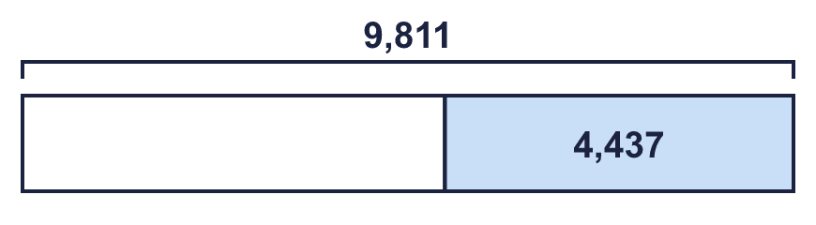
  7 | Complete the bar model. Write the missing number.
  8 | Write the missing digits in the calculation.  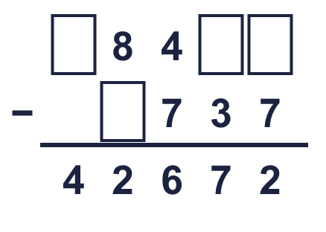
  8 | Write the missing digits in the calculation.

  9 | Do you agree with Boba? Circle yes or no.  Yes / No  Explain your answer.
     | 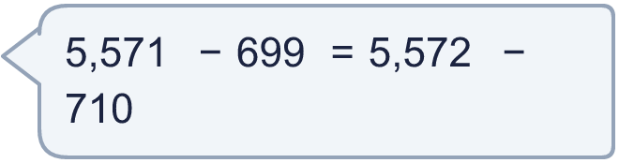
  9 | Do you agree with Boba? Circle yes or no.  Yes / No  Explain your answer.
  10 | Write three subtractions that have the same answer as 67,840 − 6,253.
  10 | Write three subtractions that have the same answer as 67,840 − 6,253.
  11 | 104,700 − 43,476 < 105,100 − ?  a) Is Boba correct? Circle yes or no.  Yes / No  b) Write a number that the missing number could be.  c) Write a number that the missing number could not be.  d) The missing number must be less than
    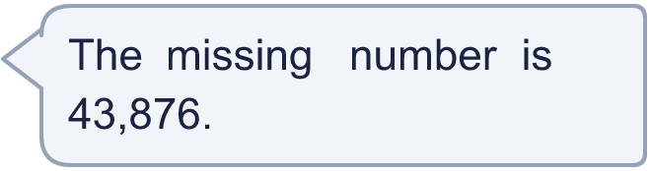
  11 | 104,700 − 43,476 < 105,100 − ?  a) Is Boba correct? Circle yes or no.  Yes / No  b) Write a number that the missing number could be.  c) Write a number that the missing number could not be.  d) The missing number must be less than
  12 | What number did I think of?
     | 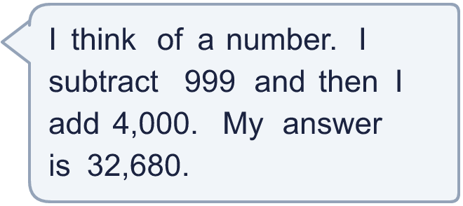
  12 | What number did I think of?
  13 | A shop has 24,600 pencils. It sells some pencils and then receives a delivery of 2,700 more. Now it has 20,541 pencils.  How many pencils did the shop sell?
  13 | A shop has 24,600 pencils. It sells some pencils and then receives a delivery of 2,700 more. Now it has 20,541 pencils.  How many pencils did the shop sell?
  14 | A circle stands for a number. A triangle stands for a different number.  circle + circle = 1,940  circle + triangle = 1,690  The circle is  The triangle is
  14 | A circle stands for a number. A triangle stands for a different number.  circle + circle = 1,940  circle + triangle = 1,690  The circle is  The triangle is

Year 5 · Addition and subtraction · Step 8
Finding missing numbers
Answers (teacher copy)

  1 | Write the missing number. Think about the place value.  a) 19,955 + 700 = 20,655  b) 19,955 − 40 = 19,915  c) 19,655 + 300 = 19,955
  2 | Write the missing number.  a) 59,487 − 100 = 59,387  b) 10,000 + 49,387 = 59,387  c) 61,387 − 2,000 = 59,387
  3 | Use what you know about equivalent calculations to write the missing numbers.  a) 96 + 99 = 100 + 95  b) 46 + 129 = 50 + 125  c) 107 + 716 = 100 + 723  d) 9,999 + 77,418 = 77,417 + 10,000
  4 | Use what you know about equivalent calculations to write the missing numbers.  a) 5,798 − 99 = 5,799 − 100  b) 16,483 − 998 = 16,485 − 1,000  c) 173,310 − 49,840 = 173,000 − 49,530
  5 | Write the missing number. Look at how the numbers have changed.  a) 60,964 + 3,978 = 61,000 + 3,942  b) 767 + 1,007 = 774 + 1,000  c) 67,654 − 10,000 = 67,660 − 10,006  d) 499,800 + 37,650 = 37,450 + 500,000
  6 | Write the missing number.  a) 720 + 280 = 1,000  b) 2,050 + 7,950 = 10,000  c) 73,900 + 26,100 = 100,000  d) 1,000,000 − 245,000 = 755,000
  7 | Complete the bar model. Write the missing number.  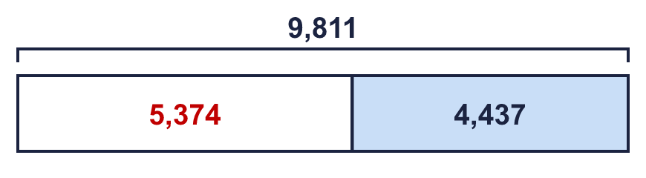  The missing number is 5,374
  8 | Write the missing digits in the calculation.  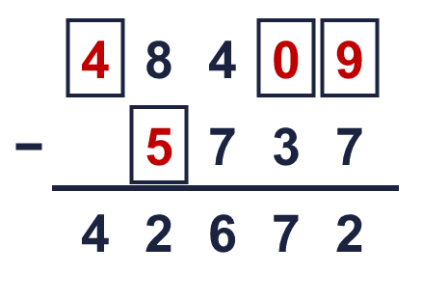  Missing digits, from top to bottom and left to right: 4 0 9 5
  9 | Do you agree with Boba? Circle yes or no.  Yes / No  Explain your answer.  5,571 − 699 = 4,872 but 5,572 − 710 = 4,862. The answers are different.
  10 | Write three subtractions that have the same answer as 67,840 − 6,253.  for example 67,870 − 6,283, 67,860 − 6,273, 67,890 − 6,303
  11 | 104,700 − 43,476 < 105,100 − ?  a) Is Boba correct? Circle yes or no.  Yes / No  b) Write a number that the missing number could be. 43,252  c) Write a number that the missing number could not be. 44,427  d) The missing number must be less than 43,876
  12 | What number did I think of? 29,679
  13 | A shop has 24,600 pencils. It sells some pencils and then receives a delivery of 2,700 more. Now it has 20,541 pencils.  How many pencils did the shop sell? 6,759
  14 | A circle stands for a number. A triangle stands for a different number.  circle + circle = 1,940  circle + triangle = 1,690  The circle is 970  The triangle is 720

