  Year 5 · Addition and subtraction · Step 5  Inverse operations | 
  Year 5 · Addition and subtraction · Step 5
  Inverse operations
  1 | Look at the bar model. Write one addition and one subtraction that it shows.  
  1 | Look at the bar model. Write one addition and one subtraction that it shows.
  2 | Ron works out 4,160 + 313 = 4,473. Which of these calculations can be used to check it? Choose all that apply.  A) 4,473 − 313  B) 313 − 4,160  C) 4,160 − 4,473  D) 4,473 − 4,160
  2 | Ron works out 4,160 + 313 = 4,473. Which of these calculations can be used to check it? Choose all that apply.  A) 4,473 − 313  B) 313 − 4,160  C) 4,160 − 4,473  D) 4,473 − 4,160
  3 | Work out each calculation. Then check it with the inverse operation.  a) 820 + 3,149 =  Check: your answer − 3,149 =  b) 11,832 − 483 =  Check: your answer + 483 =  c) 12,968 + 3,745 =  Check: your answer − 3,745 =
  3 | Work out each calculation. Then check it with the inverse operation.  a) 820 + 3,149 =  Check: your answer − 3,149 =  b) 11,832 − 483 =  Check: your answer + 483 =  c) 12,968 + 3,745 =  Check: your answer − 3,745 =
  4 | Write the missing number in each calculation.
    a) | 6,851 = 3,123 +
    b) |  | − 6,762 = 24,336
    c) | 23,722 + |  | = 32,650
  4 | Write the missing number in each calculation.
    a) | 6,851 = 3,123 +
    b) |  | − 6,762 = 24,336
    c) | 23,722 + |  | = 32,650
  5 | Use an inverse operation to check each answer. Is it correct? Circle yes or no.  a) 2,949 + 3,457 = 6,406  Check: 6,406 − 3,457 =  Yes / No  b) 3,177 + 4,631 = 7,818  Check: 7,818 − 4,631 =  Yes / No
  5 | Use an inverse operation to check each answer. Is it correct? Circle yes or no.  a) 2,949 + 3,457 = 6,406  Check: 6,406 − 3,457 =  Yes / No  b) 3,177 + 4,631 = 7,818  Check: 7,818 − 4,631 =  Yes / No
  6 | Use the fact that 4,132 + 6,277 = 10,409 to complete these calculations.  a) 6,277 + 4,132 =  b) 10,409 − 6,277 =  c) 10,409 − 4,132 =
  6 | Use the fact that 4,132 + 6,277 = 10,409 to complete these calculations.  a) 6,277 + 4,132 =  b) 10,409 − 6,277 =  c) 10,409 − 4,132 =
  7 | What number did I think of?
    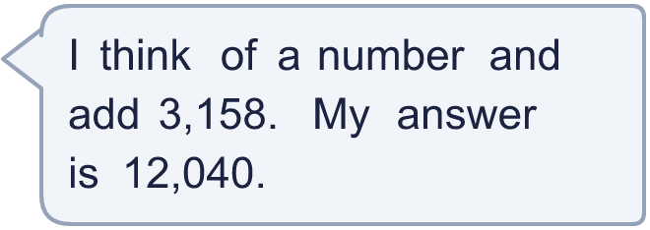
  7 | What number did I think of?
  8 | Look at the bar model. Use an inverse operation to find the missing part.  
  8 | Look at the bar model. Use an inverse operation to find the missing part.

  9 | Use the inverse to check Boba’s answer: 66,366 − 4,812 =  Is Boba correct? Circle yes or no.  Yes / No  What is the correct answer?
     | 
  9 | Use the inverse to check Boba’s answer: 66,366 − 4,812 =  Is Boba correct? Circle yes or no.  Yes / No  What is the correct answer?
  10 | What number did I start with?
     | 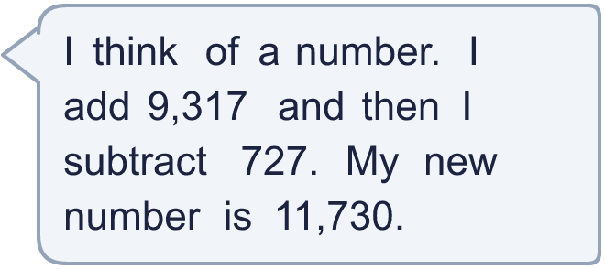
  10 | What number did I start with?
  11 | Esther and Brett play a computer game. Esther scores 9,365 points. The total of both their scores is 15,653.  a) How many points does Brett score?  b) Check your answer: Esther’s score + Brett’s score =
  11 | Esther and Brett play a computer game. Esther scores 9,365 points. The total of both their scores is 15,653.  a) How many points does Brett score?  b) Check your answer: Esther’s score + Brett’s score =
  12 | In this number pyramid, each number is the sum of the two numbers under it. Use addition and subtraction to find the missing numbers.  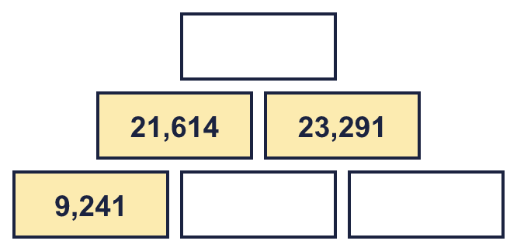  The missing numbers, from the top row to the bottom row, left to right:
  12 | In this number pyramid, each number is the sum of the two numbers under it. Use addition and subtraction to find the missing numbers.  The missing numbers, from the top row to the bottom row, left to right:
  13 | Tia swims 3,750 metres. Zach swims further than Tia. They swim 9,940 metres altogether.  a) How far does Zach swim?  b) How much further does Zach swim than Tia?
  13 | Tia swims 3,750 metres. Zach swims further than Tia. They swim 9,940 metres altogether.  a) How far does Zach swim?  b) How much further does Zach swim than Tia?
  14 | Write an addition that you can check with the subtraction 10,140 − 4,600.
  14 | Write an addition that you can check with the subtraction 10,140 − 4,600.

Year 5 · Addition and subtraction · Step 5
Inverse operations
Answers (teacher copy)

  1 | Look at the bar model. Write one addition and one subtraction that it shows.  2,950 + 6,534 = 9,484 and 9,484 − 2,950 = 6,534
  2 | Ron works out 4,160 + 313 = 4,473. Which of these calculations can be used to check it? Choose all that apply.  A) 4,473 − 313  B) 313 − 4,160  C) 4,160 − 4,473  D) 4,473 − 4,160  The checking calculations are A, D
  3 | Work out each calculation. Then check it with the inverse operation.  a) 820 + 3,149 = 3,969  Check: your answer − 3,149 = 820  b) 11,832 − 483 = 11,349  Check: your answer + 483 = 11,832  c) 12,968 + 3,745 = 16,713  Check: your answer − 3,745 = 12,968
  4 | Write the missing number in each calculation.  a) 6,851 = 3,123 + 3,728  b) 31,098 − 6,762 = 24,336  c) 23,722 + 8,928 = 32,650
  5 | Use an inverse operation to check each answer. Is it correct? Circle yes or no.  a) 2,949 + 3,457 = 6,406  Check: 6,406 − 3,457 = 2,949  Yes / No  b) 3,177 + 4,631 = 7,818  Check: 7,818 − 4,631 = 3,187  Yes / No
  6 | Use the fact that 4,132 + 6,277 = 10,409 to complete these calculations.  a) 6,277 + 4,132 = 10,409  b) 10,409 − 6,277 = 4,132  c) 10,409 − 4,132 = 6,277
  7 | What number did I think of? 8,882
  8 | Look at the bar model. Use an inverse operation to find the missing part.  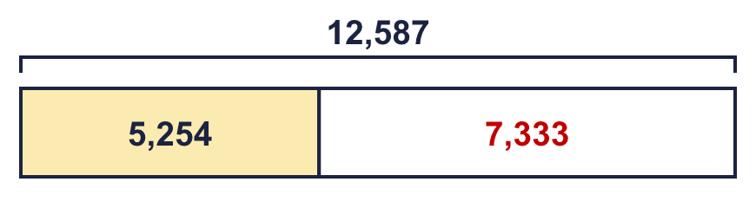  The missing part is 7,333
  9 | Use the inverse to check Boba’s answer: 66,366 − 4,812 = 61,554  Is Boba correct? Circle yes or no.  Yes / No  What is the correct answer? 23,058
  10 | What number did I start with? 3,140
  11 | Esther and Brett play a computer game. Esther scores 9,365 points. The total of both their scores is 15,653.  a) How many points does Brett score? 6,288  b) Check your answer: Esther’s score + Brett’s score = 15,653
  12 | In this number pyramid, each number is the sum of the two numbers under it. Use addition and subtraction to find the missing numbers.  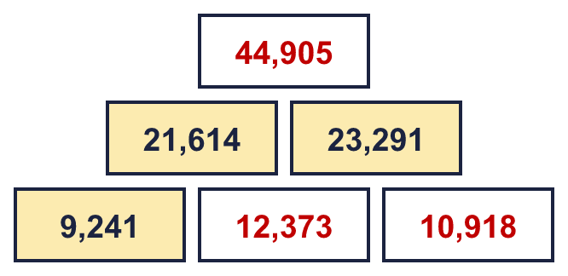  The missing numbers, from the top row to the bottom row, left to right: 44,905 12,373 10,918
  13 | Tia swims 3,750 metres. Zach swims further than Tia. They swim 9,940 metres altogether.  a) How far does Zach swim? 6,190 metres  b) How much further does Zach swim than Tia? 2,440 metres
  14 | Write an addition that you can check with the subtraction 10,140 − 4,600.  4,600 + 5,540 = 10,140

