  Year 5 · Addition and subtraction · Step 1  Mental strategies | 
  Year 5 · Addition and subtraction · Step 1
  Mental strategies
  1 | Use the fact that 7 + 9 = 16 to work out these additions.  a) 70 + 90 =  b) 700 + 900 =  c) 7,000 + 9,000 =
  1 | Use the fact that 7 + 9 = 16 to work out these additions.  a) 70 + 90 =  b) 700 + 900 =  c) 7,000 + 9,000 =
  2 | Use the fact that 7 + 9 = 16 to work out these subtractions.  a) 1,600 − 700 =  b) 16,000 − 9,000 =  c) 160,000 − 70,000 =
  2 | Use the fact that 7 + 9 = 16 to work out these subtractions.  a) 1,600 − 700 =  b) 16,000 − 9,000 =  c) 160,000 − 70,000 =
  3 | Work out these in your head.  a) 68 + 9 =  b) 94 − 50 =  c) 42 + 42 =  d) 97 − 44 =
  3 | Work out these in your head.  a) 68 + 9 =  b) 94 − 50 =  c) 42 + 42 =  d) 97 − 44 =
  4 | Use what you know about place value to work out these.  a) 45,385 + 10,000 =  b) 45,385 − 1,000 =  c) 45,385 + 200 =  d) 45,385 − 2,600 =
  4 | Use what you know about place value to work out these.  a) 45,385 + 10,000 =  b) 45,385 − 1,000 =  c) 45,385 + 200 =  d) 45,385 − 2,600 =
  5 | Find the sum of each pair of numbers.  a) 7,060 + 4,090 =  b) 100,000 + 300,000 =  c) 390,000 + 230,000 =
  5 | Find the sum of each pair of numbers.  a) 7,060 + 4,090 =  b) 100,000 + 300,000 =  c) 390,000 + 230,000 =
  6 | To add 99, add 100 and then take away 1. Use this idea to work out the calculations.  a) 103 + 99 =  b) 883 + 99 =  c) 524 − 99 =  d) 285 + 98 =
  6 | To add 99, add 100 and then take away 1. Use this idea to work out the calculations.  a) 103 + 99 =  b) 883 + 99 =  c) 524 − 99 =  d) 285 + 98 =
  7 | Work these out by partitioning the numbers.  a) 33,700 + 14,700 =  b) 19,900 − 3,200 =  c) 37,020 + 5,040 =  d) 82,900 − 19,200 =
  7 | Work these out by partitioning the numbers.  a) 33,700 + 14,700 =  b) 19,900 − 3,200 =  c) 37,020 + 5,040 =  d) 82,900 − 19,200 =
  8 | Work these out.  a) 4,321 + 999 =  b) 4,321 + 990 =  c) 4,321 − 999 =  d) 4,321 − 990 =
  8 | Work these out.  a) 4,321 + 999 =  b) 4,321 + 990 =  c) 4,321 − 999 =  d) 4,321 − 990 =

  9 | Do you agree with Boba? Circle yes or no.  Yes / No  Explain your answer.
    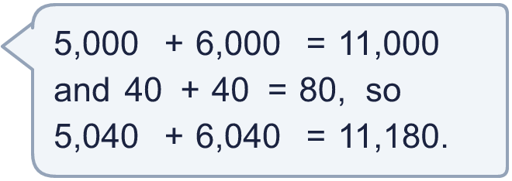
  9 | Do you agree with Boba? Circle yes or no.  Yes / No  Explain your answer.
  10 | Is each statement true? Circle yes or no.  a) Adding 99 is the same as adding 100 and taking away 1.  Yes / No  b) Subtracting 999 is the same as subtracting 1,000 and taking away 1.  Yes / No
  10 | Is each statement true? Circle yes or no.  a) Adding 99 is the same as adding 100 and taking away 1.  Yes / No  b) Subtracting 999 is the same as subtracting 1,000 and taking away 1.  Yes / No
  11 | Complete the calculations.  a) 338 + 94 =  b) 338,000 + 94,000 =  c) How many times as big is the answer to b) as the answer to a)?
  11 | Complete the calculations.  a) 338 + 94 =  b) 338,000 + 94,000 =  c) How many times as big is the answer to b) as the answer to a)?
  12 | Is Boba correct? Circle yes or no.  Yes / No  What is the correct answer?  Explain Boba’s mistake.
     | 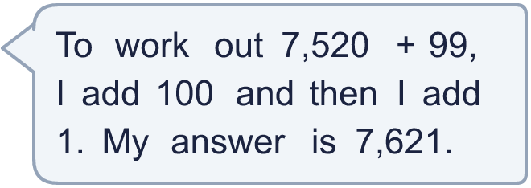
  12 | Is Boba correct? Circle yes or no.  Yes / No  What is the correct answer?  Explain Boba’s mistake.
  13 | What number did I start with?
    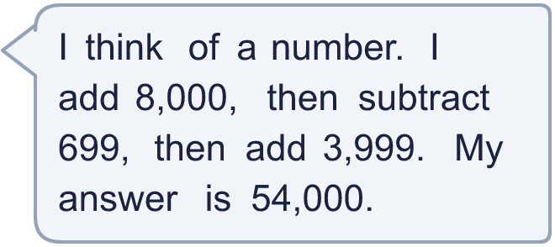
  13 | What number did I start with?
  14 | Write two different additions that add 999 to a 4-digit number. Each answer must be between 5,000 and 6,000.
  14 | Write two different additions that add 999 to a 4-digit number. Each answer must be between 5,000 and 6,000.

Year 5 · Addition and subtraction · Step 1
Mental strategies
Answers (teacher copy)

  1 | Use the fact that 7 + 9 = 16 to work out these additions.  a) 70 + 90 = 160  b) 700 + 900 = 1,600  c) 7,000 + 9,000 = 16,000
  2 | Use the fact that 7 + 9 = 16 to work out these subtractions.  a) 1,600 − 700 = 900  b) 16,000 − 9,000 = 7,000  c) 160,000 − 70,000 = 90,000
  3 | Work out these in your head.  a) 68 + 9 = 77  b) 94 − 50 = 44  c) 42 + 42 = 84  d) 97 − 44 = 53
  4 | Use what you know about place value to work out these.  a) 45,385 + 10,000 = 55,385  b) 45,385 − 1,000 = 44,385  c) 45,385 + 200 = 45,585  d) 45,385 − 2,600 = 42,785
  5 | Find the sum of each pair of numbers.  a) 7,060 + 4,090 = 11,150  b) 100,000 + 300,000 = 400,000  c) 390,000 + 230,000 = 620,000
  6 | To add 99, add 100 and then take away 1. Use this idea to work out the calculations.  a) 103 + 99 = 202  b) 883 + 99 = 982  c) 524 − 99 = 425  d) 285 + 98 = 383
  7 | Work these out by partitioning the numbers.  a) 33,700 + 14,700 = 48,400  b) 19,900 − 3,200 = 16,700  c) 37,020 + 5,040 = 42,060  d) 82,900 − 19,200 = 63,700
  8 | Work these out.  a) 4,321 + 999 = 5,320  b) 4,321 + 990 = 5,311  c) 4,321 − 999 = 3,322  d) 4,321 − 990 = 3,331
  9 | Do you agree with Boba? Circle yes or no.  Yes / No  Explain your answer.  5,040 + 6,040 = 11,080. 11,000 + 80 = 11,080.
  10 | Is each statement true? Circle yes or no.  a) Adding 99 is the same as adding 100 and taking away 1.  Yes / No  b) Subtracting 999 is the same as subtracting 1,000 and taking away 1.  Yes / No
  11 | Complete the calculations.  a) 338 + 94 = 432  b) 338,000 + 94,000 = 432,000  c) How many times as big is the answer to b) as the answer to a)? 1,000
  12 | Is Boba correct? Circle yes or no.  Yes / No  What is the correct answer? 7,619  Explain Boba’s mistake.  7,520 + 99 = 7,619. Boba should take away 1 after adding 100, not add 1.
  13 | What number did I start with? 42,700
  14 | Write two different additions that add 999 to a 4-digit number. Each answer must be between 5,000 and 6,000.  for example 4,200 + 999 = 5,199 and 4,500 + 999 = 5,499

