  Year 5 · Fractions A · Step 6  Comparing fractions less than 1 | 
  Year 5 · Fractions A · Step 6
  Comparing fractions less than 1
  1 | Write <, > or = in each box. The bars help with a).  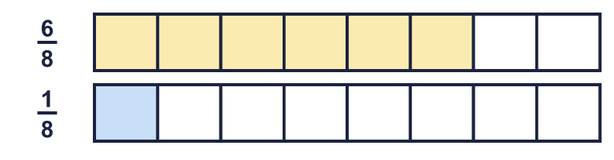
    a) | ⁶⁄₈ |  | ¹⁄₈
    b) | ²⁄₈ |  | ⁴⁄₈
    c) | ⁷⁄₁₂ |  | ¹⁄₁₂
  1 | Write <, > or = in each box. The bars help with a).
    a) | ⁶⁄₈ |  | ¹⁄₈
    b) | ²⁄₈ |  | ⁴⁄₈
    c) | ⁷⁄₁₂ |  | ¹⁄₁₂
  2 | Write <, > or = in each box.
    a) | ⁷⁄₁₀ |  | ⁴⁄₁₀
    b) | ⁹⁄₁₀ |  | ⁷⁄₁₀
    c) | ⁷⁄₉ |  | ³⁄₉
    d) | ¹⁄₉ |  | ²⁄₉
  2 | Write <, > or = in each box.
    a) | ⁷⁄₁₀ |  | ⁴⁄₁₀
    b) | ⁹⁄₁₀ |  | ⁷⁄₁₀
    c) | ⁷⁄₉ |  | ³⁄₉
    d) | ¹⁄₉ |  | ²⁄₉
  3 | Write <, > or = in each box. The numerators are the same.
    a) | ⁷⁄₁₂ |  | ⁷⁄₁₁
    b) | ⁵⁄₈ |  | ⁵⁄₁₀
    c) | ⁴⁄₈ |  | ⁴⁄₁₁
    d) | ⁵⁄₁₁ |  | ⁵⁄₉
  3 | Write <, > or = in each box. The numerators are the same.
    a) | ⁷⁄₁₂ |  | ⁷⁄₁₁
    b) | ⁵⁄₈ |  | ⁵⁄₁₀
    c) | ⁴⁄₈ |  | ⁴⁄₁₁
    d) | ⁵⁄₁₁ |  | ⁵⁄₉
  4 | Write <, > or = in each box.
    a) | ⁶⁄₁₀ |  | ³⁄₁₀
    b) | ⁸⁄₁₂ |  | ⁵⁄₁₂
    c) | ⁵⁄₇ |  | ⁵⁄₈
    d) | ²⁄₁₀ |  | ²⁄₅
  4 | Write <, > or = in each box.
    a) | ⁶⁄₁₀ |  | ³⁄₁₀
    b) | ⁸⁄₁₂ |  | ⁵⁄₁₂
    c) | ⁵⁄₇ |  | ⁵⁄₈
    d) | ²⁄₁₀ |  | ²⁄₅
  5 | Write <, > or = in each box. Compare each fraction with ¹⁄₂.
    a) | ⁵⁄₁₁ |  | ⁷⁄₁₂
    b) | ⁵⁄₁₁ |  | ⁵⁄₈
    c) | ²⁄₅ |  | ⁸⁄₁₅
  5 | Write <, > or = in each box. Compare each fraction with ¹⁄₂.
    a) | ⁵⁄₁₁ |  | ⁷⁄₁₂
    b) | ⁵⁄₁₁ |  | ⁵⁄₈
    c) | ²⁄₅ |  | ⁸⁄₁₅
  6 | Write <, > or = in each box. Change one fraction so that both have the same denominator.
    a) | ²⁄₃ |  | ⁷⁄₉
    b) | ²⁄₃ |  | ⁴⁄₉
    c) | ¹⁄₃ |  | ⁵⁄₆
    d) | ¹⁄₅ |  | ⁸⁄₁₀
  6 | Write <, > or = in each box. Change one fraction so that both have the same denominator.
    a) | ²⁄₃ |  | ⁷⁄₉
    b) | ²⁄₃ |  | ⁴⁄₉
    c) | ¹⁄₃ |  | ⁵⁄₆
    d) | ¹⁄₅ |  | ⁸⁄₁₀
  7 | Which is the smallest fraction?  ¹⁄₅ ³⁄₄ ²⁄₄
  7 | Which is the smallest fraction?  ¹⁄₅ ³⁄₄ ²⁄₄
  8 | Write <, > or = in each box.
    a) | ¹⁄₉ |  | ³⁄₈
    b) | ³⁄₆ |  | ⁷⁄₁₂
    c) | ⁴⁄₆ |  | ²⁄₈
    d) | ¹⁄₃ |  | ²⁄₇
  8 | Write <, > or = in each box.
    a) | ¹⁄₉ |  | ³⁄₈
    b) | ³⁄₆ |  | ⁷⁄₁₂
    c) | ⁴⁄₆ |  | ²⁄₈
    d) | ¹⁄₃ |  | ²⁄₇

  9 | Is Boba correct? Circle yes or no.  Yes / No  Explain your answer.
     | 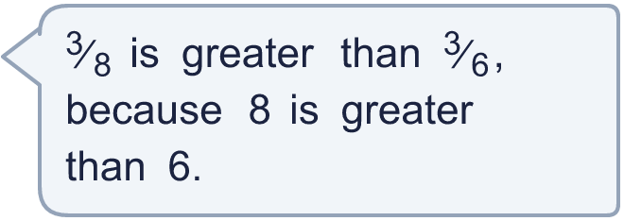
  9 | Is Boba correct? Circle yes or no.  Yes / No  Explain your answer.
  10
    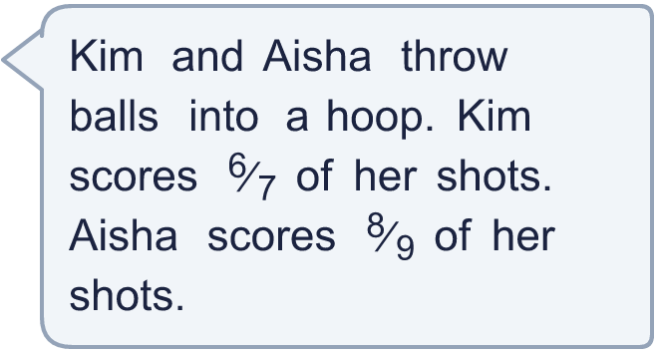
  10
  11 | Esther takes ⁷⁄₁₁ of the marbles in a bag. Scott takes ⁷⁄₁₂ of the marbles in an identical bag.
  11 | Esther takes ⁷⁄₁₁ of the marbles in a bag. Scott takes ⁷⁄₁₂ of the marbles in an identical bag.
  12 | Which is greater, ⁴⁄₆ or ⁴⁄₅? Use a common denominator to explain how you know.
  12 | Which is greater, ⁴⁄₆ or ⁴⁄₅? Use a common denominator to explain how you know.
  13 | Which fraction is nearer to 1: ⁴⁄₅ or ⁷⁄₁₂?
  13 | Which fraction is nearer to 1: ⁴⁄₅ or ⁷⁄₁₂?
  14 | Three friends each read part of a book. Ana reads ³⁄₄ of it, Ben reads ²⁄₅ of it, Cal reads ⁶⁄₁₀ of it.  Write the names in order, starting with the person who read the most.
  14 | Three friends each read part of a book. Ana reads ³⁄₄ of it, Ben reads ²⁄₅ of it, Cal reads ⁶⁄₁₀ of it.  Write the names in order, starting with the person who read the most.

Year 5 · Fractions A · Step 6
Comparing fractions less than 1
Answers (teacher copy)

  1 | Write <, > or = in each box. The bars help with a).  a) ⁶⁄₈ > ¹⁄₈  b) ²⁄₈ < ⁴⁄₈  c) ⁷⁄₁₂ > ¹⁄₁₂
  2 | Write <, > or = in each box.  a) ⁷⁄₁₀ > ⁴⁄₁₀  b) ⁹⁄₁₀ > ⁷⁄₁₀  c) ⁷⁄₉ > ³⁄₉  d) ¹⁄₉ < ²⁄₉
  3 | Write <, > or = in each box. The numerators are the same.  a) ⁷⁄₁₂ < ⁷⁄₁₁  b) ⁵⁄₈ > ⁵⁄₁₀  c) ⁴⁄₈ > ⁴⁄₁₁  d) ⁵⁄₁₁ < ⁵⁄₉
  4 | Write <, > or = in each box.  a) ⁶⁄₁₀ > ³⁄₁₀  b) ⁸⁄₁₂ > ⁵⁄₁₂  c) ⁵⁄₇ > ⁵⁄₈  d) ²⁄₁₀ < ²⁄₅
  5 | Write <, > or = in each box. Compare each fraction with ¹⁄₂.  a) ⁵⁄₁₁ < ⁷⁄₁₂  b) ⁵⁄₁₁ < ⁵⁄₈  c) ²⁄₅ < ⁸⁄₁₅
  6 | Write <, > or = in each box. Change one fraction so that both have the same denominator.  a) ²⁄₃ < ⁷⁄₉  b) ²⁄₃ > ⁴⁄₉  c) ¹⁄₃ < ⁵⁄₆  d) ¹⁄₅ < ⁸⁄₁₀
  7 | Which is the smallest fraction?  ¹⁄₅ ³⁄₄ ²⁄₄  ¹⁄₅
  8 | Write <, > or = in each box.  a) ¹⁄₉ < ³⁄₈  b) ³⁄₆ < ⁷⁄₁₂  c) ⁴⁄₆ > ²⁄₈  d) ¹⁄₃ > ²⁄₇
  9 | Is Boba correct? Circle yes or no.  Yes / No  Explain your answer.  No. When the numerators are the same, the bigger the denominator the smaller the fraction. ³⁄₈ is smaller than ³⁄₆.
  10 | Who was more accurate? Aisha
  11 | Esther takes ⁷⁄₁₁ of the marbles in a bag. Scott takes ⁷⁄₁₂ of the marbles in an identical bag.  Who has more marbles? Esther
  12 | Which is greater, ⁴⁄₆ or ⁴⁄₅? Use a common denominator to explain how you know.  ⁴⁄₆ = ²⁰⁄₃₀ and ⁴⁄₅ = ²⁴⁄₃₀. ⁴⁄₅ is greater.
  13 | Which fraction is nearer to 1: ⁴⁄₅ or ⁷⁄₁₂?  ⁴⁄₅
  14 | Three friends each read part of a book. Ana reads ³⁄₄ of it, Ben reads ²⁄₅ of it, Cal reads ⁶⁄₁₀ of it.  Write the names in order, starting with the person who read the most. Ana, Cal, Ben

