  Year 5 · Fractions A · Step 3  Recognising equivalent fractions | 
  Year 5 · Fractions A · Step 3
  Recognising equivalent fractions
  1 | Are the fractions equivalent? Write yes or no.  a) ²⁄₅ and ⁶⁄₁₅  b) ³⁄₄ and ⁷⁄₈  c) ²⁄₃ and ⁸⁄₁₂
  1 | Are the fractions equivalent? Write yes or no.  a) ²⁄₅ and ⁶⁄₁₅  b) ³⁄₄ and ⁷⁄₈  c) ²⁄₃ and ⁸⁄₁₂
  2 | Write the missing numbers in the equal fractions.  a) ⁵⁄₈ = ?⁄₁₆  b) ²⁄₅ = ⁶⁄?  c) ³⁄₅ = ?⁄₂₀  d) ²⁄₃ = ?⁄₁₂
  2 | Write the missing numbers in the equal fractions.  a) ⁵⁄₈ = ?⁄₁₆  b) ²⁄₅ = ⁶⁄?  c) ³⁄₅ = ?⁄₂₀  d) ²⁄₃ = ?⁄₁₂
  3 | Circle the fractions that are equal to ¹⁄₂. Write them below.  ³⁄₄ ¹⁄₄ ²⁄₄ ⁶⁄₁₂ ⁴⁄₄ ⁵⁄₁₀
  3 | Circle the fractions that are equal to ¹⁄₂. Write them below.  ³⁄₄ ¹⁄₄ ²⁄₄ ⁶⁄₁₂ ⁴⁄₄ ⁵⁄₁₀
  4 | Circle the fractions that are equal to ⁶⁄₇. Write them below.  ³⁰⁄₃₅ ³⁶⁄₄₂ ¹³⁄₁₄ ²⁴⁄₂₈ ³¹⁄₃₅ ²⁹⁄₃₅
  4 | Circle the fractions that are equal to ⁶⁄₇. Write them below.  ³⁰⁄₃₅ ³⁶⁄₄₂ ¹³⁄₁₄ ²⁴⁄₂₈ ³¹⁄₃₅ ²⁹⁄₃₅
  5 | Are the fractions equivalent? Write yes or no.  a) ³⁄₅ and ¹⁵⁄₂₅  b) ⁴⁄₇ and ²¹⁄₃₅  c) ⁴⁄₅ and ¹⁶⁄₂₀  d) ⁴⁄₅ and ¹⁹⁄₂₅
  5 | Are the fractions equivalent? Write yes or no.  a) ³⁄₅ and ¹⁵⁄₂₅  b) ⁴⁄₇ and ²¹⁄₃₅  c) ⁴⁄₅ and ¹⁶⁄₂₀  d) ⁴⁄₅ and ¹⁹⁄₂₅
  6 | Three of these fractions are equal to ⁶⁄₇. Write the fraction that is not.  ³⁶⁄₄₂ ²⁵⁄₂₈ ³⁰⁄₃₅ ¹²⁄₁₄
  6 | Three of these fractions are equal to ⁶⁄₇. Write the fraction that is not.  ³⁶⁄₄₂ ²⁵⁄₂₈ ³⁰⁄₃₅ ¹²⁄₁₄
  7 | Write each fraction in its simplest form.  a) ⁹⁄₂₁ =  b) ⁶⁄₂₁ =  c) ⁸⁄₂₀ =
  7 | Write each fraction in its simplest form.  a) ⁹⁄₂₁ =  b) ⁶⁄₂₁ =  c) ⁸⁄₂₀ =
  8 | Write the missing number in each pair of equal fractions.  a) ²⁰⁄₇₀ = ²⁄?  b) ²⁰⁄₂₅ = ⁴⁄?  c) ⁴⁄₅ = ?⁄₃₀
  8 | Write the missing number in each pair of equal fractions.  a) ²⁰⁄₇₀ = ²⁄?  b) ²⁰⁄₂₅ = ⁴⁄?  c) ⁴⁄₅ = ?⁄₃₀

  9 | Is Boba correct? Circle yes or no.  Yes / No  Explain your answer.
     | 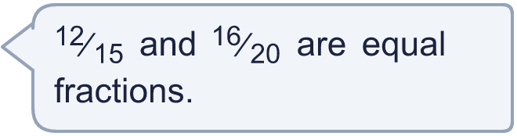
  9 | Is Boba correct? Circle yes or no.  Yes / No  Explain your answer.
  10 | Eli eats ⁹⁄₁₅ of a cake. Ben eats ⁶⁄₁₀ of an identical cake.  Who eats more cake? Explain how you know.
  10 | Eli eats ⁹⁄₁₅ of a cake. Ben eats ⁶⁄₁₀ of an identical cake.  Who eats more cake? Explain how you know.
  11 | Write two different fractions that are equal to ³⁄₅.
  11 | Write two different fractions that are equal to ³⁄₅.
  12 | Write all the whole numbers that make this correct.  ²⁄₅ < ?⁄₁₂ < ³⁄₅
  12 | Write all the whole numbers that make this correct.  ²⁄₅ < ?⁄₁₂ < ³⁄₅
  13 | What fraction am I?
    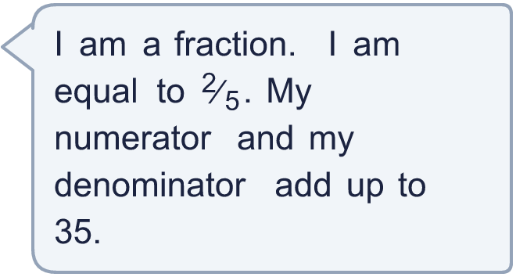
  13 | What fraction am I?
  14 | What fraction am I?
     | 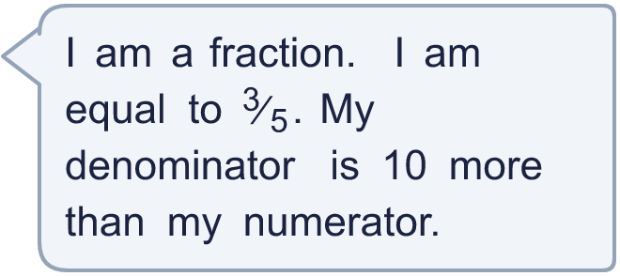
  14 | What fraction am I?

Year 5 · Fractions A · Step 3
Recognising equivalent fractions
Answers (teacher copy)

  1 | Are the fractions equivalent? Write yes or no.  a) ²⁄₅ and ⁶⁄₁₅ Yes  b) ³⁄₄ and ⁷⁄₈ No  c) ²⁄₃ and ⁸⁄₁₂ Yes
  2 | Write the missing numbers in the equal fractions.  a) ⁵⁄₈ = ?⁄₁₆ 10  b) ²⁄₅ = ⁶⁄? 15  c) ³⁄₅ = ?⁄₂₀ 12  d) ²⁄₃ = ?⁄₁₂ 8
  3 | Circle the fractions that are equal to ¹⁄₂. Write them below.  ³⁄₄ ¹⁄₄ ²⁄₄ ⁶⁄₁₂ ⁴⁄₄ ⁵⁄₁₀  ²⁄₄, ⁶⁄₁₂, ⁵⁄₁₀
  4 | Circle the fractions that are equal to ⁶⁄₇. Write them below.  ³⁰⁄₃₅ ³⁶⁄₄₂ ¹³⁄₁₄ ²⁴⁄₂₈ ³¹⁄₃₅ ²⁹⁄₃₅  ³⁰⁄₃₅, ³⁶⁄₄₂, ²⁴⁄₂₈
  5 | Are the fractions equivalent? Write yes or no.  a) ³⁄₅ and ¹⁵⁄₂₅ Yes  b) ⁴⁄₇ and ²¹⁄₃₅ No  c) ⁴⁄₅ and ¹⁶⁄₂₀ Yes  d) ⁴⁄₅ and ¹⁹⁄₂₅ No
  6 | Three of these fractions are equal to ⁶⁄₇. Write the fraction that is not.  ³⁶⁄₄₂ ²⁵⁄₂₈ ³⁰⁄₃₅ ¹²⁄₁₄  ²⁵⁄₂₈
  7 | Write each fraction in its simplest form.  a) ⁹⁄₂₁ = ³⁄₇  b) ⁶⁄₂₁ = ²⁄₇  c) ⁸⁄₂₀ = ²⁄₅
  8 | Write the missing number in each pair of equal fractions.  a) ²⁰⁄₇₀ = ²⁄? 7  b) ²⁰⁄₂₅ = ⁴⁄? 5  c) ⁴⁄₅ = ?⁄₃₀ 24
  9 | Is Boba correct? Circle yes or no.  Yes / No  Explain your answer.  Yes. ¹²⁄₁₅ = ⁴⁄₅ and ¹⁶⁄₂₀ = ⁴⁄₅. The two fractions are equal.
  10 | Eli eats ⁹⁄₁₅ of a cake. Ben eats ⁶⁄₁₀ of an identical cake.  Who eats more cake? Explain how you know.  Neither. They eat the same amount. ⁹⁄₁₅ = ³⁄₅ and ⁶⁄₁₀ = ³⁄₅.
  11 | Write two different fractions that are equal to ³⁄₅.  for example ⁶⁄₁₀, ⁹⁄₁₅
  12 | Write all the whole numbers that make this correct.  ²⁄₅ < ?⁄₁₂ < ³⁄₅ 5, 6, 7
  13 | What fraction am I?  ¹⁰⁄₂₅
  14 | What fraction am I?  ¹⁵⁄₂₅

