  Year 5 · Multiply and divide A · Step 4  Common factors | 
  Year 5 · Multiply and divide A · Step 4
  Common factors
  1 | Write all the factors of 24 and of 36.  a) 24:  b) 36:
  1 | Write all the factors of 24 and of 36.  a) 24:  b) 36:
  2 | Use your lists to write the common factors of 24 and 36.
  2 | Use your lists to write the common factors of 24 and 36.
  3 | Sort the numbers into the diagram. Write each group.  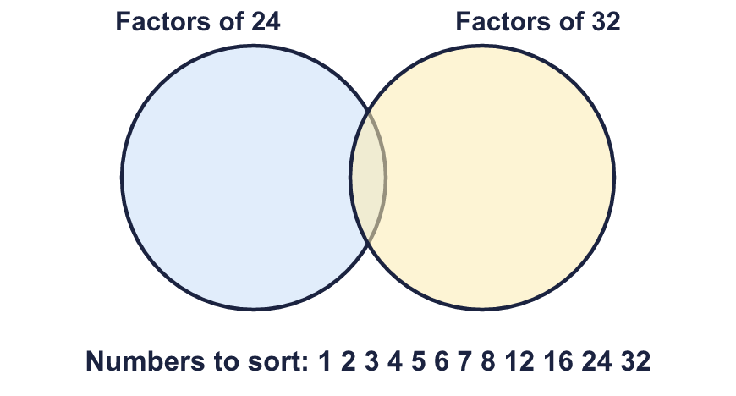  Factors of 24 only:  Factors of both:  Factors of 32 only:  Neither:
  3 | Sort the numbers into the diagram. Write each group.  Factors of 24 only:  Factors of both:  Factors of 32 only:  Neither:
  4 | Find the common factors of each pair of numbers.  a) 9 and 10:  b) 24 and 36:  c) 18 and 27:
  4 | Find the common factors of each pair of numbers.  a) 9 and 10:  b) 24 and 36:  c) 18 and 27:
  5 | Circle the numbers that are common factors of 18 and 30. Write them below.  2 3 4 5 6 8 9 12
  5 | Circle the numbers that are common factors of 18 and 30. Write them below.  2 3 4 5 6 8 9 12
  6 | Which pairs of numbers have only one common factor? Write the letters.  a) 3 and 8  b) 10 and 21  c) 16 and 9  d) 9 and 11  e) 12 and 18  f) 2 and 6
  6 | Which pairs of numbers have only one common factor? Write the letters.  a) 3 and 8  b) 10 and 21  c) 16 and 9  d) 9 and 11  e) 12 and 18  f) 2 and 6
  7 | Find the greatest common factor of each pair.  a) 27 and 45:  b) 28 and 42:
  7 | Find the greatest common factor of each pair.  a) 27 and 45:  b) 28 and 42:
  8 | List the common factors of 36 and 60 that are greater than 4.
  8 | List the common factors of 36 and 60 that are greater than 4.

  9 | Whitney bakes 12 cakes. Dexter bakes 18 cakes. Boxes can hold 2, 3, 4, 5, 6 or 10 cakes. Each person fills every box they use, with no cakes left over.  a) Which boxes could Whitney use?  b) Which boxes could Dexter use?  c) Which boxes could they both use?
  9 | Whitney bakes 12 cakes. Dexter bakes 18 cakes. Boxes can hold 2, 3, 4, 5, 6 or 10 cakes. Each person fills every box they use, with no cakes left over.  a) Which boxes could Whitney use?  b) Which boxes could Dexter use?  c) Which boxes could they both use?
  10 | Is Boba correct? Circle yes or no.  Yes / No  Explain your reasoning.
     | 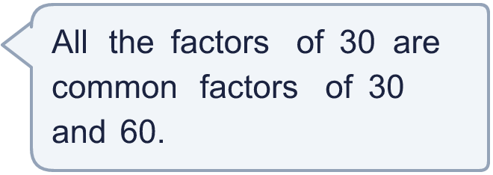
  10 | Is Boba correct? Circle yes or no.  Yes / No  Explain your reasoning.
  11 | What are the two numbers?
    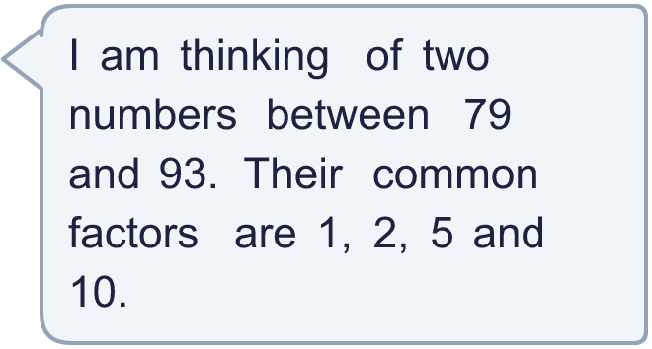
  11 | What are the two numbers?
  12 | Is Boba correct? Circle yes or no.  Yes / No  Explain how you know.  What is the greatest number of bags she can make?
     | 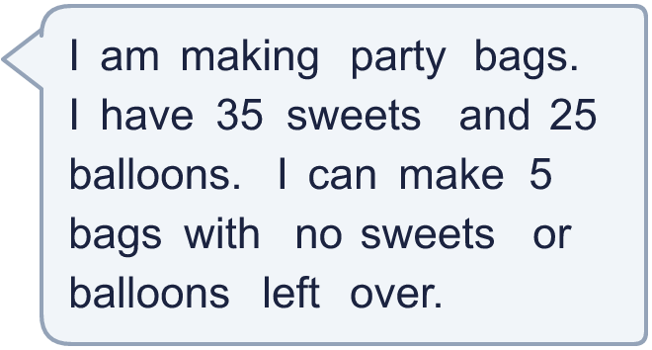
  12 | Is Boba correct? Circle yes or no.  Yes / No  Explain how you know.  What is the greatest number of bags she can make?
  13 | Look at the three pairs of numbers.  a) 9 and 27  b) 10 and 15  c) 12 and 18  Which pair has the most common factors? Write the letter.
  13 | Look at the three pairs of numbers.  a) 9 and 27  b) 10 and 15  c) 12 and 18  Which pair has the most common factors? Write the letter.
  14 | Write two different pairs of numbers (each less than 100) whose only common factors are 1 and 7.
  14 | Write two different pairs of numbers (each less than 100) whose only common factors are 1 and 7.

Year 5 · Multiply and divide A · Step 4
Common factors
Answers (teacher copy)

  1 | Write all the factors of 24 and of 36.  a) 24: 1, 2, 3, 4, 6, 8, 12, 24  b) 36: 1, 2, 3, 4, 6, 9, 12, 18, 36
  2 | Use your lists to write the common factors of 24 and 36.  1, 2, 3, 4, 6, 12
  3 | Sort the numbers into the diagram. Write each group.  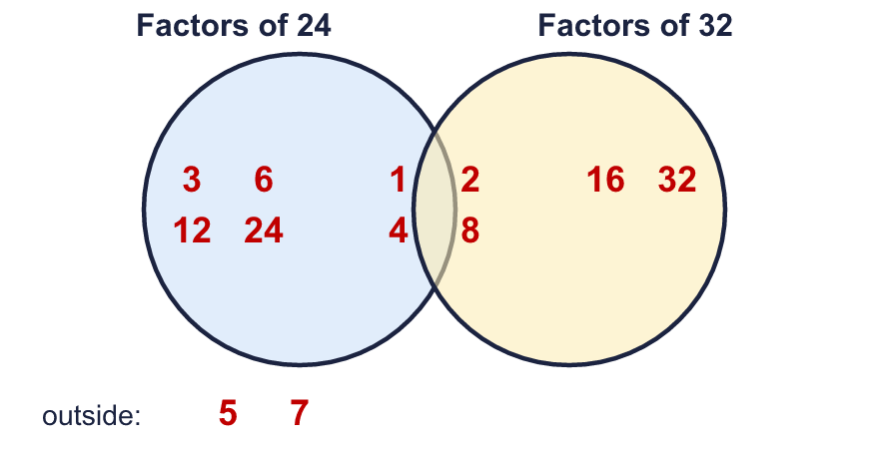  Factors of 24 only: 3, 6, 12, 24  Factors of both: 1, 2, 4, 8  Factors of 32 only: 16, 32  Neither: 5, 7
  4 | Find the common factors of each pair of numbers.  a) 9 and 10: 1  b) 24 and 36: 1, 2, 3, 4, 6, 12  c) 18 and 27: 1, 3, 9
  5 | Circle the numbers that are common factors of 18 and 30. Write them below.  2 3 4 5 6 8 9 12  2, 3, 6
  6 | Which pairs of numbers have only one common factor? Write the letters.  a) 3 and 8  b) 10 and 21  c) 16 and 9  d) 9 and 11  e) 12 and 18  f) 2 and 6  a, b, c, d
  7 | Find the greatest common factor of each pair.  a) 27 and 45: 9  b) 28 and 42: 14
  8 | List the common factors of 36 and 60 that are greater than 4.  6, 12
  9 | Whitney bakes 12 cakes. Dexter bakes 18 cakes. Boxes can hold 2, 3, 4, 5, 6 or 10 cakes. Each person fills every box they use, with no cakes left over.  a) Which boxes could Whitney use? 2, 3, 4, 6  b) Which boxes could Dexter use? 2, 3, 6  c) Which boxes could they both use? 2, 3, 6
  10 | Is Boba correct? Circle yes or no.  Yes / No  Explain your reasoning.  Yes. 30 is a factor of 60 (60 ÷ 30 = 2), so every factor of 30 is also a factor of 60.
  11 | What are the two numbers? 80 and 90
  12 | Is Boba correct? Circle yes or no.  Yes / No  Explain how you know.  5 is a common factor of 35 and 25: 35 ÷ 5 = 7 and 25 ÷ 5 = 5.  What is the greatest number of bags she can make? 5
  13 | Look at the three pairs of numbers.  a) 9 and 27  b) 10 and 15  c) 12 and 18  Which pair has the most common factors? Write the letter. c
  14 | Write two different pairs of numbers (each less than 100) whose only common factors are 1 and 7.  Any pairs with common factors 1 and 7 only, for example 14 and 21 and 28 and 35

