  Year 5 · Multiply and divide A · Step 7  Cube numbers | 
  Year 5 · Multiply and divide A · Step 7
  Cube numbers
  1 | Work out each cube number. For example, 3³ = 3 × 3 × 3 = 27.  a) 4³ =  b) 6³ =  c) 7³ =  d) 10³ =
  1 | Work out each cube number. For example, 3³ = 3 × 3 × 3 = 27.  a) 4³ =  b) 6³ =  c) 7³ =  d) 10³ =
  2 | Work out each calculation. Each one is a cube number.  a) 6 × 6 × 6 =  b) 2 × 2 × 2 =  c) 4 × 4 × 4 =
  2 | Work out each calculation. Each one is a cube number.  a) 6 × 6 × 6 =  b) 2 × 2 × 2 =  c) 4 × 4 × 4 =
  3 | Work out each calculation.  a) 5 cubed =  b) 4 cubed =  c) 2 cubed =  d) 3 cubed =
  3 | Work out each calculation.  a) 5 cubed =  b) 4 cubed =  c) 2 cubed =  d) 3 cubed =
  4 | Write the missing number.
    a) |  | ³ = 216
    b) |  | ³ = 8
    c) |  | ³ = 1,000
  4 | Write the missing number.
    a) |  | ³ = 216
    b) |  | ³ = 8
    c) |  | ³ = 1,000
  5 | Write <, > or = in each box.
    a) | 10² |  | 5³
    b) | 4² |  | 2 × 8
    c) | 3² |  | 2 × 3
    d) | 2³ |  | 4 + 4
  5 | Write <, > or = in each box.
    a) | 10² |  | 5³
    b) | 4² |  | 2 × 8
    c) | 3² |  | 2 × 3
    d) | 2³ |  | 4 + 4
  6 | Circle the cube numbers. Write them below.  100 125 150 12 1 20 64
  6 | Circle the cube numbers. Write them below.  100 125 150 12 1 20 64
  7 | A big cube is made from small cubes. How many small cubes do you need?  a) a 3 × 3 × 3 cube:  b) a 5 × 5 × 5 cube:
  7 | A big cube is made from small cubes. How many small cubes do you need?  a) a 3 × 3 × 3 cube:  b) a 5 × 5 × 5 cube:
  8 | Work out each calculation.  a) 3³ + 2³ =  b) 6² + 2³ =  c) 5³ − 5² =
  8 | Work out each calculation.  a) 3³ + 2³ =  b) 6² + 2³ =  c) 5³ − 5² =

  9 | Is Boba correct? Circle yes or no.  Yes / No  Explain how you know.
     | 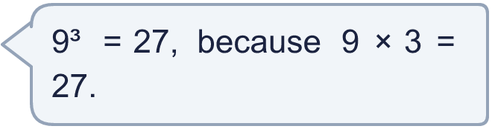
  9 | Is Boba correct? Circle yes or no.  Yes / No  Explain how you know.
  10 | Is Boba correct? Circle yes or no.  Yes / No  Explain your answer.
     | 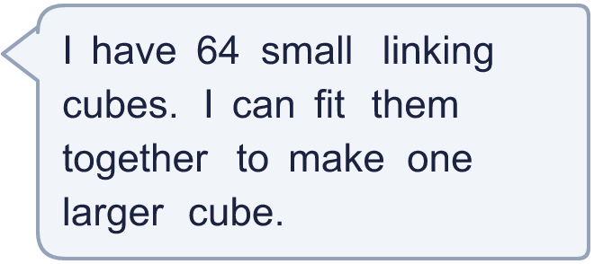
  10 | Is Boba correct? Circle yes or no.  Yes / No  Explain your answer.
  11 | Mr Lee's age is a cube number. His sister is 2 years younger than him, and her age is a square number. In 3 years, Mr Lee's age will be a multiple of 10.  How old is Mr Lee?
  11 | Mr Lee's age is a cube number. His sister is 2 years younger than him, and her age is a square number. In 3 years, Mr Lee's age will be a multiple of 10.  How old is Mr Lee?
  12 | Think about the whole numbers from 1 to 500.  a) How many of them are square numbers?  b) How many of them are cube numbers?
  12 | Think about the whole numbers from 1 to 500.  a) How many of them are square numbers?  b) How many of them are cube numbers?
  13 | Find the number between 100 and 1000 that is both a square number and a cube number.
  13 | Find the number between 100 and 1000 that is both a square number and a cube number.
  14 | Write three different cube numbers between 30 and 430.
  14 | Write three different cube numbers between 30 and 430.

Year 5 · Multiply and divide A · Step 7
Cube numbers
Answers (teacher copy)

  1 | Work out each cube number. For example, 3³ = 3 × 3 × 3 = 27.  a) 4³ = 64  b) 6³ = 216  c) 7³ = 343  d) 10³ = 1,000
  2 | Work out each calculation. Each one is a cube number.  a) 6 × 6 × 6 = 216  b) 2 × 2 × 2 = 8  c) 4 × 4 × 4 = 64
  3 | Work out each calculation.  a) 5 cubed = 125  b) 4 cubed = 64  c) 2 cubed = 8  d) 3 cubed = 27
  4 | Write the missing number.  a) 6 ³ = 216  b) 2 ³ = 8  c) 10 ³ = 1,000
  5 | Write <, > or = in each box.  a) 10² < 5³  b) 4² = 2 × 8  c) 3² > 2 × 3  d) 2³ = 4 + 4
  6 | Circle the cube numbers. Write them below.  100 125 150 12 1 20 64  1, 64, 125
  7 | A big cube is made from small cubes. How many small cubes do you need?  a) a 3 × 3 × 3 cube: 27  b) a 5 × 5 × 5 cube: 125
  8 | Work out each calculation.  a) 3³ + 2³ = 35  b) 6² + 2³ = 44  c) 5³ − 5² = 100
  9 | Is Boba correct? Circle yes or no.  Yes / No  Explain how you know.  9³ means 9 × 9 × 9, which is 729, not 27.
  10 | Is Boba correct? Circle yes or no.  Yes / No  Explain your answer.  Yes. 4 × 4 × 4 = 64, so 64 small cubes make a 4 by 4 by 4 cube.
  11 | Mr Lee's age is a cube number. His sister is 2 years younger than him, and her age is a square number. In 3 years, Mr Lee's age will be a multiple of 10.  How old is Mr Lee? 27
  12 | Think about the whole numbers from 1 to 500.  a) How many of them are square numbers? 22  b) How many of them are cube numbers? 7
  13 | Find the number between 100 and 1000 that is both a square number and a cube number.  729
  14 | Write three different cube numbers between 30 and 430.  for example 64, 216, 343

