  Year 5 · Multiply and divide A · Step 9  Dividing by 10, 100 and 1,000 | 
  Year 5 · Multiply and divide A · Step 9
  Dividing by 10, 100 and 1,000
  1 | Complete the divisions. Think about what happens to the digits.  a) 70 ÷ 10 =  b) 920 ÷ 10 =  c) 5,720 ÷ 10 =
  1 | Complete the divisions. Think about what happens to the digits.  a) 70 ÷ 10 =  b) 920 ÷ 10 =  c) 5,720 ÷ 10 =
  2 | Complete the divisions.  a) 530 ÷ 10 =  b) 9,600 ÷ 10 =  c) 5,870 ÷ 10 =  d) 83,000 ÷ 10 =
  2 | Complete the divisions.  a) 530 ÷ 10 =  b) 9,600 ÷ 10 =  c) 5,870 ÷ 10 =  d) 83,000 ÷ 10 =
  3 | Complete the divisions.  a) 500 ÷ 100 =  b) 70,000 ÷ 100 =  c) 7,000 ÷ 1,000 =  d) 970,000 ÷ 1,000 =
  3 | Complete the divisions.  a) 500 ÷ 100 =  b) 70,000 ÷ 100 =  c) 7,000 ÷ 1,000 =  d) 970,000 ÷ 1,000 =
  4 | Write the missing number.
    a) |  | ÷ 10 | = | 82
    b) |  | ÷ 100 | = | 82
    c) |  | ÷ 1,000 | = | 82
  4 | Write the missing number.
    a) |  | ÷ 10 | = | 82
    b) |  | ÷ 100 | = | 82
    c) |  | ÷ 1,000 | = | 82
  5 | Write <, > or = in each box.
    a) | 7,200 ÷ 100 |  | 720 ÷ 10
    b) | 93,000 ÷ 1,000 |  | 9,300 ÷ 100
    c) | 5,700 ÷ 100 |  | 5,700 ÷ 1,000
    d) | 4,900 ÷ 10 |  | 4,900 ÷ 100
  5 | Write <, > or = in each box.
    a) | 7,200 ÷ 100 |  | 720 ÷ 10
    b) | 93,000 ÷ 1,000 |  | 9,300 ÷ 100
    c) | 5,700 ÷ 100 |  | 5,700 ÷ 1,000
    d) | 4,900 ÷ 10 |  | 4,900 ÷ 100
  6 | Complete the sentences.  a) Dividing a number by 10 and then by 100 is the same as dividing by  b) Dividing a number by 1,000 is the same as dividing by 10 and then by
  6 | Complete the sentences.  a) Dividing a number by 10 and then by 100 is the same as dividing by  b) Dividing a number by 1,000 is the same as dividing by 10 and then by
  7 | Divide 89,000 by 10, by 100 and by 1,000. Then work out one more.  a) 89,000 ÷ 10 =  b) 89,000 ÷ 100 =  c) 89,000 ÷ 1,000 =  d) 3,800 ÷ 100 =
  7 | Divide 89,000 by 10, by 100 and by 1,000. Then work out one more.  a) 89,000 ÷ 10 =  b) 89,000 ÷ 100 =  c) 89,000 ÷ 1,000 =  d) 3,800 ÷ 100 =
  8 | In 2019, 710,700 houses were built. In 2018, 10 times fewer houses were built than in 2019. In 2017, 100 times fewer houses were built than in 2019.  a) How many houses were built in 2018?  b) How many houses were built in 2017?  c) How many more houses were built in 2019 than in 2017?
  8 | In 2019, 710,700 houses were built. In 2018, 10 times fewer houses were built than in 2019. In 2017, 100 times fewer houses were built than in 2019.  a) How many houses were built in 2018?  b) How many houses were built in 2017?  c) How many more houses were built in 2019 than in 2017?

  9 | Is Boba correct? Circle yes or no.  Yes / No  Explain how you know.
     | 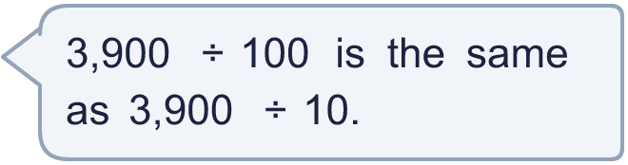
  9 | Is Boba correct? Circle yes or no.  Yes / No  Explain how you know.
  10 | What could the number be? Find three different answers.
     | 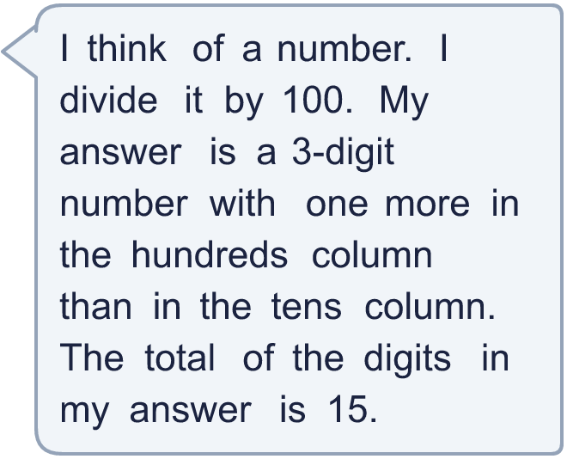
  10 | What could the number be? Find three different answers.
  11 | A school buys 6,000 pencils. It shares them equally between 100 classes. Each class then shares its pencils equally between 10 pupils.  a) How many pencils does each class get?  b) How many pencils does each pupil get?
  11 | A school buys 6,000 pencils. It shares them equally between 100 classes. Each class then shares its pencils equally between 10 pupils.  a) How many pencils does each class get?  b) How many pencils does each pupil get?
  12 | Which calculations have an answer of 83? Write the letters.  A 8,300 ÷ 100  B 830,000 ÷ 1,000  C 83,000 ÷ 100  D 8,300 ÷ 10  E 83,000 ÷ 10  F 830 ÷ 10
  12 | Which calculations have an answer of 83? Write the letters.  A 8,300 ÷ 100  B 830,000 ÷ 1,000  C 83,000 ÷ 100  D 8,300 ÷ 10  E 83,000 ÷ 10  F 830 ÷ 10
  13 | Write the missing number.
    a) |  | ÷ 10 | = | 1,300
    b) |  | ÷ 100 | = | 610
    c) |  | ÷ 1,000 | = | 780
    d) |  | ÷ 100 | = | 3,000
  13 | Write the missing number.
    a) |  | ÷ 10 | = | 1,300
    b) |  | ÷ 100 | = | 610
    c) |  | ÷ 1,000 | = | 780
    d) |  | ÷ 100 | = | 3,000
  14 | Write three different divisions by 10, 100 or 1,000 that have an answer between 20 and 40.
  14 | Write three different divisions by 10, 100 or 1,000 that have an answer between 20 and 40.

Year 5 · Multiply and divide A · Step 9
Dividing by 10, 100 and 1,000
Answers (teacher copy)

  1 | Complete the divisions. Think about what happens to the digits.  a) 70 ÷ 10 = 7  b) 920 ÷ 10 = 92  c) 5,720 ÷ 10 = 572
  2 | Complete the divisions.  a) 530 ÷ 10 = 53  b) 9,600 ÷ 10 = 960  c) 5,870 ÷ 10 = 587  d) 83,000 ÷ 10 = 8,300
  3 | Complete the divisions.  a) 500 ÷ 100 = 5  b) 70,000 ÷ 100 = 700  c) 7,000 ÷ 1,000 = 7  d) 970,000 ÷ 1,000 = 970
  4 | Write the missing number.  a) 820 ÷ 10 = 82  b) 8,200 ÷ 100 = 82  c) 82,000 ÷ 1,000 = 82
  5 | Write <, > or = in each box.  a) 7,200 ÷ 100 = 720 ÷ 10  b) 93,000 ÷ 1,000 = 9,300 ÷ 100  c) 5,700 ÷ 100 > 5,700 ÷ 1,000  d) 4,900 ÷ 10 > 4,900 ÷ 100
  6 | Complete the sentences.  a) Dividing a number by 10 and then by 100 is the same as dividing by 1,000  b) Dividing a number by 1,000 is the same as dividing by 10 and then by 100
  7 | Divide 89,000 by 10, by 100 and by 1,000. Then work out one more.  a) 89,000 ÷ 10 = 8,900  b) 89,000 ÷ 100 = 890  c) 89,000 ÷ 1,000 = 89  d) 3,800 ÷ 100 = 38
  8 | In 2019, 710,700 houses were built. In 2018, 10 times fewer houses were built than in 2019. In 2017, 100 times fewer houses were built than in 2019.  a) How many houses were built in 2018? 71,070  b) How many houses were built in 2017? 7,107  c) How many more houses were built in 2019 than in 2017? 703,593
  9 | Is Boba correct? Circle yes or no.  Yes / No  Explain how you know.  3,900 ÷ 100 = 39. 3,900 ÷ 10 = 390.
  10 | What could the number be? Find three different answers.  for example 87,000, 76,200, 54,600
  11 | A school buys 6,000 pencils. It shares them equally between 100 classes. Each class then shares its pencils equally between 10 pupils.  a) How many pencils does each class get? 60  b) How many pencils does each pupil get? 6
  12 | Which calculations have an answer of 83? Write the letters.  A 8,300 ÷ 100  B 830,000 ÷ 1,000  C 83,000 ÷ 100  D 8,300 ÷ 10  E 83,000 ÷ 10  F 830 ÷ 10  A, F
  13 | Write the missing number.  a) 13,000 ÷ 10 = 1,300  b) 61,000 ÷ 100 = 610  c) 780,000 ÷ 1,000 = 780  d) 300,000 ÷ 100 = 3,000
  14 | Write three different divisions by 10, 100 or 1,000 that have an answer between 20 and 40.  for example 240 ÷ 10 and 2,700 ÷ 100 and 23,000 ÷ 1,000

