  Year 5 · Multiply and divide A · Step 1  Multiples | 
  Year 5 · Multiply and divide A · Step 1
  Multiples
  1 | Write the first 6 multiples of each number.  a) 4:  b) 9:
  1 | Write the first 6 multiples of each number.  a) 4:  b) 9:
  2 | Complete the number track of multiples.  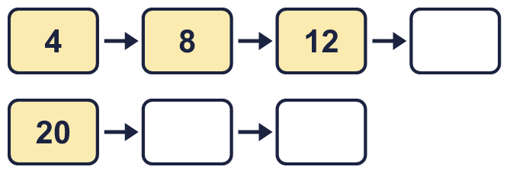
  2 | Complete the number track of multiples.
  3 | Circle the multiples of 6. Write them below.  12 34 22 36 10 66
  3 | Circle the multiples of 6. Write them below.  12 34 22 36 10 66
  4 | Find the digit sum of each number. Is the number a multiple of the number shown?
    a) | 57: digit sum
    multiple of 3?
    b) | 338: digit sum
    multiple of 3?
    c) | 193: digit sum
    multiple of 9?
  4 | Find the digit sum of each number. Is the number a multiple of the number shown?
    a) | 57: digit sum
    multiple of 3?
    b) | 338: digit sum
    multiple of 3?
    c) | 193: digit sum
    multiple of 9?
  5 | List the numbers between 10 and 50 that are multiples of both 2 and 3.
  5 | List the numbers between 10 and 50 that are multiples of both 2 and 3.
  6 | List the multiples of 5 that are between 20 and 70.
  6 | List the multiples of 5 that are between 20 and 70.
  7 | Is each number a multiple of the number shown? Write yes or no.  a) Is 56 a multiple of 8?  b) Is 84 a multiple of 12?  c) Is 47 a multiple of 4?
  7 | Is each number a multiple of the number shown? Write yes or no.  a) Is 56 a multiple of 8?  b) Is 84 a multiple of 12?  c) Is 47 a multiple of 4?
  8 | How many multiples of 7 are there from 7 up to 70?
  8 | How many multiples of 7 are there from 7 up to 70?

  9 | Is Boba correct? Circle yes or no.  Yes / No  Explain your answer.
     | 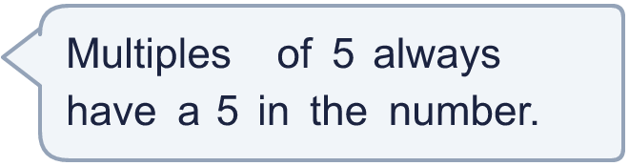
  9 | Is Boba correct? Circle yes or no.  Yes / No  Explain your answer.
  10 | Which number is the odd one out?  42 54 48 59  The odd one out is  Explain why it is the odd one out.
  10 | Which number is the odd one out?  42 54 48 59  The odd one out is  Explain why it is the odd one out.
  11 | Both numbers are less than 100. Could they be thinking of the same number? Circle yes or no.  Yes / No  Explain your answer.
     | 
     | 
  11 | Both numbers are less than 100. Could they be thinking of the same number? Circle yes or no.  Yes / No  Explain your answer.
  12 | • It is a common multiple of 3 and 12.  • It is more than 65 and less than 125.  • The digits add up to 15.  What is my number?
    
  12 | • It is a common multiple of 3 and 12.  • It is more than 65 and less than 125.  • The digits add up to 15.  What is my number?
  13 | Write all the multiples of 35 that are between 190 and 330.  Check that you have found them all.
  13 | Write all the multiples of 35 that are between 190 and 330.  Check that you have found them all.
  14 | Write three different numbers between 50 and 100 that are multiples of both 3 and 4.
  14 | Write three different numbers between 50 and 100 that are multiples of both 3 and 4.

Year 5 · Multiply and divide A · Step 1
Multiples
Answers (teacher copy)

  1 | Write the first 6 multiples of each number.  a) 4: 4, 8, 12, 16, 20, 24  b) 9: 9, 18, 27, 36, 45, 54
  2 | Complete the number track of multiples.  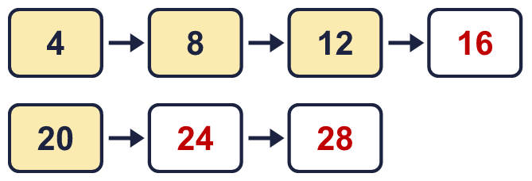
  3 | Circle the multiples of 6. Write them below.  12 34 22 36 10 66  12, 36, 66
  4 | Find the digit sum of each number. Is the number a multiple of the number shown?  a) 57: digit sum 12 multiple of 3? Yes  b) 338: digit sum 14 multiple of 3? No  c) 193: digit sum 13 multiple of 9? No
  5 | List the numbers between 10 and 50 that are multiples of both 2 and 3.  12, 18, 24, 30, 36, 42, 48
  6 | List the multiples of 5 that are between 20 and 70.  25, 30, 35, 40, 45, 50, 55, 60, 65
  7 | Is each number a multiple of the number shown? Write yes or no.  a) Is 56 a multiple of 8? Yes  b) Is 84 a multiple of 12? Yes  c) Is 47 a multiple of 4? No
  8 | How many multiples of 7 are there from 7 up to 70?  10
  9 | Is Boba correct? Circle yes or no.  Yes / No  Explain your answer.  No. 10 is a multiple of 5, but it does not fit the statement.
  10 | Which number is the odd one out?  42 54 48 59  The odd one out is 59  Explain why it is the odd one out.  59 is not a multiple of 6. The other three numbers are multiples of 6.
  11 | Both numbers are less than 100. Could they be thinking of the same number? Circle yes or no.  Yes / No  Explain your answer.  Yes. 24 is a multiple of 4, 6, 8 and 3, and it is less than 100.
  12 | • It is a common multiple of 3 and 12.  • It is more than 65 and less than 125.  • The digits add up to 15.  What is my number? 96
  13 | Write all the multiples of 35 that are between 190 and 330.  210, 245, 280, 315  Check that you have found them all.
  14 | Write three different numbers between 50 and 100 that are multiples of both 3 and 4.  Any three of the common multiples of 3 and 4 between 50 and 100, for example 60, 72, 84

