  Year 5 · Multiply and divide A · Step 8  Multiplying by 10, 100 and 1,000 | 
  Year 5 · Multiply and divide A · Step 8
  Multiplying by 10, 100 and 1,000
  1 | Complete the multiplications. Think about what happens to the digits.  a) 8 × 10 =  b) 27 × 10 =  c) 164 × 10 =
  1 | Complete the multiplications. Think about what happens to the digits.  a) 8 × 10 =  b) 27 × 10 =  c) 164 × 10 =
  2 | Complete the multiplications.  a) 60 × 10 =  b) 10 × 51 =  c) 259 × 10 =
  2 | Complete the multiplications.  a) 60 × 10 =  b) 10 × 51 =  c) 259 × 10 =
  3 | Multiply each number by 100 and then by 1,000.  a) 7 × 100 =  b) 7 × 1,000 =  c) 79 × 100 =  d) 79 × 1,000 =
  3 | Multiply each number by 100 and then by 1,000.  a) 7 × 100 =  b) 7 × 1,000 =  c) 79 × 100 =  d) 79 × 1,000 =
  4 | Complete the multiplications.  a) 40 × 100 =  b) 50 × 100 =  c) 767 × 100 =  d) 40 × 1,000 =
  4 | Complete the multiplications.  a) 40 × 100 =  b) 50 × 100 =  c) 767 × 100 =  d) 40 × 1,000 =
  5 | Write the missing number.
    a) |  | × 10 | = | 880
    b) | 10 × |  | = | 620
    c) |  | × 100 | = | 4,000
  5 | Write the missing number.
    a) |  | × 10 | = | 880
    b) | 10 × |  | = | 620
    c) |  | × 100 | = | 4,000
  6 | Write <, > or = in each box.
    a) | 25 × 100 |  | 25 × 1,000
    b) | 350 × 10 |  | 35 × 100
    c) | 10 × 64 |  | 64 × 10
    d) | 7 × 1,000 |  | 70 × 100
  6 | Write <, > or = in each box.
    a) | 25 × 100 |  | 25 × 1,000
    b) | 350 × 10 |  | 35 × 100
    c) | 10 × 64 |  | 64 × 10
    d) | 7 × 1,000 |  | 70 × 100
  7 | Write the missing number.
    a) | 70 × |  | = | 7,000
    b) |  | × 100 | = | 6,400
    c) | 57 × |  | = | 57,000
  7 | Write the missing number.
    a) | 70 × |  | = | 7,000
    b) |  | × 100 | = | 6,400
    c) | 57 × |  | = | 57,000
  8 | Ron delivers 76 papers a month. Dani delivers 10 times as many papers a month as Ron.  a) How many papers does Dani deliver?  b) How many papers do they deliver altogether?
  8 | Ron delivers 76 papers a month. Dani delivers 10 times as many papers a month as Ron.  a) How many papers does Dani deliver?  b) How many papers do they deliver altogether?

  9 | Is Boba correct? Circle yes or no.  Yes / No  Explain how you know.
     | 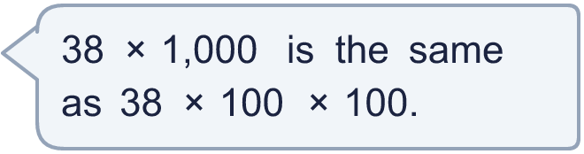
  9 | Is Boba correct? Circle yes or no.  Yes / No  Explain how you know.
  10 | Mrs Hall owns a bookshop. In January she sells 352 books. In February she sells 10 times as many books. In March she sells 10 times as many books as in February.  a) How many books does she sell in February?  b) How many books does she sell in March?
  10 | Mrs Hall owns a bookshop. In January she sells 352 books. In February she sells 10 times as many books. In March she sells 10 times as many books as in February.  a) How many books does she sell in February?  b) How many books does she sell in March?
  11 | What is the number?
     | 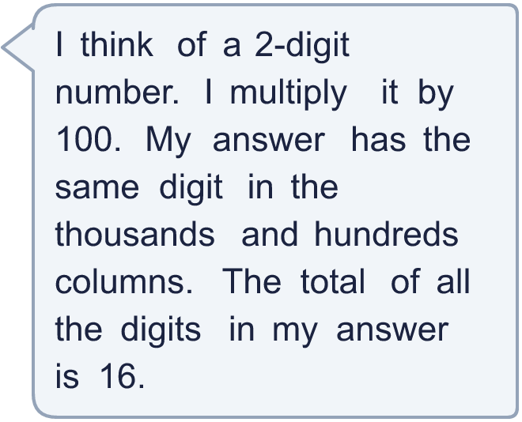
  11 | What is the number?
  12 | Which calculations have an answer of 2,500? Write the letters.  A 25 × 1,000  B 250 × 10  C 25 × 100  D 250 × 100  E 2,500 × 10  F 25 × 10
  12 | Which calculations have an answer of 2,500? Write the letters.  A 25 × 1,000  B 250 × 10  C 25 × 100  D 250 × 100  E 2,500 × 10  F 25 × 10
  13 | Write the missing number.
    a) | 73 × |  | = | 7,300
    b) |  | × 100 | = | 18,000
    c) | 44 × |  | = | 440,000
    d) |  | × 10 | = | 96,000
  13 | Write the missing number.
    a) | 73 × |  | = | 7,300
    b) |  | × 100 | = | 18,000
    c) | 44 × |  | = | 440,000
    d) |  | × 10 | = | 96,000
  14 | Write three different multiplications by 10, 100 or 1,000 that have an answer between 5,000 and 7,000.
  14 | Write three different multiplications by 10, 100 or 1,000 that have an answer between 5,000 and 7,000.

Year 5 · Multiply and divide A · Step 8
Multiplying by 10, 100 and 1,000
Answers (teacher copy)

  1 | Complete the multiplications. Think about what happens to the digits.  a) 8 × 10 = 80  b) 27 × 10 = 270  c) 164 × 10 = 1,640
  2 | Complete the multiplications.  a) 60 × 10 = 600  b) 10 × 51 = 510  c) 259 × 10 = 2,590
  3 | Multiply each number by 100 and then by 1,000.  a) 7 × 100 = 700  b) 7 × 1,000 = 7,000  c) 79 × 100 = 7,900  d) 79 × 1,000 = 79,000
  4 | Complete the multiplications.  a) 40 × 100 = 4,000  b) 50 × 100 = 5,000  c) 767 × 100 = 76,700  d) 40 × 1,000 = 40,000
  5 | Write the missing number.  a) 88 × 10 = 880  b) 10 × 62 = 620  c) 40 × 100 = 4,000
  6 | Write <, > or = in each box.  a) 25 × 100 < 25 × 1,000  b) 350 × 10 = 35 × 100  c) 10 × 64 = 64 × 10  d) 7 × 1,000 = 70 × 100
  7 | Write the missing number.  a) 70 × 100 = 7,000  b) 64 × 100 = 6,400  c) 57 × 1,000 = 57,000
  8 | Ron delivers 76 papers a month. Dani delivers 10 times as many papers a month as Ron.  a) How many papers does Dani deliver? 760  b) How many papers do they deliver altogether? 836
  9 | Is Boba correct? Circle yes or no.  Yes / No  Explain how you know.  38 × 1,000 = 38,000. 38 × 100 × 100 = 380,000.
  10 | Mrs Hall owns a bookshop. In January she sells 352 books. In February she sells 10 times as many books. In March she sells 10 times as many books as in February.  a) How many books does she sell in February? 3,520  b) How many books does she sell in March? 35,200
  11 | What is the number? 88
  12 | Which calculations have an answer of 2,500? Write the letters.  A 25 × 1,000  B 250 × 10  C 25 × 100  D 250 × 100  E 2,500 × 10  F 25 × 10  B, C
  13 | Write the missing number.  a) 73 × 100 = 7,300  b) 180 × 100 = 18,000  c) 44 × 10,000 = 440,000  d) 9,600 × 10 = 96,000
  14 | Write three different multiplications by 10, 100 or 1,000 that have an answer between 5,000 and 7,000.  for example 501 × 10 and 51 × 100 and 6 × 1,000

