  Year 5 · Place value · Step 11  Comparing and ordering numbers up to 1,000,000 | 
  Year 5 · Place value · Step 11
  Comparing and ordering numbers up to 1,000,000
  1 | Write the number shown in each place value chart. Then write <, > or = to compare them.  Chart A  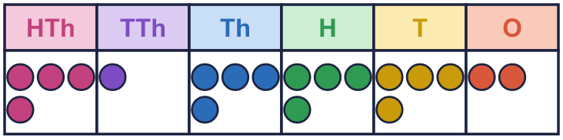  Chart B  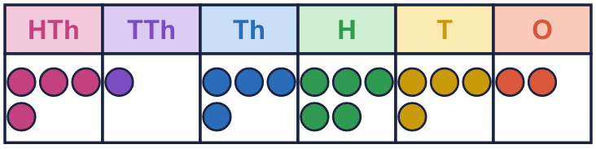
    A |  | B
  1 | Write the number shown in each place value chart. Then write <, > or = to compare them.  Chart A  Chart B
    A |  | B
  2 | Circle the smaller number in each pair. Write it.  a) 10,500 or 89,200  b) 992,000 or 420,000  c) 50,000 or 49,995  d) 8,000 or 40,000
  2 | Circle the smaller number in each pair. Write it.  a) 10,500 or 89,200  b) 992,000 or 420,000  c) 50,000 or 49,995  d) 8,000 or 40,000
  3 | Write <, > or = in each box.  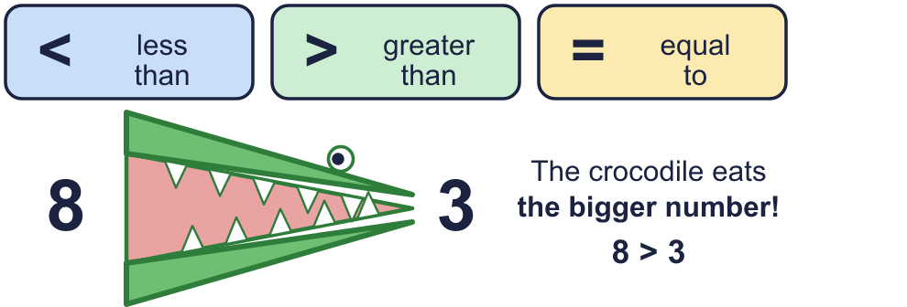
    a) | 9,974 |  | 4,799
    b) | 795,000 |  | 520,500
    c) | 500,000 + 2,000 + 35
    502,040
  3 | Write <, > or = in each box.
    a) | 9,974 |  | 4,799
    b) | 795,000 |  | 520,500
    c) | 500,000 + 2,000 + 35
    502,040
  4 | Circle the greatest number in each list. Write it.  a) 572,366 787,436 210,949 428,461  b) 959,244 957,426 950,131 954,888  c) 572,053 572,142 572,184 572,198
  4 | Circle the greatest number in each list. Write it.  a) 572,366 787,436 210,949 428,461  b) 959,244 957,426 950,131 954,888  c) 572,053 572,142 572,184 572,198
  5 | Write the numbers in order.  a) smallest first: 96,580 96,850 9,685 9,658  b) largest first: 8,569 9,658 96,580 965,800
  5 | Write the numbers in order.  a) smallest first: 96,580 96,850 9,685 9,658  b) largest first: 8,569 9,658 96,580 965,800
  6 | 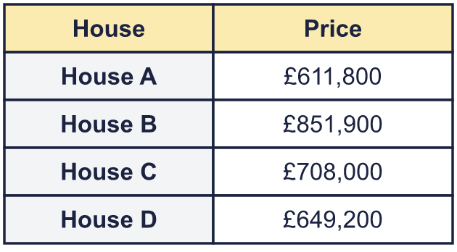  a) Write the houses in order, least expensive first.  b) How much more is the most expensive house than the cheapest?
  6 | a) Write the houses in order, least expensive first.  b) How much more is the most expensive house than the cheapest?
  7 | Write a digit in each box to make the statement correct. There may be more than one answer.
    a) | 9, |  | 75 | > | 9,472
    b) | 41 |  | ,491 | < | 414,497
    c) |  | 55,483 | > | 355,485
  7 | Write a digit in each box to make the statement correct. There may be more than one answer.
    a) | 9, |  | 75 | > | 9,472
    b) | 41 |  | ,491 | < | 414,497
    c) |  | 55,483 | > | 355,485
  8 | The numbers are written in different ways. Write their letters in order, smallest first.  a) 476,000  b) 436,000  c) six hundred and seventy-six thousand  Answer:
  8 | The numbers are written in different ways. Write their letters in order, smallest first.  a) 476,000  b) 436,000  c) six hundred and seventy-six thousand  Answer:

  9 | Here are two numbers made on a place value chart.  Chart A  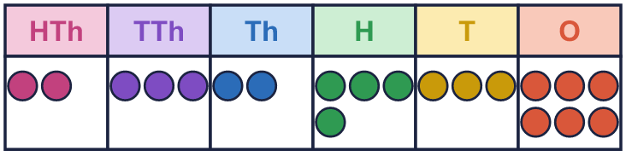  Chart B  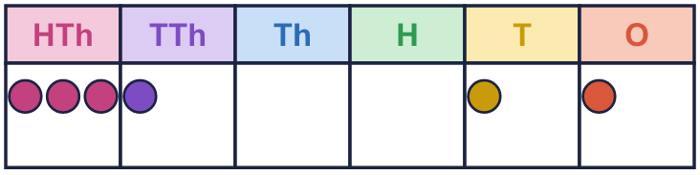  Is Boba correct? Circle yes or no.  Yes / No  Explain how you know.
    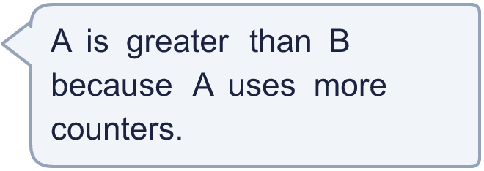
  9 | Here are two numbers made on a place value chart.  Chart A  Chart B  Is Boba correct? Circle yes or no.  Yes / No  Explain how you know.
  10 | 7,052 64,604 886,231 439,989  Is Boba correct? Circle yes or no.  Yes / No  Explain how you know.
     | 
  10 | 7,052 64,604 886,231 439,989  Is Boba correct? Circle yes or no.  Yes / No  Explain how you know.
  11 | Sort the numbers into the groups. Write the letters.  a) 736,341  b) 16,393  c) 169,262  d) 716,501  e) 751,043  f) 148,623
    less than 80,000:
    greater than 180,000:
    between 80,000 and 180,000:
  11 | Sort the numbers into the groups. Write the letters.  a) 736,341  b) 16,393  c) 169,262  d) 716,501  e) 751,043  f) 148,623
    less than 80,000:
    greater than 180,000:
    between 80,000 and 180,000:
  12 | 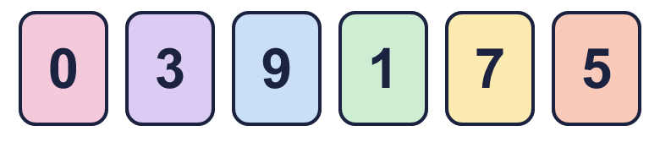  a) Make the smallest number.  b) Make the greatest number.  c) Make the number closest to 500,000.
     | 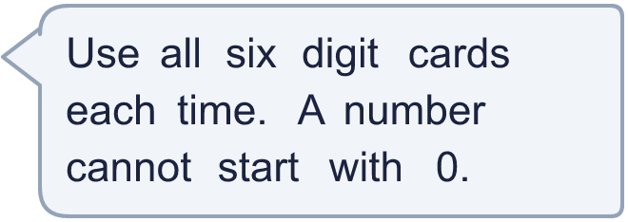
  12 | a) Make the smallest number.  b) Make the greatest number.  c) Make the number closest to 500,000.
  13 | Write four numbers that could go in the middle, in order.
     | 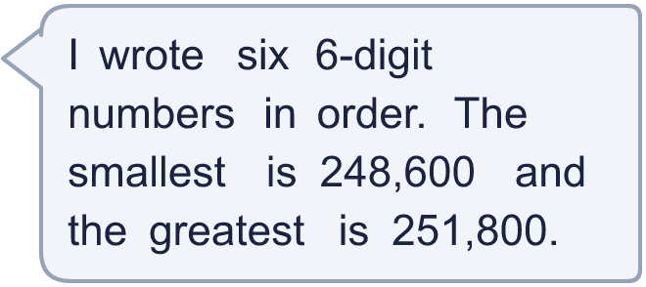
  13 | Write four numbers that could go in the middle, in order.
  14 | To compare 759,431 and 759,441, which column tells you which number is greater? Write the name of the column.  Column:
  14 | To compare 759,431 and 759,441, which column tells you which number is greater? Write the name of the column.  Column:

Year 5 · Place value · Step 11
Comparing and ordering numbers up to 1,000,000
Answers (teacher copy)

  1 | Write the number shown in each place value chart. Then write <, > or = to compare them.  Chart A  Chart B  A = 414,442 B = 414,542  A < B
  2 | Circle the smaller number in each pair. Write it.  a) 10,500 or 89,200 10,500  b) 992,000 or 420,000 420,000  c) 50,000 or 49,995 49,995  d) 8,000 or 40,000 8,000
  3 | Write <, > or = in each box.  a) 9,974 > 4,799  b) 795,000 > 520,500  c) 500,000 + 2,000 + 35 < 502,040
  4 | Circle the greatest number in each list. Write it.  a) 572,366 787,436 210,949 428,461 787,436  b) 959,244 957,426 950,131 954,888 959,244  c) 572,053 572,142 572,184 572,198 572,198
  5 | Write the numbers in order.  a) smallest first: 96,580 96,850 9,685 9,658  9,658, 9,685, 96,580, 96,850  b) largest first: 8,569 9,658 96,580 965,800  965,800, 96,580, 9,658, 8,569
  6 | a) Write the houses in order, least expensive first. House A, House D, House C, House B  b) How much more is the most expensive house than the cheapest? £240,100
  7 | Write a digit in each box to make the statement correct. There may be more than one answer.  a) 9, 4, 5, 6, 7, 8, 9 75 > 9,472  b) 41 0, 1, 2, 3, 4 ,491 < 414,497  c) 4, 5, 6, 7, 8, 9 55,483 > 355,485
  8 | The numbers are written in different ways. Write their letters in order, smallest first.  a) 476,000  b) 436,000  c) six hundred and seventy-six thousand  Answer: b, a, c
  9 | Here are two numbers made on a place value chart.  Chart A  Chart B  Is Boba correct? Circle yes or no.  Yes / No  Explain how you know.  A is 232,436 and B is 310,011. B is greater, because its hundred thousands digit is bigger. A has more counters, but the columns they are in matter more.
  10 | 7,052 64,604 886,231 439,989  Is Boba correct? Circle yes or no.  Yes / No  Explain how you know.  886,231 is bigger than 439,989, so it should come after it. The numbers should be: 7,052, 64,604, 439,989, 886,231.
  11 | Sort the numbers into the groups. Write the letters.  a) 736,341  b) 16,393  c) 169,262  d) 716,501  e) 751,043  f) 148,623  less than 80,000: b  greater than 180,000: a, d, e  between 80,000 and 180,000: c, f
  12 | a) Make the smallest number. 103,579  b) Make the greatest number. 975,310  c) Make the number closest to 500,000. 501,379
  13 | Write four numbers that could go in the middle, in order.  Any four numbers between 248,600 and 251,800 in order, for example 249,240, 249,880, 250,520, 251,160
  14 | To compare 759,431 and 759,441, which column tells you which number is greater? Write the name of the column.  Column: tens

