  Year 5 · Place value · Step 7  Finding 10, 100, 1,000, 10,000 and 100,000 more or less | 
  Year 5 · Place value · Step 7
  Finding 10, 100, 1,000, 10,000 and 100,000 more or less
  1 | Complete the number track. It goes up in 10s.  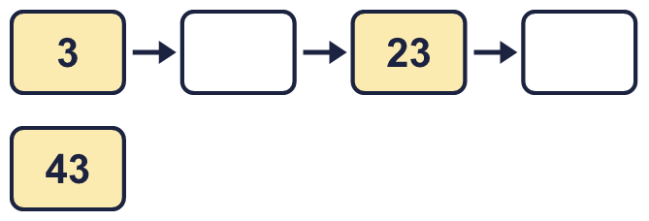
  1 | Complete the number track. It goes up in 10s.
  2 | Complete the number track. It goes down in 10s.  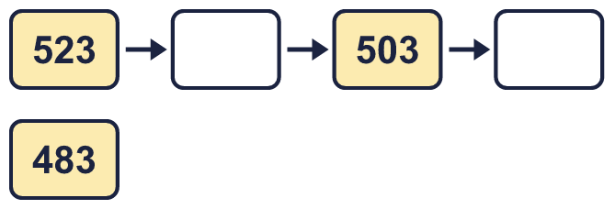
  2 | Complete the number track. It goes down in 10s.
  3 | Complete the number track. It goes up in 100s.  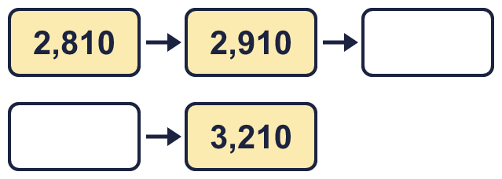
  3 | Complete the number track. It goes up in 100s.
  4 | Complete the number track. It goes up in 1,000s.  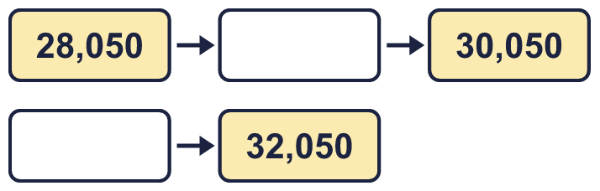
  4 | Complete the number track. It goes up in 1,000s.
  5 | This number is shown in the place value chart.  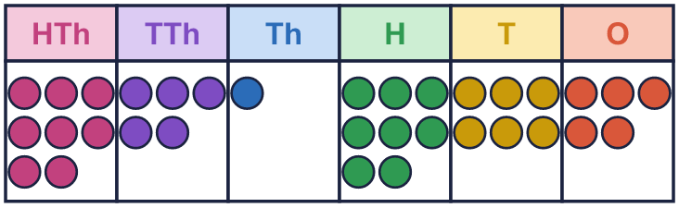  Work out the missing numbers.  a) 1,000 more than 851,865 =  b) 100 more than 851,865 =  c) 1 less than 851,865 =  d) 10 more than 851,865 =
  5 | This number is shown in the place value chart.  Work out the missing numbers.  a) 1,000 more than 851,865 =  b) 100 more than 851,865 =  c) 1 less than 851,865 =  d) 10 more than 851,865 =
  6 | Work out the missing numbers.  a) 100,000 more than 284,535 =  b) 10,000 less than 851,426 =  c) 1,000 less than 480,618 =
  6 | Work out the missing numbers.  a) 100,000 more than 284,535 =  b) 10,000 less than 851,426 =  c) 1,000 less than 480,618 =
  7 | Start with 266,524. Write the number that is...  a) 10 more =  b) 100 more =  c) 1,000 more =  d) 10,000 more =  e) 100,000 more =
  7 | Start with 266,524. Write the number that is...  a) 10 more =  b) 100 more =  c) 1,000 more =  d) 10,000 more =  e) 100,000 more =
  8 | Complete the number track. It goes down in 10,000s.  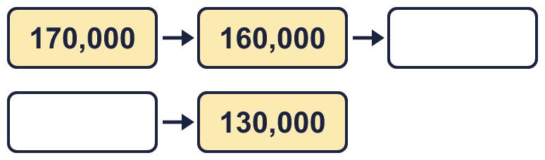
  8 | Complete the number track. It goes down in 10,000s.

  9 | 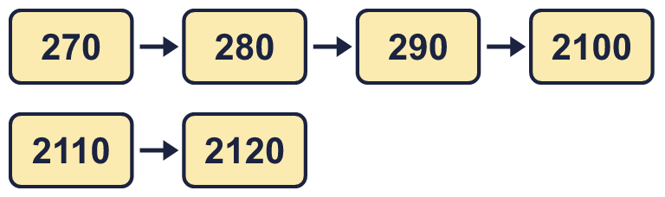  a) Explain the mistake Boba has made.  b) What number should come after 290?
     | 
  9 | a) Explain the mistake Boba has made.  b) What number should come after 290?
  10 | 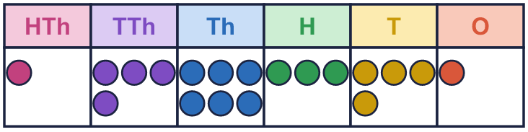  Write three different numbers I could have made.
     | 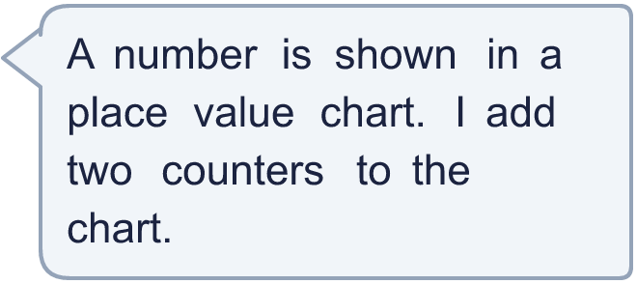
  10 | Write three different numbers I could have made.
  11 | Is Boba correct? Circle yes or no.  Yes / No  Explain how you know.
    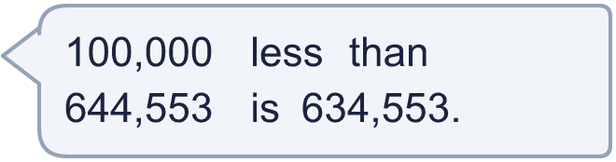
  11 | Is Boba correct? Circle yes or no.  Yes / No  Explain how you know.
  12 | Is Boba correct? Circle yes or no.  Yes / No  Explain how you know.
     | 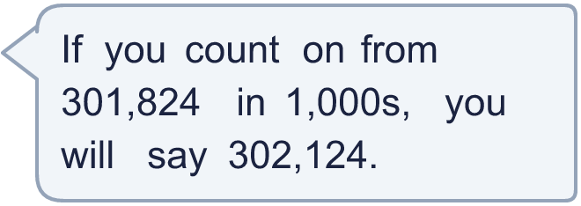
  12 | Is Boba correct? Circle yes or no.  Yes / No  Explain how you know.
  13 | a) How many times was it watched in April?  b) How many times was it watched in May?
    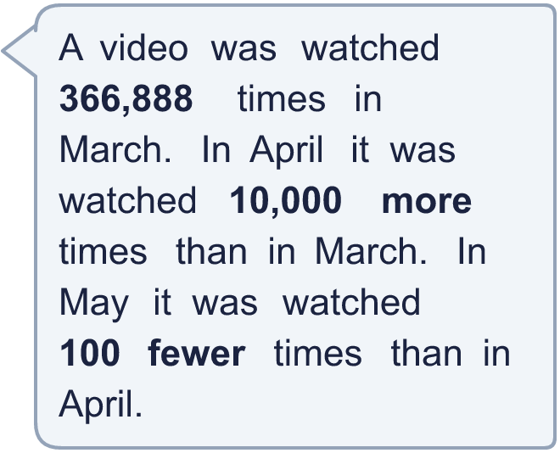
  13 | a) How many times was it watched in April?  b) How many times was it watched in May?
  14 | a) 1,000 more than my first number is 38,100. What is my first number?  b) 100,000 less than my second number is 548,365. What is my second number?
    
  14 | a) 1,000 more than my first number is 38,100. What is my first number?  b) 100,000 less than my second number is 548,365. What is my second number?

Year 5 · Place value · Step 7
Finding 10, 100, 1,000, 10,000 and 100,000 more or less
Answers (teacher copy)

  1 | Complete the number track. It goes up in 10s.  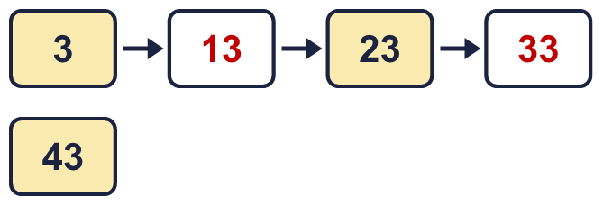
  2 | Complete the number track. It goes down in 10s.  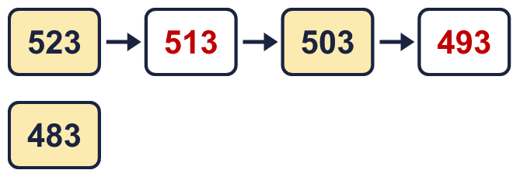
  3 | Complete the number track. It goes up in 100s.  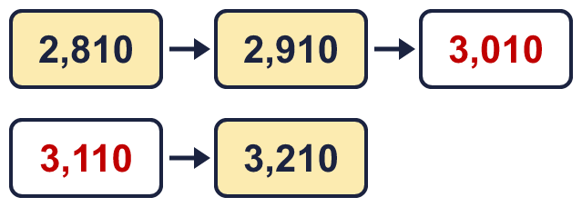
  4 | Complete the number track. It goes up in 1,000s.  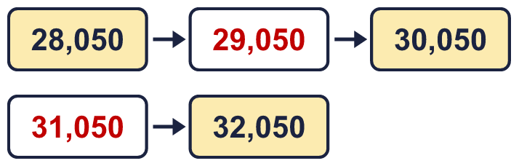
  5 | This number is shown in the place value chart.  Work out the missing numbers.  a) 1,000 more than 851,865 = 852,865  b) 100 more than 851,865 = 851,965  c) 1 less than 851,865 = 851,864  d) 10 more than 851,865 = 851,875
  6 | Work out the missing numbers.  a) 100,000 more than 284,535 = 384,535  b) 10,000 less than 851,426 = 841,426  c) 1,000 less than 480,618 = 479,618
  7 | Start with 266,524. Write the number that is...  a) 10 more = 266,534  b) 100 more = 266,624  c) 1,000 more = 267,524  d) 10,000 more = 276,524  e) 100,000 more = 366,524
  8 | Complete the number track. It goes down in 10,000s.  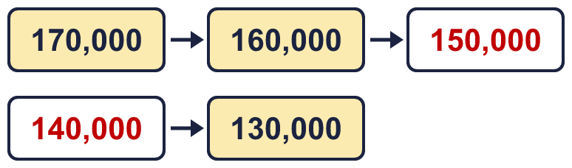
  9 | a) Explain the mistake Boba has made.  290 + 10 = 300, not 2100. When the tens column passes 90 the hundreds digit goes up by 1, so the tens column starts again at 0.  b) What number should come after 290? 300
  10 | Write three different numbers I could have made.  Any three numbers made by adding two counters, for example 148,341, 156,441, 246,351
  11 | Is Boba correct? Circle yes or no.  Yes / No  Explain how you know.  100,000 less than 644,553 is 544,553. Boba changed the wrong column: 634,553 is 10,000 less.
  12 | Is Boba correct? Circle yes or no.  Yes / No  Explain how you know.  Counting on in 1,000s from 301,824 you say 302,824, 303,824, 304,824... 302,124 is not one of them.
  13 | a) How many times was it watched in April? 376,888  b) How many times was it watched in May? 376,788
  14 | a) 1,000 more than my first number is 38,100. What is my first number? 37,100  b) 100,000 less than my second number is 548,365. What is my second number? 648,365

