  Year 5 · Place value · Step 9  Number lines up to 1,000,000 | 
  Year 5 · Place value · Step 9
  Number lines up to 1,000,000
  1 | What number is the arrow pointing to?
    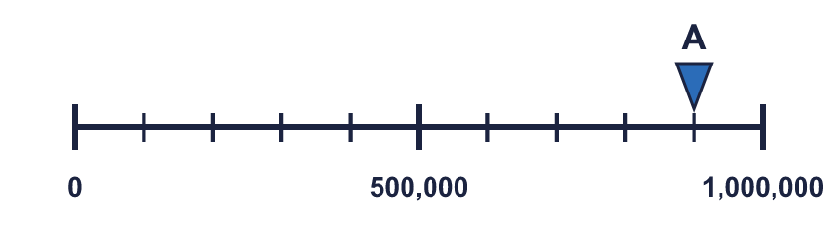
  1 | What number is the arrow pointing to?
  2 | What numbers are the arrows pointing to?  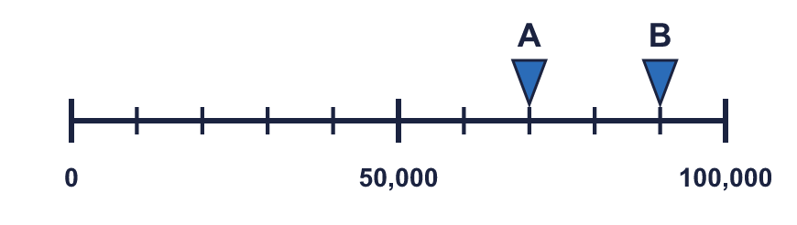
  2 | What numbers are the arrows pointing to?
  3 | Which arrow points to 100,000? Write its letter.  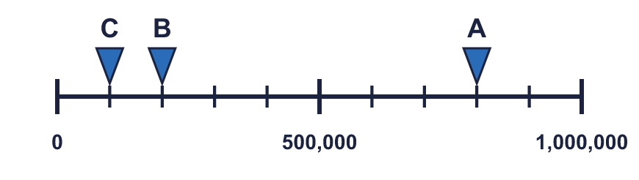  Answer:
  3 | Which arrow points to 100,000? Write its letter.  Answer:
  4 | Look at the number line.  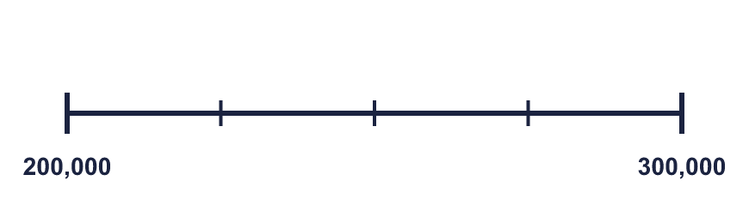  The difference between the start and the end is  The line counts up in
    There are |  | equal intervals.
  4 | Look at the number line.  The difference between the start and the end is  The line counts up in
    There are |  | equal intervals.
  5 | Write the missing numbers on the line.  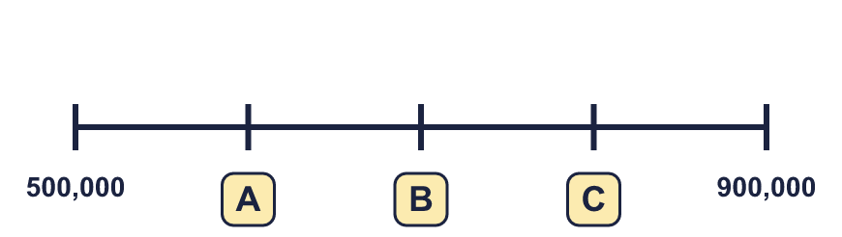
  5 | Write the missing numbers on the line.
  6 | What number is the arrow pointing to?
    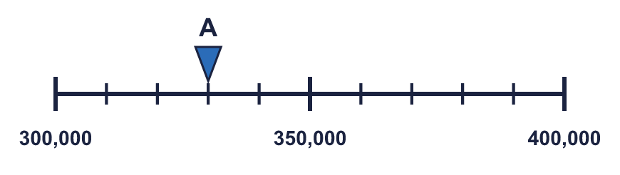
  6 | What number is the arrow pointing to?
  7 | What number is the arrow pointing to? It is exactly halfway between two marks.
    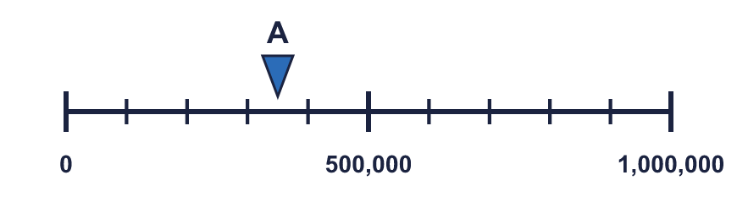
  7 | What number is the arrow pointing to? It is exactly halfway between two marks.
  8 | The arrow is between two marks. Which number is it closest to? Write the letter.  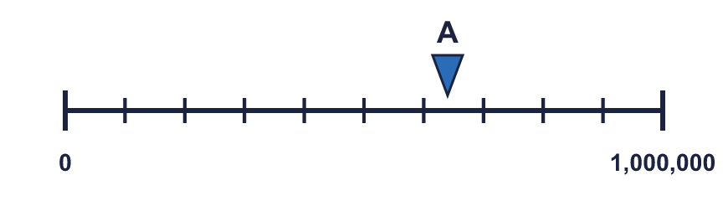  a) 450,000  b) 800,000  c) 650,000  Answer:
  8 | The arrow is between two marks. Which number is it closest to? Write the letter.  a) 450,000  b) 800,000  c) 650,000  Answer:

  9 | 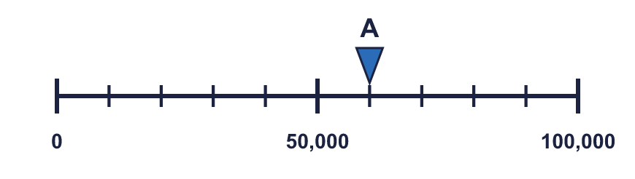  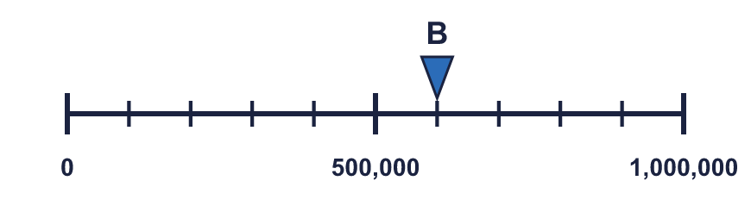  Is Boba correct? Circle yes or no.  Yes / No  Explain how you know.
    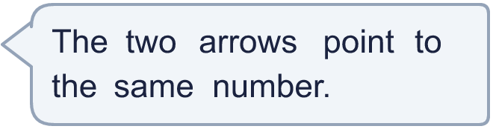
  9 | Is Boba correct? Circle yes or no.  Yes / No  Explain how you know.
  10 | 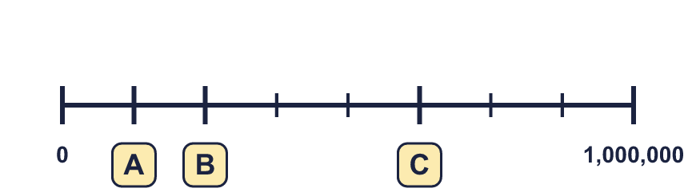
     | 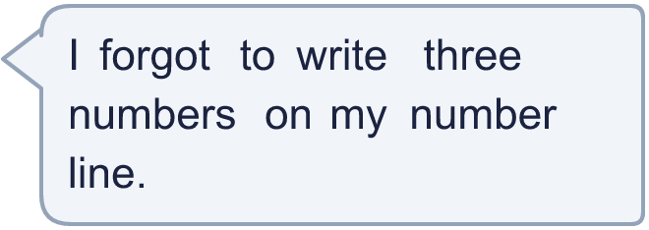
  10
  11 | 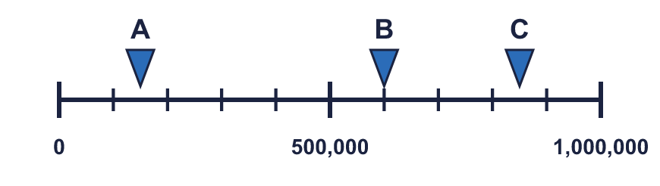  a) What number is arrow A pointing to?  b) What is the difference between B and C?
     | 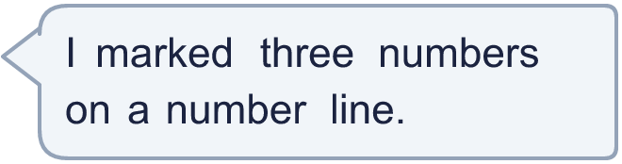
  11 | a) What number is arrow A pointing to?  b) What is the difference between B and C?
  12 | What numbers are the arrows pointing to?  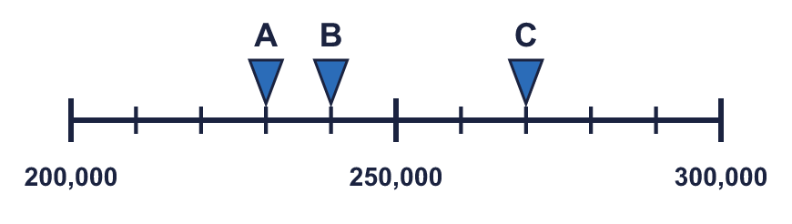
  12 | What numbers are the arrows pointing to?
  13 | 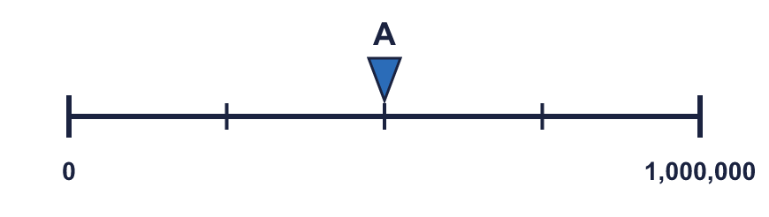  a) What is each step worth?  b) What number is arrow A pointing to?
     | 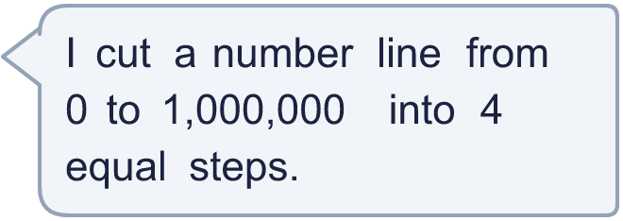
  13 | a) What is each step worth?  b) What number is arrow A pointing to?
  14 | 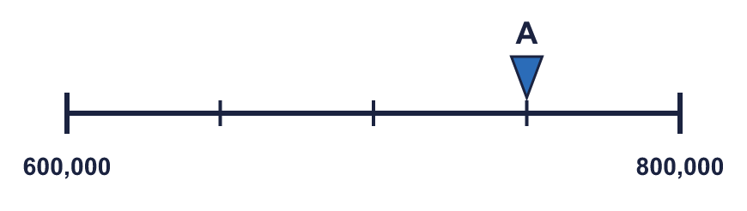  a) What mistake has Boba made?  b) What number is arrow A pointing to?
    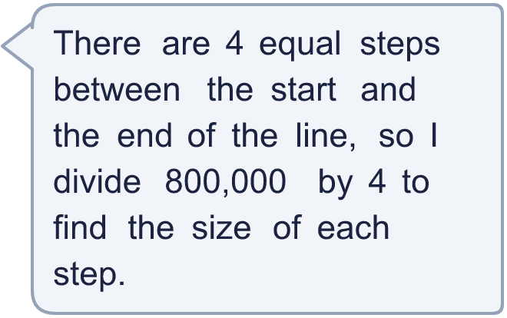
  14 | a) What mistake has Boba made?  b) What number is arrow A pointing to?

Year 5 · Place value · Step 9
Number lines up to 1,000,000
Answers (teacher copy)

  1 | What number is the arrow pointing to?
    900,000
  2 | What numbers are the arrows pointing to?  A = 70,000 B = 90,000
  3 | Which arrow points to 100,000? Write its letter.  Answer: C
  4 | Look at the number line.  The difference between the start and the end is 100,000  There are 4 equal intervals.  The line counts up in 25,000
  5 | Write the missing numbers on the line.  A = 600,000 B = 700,000 C = 800,000
  6 | What number is the arrow pointing to?
    330,000
  7 | What number is the arrow pointing to? It is exactly halfway between two marks.
    350,000
  8 | The arrow is between two marks. Which number is it closest to? Write the letter.  a) 450,000  b) 800,000  c) 650,000  Answer: c
  9 | Is Boba correct? Circle yes or no.  Yes / No  Explain how you know.  Arrow A points to 60,000 and arrow B points to 600,000. The lines have different scales: line A ends at 100,000 and line B ends at 1,000,000.
  10 | A = 125,000 B = 250,000 C = 625,000
  11 | a) What number is arrow A pointing to? 150,000  b) What is the difference between B and C? 250,000
  12 | What numbers are the arrows pointing to?  A = 230,000 B = 240,000 C = 270,000
  13 | a) What is each step worth? 250,000  b) What number is arrow A pointing to? 500,000
  14 | a) What mistake has Boba made?  Boba divided the end number. The line does not start at 0, so each step is (800,000 − 600,000) ÷ 4 = 50,000.  b) What number is arrow A pointing to? 750,000

