  Year 5 · Place value · Step 2  Numbers up to 10,000 | 
  Year 5 · Place value · Step 2
  Numbers up to 10,000
  1 | What number is shown in the place value chart?
    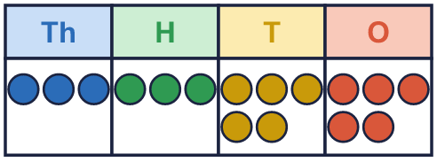
  1 | What number is shown in the place value chart?
  2 | What number is shown in the place value chart?
    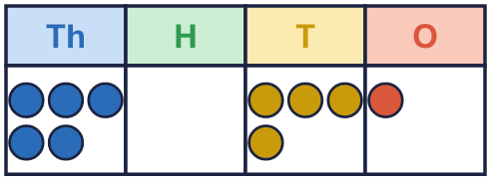
  2 | What number is shown in the place value chart?
  3 | What number is shown in the place value chart?
    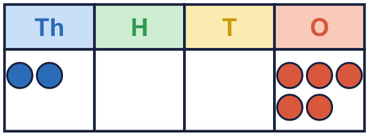
  3 | What number is shown in the place value chart?
  4 | Draw counters to show 5,033 in a place value chart.  Draw your counters here:  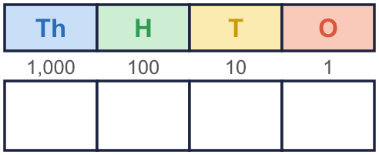
  4 | Draw counters to show 5,033 in a place value chart.  Draw your counters here:
  5 | What is the value of the 6 in each number?  a) 4,367 =  b) 896 =  c) 63 =  d) 6,011 =
  5 | What is the value of the 6 in each number?  a) 4,367 =  b) 896 =  c) 63 =  d) 6,011 =
  6 | Work out the missing numbers.  a) 8,813 + 1 =  b) 8,813 + 10 =  c) 8,813 + 100 =  d) 8,813 + 1,000 =
  6 | Work out the missing numbers.  a) 8,813 + 1 =  b) 8,813 + 10 =  c) 8,813 + 100 =  d) 8,813 + 1,000 =
  7 | Partition the number. Fill in the missing parts.
    8,079 = | 8,000 | + |  | +
  7 | Partition the number. Fill in the missing parts.
    8,079 = | 8,000 | + |  | +
  8 | Complete the part-whole models.
    a)  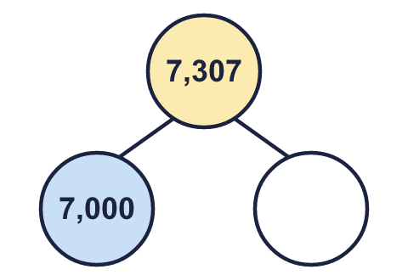 | b)  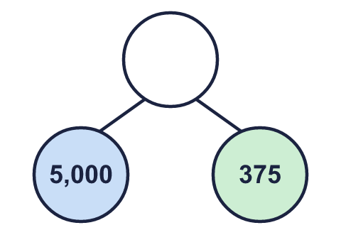 | c)  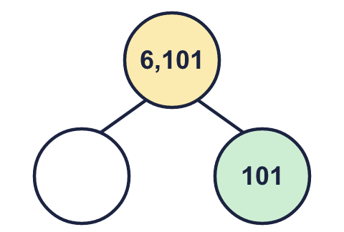
  8 | Complete the part-whole models.
    a) | b) | c)

  9 | Which numbers have a 3 in the tens column? Write the letters.  a) 93  b) 366  c) 636  d) 37  Answer:
     | 
  9 | Which numbers have a 3 in the tens column? Write the letters.  a) 93  b) 366  c) 636  d) 37  Answer:
  10 | • Its digit total is 16.  • There are 2 more counters in the hundreds column than in the thousands column.  • The ones column is empty.  Write all the numbers I could have made.
    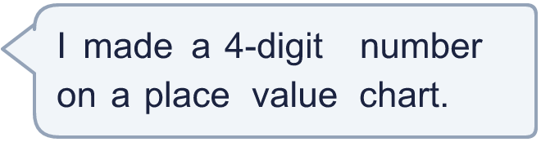
  10 | • Its digit total is 16.  • There are 2 more counters in the hundreds column than in the thousands column.  • The ones column is empty.  Write all the numbers I could have made.
  11 | Is Boba correct? Circle yes or no.  Yes / No  Explain how you know.
    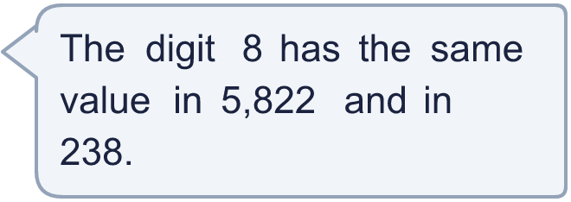
  11 | Is Boba correct? Circle yes or no.  Yes / No  Explain how you know.
  12 | 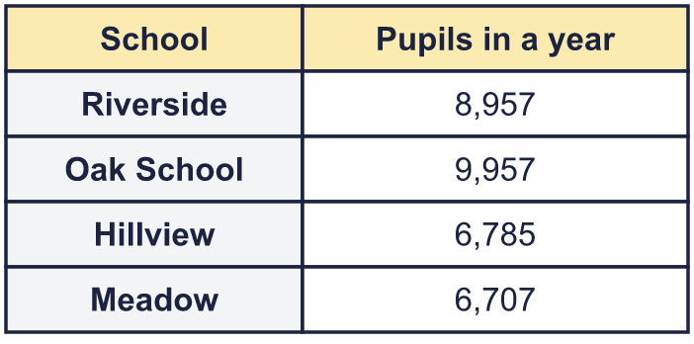  a) Write the schools in order, smallest number first.  b) Which school had 1,000 more pupils than Riverside?  c) What is the value of the digit in the box in the Hillview number: 6,785?
     | 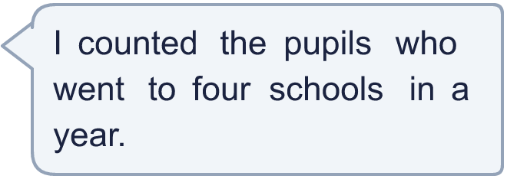
  12 | a) Write the schools in order, smallest number first.  b) Which school had 1,000 more pupils than Riverside?  c) What is the value of the digit in the box in the Hillview number: 6,785?
  13 | • The hundreds digit is 9.  • It is an even number.  • The digits add up to 34.  • The thousands digit is 9.  What is my number?
     | 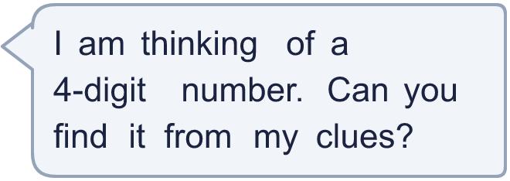
  13 | • The hundreds digit is 9.  • It is an even number.  • The digits add up to 34.  • The thousands digit is 9.  What is my number?
  14 | Write three different 4-digit numbers in which the digit 4 is worth 40.
  14 | Write three different 4-digit numbers in which the digit 4 is worth 40.

Year 5 · Place value · Step 2
Numbers up to 10,000
Answers (teacher copy)

  1 | What number is shown in the place value chart?
    3,355
  2 | What number is shown in the place value chart?
    5,041
  3 | What number is shown in the place value chart?
    2,005
  4 | Draw counters to show 5,033 in a place value chart.  Draw your counters here:  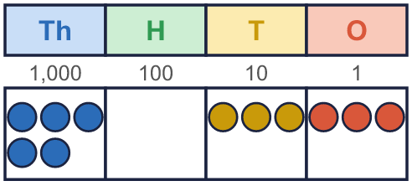
  5 | What is the value of the 6 in each number?  a) 4,367 = 60  b) 896 = 6  c) 63 = 60  d) 6,011 = 6,000
  6 | Work out the missing numbers.  a) 8,813 + 1 = 8,814  b) 8,813 + 10 = 8,823  c) 8,813 + 100 = 8,913  d) 8,813 + 1,000 = 9,813
  7 | Partition the number. Fill in the missing parts.  8,079 = 8,000 + 70 + 9
  8 | Complete the part-whole models.  a) 307 b) 5,375 c) 6,000
    a)  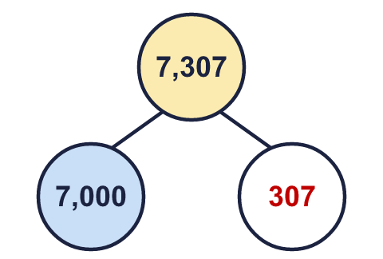 | b)  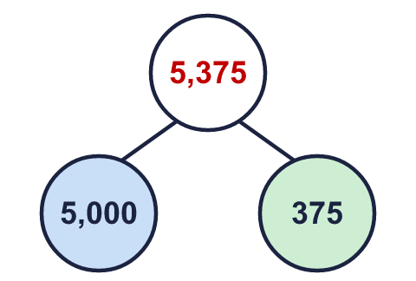 | c)  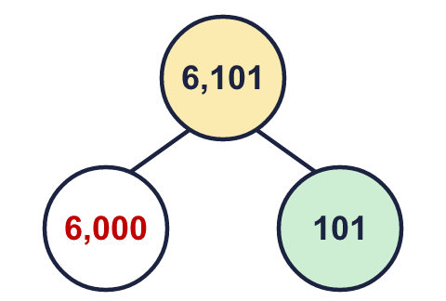
  9 | Which numbers have a 3 in the tens column? Write the letters.  a) 93  b) 366  c) 636  d) 37  Answer: c and d
  10 | • Its digit total is 16.  • There are 2 more counters in the hundreds column than in the thousands column.  • The ones column is empty.  Write all the numbers I could have made.  3,580, 4,660, 5,740, 6,820, 7,900
  11 | Is Boba correct? Circle yes or no.  Yes / No  Explain how you know.  In 5,822 the 8 is worth 800. In 238 it is worth 8. The columns are different, so the values are different.
  12 | a) Write the schools in order, smallest number first. Meadow, Hillview, Riverside, Oak School  b) Which school had 1,000 more pupils than Riverside? Oak School  c) What is the value of the digit in the box in the Hillview number: 6,785? 700
  13 | • The hundreds digit is 9.  • It is an even number.  • The digits add up to 34.  • The thousands digit is 9.  What is my number?  9,988
  14 | Write three different 4-digit numbers in which the digit 4 is worth 40.  Any numbers with the 4 in the tens column, for example 9,346, 7,046, 8,544

