  Year 5 · Place value · Step 3  Numbers up to 100,000 | 
  Year 5 · Place value · Step 3
  Numbers up to 100,000
  1 | What number is shown in the place value chart?
    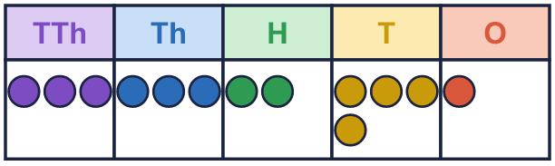
  1 | What number is shown in the place value chart?
  2 | What number is shown in the place value chart?
    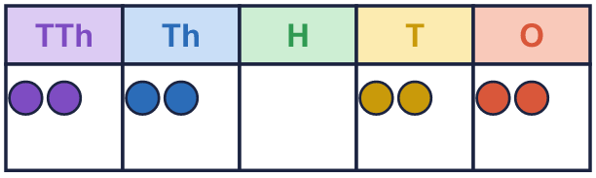
  2 | What number is shown in the place value chart?
  3 | What number is shown? Write it in digits and in words.  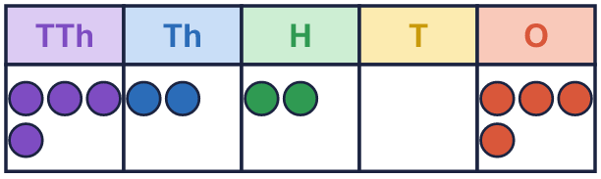  digits  words
  3 | What number is shown? Write it in digits and in words.  digits  words
  4 | This number is shown in the place value chart.  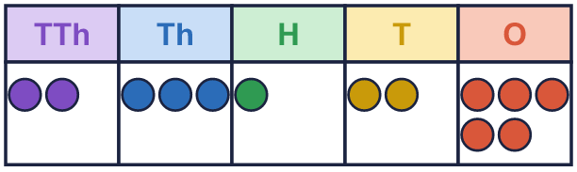  Teddy adds 1 counter to the tens column.  What number has Teddy made?
  4 | This number is shown in the place value chart.  Teddy adds 1 counter to the tens column.  What number has Teddy made?
  5 | Draw counters to show 35,031 in a place value chart.  Draw your counters here:  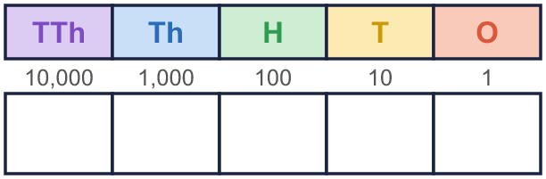
  5 | Draw counters to show 35,031 in a place value chart.  Draw your counters here:
  6 | Complete the part-whole models.
    a)  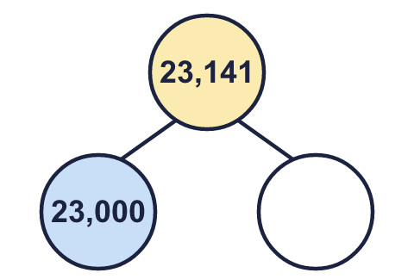 | b)  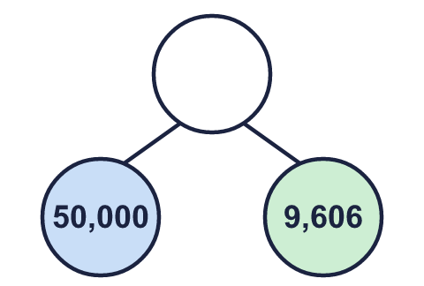 | c)  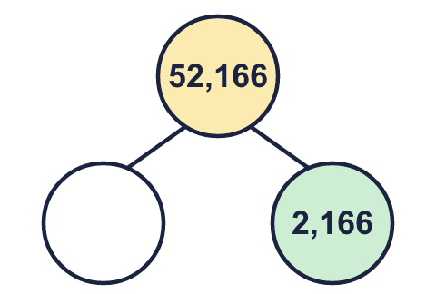
  6 | Complete the part-whole models.
    a) | b) | c)
  7 | Partition the number. Fill in the missing parts.
    83,508 = | 80,000 | + |  | +
     | + | 8
  7 | Partition the number. Fill in the missing parts.
    83,508 = | 80,000 | + |  | +
     | + | 8
  8 | What is the value of the 2 in each number?  a) 1,182 =  b) 92,147 =  c) 128 =  d) 29,001 =
  8 | What is the value of the 2 in each number?  a) 1,182 =  b) 92,147 =  c) 128 =  d) 29,001 =

  9 | 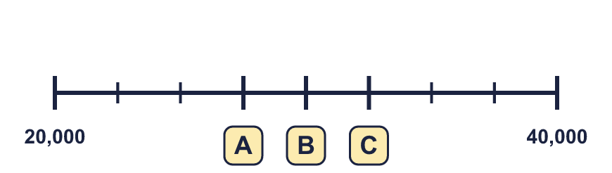
     | 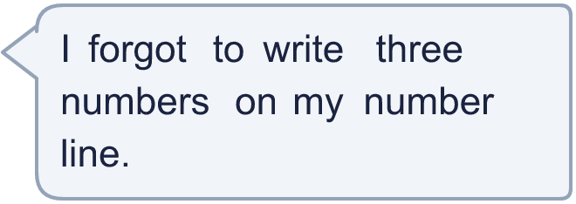
  9
  10 | Which numbers have a 9 in the thousands column? Write the letters.  a) 5,495  b) 9,848  c) 19,611  d) 97,828  Answer:
    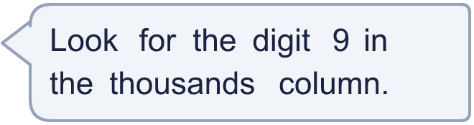
  10 | Which numbers have a 9 in the thousands column? Write the letters.  a) 5,495  b) 9,848  c) 19,611  d) 97,828  Answer:
  11 | Is Boba correct? Circle yes or no.  Yes / No  Explain how you know.
     | 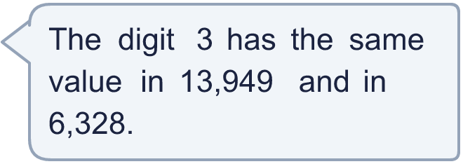
  11 | Is Boba correct? Circle yes or no.  Yes / No  Explain how you know.
  12 | 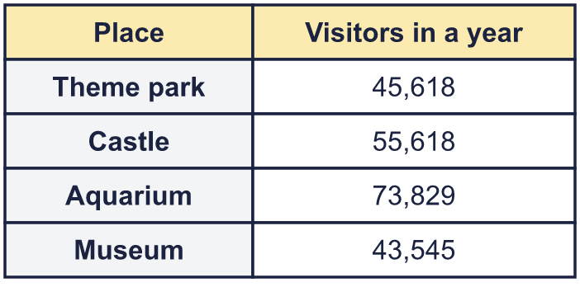  a) Write the places in order, smallest number of visitors first.  b) Which place had 10,000 more visitors than the Theme park?  c) What is the value of the digit in the box in the Museum number: 43,545?
     | 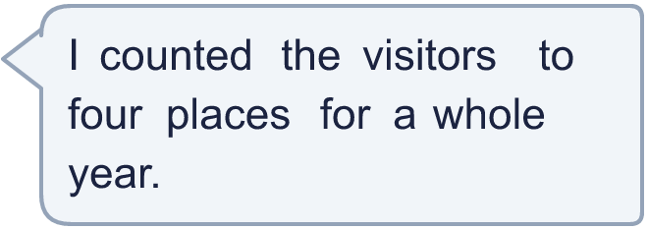
  12 | a) Write the places in order, smallest number of visitors first.  b) Which place had 10,000 more visitors than the Theme park?  c) What is the value of the digit in the box in the Museum number: 43,545?
  13 | • The ten thousands digit is 3.  • The ones digit is 8.  • The digits add up to 20.  • The hundreds digit is 2.  • The tens digit is 7.  What is my number?
    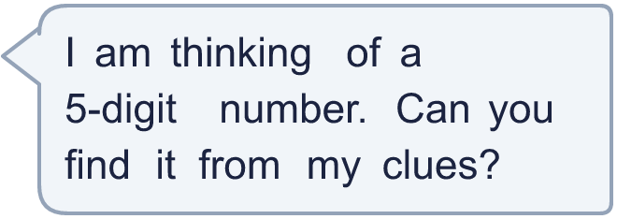
  13 | • The ten thousands digit is 3.  • The ones digit is 8.  • The digits add up to 20.  • The hundreds digit is 2.  • The tens digit is 7.  What is my number?
  14 | a) Write two 5-digit numbers that have a 3 in the thousands column.  b) Write two 4-digit numbers that have a 3 in the thousands column.
  14 | a) Write two 5-digit numbers that have a 3 in the thousands column.  b) Write two 4-digit numbers that have a 3 in the thousands column.

Year 5 · Place value · Step 3
Numbers up to 100,000
Answers (teacher copy)

  1 | What number is shown in the place value chart?
    33,241
  2 | What number is shown in the place value chart?
    22,022
  3 | What number is shown? Write it in digits and in words.  digits 42,204  words forty-two thousand two hundred and four
  4 | This number is shown in the place value chart.  Teddy adds 1 counter to the tens column.  What number has Teddy made? 23,135
  5 | Draw counters to show 35,031 in a place value chart.  Draw your counters here:  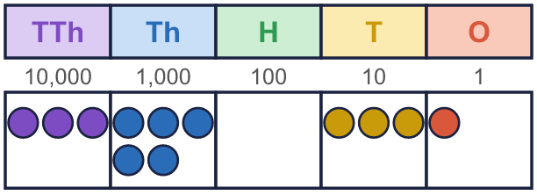
  6 | Complete the part-whole models.  a) 141 b) 59,606 c) 50,000
    a)  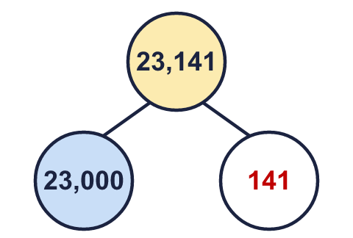 | b)  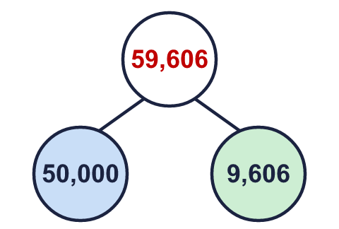 | c)  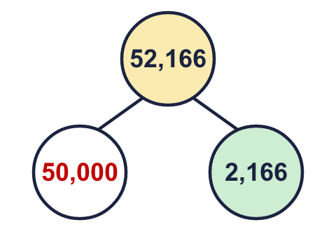
  7 | Partition the number. Fill in the missing parts.  83,508 = 80,000 + 3,000 + 500 + 8
  8 | What is the value of the 2 in each number?  a) 1,182 = 2  b) 92,147 = 2,000  c) 128 = 20  d) 29,001 = 20,000
  9 | A = 27,500 B = 30,000 C = 32,500
  10 | Which numbers have a 9 in the thousands column? Write the letters.  a) 5,495  b) 9,848  c) 19,611  d) 97,828  Answer: b and c
  11 | Is Boba correct? Circle yes or no.  Yes / No  Explain how you know.  In 13,949 the 3 is worth 3,000. In 6,328 it is worth 300. The columns are different, so the values are different.
  12 | a) Write the places in order, smallest number of visitors first. Museum, Theme park, Castle, Aquarium  b) Which place had 10,000 more visitors than the Theme park? Castle  c) What is the value of the digit in the box in the Museum number: 43,545? 3,000
  13 | • The ten thousands digit is 3.  • The ones digit is 8.  • The digits add up to 20.  • The hundreds digit is 2.  • The tens digit is 7.  What is my number?  30,278
  14 | a) Write two 5-digit numbers that have a 3 in the thousands column.  b) Write two 4-digit numbers that have a 3 in the thousands column.  Any numbers with the 3 in the thousands column, for example 5-digit: 93,589, 23,330; 4-digit: 3,541, 3,395

