  Year 5 · Place value · Step 8  Partitioning numbers up to 1,000,000 | 
  Year 5 · Place value · Step 8
  Partitioning numbers up to 1,000,000
  1 | Partition the number. Fill in the missing parts.
    752,528 =
    700,000 | + |  | + | 2,000 | +
     | + | 20 | +
  1 | Partition the number. Fill in the missing parts.
    752,528 =
    700,000 | + |  | + | 2,000 | +
     | + | 20 | +
  2 | Partition the number. Fill in the missing parts.
    70,246 = | 70,000 | + |  | +
     | + | 6
  2 | Partition the number. Fill in the missing parts.
    70,246 = | 70,000 | + |  | +
     | + | 6
  3 | Fill in the missing part of each number sentence.
    a) | 39,274 = |  | + | 9,274
    b) | 81,967 = | 80,000 | + |  | +
    7
    c) | 36,733 = |  | + | 6,000 | +
    733
  3 | Fill in the missing part of each number sentence.
    a) | 39,274 = |  | + | 9,274
    b) | 81,967 = | 80,000 | + |  | +
    7
    c) | 36,733 = |  | + | 6,000 | +
    733
  4 | Complete the part-whole models.
    a)  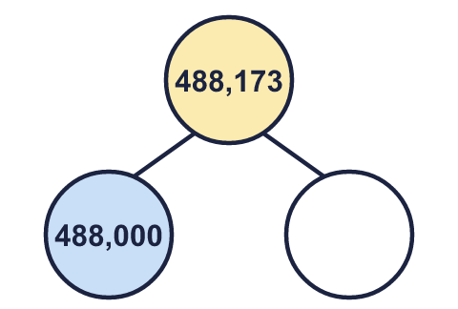 | b)  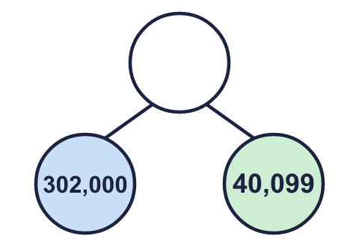 | c)  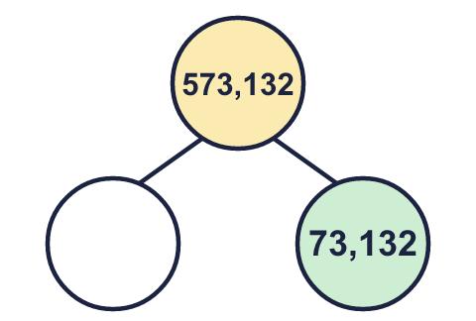
  4 | Complete the part-whole models.
    a) | b) | c)
  5 | A number is made of 7 ten thousands, 14 thousands and 18 tens. What is the number?
  5 | A number is made of 7 ten thousands, 14 thousands and 18 tens. What is the number?
  6 | Write each as a number.  a) 40 hundreds =  b) 400 tens =  c) 40 thousands =
  6 | Write each as a number.  a) 40 hundreds =  b) 400 tens =  c) 40 thousands =
  7 | Fill in the missing part of each number sentence. The parts are not always in the usual columns.
    a) | 461,829 = | 400,000 | +
     | + | 29
    b) | 458,317 =
    450,000 | + | 8,300 | + |  | + | 7
  7 | Fill in the missing part of each number sentence. The parts are not always in the usual columns.
    a) | 461,829 = | 400,000 | +
     | + | 29
    b) | 458,317 =
    450,000 | + | 8,300 | + |  | + | 7
  8 | Partition each number into its thousands part and its ones part.
    a) | 113,249 = |  | + | 249
    b) | 753,757 = |  | + | 757
    c) | 479,915 = |  | + | 915
  8 | Partition each number into its thousands part and its ones part.
    a) | 113,249 = |  | + | 249
    b) | 753,757 = |  | + | 757
    c) | 479,915 = |  | + | 915

  9 | What number am I thinking of?
     | 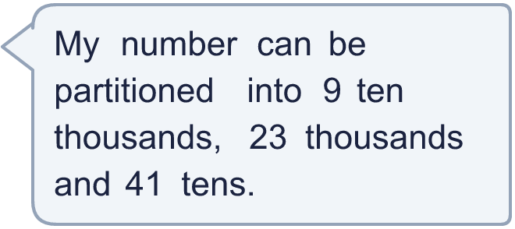
  9 | What number am I thinking of?
  10 | Partition 464,998 in three different ways. Each way must add up to 464,998.
  10 | Partition 464,998 in three different ways. Each way must add up to 464,998.
  11 | Which of these are equal to 30,000? Write the letters.  a) 30 thousands  b) 15,000 + 15,000  c) 30,000 + 100  d) 1,000 more than 31,000  e) 28,000 + 2,000  f) 30 hundreds
  11 | Which of these are equal to 30,000? Write the letters.  a) 30 thousands  b) 15,000 + 15,000  c) 30,000 + 100  d) 1,000 more than 31,000  e) 28,000 + 2,000  f) 30 hundreds
  12 | a) Which part is wrong?  b) What should it be?
     | 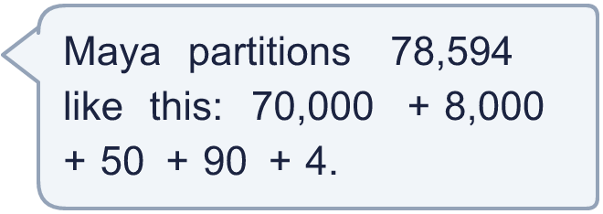
  12 | a) Which part is wrong?  b) What should it be?
  13 | Complete the part-whole models. Each one shows 328,000 split in a different way.
    a)  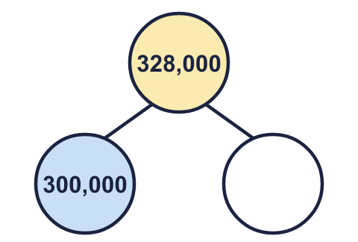 | b)  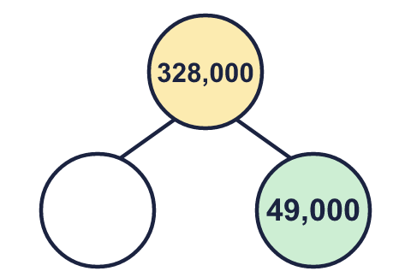 | c)  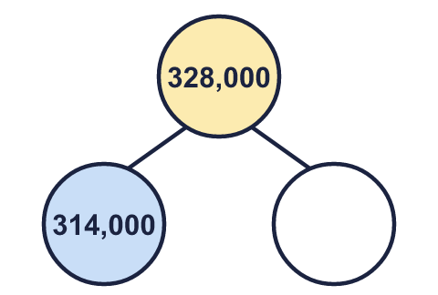
  13 | Complete the part-whole models. Each one shows 328,000 split in a different way.
    a) | b) | c)
  14 | 824,617 = 800,000 + 20,000 + ___ + ___ + 7  Write two different pairs of numbers that make this number sentence correct.
  14 | 824,617 = 800,000 + 20,000 + ___ + ___ + 7  Write two different pairs of numbers that make this number sentence correct.

Year 5 · Place value · Step 8
Partitioning numbers up to 1,000,000
Answers (teacher copy)

  1 | Partition the number. Fill in the missing parts.  752,528 = 700,000 + 50,000 + 2,000 + 500 + 20 + 8
  2 | Partition the number. Fill in the missing parts.  70,246 = 70,000 + 200 + 40 + 6
  3 | Fill in the missing part of each number sentence.  a) 39,274 = 30,000 + 9,274  b) 81,967 = 80,000 + 1,960 + 7  c) 36,733 = 30,000 + 6,000 + 733
  4 | Complete the part-whole models.  a) 173 b) 342,099 c) 500,000
    a)  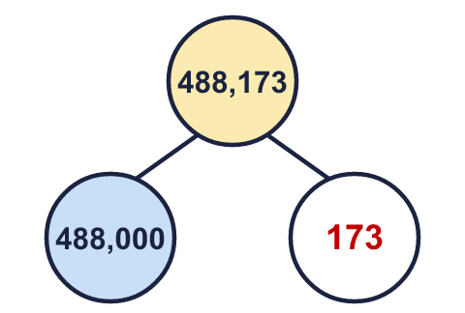 | b)  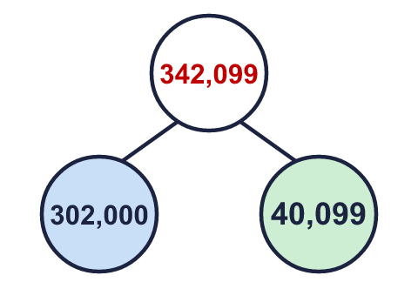 | c)  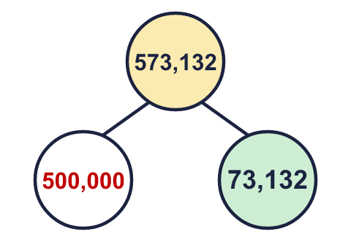
  5 | A number is made of 7 ten thousands, 14 thousands and 18 tens. What is the number?  84,180
  6 | Write each as a number.  a) 40 hundreds = 4,000  b) 400 tens = 4,000  c) 40 thousands = 40,000
  7 | Fill in the missing part of each number sentence. The parts are not always in the usual columns.  a) 461,829 = 400,000 + 61,800 + 29  b) 458,317 = 450,000 + 8,300 + 10 + 7
  8 | Partition each number into its thousands part and its ones part.  a) 113,249 = 113,000 + 249  b) 753,757 = 753,000 + 757  c) 479,915 = 479,000 + 915
  9 | What number am I thinking of? 113,410
  10 | Partition 464,998 in three different ways. Each way must add up to 464,998.  Any three correct ways, for example 400,000 + 60,000 + 4,000 + 900 + 90 + 8; 464,000 + 998; 460,000 + 4,900 + 98
  11 | Which of these are equal to 30,000? Write the letters.  a) 30 thousands  b) 15,000 + 15,000  c) 30,000 + 100  d) 1,000 more than 31,000  e) 28,000 + 2,000  f) 30 hundreds  a and b and e
  12 | a) Which part is wrong? 50  b) What should it be? 500
  13 | Complete the part-whole models. Each one shows 328,000 split in a different way.  a) 28,000 b) 279,000 c) 14,000
    a)  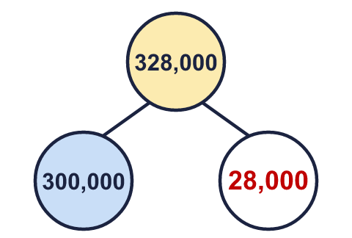 | b)  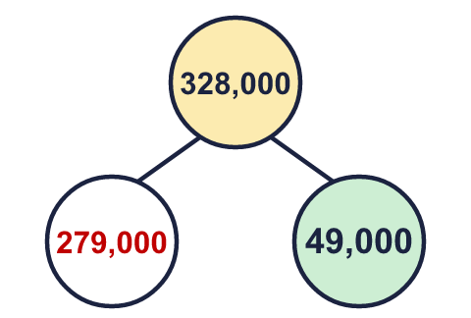 | c)  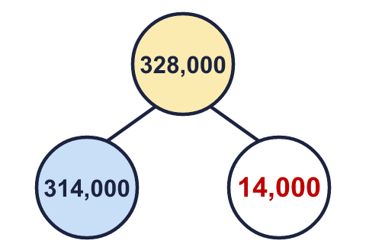
  14 | 824,617 = 800,000 + 20,000 + ___ + ___ + 7  Write two different pairs of numbers that make this number sentence correct.  Any two pairs that add to 4,610, for example 4,000 and 610; 4,600 and 10

