  Year 5 · Place value · Step 6  Powers of 10 | 
  Year 5 · Place value · Step 6
  Powers of 10
  1 | The place value chart shows a number. What is 10 times the number?
    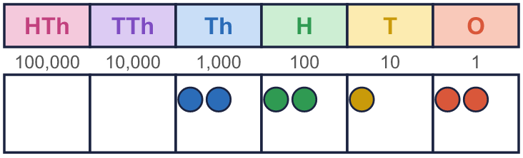
  1 | The place value chart shows a number. What is 10 times the number?
  2 | How many thousands are there in each number?
    a) | 10,000 = |  | thousands
    b) | 20,000 = |  | thousands
    c) | 24,000 = |  | thousands
    d) | 25,000 = |  | thousands
  2 | How many thousands are there in each number?
    a) | 10,000 = |  | thousands
    b) | 20,000 = |  | thousands
    c) | 24,000 = |  | thousands
    d) | 25,000 = |  | thousands
  3 | Work out the multiplications.  a) 9 × 10 =  b) 35 × 100 =  c) 47 × 1,000 =
  3 | Work out the multiplications.  a) 9 × 10 =  b) 35 × 100 =  c) 47 × 1,000 =
  4 | Work out the divisions.  a) 890 ÷ 10 =  b) 3,500 ÷ 100 =  c) 2,000 ÷ 1,000 =
  4 | Work out the divisions.  a) 890 ÷ 10 =  b) 3,500 ÷ 100 =  c) 2,000 ÷ 1,000 =
  5 | The Gattegno chart shows a number. What is the number?  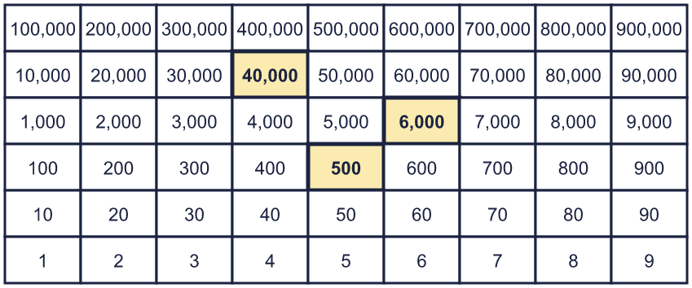
  5 | The Gattegno chart shows a number. What is the number?
  6 | Complete the sentences.  a) 7,000 is 10 times the size of  b) 7,000 is one-tenth the size of
    c)
    is 100 times the size of 7,000
    d)
    is one-hundredth the size of 7,000
  6 | Complete the sentences.  a) 7,000 is 10 times the size of  b) 7,000 is one-tenth the size of
    c)
    is 100 times the size of 7,000
    d)
    is one-hundredth the size of 7,000
  7 | There are 1,000 ml in 1 l.  a) How many ml are there in 4 l?  b) How many ml are there in 400 l?  c) How many ml are there in 40 l?  d) How many ml are there in 440 l?
  7 | There are 1,000 ml in 1 l.  a) How many ml are there in 4 l?  b) How many ml are there in 400 l?  c) How many ml are there in 40 l?  d) How many ml are there in 440 l?
  8 | Each number is made from the one before it. Complete the pattern.
    a) | × 10 each time:
    6 | → |  | → |  | →
    b) | × 100 each time:
    5 | → |  | →
  8 | Each number is made from the one before it. Complete the pattern.
    a) | × 10 each time:
    6 | → |  | → |  | →
    b) | × 100 each time:
    5 | → |  | →

  9 | 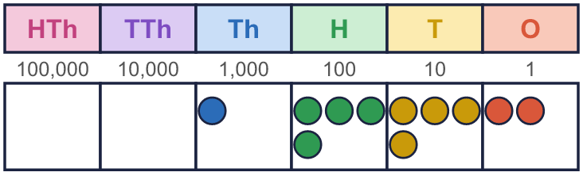  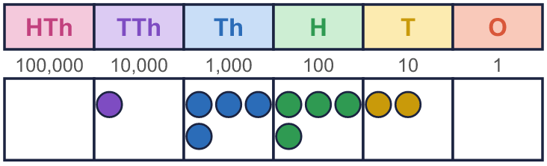  What is the same? What is different?
    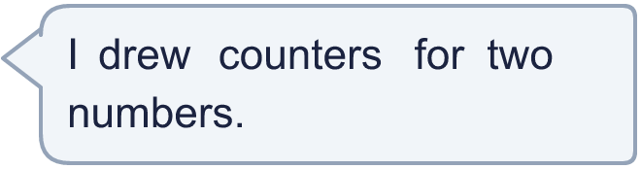
  9 | What is the same? What is different?
  10 | 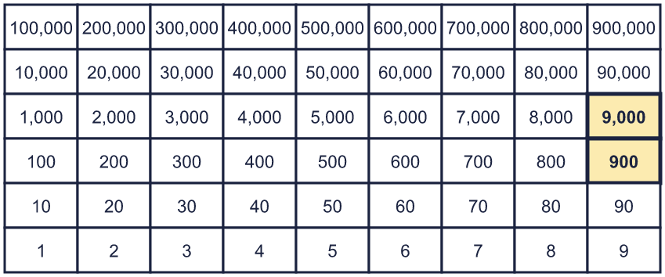  a) What number is 10 times the size of this number?  b) What number is 100 times the size of this number?  c) What number is one-tenth the size of this number?  d) What number is one-hundredth the size of this number?
     | 
  10 | a) What number is 10 times the size of this number?  b) What number is 100 times the size of this number?  c) What number is one-tenth the size of this number?  d) What number is one-hundredth the size of this number?
  11 | There are 800 pencils in one box.  a) How many pencils are in 10 boxes?  b) How many pencils are in 100 boxes?  c) The school has 45,000 pencils. How many boxes of 1,000 can they fill?
     | 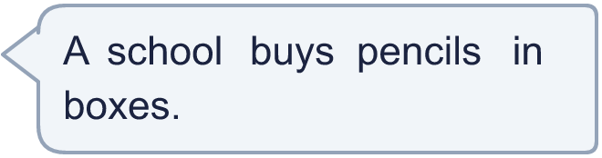
  11 | There are 800 pencils in one box.  a) How many pencils are in 10 boxes?  b) How many pencils are in 100 boxes?  c) The school has 45,000 pencils. How many boxes of 1,000 can they fill?
  12 | 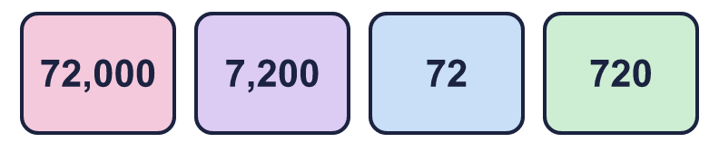  • Whitney's number is 10 times the size of Tommy's number.  • Dexter's number is 10 times the size of Whitney's number.  • Eva's number is 100 times the size of Whitney's number.  Which number card does each child have?
     | 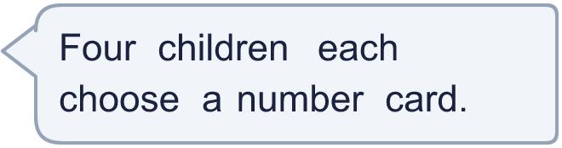
    Tommy |  | Eva
    Dexter |  | Whitney
  12 | • Whitney's number is 10 times the size of Tommy's number.  • Dexter's number is 10 times the size of Whitney's number.  • Eva's number is 100 times the size of Whitney's number.  Which number card does each child have?
    Tommy |  | Eva
    Dexter |  | Whitney
  13 | Which calculations have the same answer as 9,700 × 10? Write the letters.  a) 970,000 ÷ 10  b) 97,000 × 10  c) 97 × 1,000  d) 9,700 × 100
  13 | Which calculations have the same answer as 9,700 × 10? Write the letters.  a) 970,000 ÷ 10  b) 97,000 × 10  c) 97 × 1,000  d) 9,700 × 100
  14 | Write three different calculations that all have the answer 3,000. Use × or ÷ and 10, 100 or 1,000.
  14 | Write three different calculations that all have the answer 3,000. Use × or ÷ and 10, 100 or 1,000.

Year 5 · Place value · Step 6
Powers of 10
Answers (teacher copy)

  1 | The place value chart shows a number. What is 10 times the number?
    22,120
  2 | How many thousands are there in each number?  a) 10,000 = 10 thousands  b) 20,000 = 20 thousands  c) 24,000 = 24 thousands  d) 25,000 = 25 thousands
  3 | Work out the multiplications.  a) 9 × 10 = 90  b) 35 × 100 = 3,500  c) 47 × 1,000 = 47,000
  4 | Work out the divisions.  a) 890 ÷ 10 = 89  b) 3,500 ÷ 100 = 35  c) 2,000 ÷ 1,000 = 2
  5 | The Gattegno chart shows a number. What is the number?  46,500
  6 | Complete the sentences.  a) 7,000 is 10 times the size of 700  b) 7,000 is one-tenth the size of 70,000  c) 700,000 is 100 times the size of 7,000  d) 70 is one-hundredth the size of 7,000
  7 | There are 1,000 ml in 1 l.  a) How many ml are there in 4 l? 4,000  b) How many ml are there in 400 l? 400,000  c) How many ml are there in 40 l? 40,000  d) How many ml are there in 440 l? 440,000
  8 | Each number is made from the one before it. Complete the pattern.  a) × 10 each time: 6 → 60 → 600 → 6,000  b) × 100 each time: 5 → 500 → 50,000
  9 | What is the same? What is different?  The counters make the same pattern, but every counter in the second chart is one column to the left. The second number, 14,420, is 10 times the first number, 1,442.
  10 | a) What number is 10 times the size of this number? 99,000  b) What number is 100 times the size of this number? 990,000  c) What number is one-tenth the size of this number? 990  d) What number is one-hundredth the size of this number? 99
  11 | There are 800 pencils in one box.  a) How many pencils are in 10 boxes? 8,000  b) How many pencils are in 100 boxes? 80,000  c) The school has 45,000 pencils. How many boxes of 1,000 can they fill? 45
  12 | • Whitney's number is 10 times the size of Tommy's number.  • Dexter's number is 10 times the size of Whitney's number.  • Eva's number is 100 times the size of Whitney's number.  Which number card does each child have?  Tommy 72 Eva 72,000  Dexter 7,200 Whitney 720
  13 | Which calculations have the same answer as 9,700 × 10? Write the letters.  a) 970,000 ÷ 10  b) 97,000 × 10  c) 97 × 1,000  d) 9,700 × 100  a and c
  14 | Write three different calculations that all have the answer 3,000. Use × or ÷ and 10, 100 or 1,000.  Any three correct calculations, for example 300 × 10, 30 × 100, 30,000 ÷ 10

