  Year 5 · Place value · Step 5  Reading and writing numbers up to 1,000,000 | 
  Year 5 · Place value · Step 5
  Reading and writing numbers up to 1,000,000
  1 | What number is shown? Write it in digits and in words.  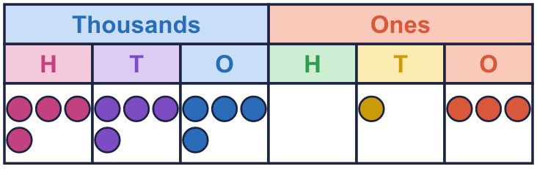  digits  words
  1 | What number is shown? Write it in digits and in words.  digits  words
  2 | Write this number in digits.  three hundred and eighty-seven thousand two hundred and sixteen
  2 | Write this number in digits.  three hundred and eighty-seven thousand two hundred and sixteen
  3 | Write this number in words.  360,273
  3 | Write this number in words.  360,273
  4 | Write this number in digits.  six hundred and seven thousand nine hundred and twenty-six
  4 | Write this number in digits.  six hundred and seven thousand nine hundred and twenty-six
  5 | Draw counters to show this number.  three hundred and one thousand one hundred and thirty-one  Draw your counters here:  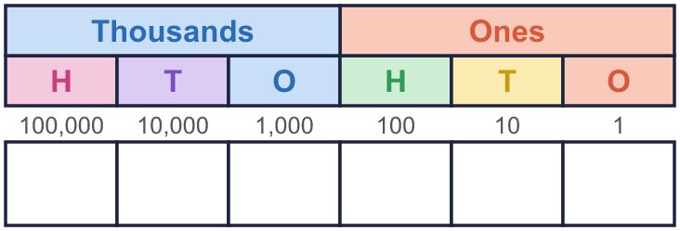
  5 | Draw counters to show this number.  three hundred and one thousand one hundred and thirty-one  Draw your counters here:
  6 | Complete the part-whole models. The numbers have a thousands part and a ones part.
    a)  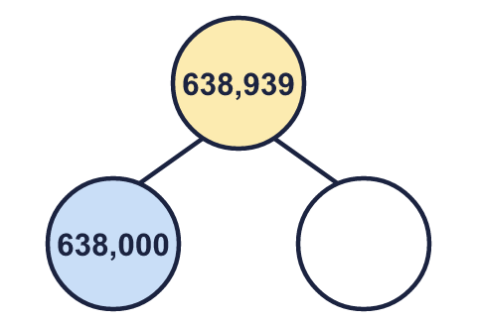 | b)  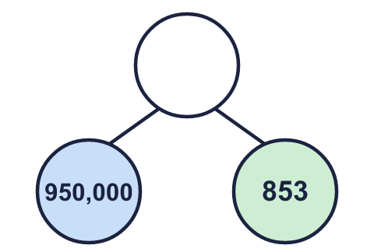
  6 | Complete the part-whole models. The numbers have a thousands part and a ones part.
    a) | b)
  7 | Circle the number that matches the words. Write its letter.  two hundred and fifty thousand five hundred and ninety-five  a) 255,095  b) 250,595  c) 205,595  Answer:
  7 | Circle the number that matches the words. Write its letter.  two hundred and fifty thousand five hundred and ninety-five  a) 255,095  b) 250,595  c) 205,595  Answer:
  8 | Write this number in digits.  eight hundred thousand and nine
  8 | Write this number in digits.  eight hundred thousand and nine

  9 | Boba has made a mistake. Write the number correctly in words.
     | 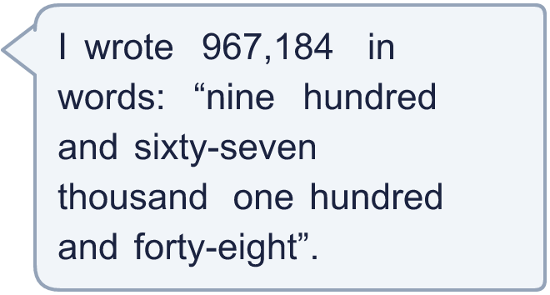
  9 | Boba has made a mistake. Write the number correctly in words.
  10 | Is Boba correct? Circle yes or no.  Yes / No  Explain how you know.
    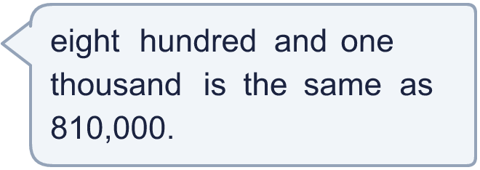
  10 | Is Boba correct? Circle yes or no.  Yes / No  Explain how you know.
  11 | 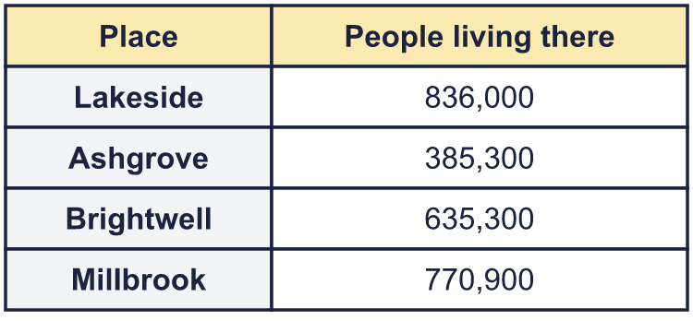  a) Which place has eight hundred and thirty-six thousand people?  b) Write the smallest number of people in words.
     | 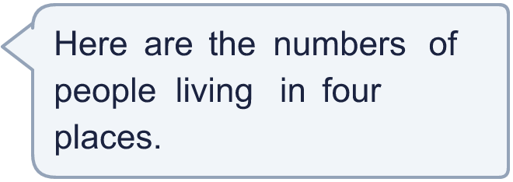
  11 | a) Which place has eight hundred and thirty-six thousand people?  b) Write the smallest number of people in words.
  12 | 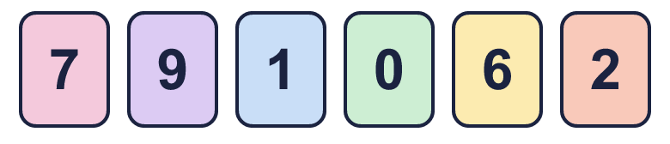  a) Make the smallest number.  b) Make the largest even number.  c) Write your answer to a) in words.
     | 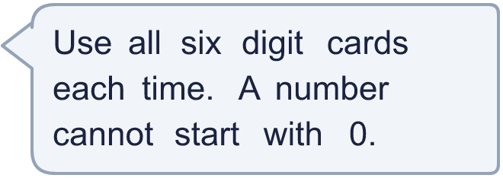
  12 | a) Make the smallest number.  b) Make the largest even number.  c) Write your answer to a) in words.
  13 | • The ten thousands digit is 3.  • The thousands digit is double the hundreds digit.  • The hundreds digit is double the tens digit.  • The ones digit is 3.  • The thousands digit is 4.  • The hundred thousands digit is 2.  digits  words
    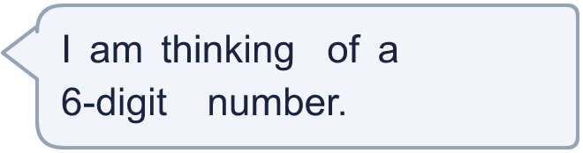
  13 | • The ten thousands digit is 3.  • The thousands digit is double the hundreds digit.  • The hundreds digit is double the tens digit.  • The ones digit is 3.  • The thousands digit is 4.  • The hundred thousands digit is 2.  digits  words
  14 | Write a 6-digit number that starts with 2 hundred thousand and has a 0 in the ten thousands column and a 0 in the tens column. Then write it in words.  digits  words
  14 | Write a 6-digit number that starts with 2 hundred thousand and has a 0 in the ten thousands column and a 0 in the tens column. Then write it in words.  digits  words

Year 5 · Place value · Step 5
Reading and writing numbers up to 1,000,000
Answers (teacher copy)

  1 | What number is shown? Write it in digits and in words.  digits 444,013  words four hundred and forty-four thousand and thirteen
  2 | Write this number in digits.  three hundred and eighty-seven thousand two hundred and sixteen  387,216
  3 | Write this number in words.  360,273  three hundred and sixty thousand two hundred and seventy-three
  4 | Write this number in digits.  six hundred and seven thousand nine hundred and twenty-six  607,926
  5 | Draw counters to show this number.  three hundred and one thousand one hundred and thirty-one  Draw your counters here:  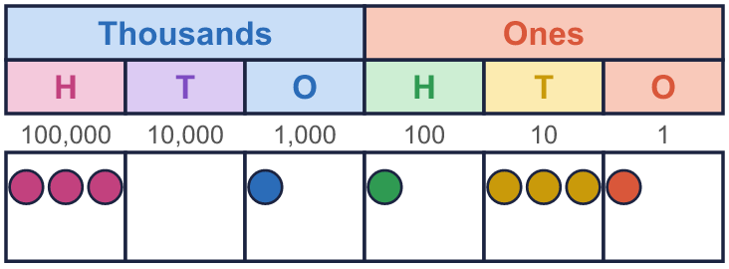
  6 | Complete the part-whole models. The numbers have a thousands part and a ones part.  a) 939 b) 950,853
    a)  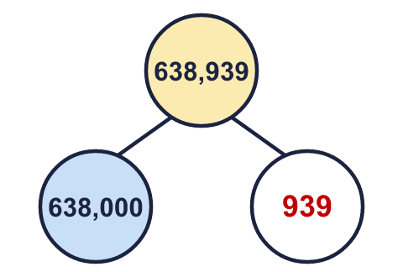 | b)  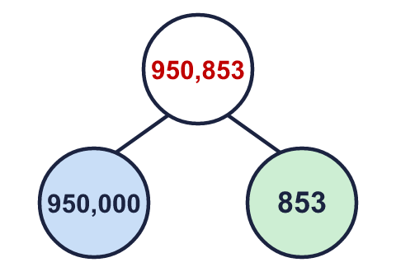
  7 | Circle the number that matches the words. Write its letter.  two hundred and fifty thousand five hundred and ninety-five  a) 255,095  b) 250,595  c) 205,595  Answer: b
  8 | Write this number in digits.  eight hundred thousand and nine  800,009
  9 | Boba has made a mistake. Write the number correctly in words.  nine hundred and sixty-seven thousand one hundred and eighty-four
  10 | Is Boba correct? Circle yes or no.  Yes / No  Explain how you know.  The words say 801,000. In 810,000 the 1 is in the ten thousands column, so it is worth 10,000, not 1,000.
  11 | a) Which place has eight hundred and thirty-six thousand people? Lakeside  b) Write the smallest number of people in words. three hundred and eighty-five thousand three hundred
  12 | a) Make the smallest number. 102,679  b) Make the largest even number. 976,210  c) Write your answer to a) in words. one hundred and two thousand six hundred and seventy-nine
  13 | • The ten thousands digit is 3.  • The thousands digit is double the hundreds digit.  • The hundreds digit is double the tens digit.  • The ones digit is 3.  • The thousands digit is 4.  • The hundred thousands digit is 2.  digits 234,213  words two hundred and thirty-four thousand two hundred and thirteen
  14 | Write a 6-digit number that starts with 2 hundred thousand and has a 0 in the ten thousands column and a 0 in the tens column. Then write it in words.  digits 206,102  words two hundred and six thousand one hundred and two  Any number that fits, for example 206,102: two hundred and six thousand one hundred and two

