  Year 5 · Place value · Step 1  Roman numerals up to 1,000 | 
  Year 5 · Place value · Step 1
  Roman numerals up to 1,000
  1 | Write each Roman numeral as a number.  a) IX =  b) XXI =  c) XXXIX =
  1 | Write each Roman numeral as a number.  a) IX =  b) XXI =  c) XXXIX =
  2 | Write each number as a Roman numeral.  a) 23 =  b) 34 =  c) 94 =
  2 | Write each number as a Roman numeral.  a) 23 =  b) 34 =  c) 94 =
  3 | Complete the Roman numeral number track.  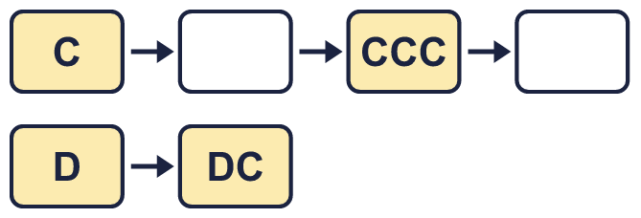
  3 | Complete the Roman numeral number track.
  4 | Change each one. Roman numerals go up to M, which is 1,000.  a) DCXL =  b) 620 =  c) DCXLVII =
  4 | Change each one. Roman numerals go up to M, which is 1,000.  a) DCXL =  b) 620 =  c) DCXLVII =
  5 | Write each number in Roman numerals.  a) one hundred and eighty-three =  b) nine hundred and fifty-one =  c) four hundred and sixty-two =
  5 | Write each number in Roman numerals.  a) one hundred and eighty-three =  b) nine hundred and fifty-one =  c) four hundred and sixty-two =
  6 | Work out each calculation. Write the answer in Roman numerals.  a) X × VII =  b) XX + C =  c) D − C =
  6 | Work out each calculation. Write the answer in Roman numerals.  a) X × VII =  b) XX + C =  c) D − C =
  7 | Each Roman numeral shows a year. Write the year in digits.  a) MDCXCIX =  b) MCMLXXVI =  c) MMXXI =
  7 | Each Roman numeral shows a year. Write the year in digits.  a) MDCXCIX =  b) MCMLXXVI =  c) MMXXI =
  8 | A date is written in Roman numerals as day / month / year.  XI/IX/MCMLXXVII  a) Which day of the month is it?  b) Which month is it?  c) Which year is it?
  8 | A date is written in Roman numerals as day / month / year.  XI/IX/MCMLXXVII  a) Which day of the month is it?  b) Which month is it?  c) Which year is it?

  9 | a) Who is correct?  b) What mistake has the other child made?
     | 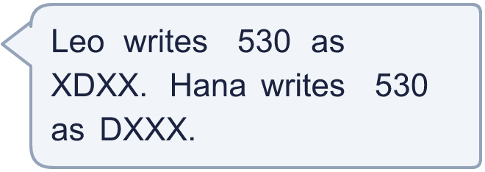
  9 | a) Who is correct?  b) What mistake has the other child made?
  10 | Is Boba correct? Circle yes or no.  Yes / No  Explain how you know.
     | 
  10 | Is Boba correct? Circle yes or no.  Yes / No  Explain how you know.
  11 | Put these Roman numerals in order. Start with the smallest.  CDXLVIII XCVII XXXVI CXII
  11 | Put these Roman numerals in order. Start with the smallest.  CDXLVIII XCVII XXXVI CXII
  12 | Film A: MMXIV Film B: MCMLXXIX  a) Which film is older? Write A or B.  b) How many years older is it than the other film?
     | 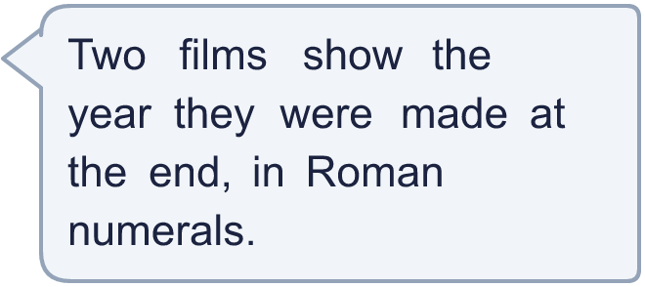
  12 | Film A: MMXIV Film B: MCMLXXIX  a) Which film is older? Write A or B.  b) How many years older is it than the other film?
  13 | a) Write the number the standard way.  b) Explain what Boba did.
    
  13 | a) Write the number the standard way.  b) Explain what Boba did.
  14 | Write three different Roman numerals that are greater than CCCXX and less than CCCLXXX.
  14 | Write three different Roman numerals that are greater than CCCXX and less than CCCLXXX.

Year 5 · Place value · Step 1
Roman numerals up to 1,000
Answers (teacher copy)

  1 | Write each Roman numeral as a number.  a) IX = 9  b) XXI = 21  c) XXXIX = 39
  2 | Write each number as a Roman numeral.  a) 23 = XXIII  b) 34 = XXXIV  c) 94 = XCIV
  3 | Complete the Roman numeral number track.  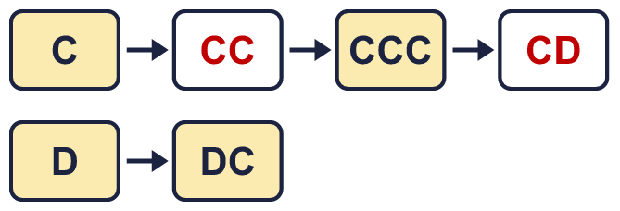
  4 | Change each one. Roman numerals go up to M, which is 1,000.  a) DCXL = 640  b) 620 = DCXX  c) DCXLVII = 647
  5 | Write each number in Roman numerals.  a) one hundred and eighty-three = CLXXXIII  b) nine hundred and fifty-one = CMLI  c) four hundred and sixty-two = CDLXII
  6 | Work out each calculation. Write the answer in Roman numerals.  a) X × VII = LXX  b) XX + C = CXX  c) D − C = CD
  7 | Each Roman numeral shows a year. Write the year in digits.  a) MDCXCIX = 1699  b) MCMLXXVI = 1976  c) MMXXI = 2021
  8 | A date is written in Roman numerals as day / month / year.  XI/IX/MCMLXXVII  a) Which day of the month is it? 11  b) Which month is it? September  c) Which year is it? 1977
  9 | a) Who is correct? Hana  b) What mistake has the other child made?  Leo wrote the smaller letter first. In XDXX the X is smaller than the D, and XD is not one of the special pairs (IV, IX, XL, XC, CD, CM). The biggest letter comes first, so 530 is DXXX.
  10 | Is Boba correct? Circle yes or no.  Yes / No  Explain how you know.  DC is 600 and C is 100. 600 + 100 = 700, which is DCC, not D.
  11 | Put these Roman numerals in order. Start with the smallest.  CDXLVIII XCVII XXXVI CXII  XXXVI, XCVII, CXII, CDXLVIII
  12 | Film A: MMXIV Film B: MCMLXXIX  a) Which film is older? Write A or B. B  b) How many years older is it than the other film? 35
  13 | a) Write the number the standard way. DIV  b) Explain what Boba did.  Boba added the letters without using the shorter forms. We write 4 as IV, 9 as IX, 40 as XL, 90 as XC, 400 as CD and 900 as CM. 504 is DIV.
  14 | Write three different Roman numerals that are greater than CCCXX and less than CCCLXXX.  Any three correct numerals, for example CCCXXXIV, CCCLI, CCCLXXIV

