  Year 5 · Place value · Step 12  Rounding to the nearest 10, 100 or 1,000 | 
  Year 5 · Place value · Step 12
  Rounding to the nearest 10, 100 or 1,000
  1 | Round each number to the nearest 10.  a) 648 to the nearest 10 =  b) 132 to the nearest 10 =  c) 668 to the nearest 10 =
  1 | Round each number to the nearest 10.  a) 648 to the nearest 10 =  b) 132 to the nearest 10 =  c) 668 to the nearest 10 =
  2 | Round each number to the nearest 100.  a) 7,533 to the nearest 100 =  b) 5,482 to the nearest 100 =  c) 9,779 to the nearest 100 =
  2 | Round each number to the nearest 100.  a) 7,533 to the nearest 100 =  b) 5,482 to the nearest 100 =  c) 9,779 to the nearest 100 =
  3 | Round each number to the nearest 1,000.  a) 48,985 to the nearest 1,000 =  b) 66,078 to the nearest 1,000 =  c) 61,959 to the nearest 1,000 =
  3 | Round each number to the nearest 1,000.  a) 48,985 to the nearest 1,000 =  b) 66,078 to the nearest 1,000 =  c) 61,959 to the nearest 1,000 =
  4 | The arrows show two numbers: A is 72 and B is 77. Round each to the nearest 10.  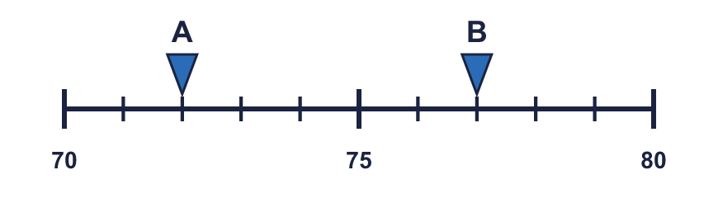
    A rounds to
    B rounds to
  4 | The arrows show two numbers: A is 72 and B is 77. Round each to the nearest 10.
    A rounds to
    B rounds to
  5 | The arrows show two numbers: A is 330 and B is 370. Round each to the nearest 100.  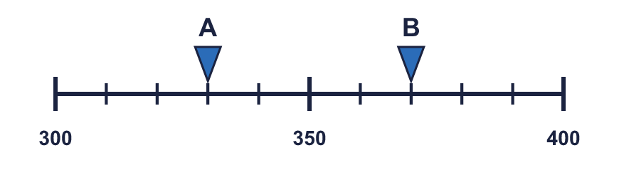
    A rounds to
    B rounds to
  5 | The arrows show two numbers: A is 330 and B is 370. Round each to the nearest 100.
    A rounds to
    B rounds to
  6 | Round each number to the nearest 10, 100 and 1,000. The headings show the place to round to. Complete the table.  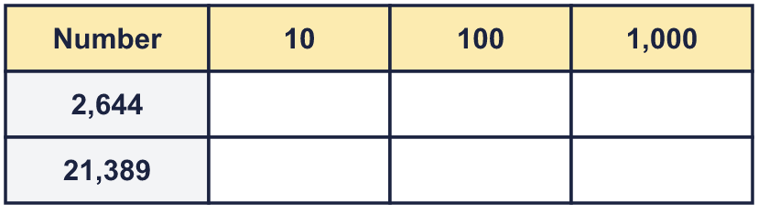
  6 | Round each number to the nearest 10, 100 and 1,000. The headings show the place to round to. Complete the table.
  7 | Circle the numbers that round to 630 to the nearest 10. Write their letters.  a) 642  b) 625  c) 626  d) 620  e) 635  f) 634
  7 | Circle the numbers that round to 630 to the nearest 10. Write their letters.  a) 642  b) 625  c) 626  d) 620  e) 635  f) 634
  8 | Round 57,847 to each place.  a) the nearest 10 =  b) the nearest 100 =  c) the nearest 1,000 =
  8 | Round 57,847 to each place.  a) the nearest 10 =  b) the nearest 100 =  c) the nearest 1,000 =

  9 | Is Boba correct? Circle yes or no.  Yes / No  Explain how you know.
    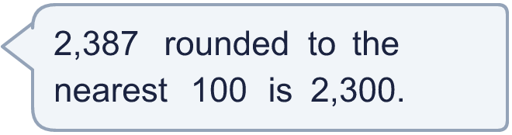
  9 | Is Boba correct? Circle yes or no.  Yes / No  Explain how you know.
  10 | 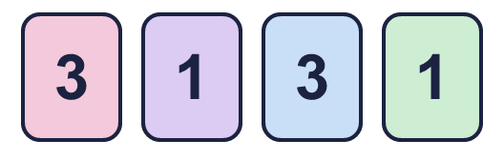  His number rounds to 1,100 to the nearest 100.  a) What number does Mo make?  b) What is Mo’s number rounded to the nearest 10?
     | 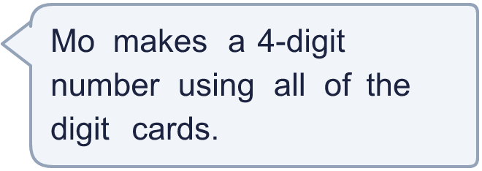
  10 | His number rounds to 1,100 to the nearest 100.  a) What number does Mo make?  b) What is Mo’s number rounded to the nearest 10?
  11 | There is a digit missing from each number. Write the digits that make it round to the number shown. There may be more than one.  a) 61_ rounds to 620 (nearest 10)  b) 4,9_0 rounds to 5,000 (nearest 100)  c) 75,_14 rounds to 76,000 (nearest 1,000)
  11 | There is a digit missing from each number. Write the digits that make it round to the number shown. There may be more than one.  a) 61_ rounds to 620 (nearest 10)  b) 4,9_0 rounds to 5,000 (nearest 100)  c) 75,_14 rounds to 76,000 (nearest 1,000)
  12 | A whole number rounds to 25,000 to the nearest 1,000.  a) What is the greatest it could be?  b) What is the smallest it could be?
  12 | A whole number rounds to 25,000 to the nearest 1,000.  a) What is the greatest it could be?  b) What is the smallest it could be?
  13 | a) Which place did the newspaper round to? Write 10, 100, 1,000.  b) What is the crowd rounded to the nearest 1,000?
     | 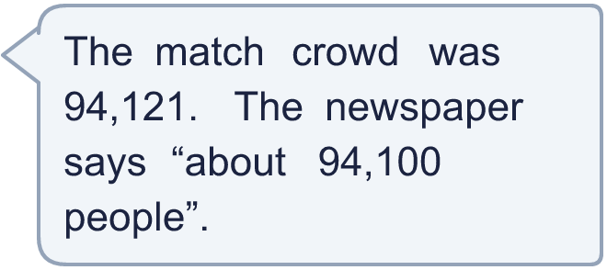
  13 | a) Which place did the newspaper round to? Write 10, 100, 1,000.  b) What is the crowd rounded to the nearest 1,000?
  14 | Write a number that rounds to 1,800 to the nearest 100 and to 2,000 to the nearest 1,000.
  14 | Write a number that rounds to 1,800 to the nearest 100 and to 2,000 to the nearest 1,000.

Year 5 · Place value · Step 12
Rounding to the nearest 10, 100 or 1,000
Answers (teacher copy)

  1 | Round each number to the nearest 10.  a) 648 to the nearest 10 = 650  b) 132 to the nearest 10 = 130  c) 668 to the nearest 10 = 670
  2 | Round each number to the nearest 100.  a) 7,533 to the nearest 100 = 7,500  b) 5,482 to the nearest 100 = 5,500  c) 9,779 to the nearest 100 = 9,800
  3 | Round each number to the nearest 1,000.  a) 48,985 to the nearest 1,000 = 49,000  b) 66,078 to the nearest 1,000 = 66,000  c) 61,959 to the nearest 1,000 = 62,000
  4 | The arrows show two numbers: A is 72 and B is 77. Round each to the nearest 10.  A rounds to 70 B rounds to 80
  5 | The arrows show two numbers: A is 330 and B is 370. Round each to the nearest 100.  A rounds to 300 B rounds to 400
  6 | Round each number to the nearest 10, 100 and 1,000. The headings show the place to round to. Complete the table.  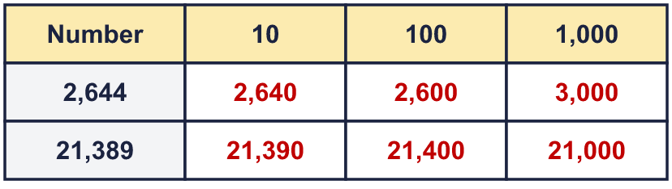
  7 | Circle the numbers that round to 630 to the nearest 10. Write their letters.  a) 642  b) 625  c) 626  d) 620  e) 635  f) 634  b, c, f
  8 | Round 57,847 to each place.  a) the nearest 10 = 57,850  b) the nearest 100 = 57,800  c) the nearest 1,000 = 58,000
  9 | Is Boba correct? Circle yes or no.  Yes / No  Explain how you know.  The digit to the right of the rounding column is 8, which is 5 or more, so we round up. 2,387 rounds to 2,400, not 2,300.
  10 | His number rounds to 1,100 to the nearest 100.  a) What number does Mo make? 1,133  b) What is Mo’s number rounded to the nearest 10? 1,130
  11 | There is a digit missing from each number. Write the digits that make it round to the number shown. There may be more than one.  a) 61_ rounds to 620 (nearest 10) 5, 6, 7, 8, 9  b) 4,9_0 rounds to 5,000 (nearest 100) 5, 6, 7, 8, 9  c) 75,_14 rounds to 76,000 (nearest 1,000) 5, 6, 7, 8, 9
  12 | A whole number rounds to 25,000 to the nearest 1,000.  a) What is the greatest it could be? 25,499  b) What is the smallest it could be? 24,500
  13 | a) Which place did the newspaper round to? Write 10, 100, 1,000. 100  b) What is the crowd rounded to the nearest 1,000? 94,000
  14 | Write a number that rounds to 1,800 to the nearest 100 and to 2,000 to the nearest 1,000.  Any number from 1,750 to 1,849, for example 1,799

