  Year 5 · Place value · Step 14  Rounding within 1,000,000 | 
  Year 5 · Place value · Step 14
  Rounding within 1,000,000
  1 | The arrows show two numbers: A is 61,900 and B is 67,000. Round each to the nearest 10,000.  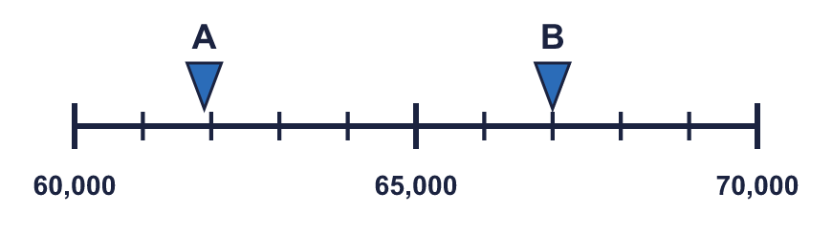
    A rounds to
    B rounds to
  1 | The arrows show two numbers: A is 61,900 and B is 67,000. Round each to the nearest 10,000.
    A rounds to
    B rounds to
  2 | The arrows show two numbers: A is 130,000 and B is 180,000. Round each to the nearest 100,000.  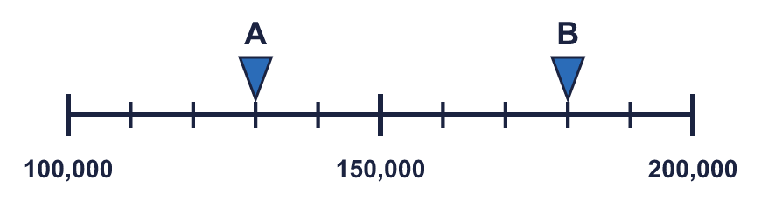
    A rounds to
    B rounds to
  2 | The arrows show two numbers: A is 130,000 and B is 180,000. Round each to the nearest 100,000.
    A rounds to
    B rounds to
  3 | Round each number to the nearest 10,000.  a) 287,096 to the nearest 10,000 =  b) 363,400 to the nearest 10,000 =  c) 875,497 to the nearest 10,000 =
  3 | Round each number to the nearest 10,000.  a) 287,096 to the nearest 10,000 =  b) 363,400 to the nearest 10,000 =  c) 875,497 to the nearest 10,000 =
  4 | Round each number to the nearest 100,000.  a) 943,249 to the nearest 100,000 =  b) 890,544 to the nearest 100,000 =  c) 556,812 to the nearest 100,000 =
  4 | Round each number to the nearest 100,000.  a) 943,249 to the nearest 100,000 =  b) 890,544 to the nearest 100,000 =  c) 556,812 to the nearest 100,000 =
  5 | Complete the sentences.
    a) | 292,206 is closer to
    than
    b) | 292,206 rounds to
    to the nearest 10,000
    c) | 628,856 is closer to
    than
    d) | 628,856 rounds to
    to the nearest 10,000
  5 | Complete the sentences.
    a) | 292,206 is closer to
    than
    b) | 292,206 rounds to
    to the nearest 10,000
    c) | 628,856 is closer to
    than
    d) | 628,856 rounds to
    to the nearest 10,000
  6 | Round each number to the nearest 1,000, 10,000 and 100,000. The headings show the place to round to. Complete the table.  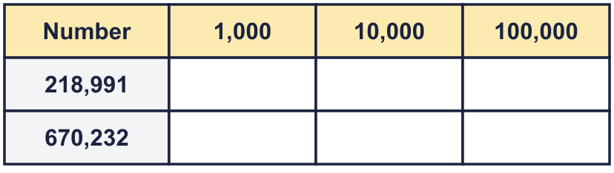
  6 | Round each number to the nearest 1,000, 10,000 and 100,000. The headings show the place to round to. Complete the table.
  7 | Round 922,038 to each place.  a) the nearest 100 =  b) the nearest 1,000 =  c) the nearest 10,000 =  d) the nearest 100,000 =
  7 | Round 922,038 to each place.  a) the nearest 100 =  b) the nearest 1,000 =  c) the nearest 10,000 =  d) the nearest 100,000 =
  8 | Round each price to the nearest £10,000 and to the nearest £100,000. The headings show the place to round to. Complete the table.  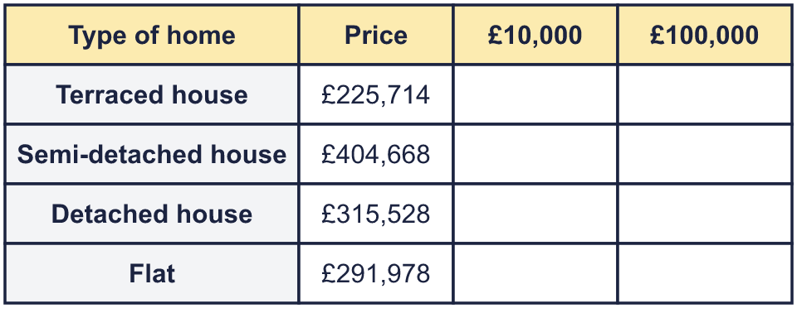
  8 | Round each price to the nearest £10,000 and to the nearest £100,000. The headings show the place to round to. Complete the table.

  9 | a) Who is correct?  b) Explain the mistakes the other two have made.
     | 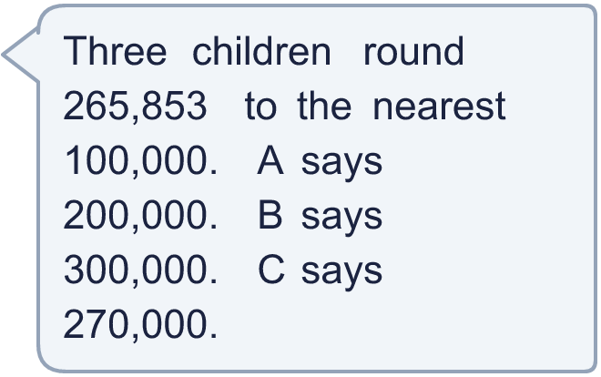
  9 | a) Who is correct?  b) Explain the mistakes the other two have made.
  10 | Is Boba correct? Circle yes or no.  Yes / No  Explain how you know.
    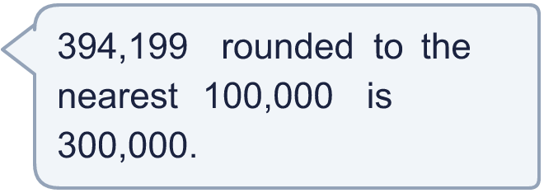
  10 | Is Boba correct? Circle yes or no.  Yes / No  Explain how you know.
  11 | A whole number rounds to 700,000 to the nearest 100,000.  a) What is the greatest it could be?  b) What is the smallest it could be?
  11 | A whole number rounds to 700,000 to the nearest 100,000.  a) What is the greatest it could be?  b) What is the smallest it could be?
  12 | a) Explain why Boba is wrong.  b) Dora’s mum needs 104 tiles. They are sold in boxes of 10. How many boxes does she need?
     | 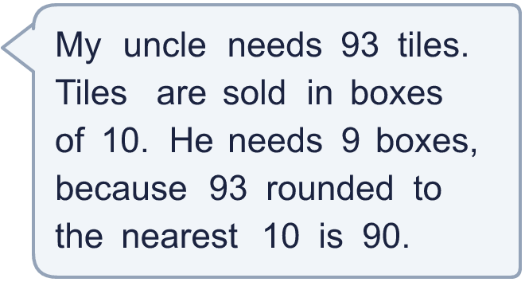
  12 | a) Explain why Boba is wrong.  b) Dora’s mum needs 104 tiles. They are sold in boxes of 10. How many boxes does she need?
  13 | a) Which place did the newspaper round to? Write 1,000, 10,000, 100,000.  b) What is the crowd rounded to the nearest 10,000?
    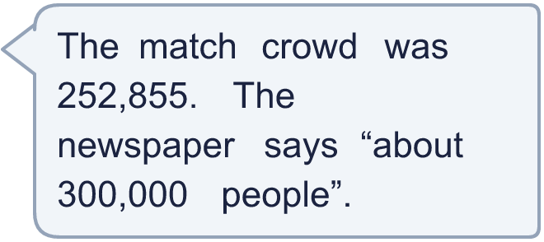
  13 | a) Which place did the newspaper round to? Write 1,000, 10,000, 100,000.  b) What is the crowd rounded to the nearest 10,000?
  14 | Write a number that rounds to 590,000 to the nearest 10,000 and to 600,000 to the nearest 100,000.
  14 | Write a number that rounds to 590,000 to the nearest 10,000 and to 600,000 to the nearest 100,000.

Year 5 · Place value · Step 14
Rounding within 1,000,000
Answers (teacher copy)

  1 | The arrows show two numbers: A is 61,900 and B is 67,000. Round each to the nearest 10,000.  A rounds to 60,000 B rounds to 70,000
  2 | The arrows show two numbers: A is 130,000 and B is 180,000. Round each to the nearest 100,000.  A rounds to 100,000 B rounds to 200,000
  3 | Round each number to the nearest 10,000.  a) 287,096 to the nearest 10,000 = 290,000  b) 363,400 to the nearest 10,000 = 360,000  c) 875,497 to the nearest 10,000 = 880,000
  4 | Round each number to the nearest 100,000.  a) 943,249 to the nearest 100,000 = 900,000  b) 890,544 to the nearest 100,000 = 900,000  c) 556,812 to the nearest 100,000 = 600,000
  5 | Complete the sentences.  a) 292,206 is closer to 290,000 than 300,000  b) 292,206 rounds to 290,000 to the nearest 10,000  c) 628,856 is closer to 630,000 than 620,000  d) 628,856 rounds to 630,000 to the nearest 10,000
  6 | Round each number to the nearest 1,000, 10,000 and 100,000. The headings show the place to round to. Complete the table.  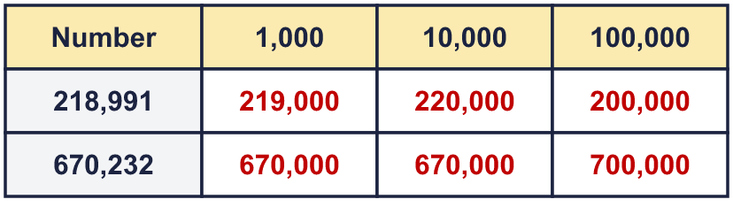
  7 | Round 922,038 to each place.  a) the nearest 100 = 922,000  b) the nearest 1,000 = 922,000  c) the nearest 10,000 = 920,000  d) the nearest 100,000 = 900,000
  8 | Round each price to the nearest £10,000 and to the nearest £100,000. The headings show the place to round to. Complete the table.  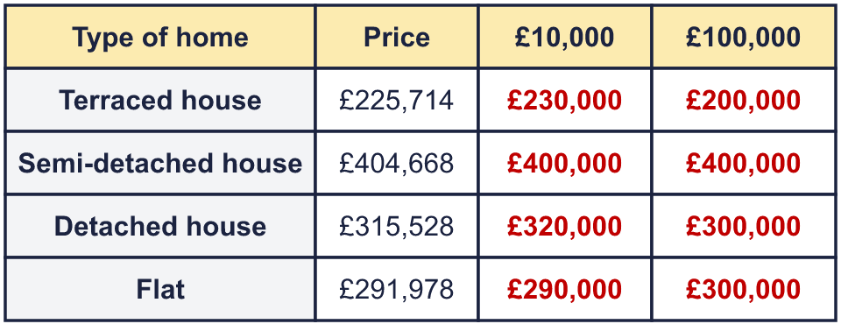
  9 | a) Who is correct? B  b) Explain the mistakes the other two have made.  The correct answer is 300,000. The digit to the right of the rounding column is 6, so we round up. One of the others rounded to the nearest 10,000, and one always rounded down.
  10 | Is Boba correct? Circle yes or no.  Yes / No  Explain how you know.  The digit to the right of the rounding column is 9, which is 5 or more, so we round up. 394,199 rounds to 400,000, not 300,000.
  11 | A whole number rounds to 700,000 to the nearest 100,000.  a) What is the greatest it could be? 749,999  b) What is the smallest it could be? 650,000
  12 | a) Explain why Boba is wrong.  93 tiles need more than 9 boxes. 9 boxes hold only 90 tiles, which is not enough, so he needs 10 boxes. When we are buying boxes we cannot round down.  b) Dora’s mum needs 104 tiles. They are sold in boxes of 10. How many boxes does she need? 11
  13 | a) Which place did the newspaper round to? Write 1,000, 10,000, 100,000. 100,000  b) What is the crowd rounded to the nearest 10,000? 250,000
  14 | Write a number that rounds to 590,000 to the nearest 10,000 and to 600,000 to the nearest 100,000.  Any number from 585,000 to 594,999, for example 589,999

