  Year 5 · Place value · Step 13  Rounding within 100,000 | 
  Year 5 · Place value · Step 13
  Rounding within 100,000
  1 | The arrows show two numbers: A is 42,800 and B is 49,200. Round each to the nearest 10,000.  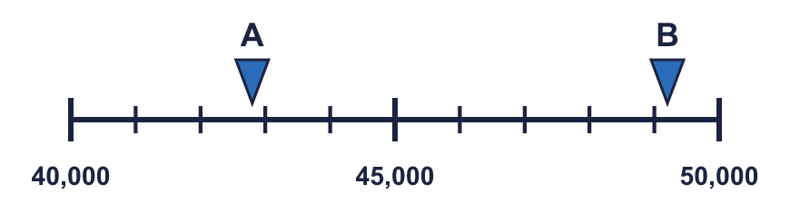
    A rounds to
    B rounds to
  1 | The arrows show two numbers: A is 42,800 and B is 49,200. Round each to the nearest 10,000.
    A rounds to
    B rounds to
  2 | Round each number to the nearest 10,000.  a) 74,804 to the nearest 10,000 =  b) 87,612 to the nearest 10,000 =  c) 88,404 to the nearest 10,000 =
  2 | Round each number to the nearest 10,000.  a) 74,804 to the nearest 10,000 =  b) 87,612 to the nearest 10,000 =  c) 88,404 to the nearest 10,000 =
  3 | Round each number to the nearest 10, 100, 1,000 and 10,000. The headings show the place to round to. Complete the table.  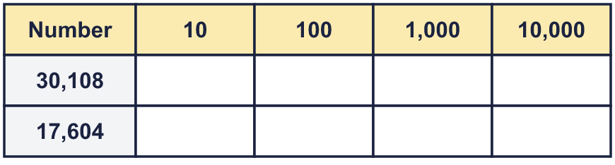
  3 | Round each number to the nearest 10, 100, 1,000 and 10,000. The headings show the place to round to. Complete the table.
  4 | These are the attendances at five sports events. Round each attendance to the nearest 1,000. Complete the last column of the table.  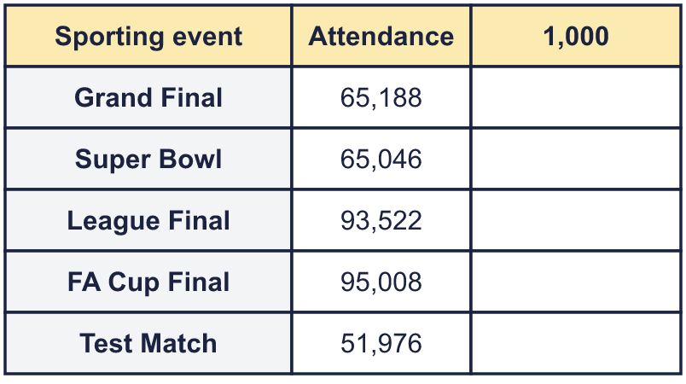
  4 | These are the attendances at five sports events. Round each attendance to the nearest 1,000. Complete the last column of the table.
  5 | Circle the numbers that round to 21,000 to the nearest 1,000. Write their letters.  a) 21,500  b) 19,638  c) 21,118  d) 20,500  e) 22,381  f) 20,789
  5 | Circle the numbers that round to 21,000 to the nearest 1,000. Write their letters.  a) 21,500  b) 19,638  c) 21,118  d) 20,500  e) 22,381  f) 20,789
  6 | Circle the numbers that round to 40,000 to the nearest 10,000. Write their letters.  a) 52,594  b) 27,976  c) 36,798  d) 35,000  e) 45,000  f) 44,368
  6 | Circle the numbers that round to 40,000 to the nearest 10,000. Write their letters.  a) 52,594  b) 27,976  c) 36,798  d) 35,000  e) 45,000  f) 44,368
  7 | Round 99,254 to each place.  a) the nearest 10 =  b) the nearest 100 =  c) the nearest 1,000 =  d) the nearest 10,000 =
  7 | Round 99,254 to each place.  a) the nearest 10 =  b) the nearest 100 =  c) the nearest 1,000 =  d) the nearest 10,000 =
  8 | The arrows show two numbers: A is 61,120 and B is 61,750. Round each to the nearest 1,000.  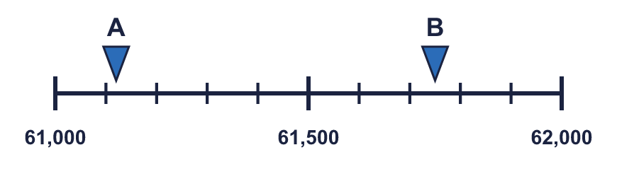
    A rounds to
    B rounds to
  8 | The arrows show two numbers: A is 61,120 and B is 61,750. Round each to the nearest 1,000.
    A rounds to
    B rounds to

  9 | Is Boba correct? Circle yes or no.  Yes / No  Explain how you know.
    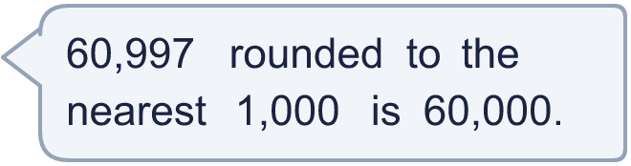
  9 | Is Boba correct? Circle yes or no.  Yes / No  Explain how you know.
  10 | A whole number rounds to 40,000 to the nearest 1,000.  a) What is the greatest it could be?  b) What is the smallest it could be?
  10 | A whole number rounds to 40,000 to the nearest 1,000.  a) What is the greatest it could be?  b) What is the smallest it could be?
  11 | The number in the report has been rounded. What is the greatest number of people who could have been at the match if it was rounded to the nearest...  a) 10,000  b) 1,000  c) 100  d) 10
     | 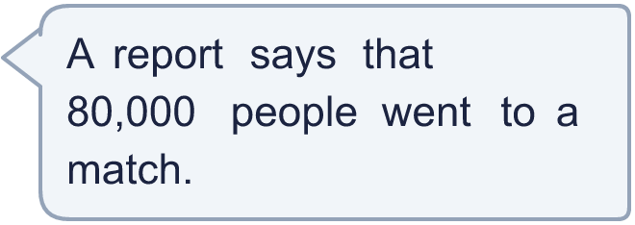
  11 | The number in the report has been rounded. What is the greatest number of people who could have been at the match if it was rounded to the nearest...  a) 10,000  b) 1,000  c) 100  d) 10
  12 | There is a digit missing from each number. Write the digits that make it round to the number shown. There may be more than one.  a) 3_,931 rounds to 40,000 (nearest 10,000)  b) 59,_43 rounds to 60,000 (nearest 1,000)  c) 33,8_1 rounds to 33,900 (nearest 100)
  12 | There is a digit missing from each number. Write the digits that make it round to the number shown. There may be more than one.  a) 3_,931 rounds to 40,000 (nearest 10,000)  b) 59,_43 rounds to 60,000 (nearest 1,000)  c) 33,8_1 rounds to 33,900 (nearest 100)
  13 | a) Which place did the newspaper round to? Write 10, 100, 1,000, 10,000.  b) What is the crowd rounded to the nearest 1,000?
     | 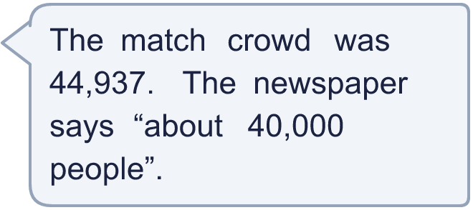
  13 | a) Which place did the newspaper round to? Write 10, 100, 1,000, 10,000.  b) What is the crowd rounded to the nearest 1,000?
  14 | Write a number that rounds to 59,000 to the nearest 1,000 and to 60,000 to the nearest 10,000.
  14 | Write a number that rounds to 59,000 to the nearest 1,000 and to 60,000 to the nearest 10,000.

Year 5 · Place value · Step 13
Rounding within 100,000
Answers (teacher copy)

  1 | The arrows show two numbers: A is 42,800 and B is 49,200. Round each to the nearest 10,000.  A rounds to 40,000 B rounds to 50,000
  2 | Round each number to the nearest 10,000.  a) 74,804 to the nearest 10,000 = 70,000  b) 87,612 to the nearest 10,000 = 90,000  c) 88,404 to the nearest 10,000 = 90,000
  3 | Round each number to the nearest 10, 100, 1,000 and 10,000. The headings show the place to round to. Complete the table.  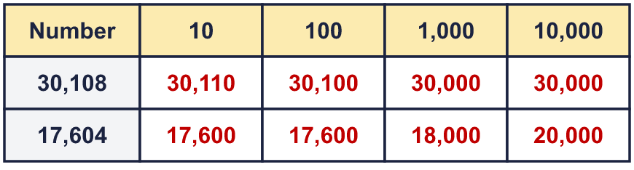
  4 | These are the attendances at five sports events. Round each attendance to the nearest 1,000. Complete the last column of the table.  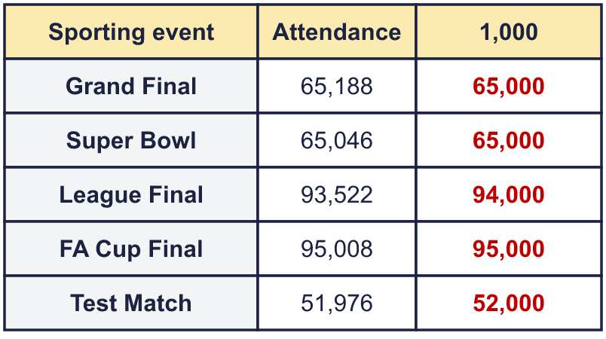
  5 | Circle the numbers that round to 21,000 to the nearest 1,000. Write their letters.  a) 21,500  b) 19,638  c) 21,118  d) 20,500  e) 22,381  f) 20,789  c, d, f
  6 | Circle the numbers that round to 40,000 to the nearest 10,000. Write their letters.  a) 52,594  b) 27,976  c) 36,798  d) 35,000  e) 45,000  f) 44,368  c, d, f
  7 | Round 99,254 to each place.  a) the nearest 10 = 99,250  b) the nearest 100 = 99,300  c) the nearest 1,000 = 99,000  d) the nearest 10,000 = 100,000
  8 | The arrows show two numbers: A is 61,120 and B is 61,750. Round each to the nearest 1,000.  A rounds to 61,000 B rounds to 62,000
  9 | Is Boba correct? Circle yes or no.  Yes / No  Explain how you know.  The digit to the right of the rounding column is 9, which is 5 or more, so we round up. 60,997 rounds to 61,000, not 60,000.
  10 | A whole number rounds to 40,000 to the nearest 1,000.  a) What is the greatest it could be? 40,499  b) What is the smallest it could be? 39,500
  11 | The number in the report has been rounded. What is the greatest number of people who could have been at the match if it was rounded to the nearest...  a) 10,000 84,999  b) 1,000 80,499  c) 100 80,049  d) 10 80,004
  12 | There is a digit missing from each number. Write the digits that make it round to the number shown. There may be more than one.  a) 3_,931 rounds to 40,000 (nearest 10,000) 5, 6, 7, 8, 9  b) 59,_43 rounds to 60,000 (nearest 1,000) 5, 6, 7, 8, 9  c) 33,8_1 rounds to 33,900 (nearest 100) 5, 6, 7, 8, 9
  13 | a) Which place did the newspaper round to? Write 10, 100, 1,000, 10,000. 10,000  b) What is the crowd rounded to the nearest 1,000? 45,000
  14 | Write a number that rounds to 59,000 to the nearest 1,000 and to 60,000 to the nearest 10,000.  Any number from 58,500 to 59,499, for example 58,999

