  Year 5 · Decimals and percentages · Step 4  Equivalent fractions and decimals (halves, quarters and fifths) | 
  Year 5 · Decimals and percentages · Step 4
  Equivalent fractions and decimals (halves, quarters and fifths)
  1 | Write each fraction as a decimal.
    a) ¹⁄₅ =
    b) ¹⁄₂ =
    c) ¹⁄₄ =
  1 | Write each fraction as a decimal.
    a) ¹⁄₅ =
    b) ¹⁄₂ =
    c) ¹⁄₄ =
  2 | Write each fraction as a decimal.
    a) ⁴⁄₅ =
    b) ³⁄₅ =
    c) ²⁄₅ =
  2 | Write each fraction as a decimal.
    a) ⁴⁄₅ =
    b) ³⁄₅ =
    c) ²⁄₅ =
  3 | Write each decimal as a fraction in its simplest form.
    a) 0.8 =
    b) 0.75 =
    c) 0.25 =
  3 | Write each decimal as a fraction in its simplest form.
    a) 0.8 =
    b) 0.75 =
    c) 0.25 =
  4 | Complete the equivalent fraction and the decimal.
    a) ¹⁄₄ = |  | /100 =
    b) ²⁄₅ = |  | /10 =
    c) ³⁄₄ = |  | /100 =
  4 | Complete the equivalent fraction and the decimal.
    a) ¹⁄₄ = |  | /100 =
    b) ²⁄₅ = |  | /10 =
    c) ³⁄₄ = |  | /100 =
  5 | Write each improper fraction as a decimal.
    a) ⁵⁄₂ =
    b) ¹³⁄₁₀ =
    c) ⁷⁄₄ =
  5 | Write each improper fraction as a decimal.
    a) ⁵⁄₂ =
    b) ¹³⁄₁₀ =
    c) ⁷⁄₄ =
  6 | The number line from 0 to 1 is split into 4 equal steps. Write the decimal each arrow points to.  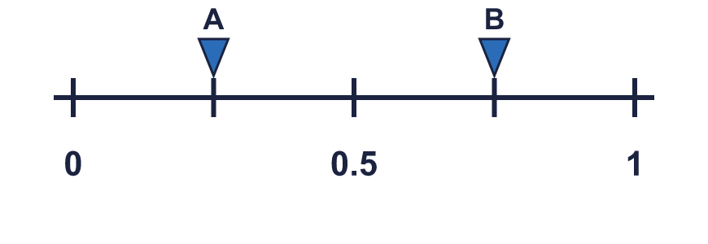
    A = |  | B =
  6 | The number line from 0 to 1 is split into 4 equal steps. Write the decimal each arrow points to.
    A = |  | B =
  7 | Write <, > or = in each box.
    a) ⁴⁄₅ |  | 0.7
    b) ¹⁄₁₀ |  | 0.85
    c) ¹⁄₄ |  | 0.45
    d) ¹⁄₄ |  | 0.7
  7 | Write <, > or = in each box.
    a) ⁴⁄₅ |  | 0.7
    b) ¹⁄₁₀ |  | 0.85
    c) ¹⁄₄ |  | 0.45
    d) ¹⁄₄ |  | 0.7
  8 | Write these in order, starting with the smallest.  ¹⁄₂ ⁴⁄₅ 0.15 0.3
  8 | Write these in order, starting with the smallest.  ¹⁄₂ ⁴⁄₅ 0.15 0.3

  9 | Is Amir correct? Circle yes or no.  Yes / No  Explain how you know.
     | 
  9 | Is Amir correct? Circle yes or no.  Yes / No  Explain how you know.
  10 | Which of these are equal to 0.5? Write the letters.  A: ⁵⁄₁₀  B: 0.05  C: 0.5  D: ¹⁄₂
  10 | Which of these are equal to 0.5? Write the letters.  A: ⁵⁄₁₀  B: 0.05  C: 0.5  D: ¹⁄₂
  11 | Match each fraction to the equal decimal. Write the letter.  A: 0.5 B: 0.4 C: 0.2 D: 0.55
    a) ²⁄₅ →
    b) ¹⁄₂ →
    c) ¹⁄₅ →
  11 | Match each fraction to the equal decimal. Write the letter.  A: 0.5 B: 0.4 C: 0.2 D: 0.55
    a) ²⁄₅ →
    b) ¹⁄₂ →
    c) ¹⁄₅ →
  12 | Mia drinks ¹⁄₄ litre of juice. Zach drinks 0.5 litre of juice.  How many litres do they drink altogether? Write a decimal.
  12 | Mia drinks ¹⁄₄ litre of juice. Zach drinks 0.5 litre of juice.  How many litres do they drink altogether? Write a decimal.
  13 | Write a decimal that is between ¹⁄₄ and ¹⁄₂.
  13 | Write a decimal that is between ¹⁄₄ and ¹⁄₂.
  14 | Write the decimal each arrow points to. The line is split into 10 equal steps.  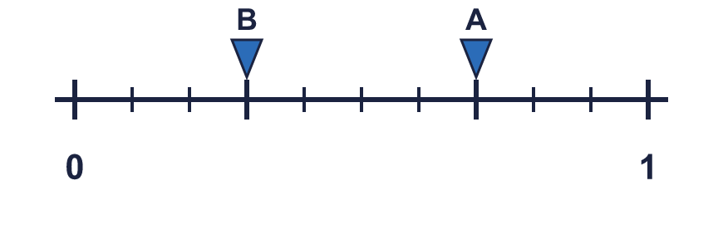
    A = |  | B =
  14 | Write the decimal each arrow points to. The line is split into 10 equal steps.
    A = |  | B =

Year 5 · Decimals and percentages · Step 4
Equivalent fractions and decimals (halves, quarters and fifths)
Answers (teacher copy)

  1 | Write each fraction as a decimal.  a) ¹⁄₅ = 0.2  b) ¹⁄₂ = 0.5  c) ¹⁄₄ = 0.25
  2 | Write each fraction as a decimal.  a) ⁴⁄₅ = 0.8  b) ³⁄₅ = 0.6  c) ²⁄₅ = 0.4
  3 | Write each decimal as a fraction in its simplest form.  a) 0.8 = ⁴⁄₅  b) 0.75 = ³⁄₄  c) 0.25 = ¹⁄₄
  4 | Complete the equivalent fraction and the decimal.  a) ¹⁄₄ = 25 /100 = 0.25  b) ²⁄₅ = 4 /10 = 0.4  c) ³⁄₄ = 75 /100 = 0.75
  5 | Write each improper fraction as a decimal.  a) ⁵⁄₂ = 2.5  b) ¹³⁄₁₀ = 1.3  c) ⁷⁄₄ = 1.75
  6 | The number line from 0 to 1 is split into 4 equal steps. Write the decimal each arrow points to.  A = 0.25 B = 0.75
  7 | Write <, > or = in each box.  a) ⁴⁄₅ > 0.7  b) ¹⁄₁₀ < 0.85  c) ¹⁄₄ < 0.45  d) ¹⁄₄ < 0.7
  8 | Write these in order, starting with the smallest.  ¹⁄₂ ⁴⁄₅ 0.15 0.3  0.15, 0.3, ¹⁄₂, ⁴⁄₅
  9 | Is Amir correct? Circle yes or no.  Yes / No  Explain how you know.  No. ²⁄₅ = 0.4 and 0.04 = 0.04, so they are not equal.
  10 | Which of these are equal to 0.5? Write the letters.  A: ⁵⁄₁₀  B: 0.05  C: 0.5  D: ¹⁄₂  A, C, D
  11 | Match each fraction to the equal decimal. Write the letter.  A: 0.5 B: 0.4 C: 0.2 D: 0.55  a) ²⁄₅ → B  b) ¹⁄₂ → A  c) ¹⁄₅ → C
  12 | Mia drinks ¹⁄₄ litre of juice. Zach drinks 0.5 litre of juice.  How many litres do they drink altogether? Write a decimal. 0.75
  13 | Write a decimal that is between ¹⁄₄ and ¹⁄₂.  0.3
  14 | Write the decimal each arrow points to. The line is split into 10 equal steps.  A = 0.7 B = 0.3

