  Year 5 · Decimals and percentages · Step 3  Equivalent fractions and decimals (hundredths) | 
  Year 5 · Decimals and percentages · Step 3
  Equivalent fractions and decimals (hundredths)
  1 | The hundred square is 1 whole. Write the fraction and the decimal that is shaded.  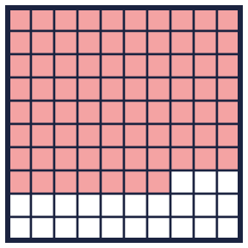  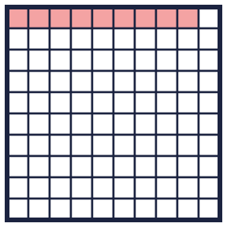
    a) fraction: |  | decimal:
    b) fraction: |  | decimal:
  1 | The hundred square is 1 whole. Write the fraction and the decimal that is shaded.
    a) fraction: |  | decimal:
    b) fraction: |  | decimal:
  2 | Write each fraction as a decimal.
    a) ⁸⁰⁄₁₀₀ =
    b) ²⁷⁄₁₀₀ =
    c) ¹⁵⁄₁₀₀ =
  2 | Write each fraction as a decimal.
    a) ⁸⁰⁄₁₀₀ =
    b) ²⁷⁄₁₀₀ =
    c) ¹⁵⁄₁₀₀ =
  3 | Write each decimal as a fraction.
    a) 0.39 =
    b) 0.23 =
    c) 0.57 =
  3 | Write each decimal as a fraction.
    a) 0.39 =
    b) 0.23 =
    c) 0.57 =
  4 | Write each number as one decimal.
    a) 1 + 0.1 + 0.04 =
    b) 8 + 0.7 + 0.02 =
    c) 7 + 0.4 + 0.03 =
  4 | Write each number as one decimal.
    a) 1 + 0.1 + 0.04 =
    b) 8 + 0.7 + 0.02 =
    c) 7 + 0.4 + 0.03 =
  5 | Write the missing number.
    a) 3.24 = 3 + 0.2 +
    b) 7.83 = 7 + 0.8 +
  5 | Write the missing number.
    a) 3.24 = 3 + 0.2 +
    b) 7.83 = 7 + 0.8 +
  6 | Write <, > or = in each box.
    a) 0.39 |  | 0.82
    b) 0.13 |  | 0.34
    c) 0.61 |  | 0.72
    d) 0.3 |  | 0.5
  6 | Write <, > or = in each box.
    a) 0.39 |  | 0.82
    b) 0.13 |  | 0.34
    c) 0.61 |  | 0.72
    d) 0.3 |  | 0.5
  7 | Match each fraction to the equal decimal. Write the letter.  A: 0.21 B: 1.2 C: 0.41 D: 0.37
    a) ³⁷⁄₁₀₀ →
    b) ⁴¹⁄₁₀₀ →
    c) ²¹⁄₁₀₀ →
  7 | Match each fraction to the equal decimal. Write the letter.  A: 0.21 B: 1.2 C: 0.41 D: 0.37
    a) ³⁷⁄₁₀₀ →
    b) ⁴¹⁄₁₀₀ →
    c) ²¹⁄₁₀₀ →
  8 | Write these decimals in order, starting with the smallest.  0.7 0.9 0.6 0.2
  8 | Write these decimals in order, starting with the smallest.  0.7 0.9 0.6 0.2

  9 | 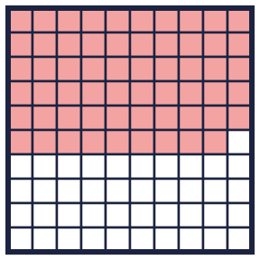  Is Amir correct? Circle yes or no.  Yes / No  Explain how you know.
     | 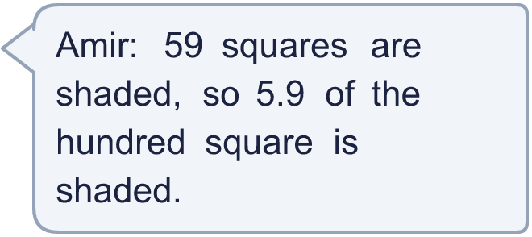
  9 | Is Amir correct? Circle yes or no.  Yes / No  Explain how you know.
  10 | Which of these are equal to ¹¹⁄_{100?} Write the letters.  A: 1.1  B: ¹¹⁄₁₀₀  C: 0.11  D: ¹¹⁰⁄₁₀₀₀
  10 | Which of these are equal to ¹¹⁄_{100?} Write the letters.  A: 1.1  B: ¹¹⁄₁₀₀  C: 0.11  D: ¹¹⁰⁄₁₀₀₀
  11 | Is Alex correct? Circle yes or no.  Yes / No  Explain how you know.
     | 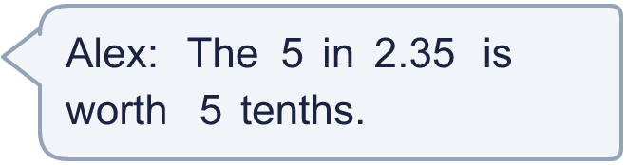
  11 | Is Alex correct? Circle yes or no.  Yes / No  Explain how you know.
  12 | Write the total as a decimal.
    a) ⁹⁄₁₀₀ + ⁹⁄₁₀ + 1 =
  12 | Write the total as a decimal.
    a) ⁹⁄₁₀₀ + ⁹⁄₁₀ + 1 =
  13 | Write a decimal with 2 decimal places that is between 1.3 and 1.4.
  13 | Write a decimal with 2 decimal places that is between 1.3 and 1.4.
  14 | Challenge  How many hundredths (0.01) make 1.7?
  14 | Challenge  How many hundredths (0.01) make 1.7?

Year 5 · Decimals and percentages · Step 3
Equivalent fractions and decimals (hundredths)
Answers (teacher copy)

  1 | The hundred square is 1 whole. Write the fraction and the decimal that is shaded.  a) fraction: ⁷⁷⁄₁₀₀ decimal: 0.77  b) fraction: ⁹⁄₁₀₀ decimal: 0.09
  2 | Write each fraction as a decimal.  a) ⁸⁰⁄₁₀₀ = 0.8  b) ²⁷⁄₁₀₀ = 0.27  c) ¹⁵⁄₁₀₀ = 0.15
  3 | Write each decimal as a fraction.  a) 0.39 = ³⁹⁄₁₀₀  b) 0.23 = ²³⁄₁₀₀  c) 0.57 = ⁵⁷⁄₁₀₀
  4 | Write each number as one decimal.  a) 1 + 0.1 + 0.04 = 1.14  b) 8 + 0.7 + 0.02 = 8.72  c) 7 + 0.4 + 0.03 = 7.43
  5 | Write the missing number.  a) 3.24 = 3 + 0.2 + 0.04  b) 7.83 = 7 + 0.8 + 0.03
  6 | Write <, > or = in each box.  a) 0.39 < 0.82  b) 0.13 < 0.34  c) 0.61 < 0.72  d) 0.3 < 0.5
  7 | Match each fraction to the equal decimal. Write the letter.  A: 0.21 B: 1.2 C: 0.41 D: 0.37  a) ³⁷⁄₁₀₀ → D  b) ⁴¹⁄₁₀₀ → C  c) ²¹⁄₁₀₀ → A
  8 | Write these decimals in order, starting with the smallest.  0.7 0.9 0.6 0.2  0.2, 0.6, 0.7, 0.9
  9 | Is Amir correct? Circle yes or no.  Yes / No  Explain how you know.  No. 59 squares out of 100 are shaded. That is ⁵⁹⁄₁₀₀, which is 0.59.
  10 | Which of these are equal to ¹¹⁄_{100?} Write the letters.  A: 1.1  B: ¹¹⁄₁₀₀  C: 0.11  D: ¹¹⁰⁄₁₀₀₀  B, C, D
  11 | Is Alex correct? Circle yes or no.  Yes / No  Explain how you know.  No. In 2.35 the 5 is in the hundredths column, so it is worth 5 hundredths.
  12 | Write the total as a decimal.  a) ⁹⁄₁₀₀ + ⁹⁄₁₀ + 1 = 1.99
  13 | Write a decimal with 2 decimal places that is between 1.3 and 1.4.  1.35
  14 | Challenge  How many hundredths (0.01) make 1.7?  170

