  Year 5 · Decimals and percentages · Step 2  Equivalent fractions and decimals (tenths) | 
  Year 5 · Decimals and percentages · Step 2
  Equivalent fractions and decimals (tenths)
  1 | Each bar is split into 10 equal parts. Write the fraction and the decimal that is shaded.  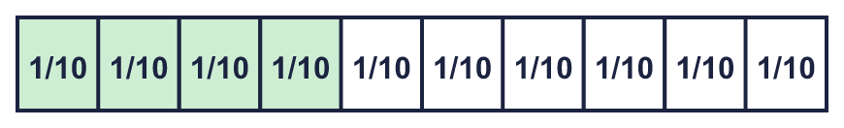  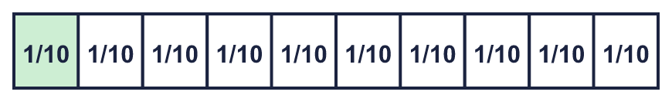
    a) fraction: |  | decimal:
    b) fraction: |  | decimal:
  1 | Each bar is split into 10 equal parts. Write the fraction and the decimal that is shaded.
    a) fraction: |  | decimal:
    b) fraction: |  | decimal:
  2 | Write each fraction as a decimal.
    a) ³⁄₁₀ =
    b) ⁴⁄₁₀ =
    c) ⁹⁄₁₀ =
  2 | Write each fraction as a decimal.
    a) ³⁄₁₀ =
    b) ⁴⁄₁₀ =
    c) ⁹⁄₁₀ =
  3 | Write each decimal as a fraction.
    a) 0.1 =
    b) 0.3 =
    c) 0.7 =
  3 | Write each decimal as a fraction.
    a) 0.1 =
    b) 0.3 =
    c) 0.7 =
  4 | The number line is split into 10 equal steps. Write the number that each arrow points to.  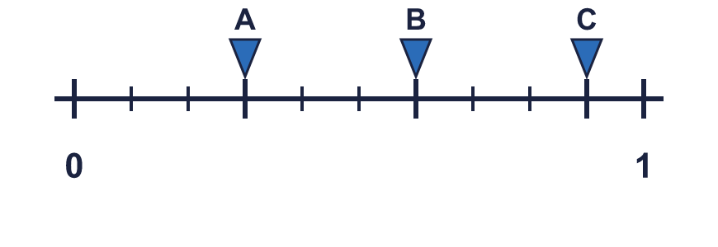
    A = |  | B = |  | C =
  4 | The number line is split into 10 equal steps. Write the number that each arrow points to.
    A = |  | B = |  | C =
  5 | Write each fraction as a decimal.
    a) ²⁴⁄₁₀ =
    b) ³⁵⁄₁₀ =
    c) ¹⁷⁄₁₀ =
  5 | Write each fraction as a decimal.
    a) ²⁴⁄₁₀ =
    b) ³⁵⁄₁₀ =
    c) ¹⁷⁄₁₀ =
  6 | Write each decimal as a mixed number.
    a) 1.1 =
    b) 1.3 =
    c) 3.9 =
  6 | Write each decimal as a mixed number.
    a) 1.1 =
    b) 1.3 =
    c) 3.9 =
  7 | Write <, > or = in each box.
    a) ⁶⁄₁₀ |  | 0.2
    b) ⁵⁄₁₀ |  | 0.6
    c) ⁴⁄₁₀ |  | 0.6
    d) ⁴⁄₁₀ |  | 0.2
  7 | Write <, > or = in each box.
    a) ⁶⁄₁₀ |  | 0.2
    b) ⁵⁄₁₀ |  | 0.6
    c) ⁴⁄₁₀ |  | 0.6
    d) ⁴⁄₁₀ |  | 0.2
  8 | Write these in order, starting with the smallest.  0.5 ⁸⁄₁₀ 0.9 ⁷⁄₁₀
  8 | Write these in order, starting with the smallest.  0.5 ⁸⁄₁₀ 0.9 ⁷⁄₁₀

  9 | 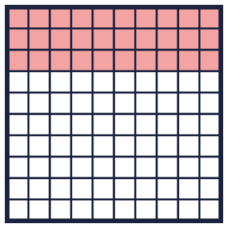  Is Huan correct? Circle yes or no.  Yes / No  Explain how you know.
     | 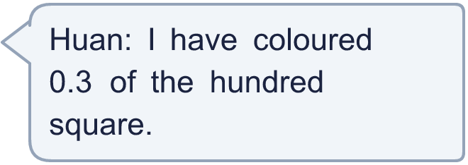
  9 | Is Huan correct? Circle yes or no.  Yes / No  Explain how you know.
  10 | Which of these are equal to 0.7? Write the letters.  A: ⁷⁰⁄₁₀₀  B: ⁷⁄₁₀  C: 0.70  D: 0.07
  10 | Which of these are equal to 0.7? Write the letters.  A: ⁷⁰⁄₁₀₀  B: ⁷⁄₁₀  C: 0.70  D: 0.07
  11 | Match each fraction to the equal decimal. Write the letter.  A: 0.7 B: 0.3 C: 0.1 D: 0.25
    a) ³⁄₁₀ →
    b) ¹⁄₁₀ →
    c) ⁷⁄₁₀ →
  11 | Match each fraction to the equal decimal. Write the letter.  A: 0.7 B: 0.3 C: 0.1 D: 0.25
    a) ³⁄₁₀ →
    b) ¹⁄₁₀ →
    c) ⁷⁄₁₀ →
  12 | Is Jo correct? Circle yes or no.  Yes / No  Explain how you know.
     | 
  12 | Is Jo correct? Circle yes or no.  Yes / No  Explain how you know.
  13 | Write a decimal that is between 0.1 and 0.2.
  13 | Write a decimal that is between 0.1 and 0.2.
  14 | Challenge  A bar is split into 10 equal parts. Mia shades 0.4 of the bar. Eva shades 0.2 of the bar.  How much of the bar is not shaded? Write a decimal.
  14 | Challenge  A bar is split into 10 equal parts. Mia shades 0.4 of the bar. Eva shades 0.2 of the bar.  How much of the bar is not shaded? Write a decimal.

Year 5 · Decimals and percentages · Step 2
Equivalent fractions and decimals (tenths)
Answers (teacher copy)

  1 | Each bar is split into 10 equal parts. Write the fraction and the decimal that is shaded.  a) fraction: ⁴⁄₁₀ decimal: 0.4  b) fraction: ¹⁄₁₀ decimal: 0.1
  2 | Write each fraction as a decimal.  a) ³⁄₁₀ = 0.3  b) ⁴⁄₁₀ = 0.4  c) ⁹⁄₁₀ = 0.9
  3 | Write each decimal as a fraction.  a) 0.1 = ¹⁄₁₀  b) 0.3 = ³⁄₁₀  c) 0.7 = ⁷⁄₁₀
  4 | The number line is split into 10 equal steps. Write the number that each arrow points to.  A = 0.3 B = 0.6 C = 0.9
  5 | Write each fraction as a decimal.  a) ²⁴⁄₁₀ = 2.4  b) ³⁵⁄₁₀ = 3.5  c) ¹⁷⁄₁₀ = 1.7
  6 | Write each decimal as a mixed number.  a) 1.1 = 1 ¹⁄₁₀  b) 1.3 = 1 ³⁄₁₀  c) 3.9 = 3 ⁹⁄₁₀
  7 | Write <, > or = in each box.  a) ⁶⁄₁₀ > 0.2  b) ⁵⁄₁₀ < 0.6  c) ⁴⁄₁₀ < 0.6  d) ⁴⁄₁₀ > 0.2
  8 | Write these in order, starting with the smallest.  0.5 ⁸⁄₁₀ 0.9 ⁷⁄₁₀  0.5, ⁷⁄₁₀, ⁸⁄₁₀, 0.9
  9 | Is Huan correct? Circle yes or no.  Yes / No  Explain how you know.  Yes. 30 squares out of 100 are coloured. That is ³⁄₁₀, which is 0.3.
  10 | Which of these are equal to 0.7? Write the letters.  A: ⁷⁰⁄₁₀₀  B: ⁷⁄₁₀  C: 0.70  D: 0.07  A, B, C
  11 | Match each fraction to the equal decimal. Write the letter.  A: 0.7 B: 0.3 C: 0.1 D: 0.25  a) ³⁄₁₀ → B  b) ¹⁄₁₀ → C  c) ⁷⁄₁₀ → A
  12 | Is Jo correct? Circle yes or no.  Yes / No  Explain how you know.  No. ⁷⁄₁₀ = 0.7 and 0.07 = 0.07, so they are not equal.
  13 | Write a decimal that is between 0.1 and 0.2.  0.15
  14 | Challenge  A bar is split into 10 equal parts. Mia shades 0.4 of the bar. Eva shades 0.2 of the bar.  How much of the bar is not shaded? Write a decimal. 0.4

