  Year 5 · Decimals and percentages · Step 9  Order and compare any decimals with up to 3 decimal places | 
  Year 5 · Decimals and percentages · Step 9
  Order and compare any decimals with up to 3 decimal places
  1 | Write < or > in each box.
    a) 0.512 |  | 0.9
    b) 0.79 |  | 0.9
    c) 0.285 |  | 0.6
  1 | Write < or > in each box.
    a) 0.512 |  | 0.9
    b) 0.79 |  | 0.9
    c) 0.285 |  | 0.6
  2 | Write < or > in each box.
    a) 4.44 |  | 3.2
    b) 5.575 |  | 6.115
    c) 5.11 |  | 6.32
    d) 7.61 |  | 6.9
  2 | Write < or > in each box.
    a) 4.44 |  | 3.2
    b) 5.575 |  | 6.115
    c) 5.11 |  | 6.32
    d) 7.61 |  | 6.9
  3 | Write these decimals in order, starting with the smallest.  0.5 0.92 0.403 0.1
  3 | Write these decimals in order, starting with the smallest.  0.5 0.92 0.403 0.1
  4 | Write these decimals in order, starting with the greatest.  3.7 3.91 7.6 9.328
  4 | Write these decimals in order, starting with the greatest.  3.7 3.91 7.6 9.328
  5 | The children measure their heights with a metre ruler.  Amir: 1.4 m  Jack: 1.48 m  Mo: 1.6 m  Ron: 1.35 m  Who is the shortest? Write the name.
  5 | The children measure their heights with a metre ruler.  Amir: 1.4 m  Jack: 1.48 m  Mo: 1.6 m  Ron: 1.35 m  Who is the shortest? Write the name.
  6 | Write the masses in order, starting with the lightest.  7.2 kg 7.524 kg 7.059 kg 7.61 kg
  6 | Write the masses in order, starting with the lightest.  7.2 kg 7.524 kg 7.059 kg 7.61 kg
  7 | Which of these are equal to 3.4? Write the letters.  A: 3 ⁴⁄₁₀  B: 3.34  C: 3 ⁴⁰⁄₁₀₀  D: 3.4
  7 | Which of these are equal to 3.4? Write the letters.  A: 3 ⁴⁄₁₀  B: 3.34  C: 3 ⁴⁰⁄₁₀₀  D: 3.4
  8 | Work out each answer.
    a) 0.326 + 0.001 =
    b) 0.326 − 0.01 =
    c) 0.326 + 0.1 =
  8 | Work out each answer.
    a) 0.326 + 0.001 =
    b) 0.326 − 0.01 =
    c) 0.326 + 0.1 =

  9 | Mo wants to complete the statement using < or >.  1.34 > 1.4  Is Mo’s statement correct? Circle yes or no.  Yes / No  Explain. Then write the correct symbol.
     | 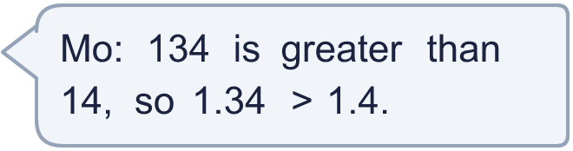
  9 | Mo wants to complete the statement using < or >.  1.34 > 1.4  Is Mo’s statement correct? Circle yes or no.  Yes / No  Explain. Then write the correct symbol.
  10 | Use each card once to make the smallest decimal of the form ___.__
    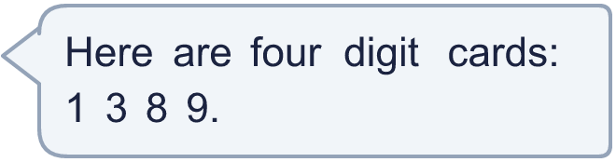
  10 | Use each card once to make the smallest decimal of the form ___.__
  11 | Three of these numbers are equal. Write the letter of the number that is different.  A: 0.4  B: 0.400  C: 0.04  D: 0.40
  11 | Three of these numbers are equal. Write the letter of the number that is different.  A: 0.4  B: 0.400  C: 0.04  D: 0.40
  12 | Dexter is thinking of a number with 2 decimal places. It is greater than 2.49 and less than 2.59. Write a number he could be thinking of.
  12 | Dexter is thinking of a number with 2 decimal places. It is greater than 2.49 and less than 2.59. Write a number he could be thinking of.
  13 | Write the numbers in order, starting with the heaviest.  25.1 kg 25.15 kg 25.511 kg 25.9 kg 25.202 kg
  13 | Write the numbers in order, starting with the heaviest.  25.1 kg 25.15 kg 25.511 kg 25.9 kg 25.202 kg
  14 | Alex jumps 1.47 m and Dora jumps 1.48 m in the long jump.  What is the difference between their jumps? (m)
  14 | Alex jumps 1.47 m and Dora jumps 1.48 m in the long jump.  What is the difference between their jumps? (m)

Year 5 · Decimals and percentages · Step 9
Order and compare any decimals with up to 3 decimal places
Answers (teacher copy)

  1 | Write < or > in each box.  a) 0.512 < 0.9  b) 0.79 < 0.9  c) 0.285 < 0.6
  2 | Write < or > in each box.  a) 4.44 > 3.2  b) 5.575 < 6.115  c) 5.11 < 6.32  d) 7.61 > 6.9
  3 | Write these decimals in order, starting with the smallest.  0.5 0.92 0.403 0.1  0.1, 0.403, 0.5, 0.92
  4 | Write these decimals in order, starting with the greatest.  3.7 3.91 7.6 9.328  9.328, 7.6, 3.91, 3.7
  5 | The children measure their heights with a metre ruler.  Amir: 1.4 m  Jack: 1.48 m  Mo: 1.6 m  Ron: 1.35 m  Who is the shortest? Write the name. Ron
  6 | Write the masses in order, starting with the lightest.  7.2 kg 7.524 kg 7.059 kg 7.61 kg  7.059 kg, 7.2 kg, 7.524 kg, 7.61 kg
  7 | Which of these are equal to 3.4? Write the letters.  A: 3 ⁴⁄₁₀  B: 3.34  C: 3 ⁴⁰⁄₁₀₀  D: 3.4  A, C, D
  8 | Work out each answer.  a) 0.326 + 0.001 = 0.327  b) 0.326 − 0.01 = 0.316  c) 0.326 + 0.1 = 0.426
  9 | Mo wants to complete the statement using < or >.  1.34 > 1.4  Is Mo’s statement correct? Circle yes or no.  Yes / No  Explain. Then write the correct symbol.  1.34 is less than 1.4. You must compare the tenths first, not the number of digits.  <
  10 | Use each card once to make the smallest decimal of the form ___.__  13.89
  11 | Three of these numbers are equal. Write the letter of the number that is different.  A: 0.4  B: 0.400  C: 0.04  D: 0.40  C
  12 | Dexter is thinking of a number with 2 decimal places. It is greater than 2.49 and less than 2.59. Write a number he could be thinking of.  2.51
  13 | Write the numbers in order, starting with the heaviest.  25.1 kg 25.15 kg 25.511 kg 25.9 kg 25.202 kg  25.9 kg, 25.511 kg, 25.202 kg, 25.15 kg, 25.1 kg
  14 | Alex jumps 1.47 m and Dora jumps 1.48 m in the long jump.  What is the difference between their jumps? (m) 0.01

