  Year 5 · Decimals and percentages · Step 8  Order and compare decimals (same number of decimal places) | 
  Year 5 · Decimals and percentages · Step 8
  Order and compare decimals (same number of decimal places)
  1 | Write < or > in each box.
    a) 7.3 |  | 6.3
    b) 2.2 |  | 8.5
    c) 2.6 |  | 9.6
  1 | Write < or > in each box.
    a) 7.3 |  | 6.3
    b) 2.2 |  | 8.5
    c) 2.6 |  | 9.6
  2 | Write < or > in each box.
    a) 0.38 |  | 0.97
    b) 0.24 |  | 0.78
    c) 0.25 |  | 0.14
    d) 0.65 |  | 0.45
  2 | Write < or > in each box.
    a) 0.38 |  | 0.97
    b) 0.24 |  | 0.78
    c) 0.25 |  | 0.14
    d) 0.65 |  | 0.45
  3 | Write these decimals in order, starting with the smallest.  7.8 9.4 3.8 8.3
  3 | Write these decimals in order, starting with the smallest.  7.8 9.4 3.8 8.3
  4 | Write these decimals in order, starting with the greatest.  0.434 0.156 0.601 0.277
  4 | Write these decimals in order, starting with the greatest.  0.434 0.156 0.601 0.277
  5 | A bag of flour has a mass of 0.136 kg. A bag of sugar has a mass of 0.195 kg.  Which bag has the smaller mass? Write flour or sugar.
  5 | A bag of flour has a mass of 0.136 kg. A bag of sugar has a mass of 0.195 kg.  Which bag has the smaller mass? Write flour or sugar.
  6 | Write the distances in order, starting with the shortest.  1.146 km 2.675 km 2.104 km 2.375 km 1.516 km
  6 | Write the distances in order, starting with the shortest.  1.146 km 2.675 km 2.104 km 2.375 km 1.516 km
  7 | Work out each answer.
    a) 0.258 + 0.001 =
    b) 0.258 − 0.001 =
    c) 0.258 + 0.01 =
    d) 0.258 − 0.01 =
  7 | Work out each answer.
    a) 0.258 + 0.001 =
    b) 0.258 − 0.001 =
    c) 0.258 + 0.01 =
    d) 0.258 − 0.01 =
  8 | The children measure their heights.  Jack: 1.45 m  Ron: 1.54 m  Amir: 1.44 m  Who is the tallest? Write the name.
  8 | The children measure their heights.  Jack: 1.45 m  Ron: 1.54 m  Amir: 1.44 m  Who is the tallest? Write the name.

  9 | Sam wants to complete the statement using < or >.  0.43 > 0.41  Is Sam’s statement correct? Circle yes or no.  Yes / No  Explain. Then write the correct symbol.
     | 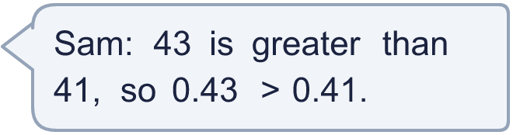
  9 | Sam wants to complete the statement using < or >.  0.43 > 0.41  Is Sam’s statement correct? Circle yes or no.  Yes / No  Explain. Then write the correct symbol.
  10 | Use each card once to make the smallest decimal of the form 0.___.
    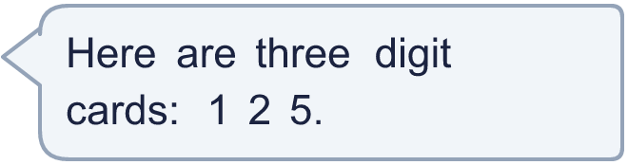
  10 | Use each card once to make the smallest decimal of the form 0.___.
  11 | Three of these numbers are equal. Write the letter of the number that is different.  A: 0.80  B: 0.08  C: 0.800  D: 0.8
  11 | Three of these numbers are equal. Write the letter of the number that is different.  A: 0.80  B: 0.08  C: 0.800  D: 0.8
  12 | Write a decimal with 2 decimal places that is greater than 0.55 and less than 0.6.
  12 | Write a decimal with 2 decimal places that is greater than 0.55 and less than 0.6.
  13 | A bag of rice has a mass of 0.513 kg. A bag of lentils has a mass of 0.493 kg.  How much heavier is the bag of rice? (kg)
  13 | A bag of rice has a mass of 0.513 kg. A bag of lentils has a mass of 0.493 kg.  How much heavier is the bag of rice? (kg)
  14 | Is Mia correct? Circle yes or no.  Yes / No  Explain how you know.
     | 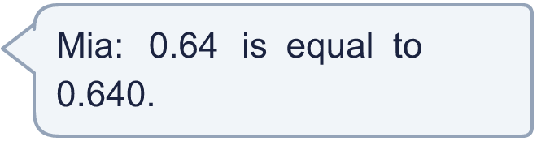
  14 | Is Mia correct? Circle yes or no.  Yes / No  Explain how you know.

Year 5 · Decimals and percentages · Step 8
Order and compare decimals (same number of decimal places)
Answers (teacher copy)

  1 | Write < or > in each box.  a) 7.3 > 6.3  b) 2.2 < 8.5  c) 2.6 < 9.6
  2 | Write < or > in each box.  a) 0.38 < 0.97  b) 0.24 < 0.78  c) 0.25 > 0.14  d) 0.65 > 0.45
  3 | Write these decimals in order, starting with the smallest.  7.8 9.4 3.8 8.3  3.8, 7.8, 8.3, 9.4
  4 | Write these decimals in order, starting with the greatest.  0.434 0.156 0.601 0.277  0.601, 0.434, 0.277, 0.156
  5 | A bag of flour has a mass of 0.136 kg. A bag of sugar has a mass of 0.195 kg.  Which bag has the smaller mass? Write flour or sugar. flour
  6 | Write the distances in order, starting with the shortest.  1.146 km 2.675 km 2.104 km 2.375 km 1.516 km  1.146 km, 1.516 km, 2.104 km, 2.375 km, 2.675 km
  7 | Work out each answer.  a) 0.258 + 0.001 = 0.259  b) 0.258 − 0.001 = 0.257  c) 0.258 + 0.01 = 0.268  d) 0.258 − 0.01 = 0.248
  8 | The children measure their heights.  Jack: 1.45 m  Ron: 1.54 m  Amir: 1.44 m  Who is the tallest? Write the name. Ron
  9 | Sam wants to complete the statement using < or >.  0.43 > 0.41  Is Sam’s statement correct? Circle yes or no.  Yes / No  Explain. Then write the correct symbol.  0.43 is more than 0.41. Compare the tenths first, then the hundredths.  >
  10 | Use each card once to make the smallest decimal of the form 0.___.  0.125
  11 | Three of these numbers are equal. Write the letter of the number that is different.  A: 0.80  B: 0.08  C: 0.800  D: 0.8  B
  12 | Write a decimal with 2 decimal places that is greater than 0.55 and less than 0.6.  0.57
  13 | A bag of rice has a mass of 0.513 kg. A bag of lentils has a mass of 0.493 kg.  How much heavier is the bag of rice? (kg) 0.02
  14 | Is Mia correct? Circle yes or no.  Yes / No  Explain how you know.  Yes. 0.64 = 0.64 and 0.640 = 0.64, so they are equal.

