  Year 5 · Decimals and percentages · Step 10  Round to the nearest whole number | 
  Year 5 · Decimals and percentages · Step 10
  Round to the nearest whole number
  1 | Write the two whole numbers each decimal lies between.
    a) 15.8 is between |  | and
    b) 17.7 is between |  | and
    c) 19.2 is between |  | and
  1 | Write the two whole numbers each decimal lies between.
    a) 15.8 is between |  | and
    b) 17.7 is between |  | and
    c) 19.2 is between |  | and
  2 | Round each number to the nearest whole number.
    a) 47.6 →
    b) 29.9 →
    c) 84.8 →
    d) 34.8 →
  2 | Round each number to the nearest whole number.
    a) 47.6 →
    b) 29.9 →
    c) 84.8 →
    d) 34.8 →
  3 | Round each number to the nearest whole number.
    a) 8.5 →
    b) 0.4 →
    c) 0.9 →
    d) 100.1 →
  3 | Round each number to the nearest whole number.
    a) 8.5 →
    b) 0.4 →
    c) 0.9 →
    d) 100.1 →
  4 | Round each number to the nearest whole number.
    a) 58.45 →
    b) 38.73 →
    c) 10.24 →
  4 | Round each number to the nearest whole number.
    a) 58.45 →
    b) 38.73 →
    c) 10.24 →
  5 | Which of these numbers round to 13 to the nearest whole number? Write the letters.  A: 12.5  B: 13.4  C: 13.5  D: 12.4
  5 | Which of these numbers round to 13 to the nearest whole number? Write the letters.  A: 12.5  B: 13.4  C: 13.5  D: 12.4
  6 | Round each measurement to the nearest whole number.
    a) A parcel has a mass of 9.61 kg:
    b) A pencil is 19.01 cm long:
    c) A bottle holds 2.32 litres:
  6 | Round each measurement to the nearest whole number.
    a) A parcel has a mass of 9.61 kg:
    b) A pencil is 19.01 cm long:
    c) A bottle holds 2.32 litres:
  7 | The number line is split into 10 equal steps. Write the number each arrow points to.  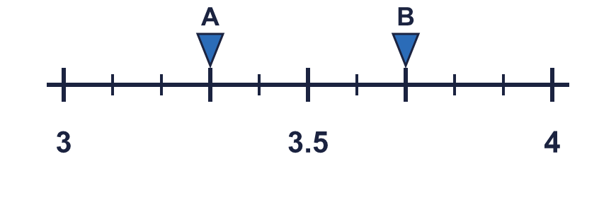
    A = |  | B =
  7 | The number line is split into 10 equal steps. Write the number each arrow points to.
    A = |  | B =
  8 | Round each number to the nearest whole number. Think about where it is on a number line between 3 and 4.
    a) 3.97 →
    b) 3.05 →
    c) 3.35 →
    d) 3.88 →
  8 | Round each number to the nearest whole number. Think about where it is on a number line between 3 and 4.
    a) 3.97 →
    b) 3.05 →
    c) 3.35 →
    d) 3.88 →

  9 | Is Jo correct? Circle yes or no.  Yes / No  Explain how you know.
     | 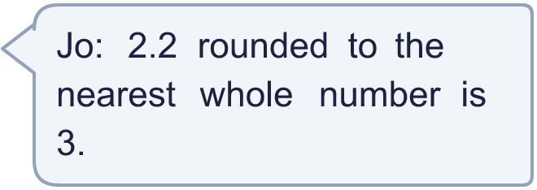
  9 | Is Jo correct? Circle yes or no.  Yes / No  Explain how you know.
  10 | A: 40.4  B: 41.6  C: 40.5  D: 41.4
    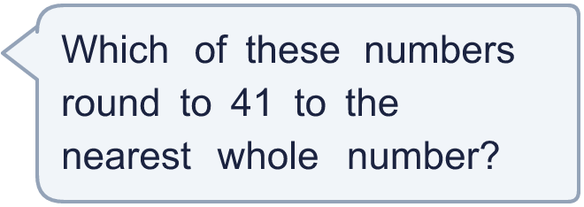
  10 | A: 40.4  B: 41.6  C: 40.5  D: 41.4
  11 | A number with one decimal place rounds to 35 to the nearest whole number.
    The smallest it could be:
    The largest it could be:
  11 | A number with one decimal place rounds to 35 to the nearest whole number.
    The smallest it could be:
    The largest it could be:
  12 | How many numbers with two decimal places round to 22 to the nearest whole number?
  12 | How many numbers with two decimal places round to 22 to the nearest whole number?
  13 | a) A farmer walks 16.76 km. Round this to the nearest whole number.  b) A jug holds 6.33 litres. Round this to the nearest whole number.
  13 | a) A farmer walks 16.76 km. Round this to the nearest whole number.  b) A jug holds 6.33 litres. Round this to the nearest whole number.
  14 | Challenge  Tiny is thinking of a number with 2 decimal places. It rounds to 15 to the nearest whole number. Write a number Tiny could be thinking of.
  14 | Challenge  Tiny is thinking of a number with 2 decimal places. It rounds to 15 to the nearest whole number. Write a number Tiny could be thinking of.

Year 5 · Decimals and percentages · Step 10
Round to the nearest whole number
Answers (teacher copy)

  1 | Write the two whole numbers each decimal lies between.  a) 15.8 is between 15 and 16  b) 17.7 is between 17 and 18  c) 19.2 is between 19 and 20
  2 | Round each number to the nearest whole number.  a) 47.6 → 48  b) 29.9 → 30  c) 84.8 → 85  d) 34.8 → 35
  3 | Round each number to the nearest whole number.  a) 8.5 → 9  b) 0.4 → 0  c) 0.9 → 1  d) 100.1 → 100
  4 | Round each number to the nearest whole number.  a) 58.45 → 58  b) 38.73 → 39  c) 10.24 → 10
  5 | Which of these numbers round to 13 to the nearest whole number? Write the letters.  A: 12.5  B: 13.4  C: 13.5  D: 12.4  A, B
  6 | Round each measurement to the nearest whole number.  a) A parcel has a mass of 9.61 kg: 10  b) A pencil is 19.01 cm long: 19  c) A bottle holds 2.32 litres: 2
  7 | The number line is split into 10 equal steps. Write the number each arrow points to.  A = 3.3 B = 3.7
  8 | Round each number to the nearest whole number. Think about where it is on a number line between 3 and 4.  a) 3.97 → 4  b) 3.05 → 3  c) 3.35 → 3  d) 3.88 → 4
  9 | Is Jo correct? Circle yes or no.  Yes / No  Explain how you know.  No. The tenths digit of 2.2 is 2, so it rounds to 2.
  10 | A: 40.4  B: 41.6  C: 40.5  D: 41.4  Write the letters: C, D
  11 | A number with one decimal place rounds to 35 to the nearest whole number.  The smallest it could be: 34.5 The largest it could be: 35.4
  12 | How many numbers with two decimal places round to 22 to the nearest whole number?  100
  13 | a) A farmer walks 16.76 km. Round this to the nearest whole number.  17 km  b) A jug holds 6.33 litres. Round this to the nearest whole number.  6 litres
  14 | Challenge  Tiny is thinking of a number with 2 decimal places. It rounds to 15 to the nearest whole number. Write a number Tiny could be thinking of.  15.24

