  Year 5 · Decimals and percentages · Step 6  Thousandths as decimals | 
  Year 5 · Decimals and percentages · Step 6
  Thousandths as decimals
  1 | Write the number shown on each place value chart.  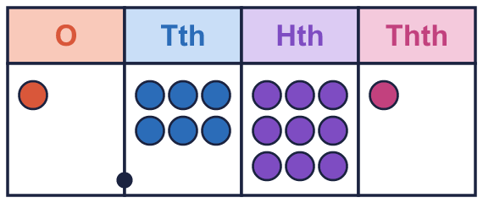  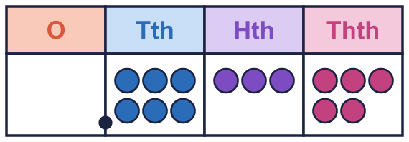
    a) The number is
    b) The number is
  1 | Write the number shown on each place value chart.
    a) The number is
    b) The number is
  2 | Use counters to make each number. Write how many counters go in each column.  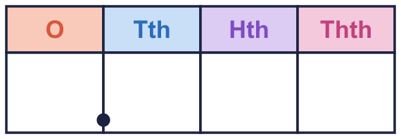
    a) 2.958:
    b) 0.189:
  2 | Use counters to make each number. Write how many counters go in each column.
    a) 2.958:
    b) 0.189:
  3 | Write each number as one decimal.
    a) 0.9 + 0.09 + 0.004 =
    b) 0.3 + 0.07 + 0.006 =
    c) 0.4 + 0.02 + 0.005 =
  3 | Write each number as one decimal.
    a) 0.9 + 0.09 + 0.004 =
    b) 0.3 + 0.07 + 0.006 =
    c) 0.4 + 0.02 + 0.005 =
  4 | Write the missing number.
    a) 0.412 = 0.4 + 0.01 +
    b) 0.131 = 0.1 + 0.03 +
  4 | Write the missing number.
    a) 0.412 = 0.4 + 0.01 +
    b) 0.131 = 0.1 + 0.03 +
  5 | What is the value of the digit in each number?
    a) the digit 2 in 5.721:
    b) the digit 8 in 2.874:
    c) the digit 6 in 6.359:
  5 | What is the value of the digit in each number?
    a) the digit 2 in 5.721:
    b) the digit 8 in 2.874:
    c) the digit 6 in 6.359:
  6 | Write <, > or = in each box.
    a) 0.164 |  | 0.253
    b) 0.634 |  | 0.363
    c) 0.992 |  | 0.353
    d) 0.499 |  | 0.683
  6 | Write <, > or = in each box.
    a) 0.164 |  | 0.253
    b) 0.634 |  | 0.363
    c) 0.992 |  | 0.353
    d) 0.499 |  | 0.683
  7 | Write these decimals in order, starting with the smallest.  0.245 0.244 0.034 0.682
  7 | Write these decimals in order, starting with the smallest.  0.245 0.244 0.034 0.682
  8 | How many thousandths (0.001) are in each number?
    a) 0.38:
    b) 0.3:
  8 | How many thousandths (0.001) are in each number?
    a) 0.38:
    b) 0.3:

  9 | Is Jo correct? Circle yes or no.  Yes / No  Explain how you know.
     | 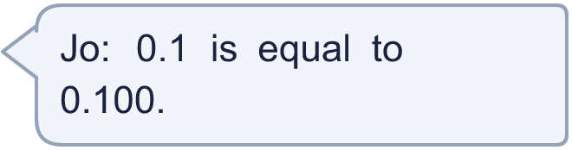
  9 | Is Jo correct? Circle yes or no.  Yes / No  Explain how you know.
  10 | Here are three digit cards: 1 4 5.  Use each card once to make the largest decimal of the form 0.___.
  10 | Here are three digit cards: 1 4 5.  Use each card once to make the largest decimal of the form 0.___.
  11 | Which of these are equal to 0.03? Write the letters.  A: 0.030  B: 0.02 + 0.01  C: ³⁰⁄₁₀₀₀  D: 0.003
  11 | Which of these are equal to 0.03? Write the letters.  A: 0.030  B: 0.02 + 0.01  C: ³⁰⁄₁₀₀₀  D: 0.003
  12 | Write the missing number.
    a) 2 + 0.6 +
    + 0.001 = 2.681
  12 | Write the missing number.
    a) 2 + 0.6 +
    + 0.001 = 2.681
  13 | Write a decimal with 3 decimal places that is between 0.97 and 0.98.
  13 | Write a decimal with 3 decimal places that is between 0.97 and 0.98.
  14 | Challenge  How many thousandths (0.001) make 0.75?
  14 | Challenge  How many thousandths (0.001) make 0.75?

Year 5 · Decimals and percentages · Step 6
Thousandths as decimals
Answers (teacher copy)

  1 | Write the number shown on each place value chart.  a) The number is 1.691  b) The number is 0.635
  2 | Use counters to make each number. Write how many counters go in each column.  a) 2.958: 2 9 5 8  b) 0.189: 0 1 8 9
  3 | Write each number as one decimal.  a) 0.9 + 0.09 + 0.004 = 0.994  b) 0.3 + 0.07 + 0.006 = 0.376  c) 0.4 + 0.02 + 0.005 = 0.425
  4 | Write the missing number.  a) 0.412 = 0.4 + 0.01 + 0.002  b) 0.131 = 0.1 + 0.03 + 0.001
  5 | What is the value of the digit in each number?  a) the digit 2 in 5.721: 0.02  b) the digit 8 in 2.874: 0.8  c) the digit 6 in 6.359: 6
  6 | Write <, > or = in each box.  a) 0.164 < 0.253  b) 0.634 > 0.363  c) 0.992 > 0.353  d) 0.499 < 0.683
  7 | Write these decimals in order, starting with the smallest.  0.245 0.244 0.034 0.682  0.034, 0.244, 0.245, 0.682
  8 | How many thousandths (0.001) are in each number?  a) 0.38: 380  b) 0.3: 300
  9 | Is Jo correct? Circle yes or no.  Yes / No  Explain how you know.  Yes. 0.1 = 0.1 and 0.100 = 0.1, so they are equal.
  10 | Here are three digit cards: 1 4 5.  Use each card once to make the largest decimal of the form 0.___.  0.541
  11 | Which of these are equal to 0.03? Write the letters.  A: 0.030  B: 0.02 + 0.01  C: ³⁰⁄₁₀₀₀  D: 0.003  A, B, C
  12 | Write the missing number.  a) 2 + 0.6 + 0.08 + 0.001 = 2.681
  13 | Write a decimal with 3 decimal places that is between 0.97 and 0.98.  0.975
  14 | Challenge  How many thousandths (0.001) make 0.75?  750

