  Year 5 · Decimals and percentages · Step 7  Thousandths on a place value chart | 
  Year 5 · Decimals and percentages · Step 7
  Thousandths on a place value chart
  1 | Write the number shown on each place value chart.  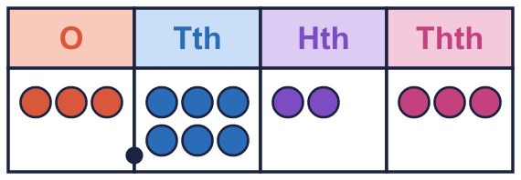  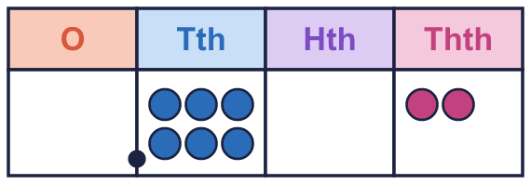
    a) The number is
    b) The number is
  1 | Write the number shown on each place value chart.
    a) The number is
    b) The number is
  2 | Write the number shown on each place value chart.  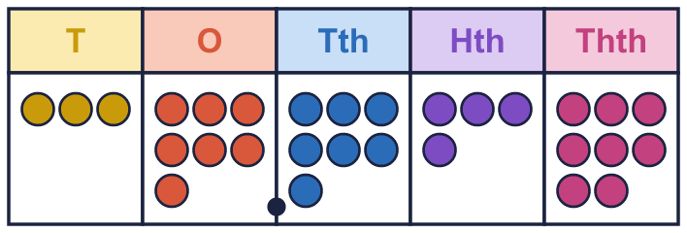  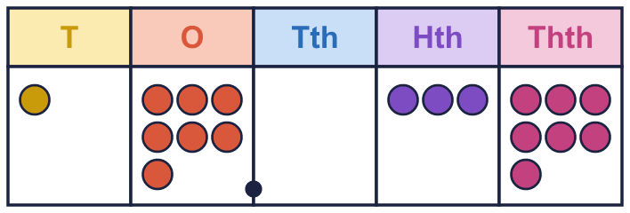
    a) The number is
    b) The number is
  2 | Write the number shown on each place value chart.
    a) The number is
    b) The number is
  3 | Use counters to make each number. Write how many counters go in each column.  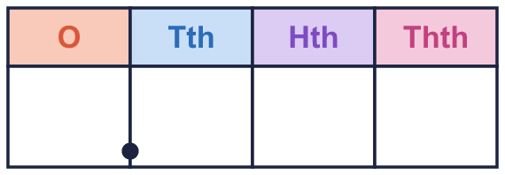
    a) 3.719:
    b) 0.348:
  3 | Use counters to make each number. Write how many counters go in each column.
    a) 3.719:
    b) 0.348:
  4 | Write what 10 counters in a column can be exchanged for.
    a) 10 thousandths = 1
    b) 10 hundredths = 1
    c) 10 tenths = 1
  4 | Write what 10 counters in a column can be exchanged for.
    a) 10 thousandths = 1
    b) 10 hundredths = 1
    c) 10 tenths = 1
  5 | What is the value of the digit in each number?
    a) the digit 2 in 8.927:
    b) the digit 9 in 2.149:
    c) the digit 9 in 7.396:
  5 | What is the value of the digit in each number?
    a) the digit 2 in 8.927:
    b) the digit 9 in 2.149:
    c) the digit 9 in 7.396:
  6 | Write each number as one decimal.
    a) 1 + 0.5 + 0.06 + 0.002 =
    b) 7 + 0.9 + 0.02 + 0.003 =
  6 | Write each number as one decimal.
    a) 1 + 0.5 + 0.06 + 0.002 =
    b) 7 + 0.9 + 0.02 + 0.003 =
  7 | Write < or > in each box. Use a place value chart to help.
    a) 0.565 |  | 0.698
    b) 0.249 |  | 0.257
    c) 0.912 |  | 0.171
    d) 0.874 |  | 0.141
  7 | Write < or > in each box. Use a place value chart to help.
    a) 0.565 |  | 0.698
    b) 0.249 |  | 0.257
    c) 0.912 |  | 0.171
    d) 0.874 |  | 0.141
  8 | Write these decimals in order, starting with the greatest.  3.778 0.443 1.667 3.614
  8 | Write these decimals in order, starting with the greatest.  3.778 0.443 1.667 3.614

  9 | Is Nina correct? Circle yes or no.  Yes / No  Explain how you know.
     | 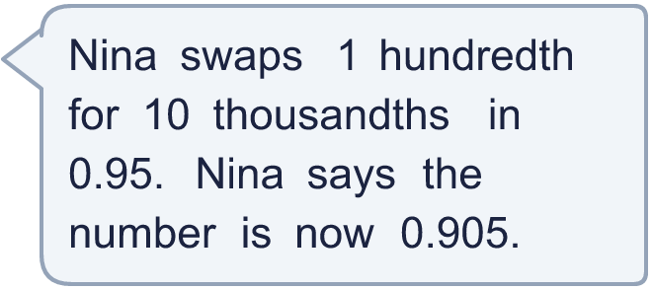
  9 | Is Nina correct? Circle yes or no.  Yes / No  Explain how you know.
  10 | Use each card once to make the smallest decimal of the form 0.___.
    
  10 | Use each card once to make the smallest decimal of the form 0.___.
  11 | Which of these are equal to 0.5? Write the letters.  A: ⁵⁰⁰⁄₁₀₀₀  B: 0.05  C: 0.500  D: 0.4 + 0.1
  11 | Which of these are equal to 0.5? Write the letters.  A: ⁵⁰⁰⁄₁₀₀₀  B: 0.05  C: 0.500  D: 0.4 + 0.1
  12 | Write the missing number.
    a) 0.9 + 0.02 + |  | = 0.924
  12 | Write the missing number.
    a) 0.9 + 0.02 + |  | = 0.924
  13 | Write a decimal that is between 0.37 and 0.38.
  13 | Write a decimal that is between 0.37 and 0.38.
  14 | Challenge  How many counters are needed in the thousandths (0.001) column to make 0.4 using only thousandths?
  14 | Challenge  How many counters are needed in the thousandths (0.001) column to make 0.4 using only thousandths?

Year 5 · Decimals and percentages · Step 7
Thousandths on a place value chart
Answers (teacher copy)

  1 | Write the number shown on each place value chart.  a) The number is 3.623  b) The number is 0.602
  2 | Write the number shown on each place value chart.  a) The number is 37.748  b) The number is 17.037
  3 | Use counters to make each number. Write how many counters go in each column.  a) 3.719: 3 7 1 9  b) 0.348: 0 3 4 8
  4 | Write what 10 counters in a column can be exchanged for.  a) 10 thousandths = 1 hundredth  b) 10 hundredths = 1 tenth  c) 10 tenths = 1 one
  5 | What is the value of the digit in each number?  a) the digit 2 in 8.927: 0.02  b) the digit 9 in 2.149: 0.009  c) the digit 9 in 7.396: 0.09
  6 | Write each number as one decimal.  a) 1 + 0.5 + 0.06 + 0.002 = 1.562  b) 7 + 0.9 + 0.02 + 0.003 = 7.923
  7 | Write < or > in each box. Use a place value chart to help.  a) 0.565 < 0.698  b) 0.249 < 0.257  c) 0.912 > 0.171  d) 0.874 > 0.141
  8 | Write these decimals in order, starting with the greatest.  3.778 0.443 1.667 3.614  3.778, 3.614, 1.667, 0.443
  9 | Is Nina correct? Circle yes or no.  Yes / No  Explain how you know.  No. 0.95 = 0.95 and 0.905 = 0.905, so they are not equal.
  10 | Use each card once to make the smallest decimal of the form 0.___.  0.147
  11 | Which of these are equal to 0.5? Write the letters.  A: ⁵⁰⁰⁄₁₀₀₀  B: 0.05  C: 0.500  D: 0.4 + 0.1  A, C, D
  12 | Write the missing number.  a) 0.9 + 0.02 + 0.004 = 0.924
  13 | Write a decimal that is between 0.37 and 0.38.  0.375
  14 | Challenge  How many counters are needed in the thousandths (0.001) column to make 0.4 using only thousandths?  400

