  Year 5 · Decimals and percentages · Step 12  Understand percentages | 
  Year 5 · Decimals and percentages · Step 12
  Understand percentages
  1 | Complete the sentences for each hundred square.  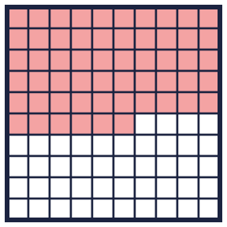  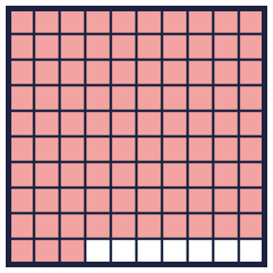
    a) There are
    parts out of a hundred shaded. This is
    %.
    b) There are
    parts out of a hundred shaded. This is
    %.
  1 | Complete the sentences for each hundred square.
    a) There are
    parts out of a hundred shaded. This is
    %.
    b) There are
    parts out of a hundred shaded. This is
    %.
  2 | Write the percentage of each hundred square that is shaded.  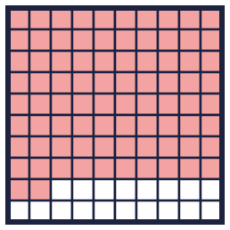  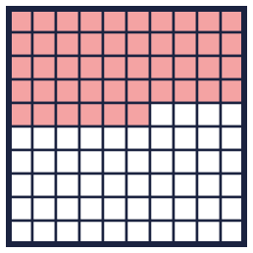  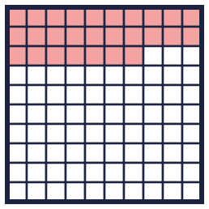
    a) |  | %
    b) |  | %
    c) |  | %
  2 | Write the percentage of each hundred square that is shaded.
    a) |  | %
    b) |  | %
    c) |  | %
  3 | The hundred square has 14% shaded pink and 26% shaded yellow.  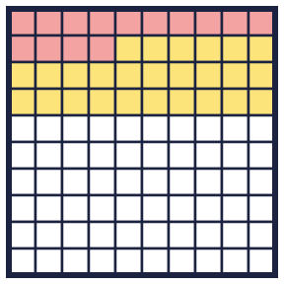
    What percentage is not shaded?
    %
  3 | The hundred square has 14% shaded pink and 26% shaded yellow.
    What percentage is not shaded?
    %
  4 | What percentage of each bar is shaded?      
    a) |  | %
    b) |  | %
    c) |  | %
  4 | What percentage of each bar is shaded?
    a) |  | %
    b) |  | %
    c) |  | %
  5 | A bar is split into 100 equal parts. 49% of the bar is shaded.
    What percentage is not shaded?
    %
  5 | A bar is split into 100 equal parts. 49% of the bar is shaded.
    What percentage is not shaded?
    %
  6 | a) How many passengers are already on the plane?  b) How many seats have been booked?
     | 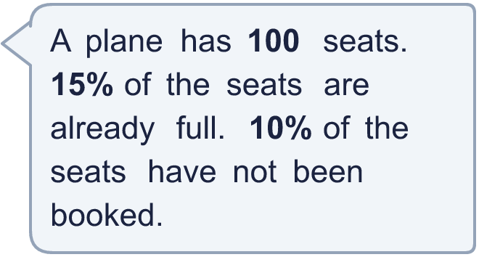
  6 | a) How many passengers are already on the plane?  b) How many seats have been booked?
  7 | What percentage of his money did Dexter spend?
     | 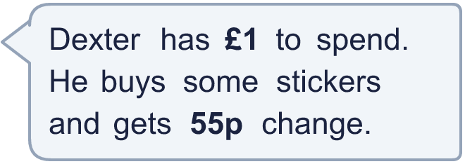
  7 | What percentage of his money did Dexter spend?
  8 | Ron, Alex and Amir are exploring how to make 90%.  Ron: 90% = 100% − 10%  Alex: 90% = 50% + 40%  Amir: 90% = 9 × 10%  Who is correct? Write the names, or All of them, or None.
  8 | Ron, Alex and Amir are exploring how to make 90%.  Ron: 90% = 100% − 10%  Alex: 90% = 50% + 40%  Amir: 90% = 9 × 10%  Who is correct? Write the names, or All of them, or None.

  9 | How many tickets were sold on Wednesday?
    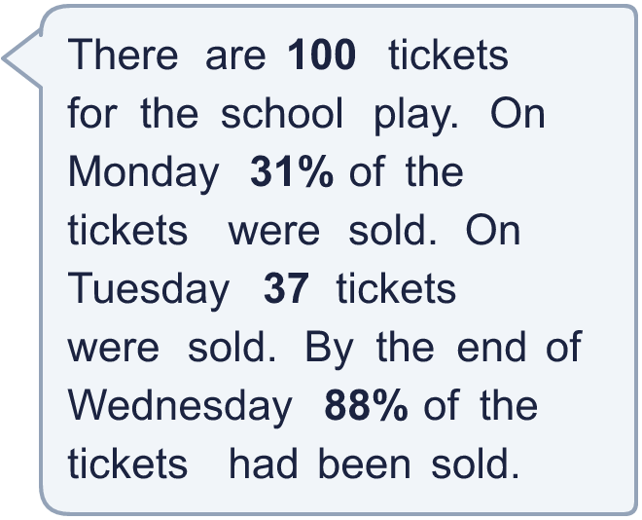
  9 | How many tickets were sold on Wednesday?
  10 | Rosie says that 25% of this bar is shaded.    Is Rosie correct? Circle yes or no.  Yes / No  Explain how you know.
  10 | Rosie says that 25% of this bar is shaded.  Is Rosie correct? Circle yes or no.  Yes / No  Explain how you know.
  11 | A bag has red, blue and green counters. 20% are red. 15% are blue. The rest are green.
    What percentage are green? |  | %
  11 | A bag has red, blue and green counters. 20% are red. 15% are blue. The rest are green.
    What percentage are green? |  | %
  12 | Work out the percentage for each.
    a) 3 out of 5 equal parts: |  | %
    b) 3 out of 4 equal parts: |  | %
  12 | Work out the percentage for each.
    a) 3 out of 5 equal parts: |  | %
    b) 3 out of 4 equal parts: |  | %
  13 | Find three different ways to make 65%.
  13 | Find three different ways to make 65%.
  14 | How many parts are not shaded?
     | 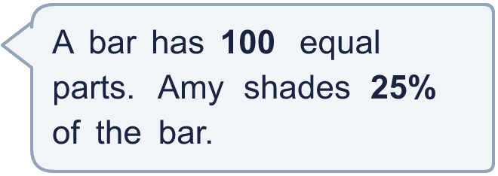
  14 | How many parts are not shaded?

Year 5 · Decimals and percentages · Step 12
Understand percentages
Answers (teacher copy)

  1 | Complete the sentences for each hundred square.  a) There are 56 parts out of a hundred shaded. This is 56 %.  b) There are 93 parts out of a hundred shaded. This is 93 %.
  2 | Write the percentage of each hundred square that is shaded.  a) 82 %  b) 46 %  c) 27 %
  3 | The hundred square has 14% shaded pink and 26% shaded yellow.  What percentage is not shaded? 60 %
  4 | What percentage of each bar is shaded?  a) 64 %  b) 75 %  c) 60 %
  5 | A bar is split into 100 equal parts. 49% of the bar is shaded.  What percentage is not shaded? 51 %
  6 | a) How many passengers are already on the plane? 15  b) How many seats have been booked? 90
  7 | What percentage of his money did Dexter spend? 45%
  8 | Ron, Alex and Amir are exploring how to make 90%.  Ron: 90% = 100% − 10%  Alex: 90% = 50% + 40%  Amir: 90% = 9 × 10%  Who is correct? Write the names, or All of them, or None.  All of them
  9 | How many tickets were sold on Wednesday? 20
  10 | Rosie says that 25% of this bar is shaded.  Is Rosie correct? Circle yes or no.  Yes / No  Explain how you know.  Yes. The bar has 4 equal parts, so each part is 25%. One part is shaded, so 25% is shaded.
  11 | A bag has red, blue and green counters. 20% are red. 15% are blue. The rest are green.  What percentage are green? 65 %
  12 | Work out the percentage for each.  a) 3 out of 5 equal parts: 60 %  b) 3 out of 4 equal parts: 75 %
  13 | Find three different ways to make 65%.  55% + 10%, 60% + 5%, 100% − 35%
  14 | How many parts are not shaded? 75

