  Year 5 · Fractions B · Step 6  Finding the whole | 
  Year 5 · Fractions B · Step 6
  Finding the whole
  1 | Write the whole amount.  a) ¹⁄₄ of ? = 9  b) ¹⁄₃ of ? = 12  c) ¹⁄₂ of ? = 8  d) ¹⁄₂ of ? = 10
  1 | Write the whole amount.  a) ¹⁄₄ of ? = 9  b) ¹⁄₃ of ? = 12  c) ¹⁄₂ of ? = 8  d) ¹⁄₂ of ? = 10
  2 | Write the whole amount.  a) ²⁄₂ of ? = 12  b) ²⁄₂ of ? = 8  c) ³⁄₅ of ? = 21  d) ⁴⁄₆ of ? = 16
  2 | Write the whole amount.  a) ²⁄₂ of ? = 12  b) ²⁄₂ of ? = 8  c) ³⁄₅ of ? = 21  d) ⁴⁄₆ of ? = 16
  3 | Write the whole amount. What do you notice?  a) ¹⁄₈ of ? = 6  b) ¹⁄₃ of ? = 6  c) ¹⁄₄ of ? = 6
  3 | Write the whole amount. What do you notice?  a) ¹⁄₈ of ? = 6  b) ¹⁄₃ of ? = 6  c) ¹⁄₄ of ? = 6
  4 | Write the whole amount.  a) ⁹⁄₁₀ of ? = 378  b) ²⁄₃ of ? = 92  c) ⁶⁄₇ of ? = 150  d) ²⁄₅ of ? = 6
  4 | Write the whole amount.  a) ⁹⁄₁₀ of ? = 378  b) ²⁄₃ of ? = 92  c) ⁶⁄₇ of ? = 150  d) ²⁄₅ of ? = 6
  5 | Jo is ⁴⁄₅ of the way through a race. She has run 1,060 m so far.
  5 | Jo is ⁴⁄₅ of the way through a race. She has run 1,060 m so far.
  6 | Tia drinks ³⁄₄ of a bottle of juice. There is 150 ml of juice left in the bottle.  How much juice was in the bottle when it was full? ml
  6 | Tia drinks ³⁄₄ of a bottle of juice. There is 150 ml of juice left in the bottle.  How much juice was in the bottle when it was full? ml
  7 | ¹⁄₃ of the sweets in a jar have been eaten. 4 sweets have been eaten.
  7 | ¹⁄₃ of the sweets in a jar have been eaten. 4 sweets have been eaten.
  8 | Write the whole amount.  a) ¹⁄₂ of ? = 2  b) ⁴⁄₆ of ? = 48  c) ²⁄₄ of ? = 20  d) ²⁄₂ of ? = 10
  8 | Write the whole amount.  a) ¹⁄₂ of ? = 2  b) ⁴⁄₆ of ? = 48  c) ²⁄₄ of ? = 20  d) ²⁄₂ of ? = 10

  9 | Is Boba correct? Circle yes or no.  Yes / No  Explain your answer.
     | 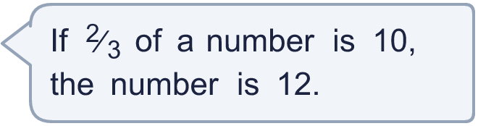
  9 | Is Boba correct? Circle yes or no.  Yes / No  Explain your answer.
  10 | ³⁄₇ of the apples in a bag are green. There are 33 green apples. All the other apples are red.  How many red apples are there?
  10 | ³⁄₇ of the apples in a bag are green. There are 33 green apples. All the other apples are red.  How many red apples are there?
  11 | ⁵⁄₁₀ of a number is 195. What is the number?
  11 | ⁵⁄₁₀ of a number is 195. What is the number?
  12 | ¹⁄₈ of an amount is 8.  What is ³⁄₈ of the same amount?
  12 | ¹⁄₈ of an amount is 8.  What is ³⁄₈ of the same amount?
  13 | A shop sells ²⁄₅ of its newspapers in the morning. It sells 10 newspapers.
  13 | A shop sells ²⁄₅ of its newspapers in the morning. It sells 10 newspapers.
  14 | Is Boba correct? Circle yes or no.  Yes / No  Explain your answer.
     | 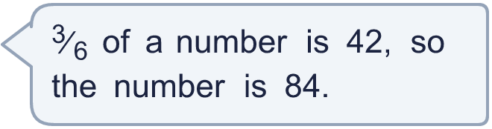
  14 | Is Boba correct? Circle yes or no.  Yes / No  Explain your answer.

Year 5 · Fractions B · Step 6
Finding the whole
Answers (teacher copy)

  1 | Write the whole amount.  a) ¹⁄₄ of ? = 9 36  b) ¹⁄₃ of ? = 12 36  c) ¹⁄₂ of ? = 8 16  d) ¹⁄₂ of ? = 10 20
  2 | Write the whole amount.  a) ²⁄₂ of ? = 12 12  b) ²⁄₂ of ? = 8 8  c) ³⁄₅ of ? = 21 35  d) ⁴⁄₆ of ? = 16 24
  3 | Write the whole amount. What do you notice?  a) ¹⁄₈ of ? = 6 48  b) ¹⁄₃ of ? = 6 18  c) ¹⁄₄ of ? = 6 24
  4 | Write the whole amount.  a) ⁹⁄₁₀ of ? = 378 420  b) ²⁄₃ of ? = 92 138  c) ⁶⁄₇ of ? = 150 175  d) ²⁄₅ of ? = 6 15
  5 | Jo is ⁴⁄₅ of the way through a race. She has run 1,060 m so far.  How long is the race? 1,325 m
  6 | Tia drinks ³⁄₄ of a bottle of juice. There is 150 ml of juice left in the bottle.  How much juice was in the bottle when it was full? 600 ml
  7 | ¹⁄₃ of the sweets in a jar have been eaten. 4 sweets have been eaten.  Total: 12, 8 Left:
  8 | Write the whole amount.  a) ¹⁄₂ of ? = 2 4  b) ⁴⁄₆ of ? = 48 72  c) ²⁄₄ of ? = 20 40  d) ²⁄₂ of ? = 10 10
  9 | Is Boba correct? Circle yes or no.  Yes / No  Explain your answer.  No. 10 ÷ 2 = 5 is one part, and 5 × 3 = 15, so the number is 15.
  10 | ³⁄₇ of the apples in a bag are green. There are 33 green apples. All the other apples are red.  How many red apples are there? 44
  11 | ⁵⁄₁₀ of a number is 195. What is the number?  390
  12 | ¹⁄₈ of an amount is 8.  What is ³⁄₈ of the same amount? 24
  13 | A shop sells ²⁄₅ of its newspapers in the morning. It sells 10 newspapers.  Total: 25, 15 Left:
  14 | Is Boba correct? Circle yes or no.  Yes / No  Explain your answer.  Yes. 42 ÷ 3 = 14 and 14 × 6 = 84, so the number is 84.

