  Year 5 · Multiply and divide B · Step 8  Dividing 4 digits by 1 digit | 
  Year 5 · Multiply and divide B · Step 8
  Dividing 4 digits by 1 digit
  1 | Work out the divisions.  a) 288 ÷ 9 =  b) 2,093 ÷ 7 =  c) 9,680 ÷ 8 =
  1 | Work out the divisions.  a) 288 ÷ 9 =  b) 2,093 ÷ 7 =  c) 9,680 ÷ 8 =
  2 | Work out the divisions. Watch for the zeros.  a) 5,190 ÷ 5 =  b) 1,288 ÷ 8 =  c) 4,140 ÷ 4 =
  2 | Work out the divisions. Watch for the zeros.  a) 5,190 ÷ 5 =  b) 1,288 ÷ 8 =  c) 4,140 ÷ 4 =
  3 | Write the missing number.
    a) |  | ÷ 2 | = | 888
    b) |  | ÷ 8 | = | 773
  3 | Write the missing number.
    a) |  | ÷ 2 | = | 888
    b) |  | ÷ 8 | = | 773
  4 | Write <, > or = in each box.
    a) | 4,923 ÷ 3 |  | 1,355 ÷ 5
    b) | 5,334 ÷ 7 |  | 1,526 ÷ 7
  4 | Write <, > or = in each box.
    a) | 4,923 ÷ 3 |  | 1,355 ÷ 5
    b) | 5,334 ÷ 7 |  | 1,526 ÷ 7
  5 | 3,470 sweets are shared equally between 5 schools.  How many sweets does each school get?
  5 | 3,470 sweets are shared equally between 5 schools.  How many sweets does each school get?
  6 | Work out the divisions.  a) 6,910 ÷ 5 =  b) 8,440 ÷ 8 =
  6 | Work out the divisions.  a) 6,910 ÷ 5 =  b) 8,440 ÷ 8 =
  7 | £34.00 is shared equally between 5 children.  How much does each child get?
  7 | £34.00 is shared equally between 5 children.  How much does each child get?
  8 | 56 ÷ 7 = 8. Use this fact to work out the divisions.  a) 560 ÷ 7 =  b) 5,600 ÷ 7 =  c) 5,600 ÷ 70 =
  8 | 56 ÷ 7 = 8. Use this fact to work out the divisions.  a) 560 ÷ 7 =  b) 5,600 ÷ 7 =  c) 5,600 ÷ 70 =

  9 | Is Boba correct? Circle yes or no.  Yes / No  Explain how you know.
     | 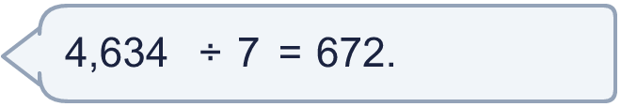
  9 | Is Boba correct? Circle yes or no.  Yes / No  Explain how you know.
  10 | What number did I start with?
     | 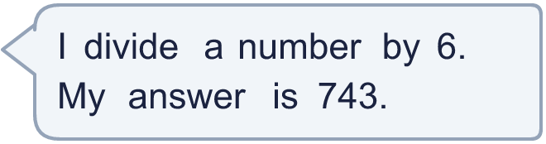
  10 | What number did I start with?
  11 | a) How many trays are filled?  b) How much money does the farm get for all the trays?
     | 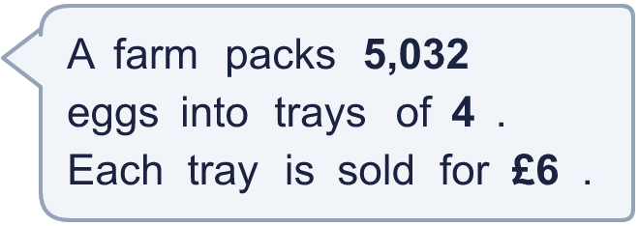
  11 | a) How many trays are filled?  b) How much money does the farm get for all the trays?
  12 | Which is greater: 7,710 ÷ 2 or 8,622 ÷ 9?  Write a or b. (a is the first calculation.)
  12 | Which is greater: 7,710 ÷ 2 or 8,622 ÷ 9?  Write a or b. (a is the first calculation.)
  13 | How many books does each library have now?
    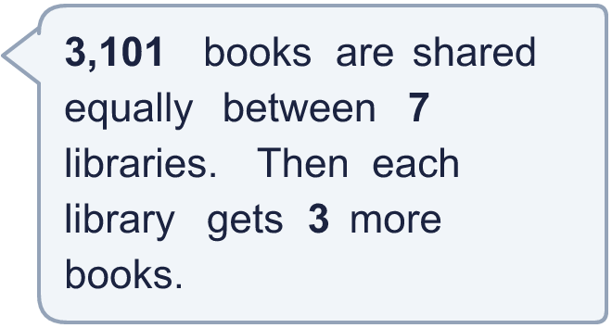
  13 | How many books does each library have now?
  14 | Write three different 4-digit numbers that can be divided by 9 with no remainder.
  14 | Write three different 4-digit numbers that can be divided by 9 with no remainder.

Year 5 · Multiply and divide B · Step 8
Dividing 4 digits by 1 digit
Answers (teacher copy)

  1 | Work out the divisions.  a) 288 ÷ 9 = 32  b) 2,093 ÷ 7 = 299  c) 9,680 ÷ 8 = 1,210
  2 | Work out the divisions. Watch for the zeros.  a) 5,190 ÷ 5 = 1,038  b) 1,288 ÷ 8 = 161  c) 4,140 ÷ 4 = 1,035
  3 | Write the missing number.  a) 1,776 ÷ 2 = 888  b) 6,184 ÷ 8 = 773
  4 | Write <, > or = in each box.  a) 4,923 ÷ 3 > 1,355 ÷ 5  b) 5,334 ÷ 7 > 1,526 ÷ 7
  5 | 3,470 sweets are shared equally between 5 schools.  How many sweets does each school get? 694
  6 | Work out the divisions.  a) 6,910 ÷ 5 = 1,382  b) 8,440 ÷ 8 = 1,055
  7 | £34.00 is shared equally between 5 children.  How much does each child get? £6.80
  8 | 56 ÷ 7 = 8. Use this fact to work out the divisions.  a) 560 ÷ 7 = 80  b) 5,600 ÷ 7 = 800  c) 5,600 ÷ 70 = 80
  9 | Is Boba correct? Circle yes or no.  Yes / No  Explain how you know.  672 × 7 = 4,704, not 4,634. The correct answer is 4,634 ÷ 7 = 662.
  10 | What number did I start with? 4,458
  11 | a) How many trays are filled? 1,258  b) How much money does the farm get for all the trays? £7,548
  12 | Which is greater: 7,710 ÷ 2 or 8,622 ÷ 9?  Write a or b. (a is the first calculation.) a
  13 | How many books does each library have now? 446
  14 | Write three different 4-digit numbers that can be divided by 9 with no remainder.  Any three 4-digit numbers with remainder 0 when divided by 9, for example 3,249, 5,499, 7,749

