  Year 5 · Multiply and divide B · Step 11  Multiplication and division problems | 
  Year 5 · Multiply and divide B · Step 11
  Multiplication and division problems
  1 | Work out the multiplications.  a) 220 × 7 =  b) 14 × 29 =  c) 2,852 × 7 =
  1 | Work out the multiplications.  a) 220 × 7 =  b) 14 × 29 =  c) 2,852 × 7 =
  2 | Work out the divisions. Write any remainder like this: 56 r 3.  a) 845 ÷ 3 =  b) 3,286 ÷ 4 =
  2 | Work out the divisions. Write any remainder like this: 56 r 3.  a) 845 ÷ 3 =  b) 3,286 ÷ 4 =
  3 | Pencils are packed in boxes of 8. There are 778 pencils.  a) How many full boxes can be made?  b) How many pencils are left over?
  3 | Pencils are packed in boxes of 8. There are 778 pencils.  a) How many full boxes can be made?  b) How many pencils are left over?
  4 | 263 people are coming to an event. Each table seats 6 people.  a) How many tables are needed?  b) How many empty seats will there be on the last table?
  4 | 263 people are coming to an event. Each table seats 6 people.  a) How many tables are needed?  b) How many empty seats will there be on the last table?
  5 | A multipack has 6 bottles of water. A box holds 3 multipacks. A shop orders 18 boxes.  How many bottles of water does the shop order?
  5 | A multipack has 6 bottles of water. A box holds 3 multipacks. A shop orders 18 boxes.  How many bottles of water does the shop order?
  6 | A packet has 35 stickers. Ron buys 7 packets. He shares the stickers equally between himself and 4 friends.  How many stickers do they each get?
  6 | A packet has 35 stickers. Ron buys 7 packets. He shares the stickers equally between himself and 4 friends.  How many stickers do they each get?
  7 | A blue ribbon is 48 cm long. A red ribbon is 9 times as long as the blue ribbon.  a) How long is the red ribbon? (cm)  b) How much longer is the red ribbon? (cm)
  7 | A blue ribbon is 48 cm long. A red ribbon is 9 times as long as the blue ribbon.  a) How long is the red ribbon? (cm)  b) How much longer is the red ribbon? (cm)
  8 | The children are working out how to find 36 × 6 ÷ 3.  Whose methods work? Write the names.
     | 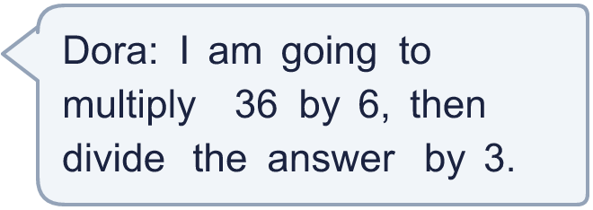
     | 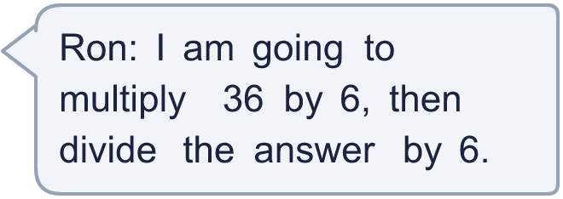
    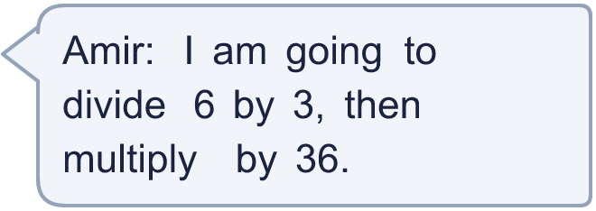
     | 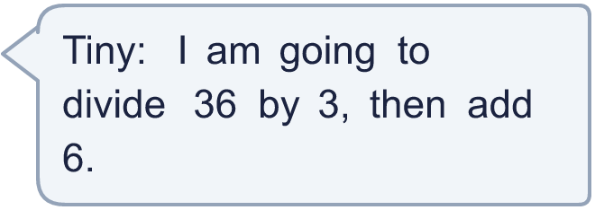
  8 | The children are working out how to find 36 × 6 ÷ 3.  Whose methods work? Write the names.

  9 | a) How much at Book Barn?  b) How much at Pen Place?  c) Which shop is cheaper?
    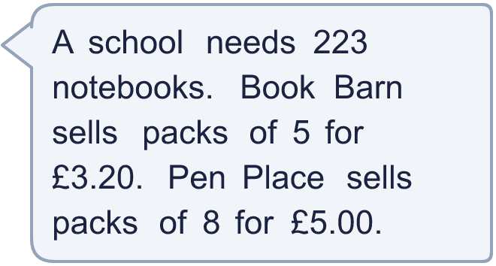
  9 | a) How much at Book Barn?  b) How much at Pen Place?  c) Which shop is cheaper?
  10 | a) How many full bags can be made?  b) How many buns are left over?
    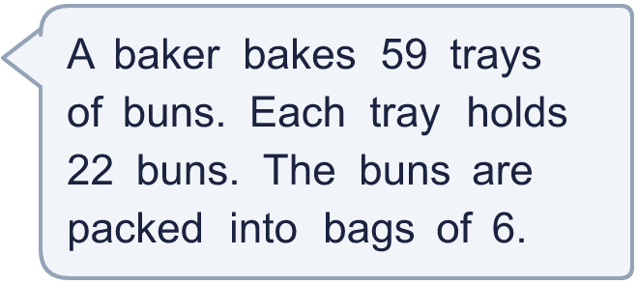
  10 | a) How many full bags can be made?  b) How many buns are left over?
  11 | Is Boba correct? Circle yes or no.  Yes / No  Explain how you know.
    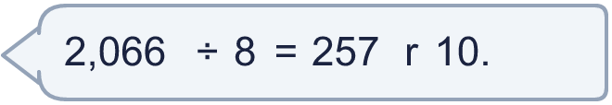
  11 | Is Boba correct? Circle yes or no.  Yes / No  Explain how you know.
  12 | What number did I start with?
    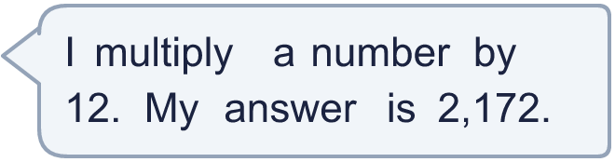
  12 | What number did I start with?
  13 | a) How many times must the ride go round so that everyone rides once?  b) How many people are on the last ride?
    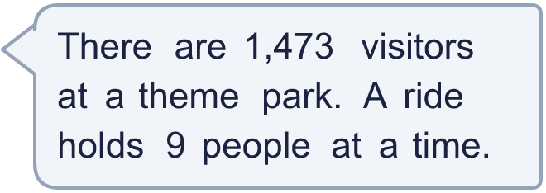
  13 | a) How many times must the ride go round so that everyone rides once?  b) How many people are on the last ride?
  14 | Write a 3-digit number and a 2-digit number that multiply to give an answer between 40,000 and 50,000.
  14 | Write a 3-digit number and a 2-digit number that multiply to give an answer between 40,000 and 50,000.

Year 5 · Multiply and divide B · Step 11
Multiplication and division problems
Answers (teacher copy)

  1 | Work out the multiplications.  a) 220 × 7 = 1,540  b) 14 × 29 = 406  c) 2,852 × 7 = 19,964
  2 | Work out the divisions. Write any remainder like this: 56 r 3.  a) 845 ÷ 3 = 281 r 2  b) 3,286 ÷ 4 = 821 r 2
  3 | Pencils are packed in boxes of 8. There are 778 pencils.  a) How many full boxes can be made? 97  b) How many pencils are left over? 2
  4 | 263 people are coming to an event. Each table seats 6 people.  a) How many tables are needed? 44  b) How many empty seats will there be on the last table? 1
  5 | A multipack has 6 bottles of water. A box holds 3 multipacks. A shop orders 18 boxes.  How many bottles of water does the shop order? 324
  6 | A packet has 35 stickers. Ron buys 7 packets. He shares the stickers equally between himself and 4 friends.  How many stickers do they each get? 49
  7 | A blue ribbon is 48 cm long. A red ribbon is 9 times as long as the blue ribbon.  a) How long is the red ribbon? (cm) 432  b) How much longer is the red ribbon? (cm) 384
  8 | The children are working out how to find 36 × 6 ÷ 3.  Whose methods work? Write the names. Dora, Amir
  9 | a) How much at Book Barn? £144.00  b) How much at Pen Place? £140.00  c) Which shop is cheaper? Pen Place
  10 | a) How many full bags can be made? 216  b) How many buns are left over? 2
  11 | Is Boba correct? Circle yes or no.  Yes / No  Explain how you know.  The remainder 10 is bigger than 8, so another group of 8 can be made. 2,066 ÷ 8 = 258 r 2.
  12 | What number did I start with? 181
  13 | a) How many times must the ride go round so that everyone rides once? 164  b) How many people are on the last ride? 6
  14 | Write a 3-digit number and a 2-digit number that multiply to give an answer between 40,000 and 50,000.  Any 3-digit × 2-digit multiplication with a product between 40,000 and 50,000, for example 991 × 45 or 880 × 51

