  Year 5 · Multiply and divide B · Step 6  Multiplication problems | 
  Year 5 · Multiply and divide B · Step 6
  Multiplication problems
  1 | Work out 38 × 100 and then 38 × 99. What do you notice?  a) 38 × 100 =  b) 38 × 99 =
  1 | Work out 38 × 100 and then 38 × 99. What do you notice?  a) 38 × 100 =  b) 38 × 99 =
  2 | Work out the multiplications. Think about multiplying by 100 or 1,000 first.  a) 36 × 99 =  b) 47 × 99 =  c) 23 × 999 =  d) 99 × 204 =
  2 | Work out the multiplications. Think about multiplying by 100 or 1,000 first.  a) 36 × 99 =  b) 47 × 99 =  c) 23 × 999 =  d) 99 × 204 =
  3 | Write the missing number. Use factor pairs.
    a) | 213 × 15 | = | 213 × 3 ×
    b) | 320 × 16 | = | 320 × 2 ×
  3 | Write the missing number. Use factor pairs.
    a) | 213 × 15 | = | 213 × 3 ×
    b) | 320 × 16 | = | 320 × 2 ×
  4 | Mo works out 161 × 15. He multiplies by 3 first, then by 5.  a) 161 × 3 =  b) So 161 × 15 =
  4 | Mo works out 161 × 15. He multiplies by 3 first, then by 5.  a) 161 × 3 =  b) So 161 × 15 =
  5 | Use factor pairs to work out the multiplications. For example, 8 = 2 × 4.  a) 339 × 8 =  b) 278 × 15 =  c) 18 × 308 =  d) 27 × 273 =
  5 | Use factor pairs to work out the multiplications. For example, 8 = 2 × 4.  a) 339 × 8 =  b) 278 × 15 =  c) 18 × 308 =  d) 27 × 273 =
  6 | A school serves 178 dinners every day. There are 5 days in a week and 9 weeks in a half term.  How many dinners does the school serve in a half term?
  6 | A school serves 178 dinners every day. There are 5 days in a week and 9 weeks in a half term.  How many dinners does the school serve in a half term?
  7 | A pen costs £2.43. A school buys 33 boxes with 11 pens in each box.  How much do the pens cost altogether?
  7 | A pen costs £2.43. A school buys 33 boxes with 11 pens in each box.  How much do the pens cost altogether?
  8 | Kim works out the multiplication below. Write the missing digits.  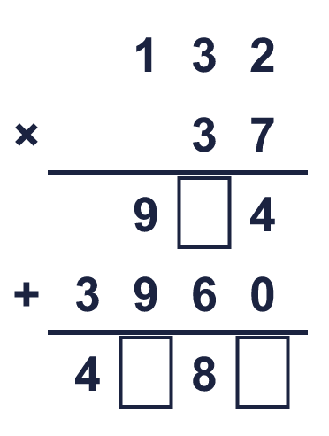  Missing digits, from top to bottom and left to right:
  8 | Kim works out the multiplication below. Write the missing digits.  Missing digits, from top to bottom and left to right:

  9 | a) How far does the lorry travel? (km)  b) How far does the train travel? (km)  c) How much further does the one that goes furthest travel? (km)
     | 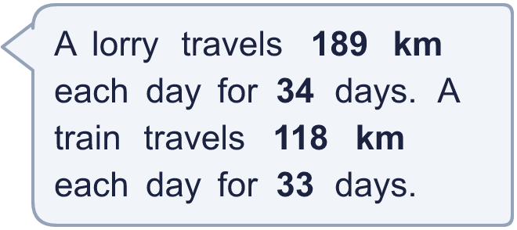
  9 | a) How far does the lorry travel? (km)  b) How far does the train travel? (km)  c) How much further does the one that goes furthest travel? (km)
  10 | Use this fact to work out the other multiplications. You do not need a written method.  a) 1,883 × 20 =  b) 1,883 × 22 =  c) 1,882 × 21 =
    
  10 | Use this fact to work out the other multiplications. You do not need a written method.  a) 1,883 × 20 =  b) 1,883 × 22 =  c) 1,882 × 21 =
  11 | Is this statement true? 83 × 410 = 8,300 × 41  Yes / No  Explain how you know.
  11 | Is this statement true? 83 × 410 = 8,300 × 41  Yes / No  Explain how you know.
  12 | Is this statement true? 152 × 48 + 15 = (152 + 15) × 48  Yes / No  Explain how you know.
  12 | Is this statement true? 152 × 48 + 15 = (152 + 15) × 48  Yes / No  Explain how you know.
  13 | a) Mo’s first answer:  b) Mo’s final answer:  c) Sam’s first answer:  d) Sam’s final answer:
     | 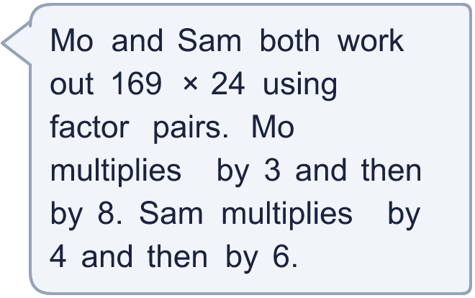
  13 | a) Mo’s first answer:  b) Mo’s final answer:  c) Sam’s first answer:  d) Sam’s final answer:
  14 | Complete the multiplication in two different ways: ___ × ___ = 756
  14 | Complete the multiplication in two different ways: ___ × ___ = 756

Year 5 · Multiply and divide B · Step 6
Multiplication problems
Answers (teacher copy)

  1 | Work out 38 × 100 and then 38 × 99. What do you notice?  a) 38 × 100 = 3,800  b) 38 × 99 = 3,762
  2 | Work out the multiplications. Think about multiplying by 100 or 1,000 first.  a) 36 × 99 = 3,564  b) 47 × 99 = 4,653  c) 23 × 999 = 22,977  d) 99 × 204 = 20,196
  3 | Write the missing number. Use factor pairs.  a) 213 × 15 = 213 × 3 × 5  b) 320 × 16 = 320 × 2 × 8
  4 | Mo works out 161 × 15. He multiplies by 3 first, then by 5.  a) 161 × 3 = 483  b) So 161 × 15 = 2,415
  5 | Use factor pairs to work out the multiplications. For example, 8 = 2 × 4.  a) 339 × 8 = 2,712  b) 278 × 15 = 4,170  c) 18 × 308 = 5,544  d) 27 × 273 = 7,371
  6 | A school serves 178 dinners every day. There are 5 days in a week and 9 weeks in a half term.  How many dinners does the school serve in a half term? 8,010
  7 | A pen costs £2.43. A school buys 33 boxes with 11 pens in each box.  How much do the pens cost altogether? £882.09
  8 | Kim works out the multiplication below. Write the missing digits.  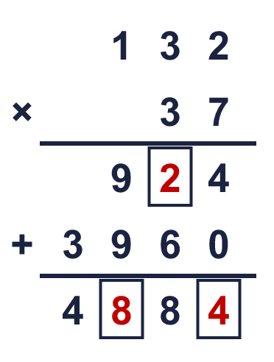  Missing digits, from top to bottom and left to right: 2 8 4
  9 | a) How far does the lorry travel? (km) 6,426  b) How far does the train travel? (km) 3,894  c) How much further does the one that goes furthest travel? (km) 2,532
  10 | Use this fact to work out the other multiplications. You do not need a written method.  a) 1,883 × 20 = 37,660  b) 1,883 × 22 = 41,426  c) 1,882 × 21 = 39,522
  11 | Is this statement true? 83 × 410 = 8,300 × 41  Yes / No  Explain how you know.  83 × 410 = 34,030 but 8,300 × 41 = 340,300. One number is 10 times bigger and the other has stayed the same, so the products are not equal.
  12 | Is this statement true? 152 × 48 + 15 = (152 + 15) × 48  Yes / No  Explain how you know.  152 × 48 + 15 = 7,311 but (152 + 15) × 48 = 8,016. The 15 must be multiplied by 48 as well.
  13 | a) Mo’s first answer: 507  b) Mo’s final answer: 4,056  c) Sam’s first answer: 676  d) Sam’s final answer: 4,056
  14 | Complete the multiplication in two different ways: ___ × ___ = 756  Any two pairs of whole numbers that multiply to 756, for example 2 × 378 or 3 × 252

