  Year 5 · Multiply and divide B · Step 2  Multiplying 2 digits by 2 digits (area model) | 
  Year 5 · Multiply and divide B · Step 2
  Multiplying 2 digits by 2 digits (area model)
  1 | Complete the area model for 19 × 24.  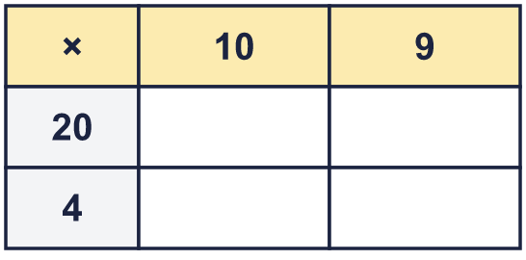  So 19 × 24 =
  1 | Complete the area model for 19 × 24.  So 19 × 24 =
  2 | Complete the area model for 26 × 28.  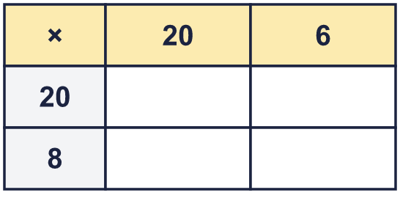  So 26 × 28 =
  2 | Complete the area model for 26 × 28.  So 26 × 28 =
  3 | Work out the parts of 21 × 32.  a) 21 × 2 =  b) 21 × 30 =  c) 21 × 32 =
  3 | Work out the parts of 21 × 32.  a) 21 × 2 =  b) 21 × 30 =  c) 21 × 32 =
  4 | The area model shows 39 × 22 = 858. Write the missing number.  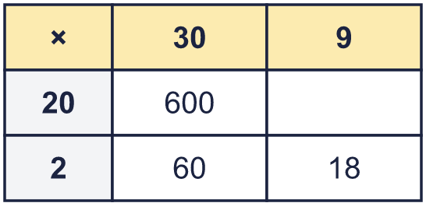  Missing number:
  4 | The area model shows 39 × 22 = 858. Write the missing number.  Missing number:
  5 | Complete the area model for 43 × 48.  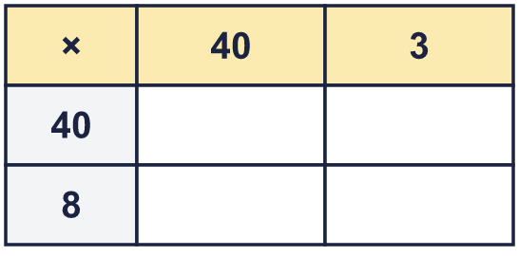  So 43 × 48 =
  5 | Complete the area model for 43 × 48.  So 43 × 48 =
  6 | Work out the multiplications. Draw an area model in your book to help you.  a) 32 × 25 =  b) 45 × 33 =  c) 53 × 53 =
  6 | Work out the multiplications. Draw an area model in your book to help you.  a) 32 × 25 =  b) 45 × 33 =  c) 53 × 53 =
  7 | Write the missing number. Use an area model to help.
    a) | 27 × |  | = | 567
    b) | 21 × |  | = | 462
  7 | Write the missing number. Use an area model to help.
    a) | 27 × |  | = | 567
    b) | 21 × |  | = | 462
  8 | A hall has 31 rows of 14 seats.  How many seats are there altogether?
  8 | A hall has 31 rows of 14 seats.  How many seats are there altogether?

  9 | Is Boba correct? Circle yes or no.  Yes / No  Explain how you know.
     | 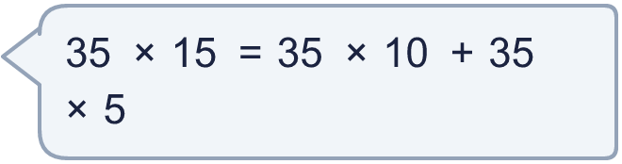
  9 | Is Boba correct? Circle yes or no.  Yes / No  Explain how you know.
  10 | 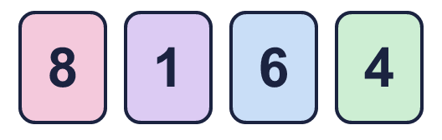  a) What is the greatest product you can make?  b) What is the smallest product you can make?  c) How many different products are between 1,100 and 3,800?
    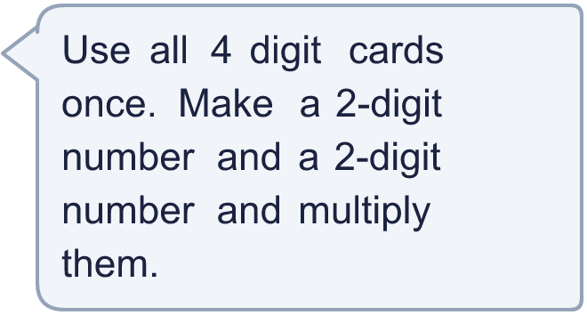
  10 | a) What is the greatest product you can make?  b) What is the smallest product you can make?  c) How many different products are between 1,100 and 3,800?
  11 | a) How many square metres of tiles are needed?  b) How much do the tiles cost?
     | 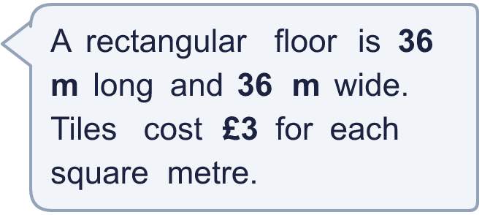
  11 | a) How many square metres of tiles are needed?  b) How much do the tiles cost?
  12 | Is Boba correct? Circle yes or no.  Yes / No  Explain how you know.
     | 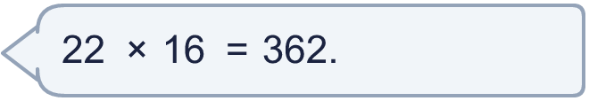
  12 | Is Boba correct? Circle yes or no.  Yes / No  Explain how you know.
  13 | The area model shows 41 × 45 = 1,845. Write the missing number.  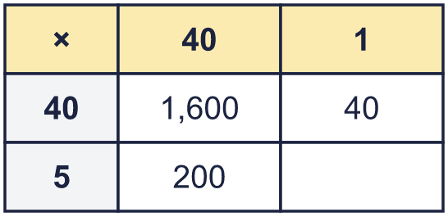  Missing number:
  13 | The area model shows 41 × 45 = 1,845. Write the missing number.  Missing number:
  14 | Write a 2-digit number and a 2-digit number that multiply to give an answer between 400 and 500.
  14 | Write a 2-digit number and a 2-digit number that multiply to give an answer between 400 and 500.

Year 5 · Multiply and divide B · Step 2
Multiplying 2 digits by 2 digits (area model)
Answers (teacher copy)

  1 | Complete the area model for 19 × 24.  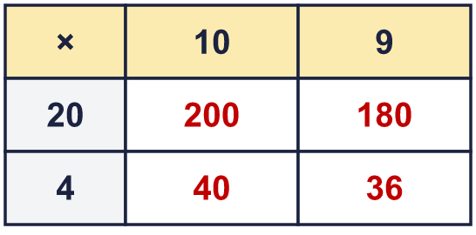  So 19 × 24 = 456
  2 | Complete the area model for 26 × 28.  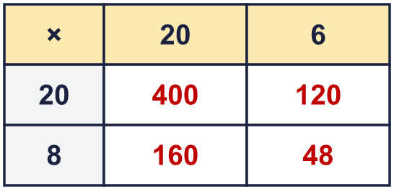  So 26 × 28 = 728
  3 | Work out the parts of 21 × 32.  a) 21 × 2 = 42  b) 21 × 30 = 630  c) 21 × 32 = 672
  4 | The area model shows 39 × 22 = 858. Write the missing number.  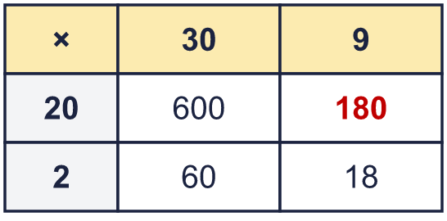  Missing number: 180
  5 | Complete the area model for 43 × 48.  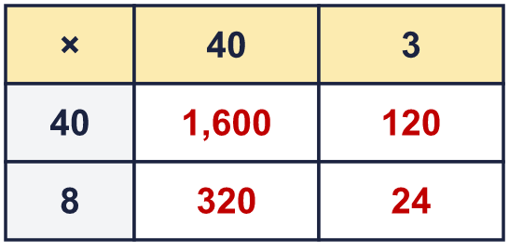  So 43 × 48 = 2,064
  6 | Work out the multiplications. Draw an area model in your book to help you.  a) 32 × 25 = 800  b) 45 × 33 = 1,485  c) 53 × 53 = 2,809
  7 | Write the missing number. Use an area model to help.  a) 27 × 21 = 567  b) 21 × 22 = 462
  8 | A hall has 31 rows of 14 seats.  How many seats are there altogether? 434
  9 | Is Boba correct? Circle yes or no.  Yes / No  Explain how you know.  35 × 10 + 35 × 5 = 525 and 35 × 15 = 525, so they are equal. Both parts of 35 are multiplied by both parts of 15.
  10 | a) What is the greatest product you can make? 5,184  b) What is the smallest product you can make? 768  c) How many different products are between 1,100 and 3,800? 7
  11 | a) How many square metres of tiles are needed? 1,296  b) How much do the tiles cost? £3,888
  12 | Is Boba correct? Circle yes or no.  Yes / No  Explain how you know.  2 × 6 = 12, so the answer must end in 2. The correct answer is 22 × 16 = 352, not 362.
  13 | The area model shows 41 × 45 = 1,845. Write the missing number.  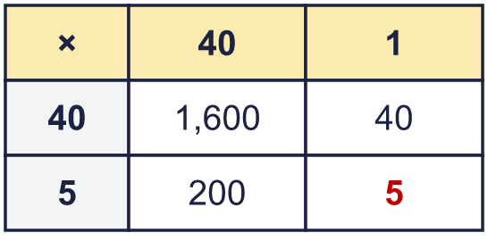  Missing number: 5
  14 | Write a 2-digit number and a 2-digit number that multiply to give an answer between 400 and 500.  Any 2-digit × 2-digit multiplication with a product between 400 and 500, for example 24 × 19 or 43 × 10

