  Year 5 · Multiply and divide B · Step 3  Multiplying 2 digits by 2 digits | 
  Year 5 · Multiply and divide B · Step 3
  Multiplying 2 digits by 2 digits
  1 | Complete the multiplications. Use the first answer to help with the second.  a) 54 × 7 =  b) 54 × 70 =  c) 73 × 7 =  d) 73 × 70 =
  1 | Complete the multiplications. Use the first answer to help with the second.  a) 54 × 7 =  b) 54 × 70 =  c) 73 × 7 =  d) 73 × 70 =
  2 | Write the missing digits in the multiplication 50 × 33.  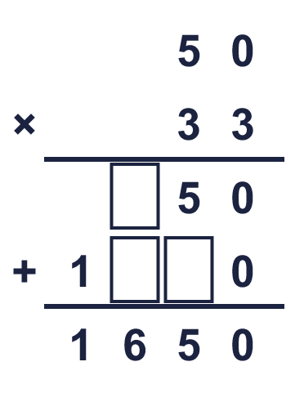  Missing digits, from top to bottom and left to right:
  2 | Write the missing digits in the multiplication 50 × 33.  Missing digits, from top to bottom and left to right:
  3 | Work out the multiplications. Use the column method.  a) 25 × 24 =  b) 56 × 83 =  c) 33 × 22 =
  3 | Work out the multiplications. Use the column method.  a) 25 × 24 =  b) 56 × 83 =  c) 33 × 22 =
  4 | Work out the multiplications. Watch the zeros.  a) 90 × 49 =  b) 703 × 86 =
  4 | Work out the multiplications. Watch the zeros.  a) 90 × 49 =  b) 703 × 86 =
  5 | Estimate 65 × 36 by rounding each number to its first digit (1 significant figure).  Estimate:
  5 | Estimate 65 × 36 by rounding each number to its first digit (1 significant figure).  Estimate:
  6 | A box holds 32 pencils. A shop has 21 boxes.  How many pencils are there?
  6 | A box holds 32 pencils. A shop has 21 boxes.  How many pencils are there?
  7 | One ticket costs £5.22. A family buys 69 tickets.  How much do the tickets cost altogether?
  7 | One ticket costs £5.22. A family buys 69 tickets.  How much do the tickets cost altogether?
  8 | Look at this calculation: 71 × 71. Without working it out, which of these could be the answer? Use the ones digit and an estimate.  504 5,041 5,049
  8 | Look at this calculation: 71 × 71. Without working it out, which of these could be the answer? Use the ones digit and an estimate.  504 5,041 5,049

  9 | Is Boba correct? Circle yes or no.  Yes / No  Explain how you know.
     | 
  9 | Is Boba correct? Circle yes or no.  Yes / No  Explain how you know.
  10 | 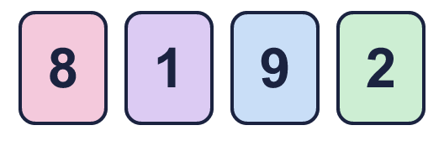  a) What is the greatest product you can make?  b) What is the smallest product you can make?  c) How many different products are between 1,100 and 2,600?
    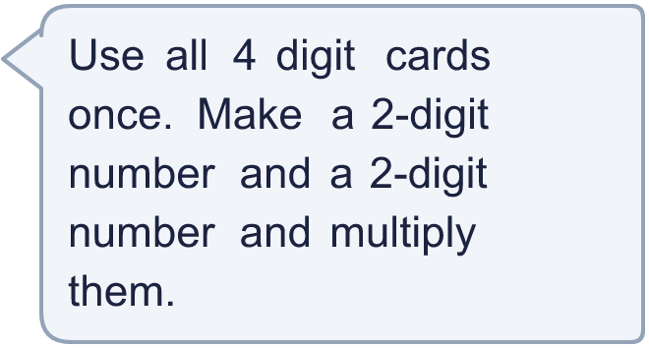
  10 | a) What is the greatest product you can make?  b) What is the smallest product you can make?  c) How many different products are between 1,100 and 2,600?
  11 | What number did I start with?
     | 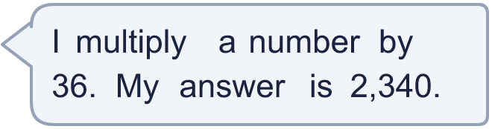
  11 | What number did I start with?
  12 | a) How many points does Amir score altogether?  b) How many points does Whitney score altogether?  c) How many more points does the higher scorer have?
     | 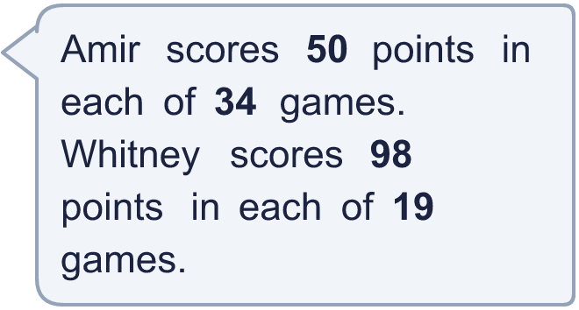
  12 | a) How many points does Amir score altogether?  b) How many points does Whitney score altogether?  c) How many more points does the higher scorer have?
  13 | Use this fact to work out the other multiplications. You do not need the column method.  a) 20 × 12 =  b) 20 × 14 =  c) 21 × 13 =
    
  13 | Use this fact to work out the other multiplications. You do not need the column method.  a) 20 × 12 =  b) 20 × 14 =  c) 21 × 13 =
  14 | Write a 2-digit number and a 2-digit number that multiply to give an answer between 3,000 and 4,000.
  14 | Write a 2-digit number and a 2-digit number that multiply to give an answer between 3,000 and 4,000.

Year 5 · Multiply and divide B · Step 3
Multiplying 2 digits by 2 digits
Answers (teacher copy)

  1 | Complete the multiplications. Use the first answer to help with the second.  a) 54 × 7 = 378  b) 54 × 70 = 3,780  c) 73 × 7 = 511  d) 73 × 70 = 5,110
  2 | Write the missing digits in the multiplication 50 × 33.  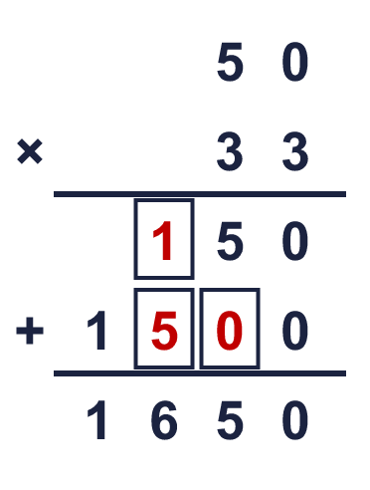  Missing digits, from top to bottom and left to right: 1 5 0
  3 | Work out the multiplications. Use the column method.  a) 25 × 24 = 600  b) 56 × 83 = 4,648  c) 33 × 22 = 726
  4 | Work out the multiplications. Watch the zeros.  a) 90 × 49 = 4,410  b) 703 × 86 = 60,458
  5 | Estimate 65 × 36 by rounding each number to its first digit (1 significant figure).  Estimate: 2,800
  6 | A box holds 32 pencils. A shop has 21 boxes.  How many pencils are there? 672
  7 | One ticket costs £5.22. A family buys 69 tickets.  How much do the tickets cost altogether? £360.18
  8 | Look at this calculation: 71 × 71. Without working it out, which of these could be the answer? Use the ones digit and an estimate.  504 5,041 5,049  5,041
  9 | Is Boba correct? Circle yes or no.  Yes / No  Explain how you know.  3 × 8 = 24, so the answer must end in 4. The correct answer is 63 × 28 = 1,764, not 1,664.
  10 | a) What is the greatest product you can make? 7,462  b) What is the smallest product you can make? 522  c) How many different products are between 1,100 and 2,600? 7
  11 | What number did I start with? 65
  12 | a) How many points does Amir score altogether? 1,700  b) How many points does Whitney score altogether? 1,862  c) How many more points does the higher scorer have? 162
  13 | Use this fact to work out the other multiplications. You do not need the column method.  a) 20 × 12 = 240  b) 20 × 14 = 280  c) 21 × 13 = 273
  14 | Write a 2-digit number and a 2-digit number that multiply to give an answer between 3,000 and 4,000.  Any 2-digit × 2-digit multiplication with a product between 3,000 and 4,000, for example 97 × 36 or 87 × 40

