  Year 5 · Multiply and divide B · Step 4  Multiplying 3 digits by 2 digits | 
  Year 5 · Multiply and divide B · Step 4
  Multiplying 3 digits by 2 digits
  1 | Complete the multiplications. Use the first answer to help with the second.  a) 497 × 2 =  b) 497 × 20 =  c) 332 × 8 =  d) 332 × 80 =
  1 | Complete the multiplications. Use the first answer to help with the second.  a) 497 × 2 =  b) 497 × 20 =  c) 332 × 8 =  d) 332 × 80 =
  2 | Write the missing digits in the multiplication 201 × 47.  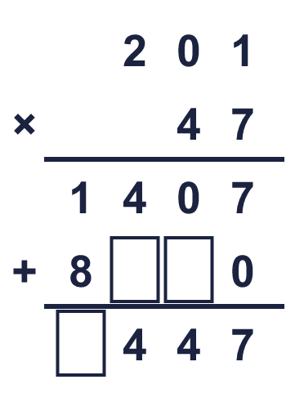  Missing digits, from top to bottom and left to right:
  2 | Write the missing digits in the multiplication 201 × 47.  Missing digits, from top to bottom and left to right:
  3 | Work out the multiplications. Use the column method.  a) 86 × 33 =  b) 744 × 16 =  c) 850 × 83 =
  3 | Work out the multiplications. Use the column method.  a) 86 × 33 =  b) 744 × 16 =  c) 850 × 83 =
  4 | Work out the multiplications. Watch the zeros.  a) 702 × 24 =  b) 705 × 54 =
  4 | Work out the multiplications. Watch the zeros.  a) 702 × 24 =  b) 705 × 54 =
  5 | Estimate 635 × 98 by rounding each number to its first digit (1 significant figure).  Estimate:
  5 | Estimate 635 × 98 by rounding each number to its first digit (1 significant figure).  Estimate:
  6 | A machine prints 322 labels every minute. It runs for 84 minutes.  How many labels does it print?
  6 | A machine prints 322 labels every minute. It runs for 84 minutes.  How many labels does it print?
  7 | One ticket costs £7.31. A family buys 44 tickets.  How much do the tickets cost altogether?
  7 | One ticket costs £7.31. A family buys 44 tickets.  How much do the tickets cost altogether?
  8 | Look at this calculation: 636 × 22. Without working it out, which of these could be the answer? Use the ones digit and an estimate.  13,996 13,992 139,920
  8 | Look at this calculation: 636 × 22. Without working it out, which of these could be the answer? Use the ones digit and an estimate.  13,996 13,992 139,920

  9 | Is Boba correct? Circle yes or no.  Yes / No  Explain how you know.
     | 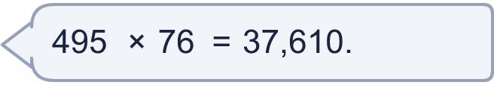
  9 | Is Boba correct? Circle yes or no.  Yes / No  Explain how you know.
  10 | 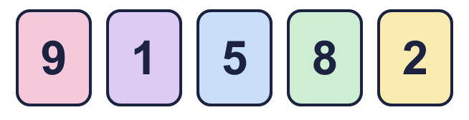  a) What is the greatest product you can make?  b) What is the smallest product you can make?
    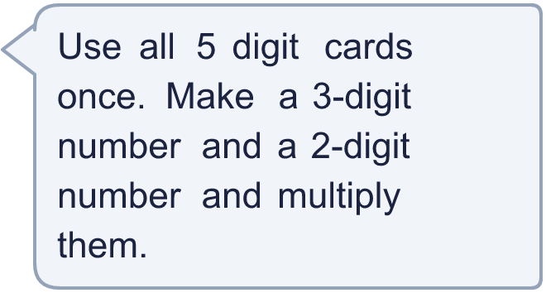
  10 | a) What is the greatest product you can make?  b) What is the smallest product you can make?
  11 | What number did I start with?
     | 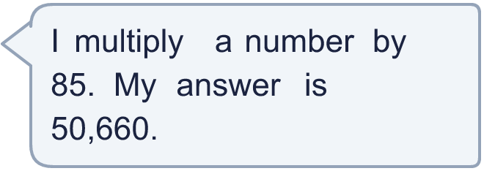
  11 | What number did I start with?
  12 | a) How many points does Amir score altogether?  b) How many points does Whitney score altogether?  c) How many more points does the higher scorer have?
     | 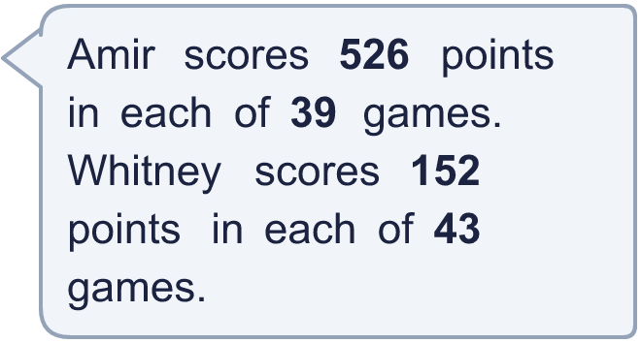
  12 | a) How many points does Amir score altogether?  b) How many points does Whitney score altogether?  c) How many more points does the higher scorer have?
  13 | Use this fact to work out the other multiplications. You do not need the column method.  a) 843 × 26 =  b) 843 × 28 =  c) 844 × 27 =
    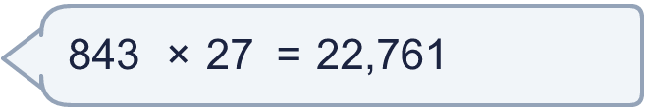
  13 | Use this fact to work out the other multiplications. You do not need the column method.  a) 843 × 26 =  b) 843 × 28 =  c) 844 × 27 =
  14 | Write a 3-digit number and a 2-digit number that multiply to give an answer between 10,000 and 20,000.
  14 | Write a 3-digit number and a 2-digit number that multiply to give an answer between 10,000 and 20,000.

Year 5 · Multiply and divide B · Step 4
Multiplying 3 digits by 2 digits
Answers (teacher copy)

  1 | Complete the multiplications. Use the first answer to help with the second.  a) 497 × 2 = 994  b) 497 × 20 = 9,940  c) 332 × 8 = 2,656  d) 332 × 80 = 26,560
  2 | Write the missing digits in the multiplication 201 × 47.  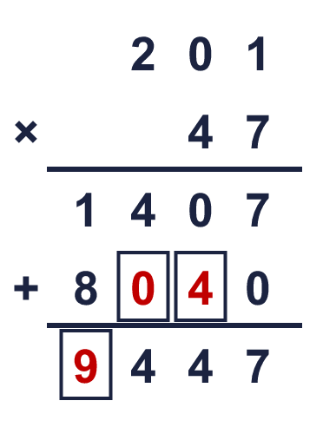  Missing digits, from top to bottom and left to right: 0 4 9
  3 | Work out the multiplications. Use the column method.  a) 86 × 33 = 2,838  b) 744 × 16 = 11,904  c) 850 × 83 = 70,550
  4 | Work out the multiplications. Watch the zeros.  a) 702 × 24 = 16,848  b) 705 × 54 = 38,070
  5 | Estimate 635 × 98 by rounding each number to its first digit (1 significant figure).  Estimate: 60,000
  6 | A machine prints 322 labels every minute. It runs for 84 minutes.  How many labels does it print? 27,048
  7 | One ticket costs £7.31. A family buys 44 tickets.  How much do the tickets cost altogether? £321.64
  8 | Look at this calculation: 636 × 22. Without working it out, which of these could be the answer? Use the ones digit and an estimate.  13,996 13,992 139,920  13,992
  9 | Is Boba correct? Circle yes or no.  Yes / No  Explain how you know.  5 × 6 = 30, so the answer must end in 0. The correct answer is 495 × 76 = 37,620, not 37,610.
  10 | a) What is the greatest product you can make? 78,292  b) What is the smallest product you can make? 4,335
  11 | What number did I start with? 596
  12 | a) How many points does Amir score altogether? 20,514  b) How many points does Whitney score altogether? 6,536  c) How many more points does the higher scorer have? 13,978
  13 | Use this fact to work out the other multiplications. You do not need the column method.  a) 843 × 26 = 21,918  b) 843 × 28 = 23,604  c) 844 × 27 = 22,788
  14 | Write a 3-digit number and a 2-digit number that multiply to give an answer between 10,000 and 20,000.  Any 3-digit × 2-digit multiplication with a product between 10,000 and 20,000, for example 974 × 15 or 921 × 16

