  Year 5 · Multiply and divide B · Step 5  Multiplying 4 digits by 2 digits | 
  Year 5 · Multiply and divide B · Step 5
  Multiplying 4 digits by 2 digits
  1 | Complete the multiplications. Use the first answer to help with the second.  a) 6,524 × 8 =  b) 6,524 × 80 =  c) 8,922 × 8 =  d) 8,922 × 80 =
  1 | Complete the multiplications. Use the first answer to help with the second.  a) 6,524 × 8 =  b) 6,524 × 80 =  c) 8,922 × 8 =  d) 8,922 × 80 =
  2 | Write the missing digits in the multiplication 8,179 × 33.  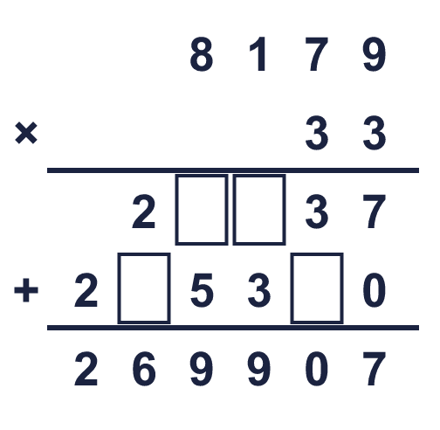  Missing digits, from top to bottom and left to right:
  2 | Write the missing digits in the multiplication 8,179 × 33.  Missing digits, from top to bottom and left to right:
  3 | Work out the multiplications. Use the column method.  a) 370 × 48 =  b) 5,153 × 68 =  c) 5,393 × 28 =
  3 | Work out the multiplications. Use the column method.  a) 370 × 48 =  b) 5,153 × 68 =  c) 5,393 × 28 =
  4 | Work out the multiplications. Watch the zeros.  a) 5,014 × 21 =  b) 9,407 × 46 =
  4 | Work out the multiplications. Watch the zeros.  a) 5,014 × 21 =  b) 9,407 × 46 =
  5 | Estimate 6,912 × 19 by rounding each number to its first digit (1 significant figure).  Estimate:
  5 | Estimate 6,912 × 19 by rounding each number to its first digit (1 significant figure).  Estimate:
  6 | A stadium holds 8,638 people. It is full for 64 matches in a row.  What is the attendance for all the matches?
  6 | A stadium holds 8,638 people. It is full for 64 matches in a row.  What is the attendance for all the matches?
  7 | One ticket costs £1.36. A family buys 11 tickets.  How much do the tickets cost altogether?
  7 | One ticket costs £1.36. A family buys 11 tickets.  How much do the tickets cost altogether?
  8 | Look at this calculation: 9,957 × 33. Without working it out, which of these could be the answer? Use the ones digit and an estimate.  328,581 328,590 32,858
  8 | Look at this calculation: 9,957 × 33. Without working it out, which of these could be the answer? Use the ones digit and an estimate.  328,581 328,590 32,858

  9 | Is Boba correct? Circle yes or no.  Yes / No  Explain how you know.
     | 
  9 | Is Boba correct? Circle yes or no.  Yes / No  Explain how you know.
  10 | 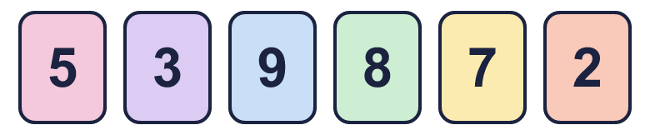  a) What is the greatest product you can make?  b) What is the smallest product you can make?
    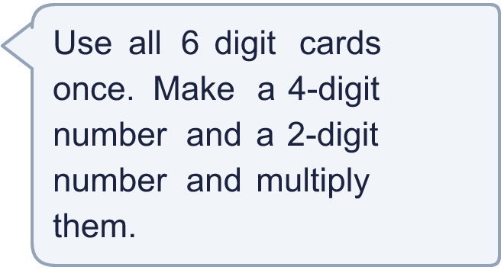
  10 | a) What is the greatest product you can make?  b) What is the smallest product you can make?
  11 | What number did I start with?
     | 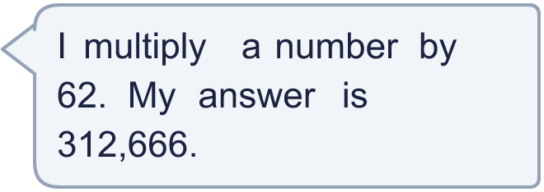
  11 | What number did I start with?
  12 | a) How many points does Amir score altogether?  b) How many points does Whitney score altogether?  c) How many more points does the higher scorer have?
     | 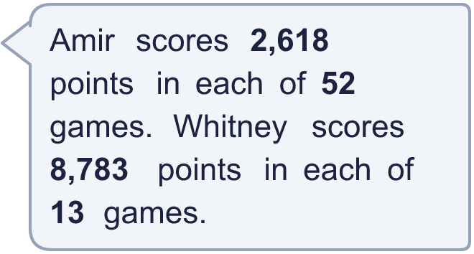
  12 | a) How many points does Amir score altogether?  b) How many points does Whitney score altogether?  c) How many more points does the higher scorer have?
  13 | Use this fact to work out the other multiplications. You do not need the column method.  a) 2,452 × 45 =  b) 2,452 × 47 =  c) 2,453 × 46 =
    
  13 | Use this fact to work out the other multiplications. You do not need the column method.  a) 2,452 × 45 =  b) 2,452 × 47 =  c) 2,453 × 46 =
  14 | Write a 4-digit number and a 2-digit number that multiply to give an answer between 400,000 and 500,000.
  14 | Write a 4-digit number and a 2-digit number that multiply to give an answer between 400,000 and 500,000.

Year 5 · Multiply and divide B · Step 5
Multiplying 4 digits by 2 digits
Answers (teacher copy)

  1 | Complete the multiplications. Use the first answer to help with the second.  a) 6,524 × 8 = 52,192  b) 6,524 × 80 = 521,920  c) 8,922 × 8 = 71,376  d) 8,922 × 80 = 713,760
  2 | Write the missing digits in the multiplication 8,179 × 33.  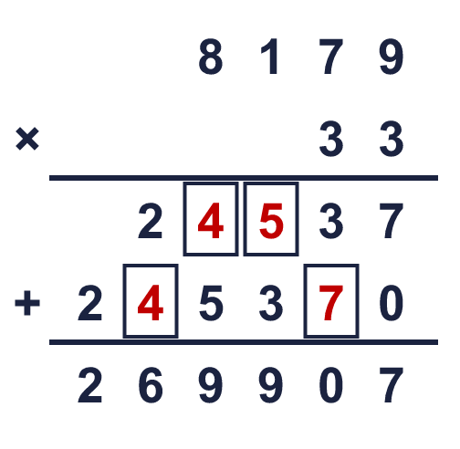  Missing digits, from top to bottom and left to right: 4 5 4 7
  3 | Work out the multiplications. Use the column method.  a) 370 × 48 = 17,760  b) 5,153 × 68 = 350,404  c) 5,393 × 28 = 151,004
  4 | Work out the multiplications. Watch the zeros.  a) 5,014 × 21 = 105,294  b) 9,407 × 46 = 432,722
  5 | Estimate 6,912 × 19 by rounding each number to its first digit (1 significant figure).  Estimate: 140,000
  6 | A stadium holds 8,638 people. It is full for 64 matches in a row.  What is the attendance for all the matches? 552,832
  7 | One ticket costs £1.36. A family buys 11 tickets.  How much do the tickets cost altogether? £14.96
  8 | Look at this calculation: 9,957 × 33. Without working it out, which of these could be the answer? Use the ones digit and an estimate.  328,581 328,590 32,858  328,581
  9 | Is Boba correct? Circle yes or no.  Yes / No  Explain how you know.  0 × 5 = 0, so the answer must end in 0. The correct answer is 2,990 × 65 = 194,350, not 194,360.
  10 | a) What is the greatest product you can make? 829,540  b) What is the smallest product you can make? 94,725
  11 | What number did I start with? 5,043
  12 | a) How many points does Amir score altogether? 136,136  b) How many points does Whitney score altogether? 114,179  c) How many more points does the higher scorer have? 21,957
  13 | Use this fact to work out the other multiplications. You do not need the column method.  a) 2,452 × 45 = 110,340  b) 2,452 × 47 = 115,244  c) 2,453 × 46 = 112,838
  14 | Write a 4-digit number and a 2-digit number that multiply to give an answer between 400,000 and 500,000.  Any 4-digit × 2-digit multiplication with a product between 400,000 and 500,000, for example 6,182 × 73 or 5,266 × 85

