  Year 5 · Multiply and divide B · Step 1  Multiplying up to 4 digits by 1 digit | 
  Year 5 · Multiply and divide B · Step 1
  Multiplying up to 4 digits by 1 digit
  1 | Multiply. There is no exchange to make.  a) 22 × 3 =  b) 121 × 4 =  c) 1,422 × 2 =
  1 | Multiply. There is no exchange to make.  a) 22 × 3 =  b) 121 × 4 =  c) 1,422 × 2 =
  2 | Write the missing digits in the multiplication 5,381 × 2.  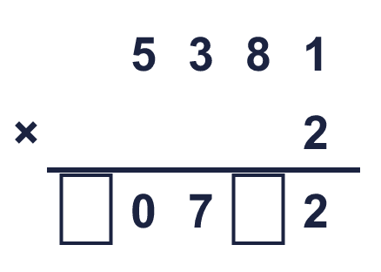  Missing digits, from top to bottom and left to right:
  2 | Write the missing digits in the multiplication 5,381 × 2.  Missing digits, from top to bottom and left to right:
  3 | Work out the multiplications. Use the column method.  a) 282 × 8 =  b) 1,950 × 4 =  c) 1,289 × 4 =
  3 | Work out the multiplications. Use the column method.  a) 282 × 8 =  b) 1,950 × 4 =  c) 1,289 × 4 =
  4 | Work out the multiplications. Watch the zeros.  a) 2,033 × 2 =  b) 4,702 × 9 =
  4 | Work out the multiplications. Watch the zeros.  a) 2,033 × 2 =  b) 4,702 × 9 =
  5 | Estimate 7,443 × 7 by rounding each number to its first digit (1 significant figure).  Estimate:
  5 | Estimate 7,443 × 7 by rounding each number to its first digit (1 significant figure).  Estimate:
  6 | A stadium holds 8,494 people. It is full for 5 matches in a row.  What is the attendance for all the matches?
  6 | A stadium holds 8,494 people. It is full for 5 matches in a row.  What is the attendance for all the matches?
  7 | One ticket costs £51.99. A family buys 2 tickets.  How much do the tickets cost altogether?
  7 | One ticket costs £51.99. A family buys 2 tickets.  How much do the tickets cost altogether?
  8 | Look at this calculation: 9,325 × 7. Without working it out, which of these could be the answer? Use the ones digit and an estimate.  65,284 652,750 65,275
  8 | Look at this calculation: 9,325 × 7. Without working it out, which of these could be the answer? Use the ones digit and an estimate.  65,284 652,750 65,275

  9 | Is Boba correct? Circle yes or no.  Yes / No  Explain how you know.
     | 
  9 | Is Boba correct? Circle yes or no.  Yes / No  Explain how you know.
  10 | 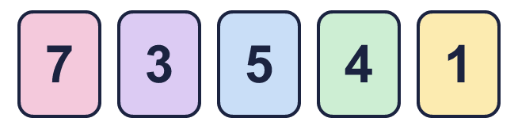  a) What is the greatest product you can make?  b) What is the smallest product you can make?
    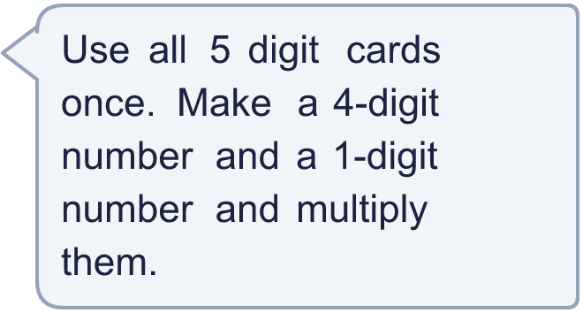
  10 | a) What is the greatest product you can make?  b) What is the smallest product you can make?
  11 | What number did I start with?
     | 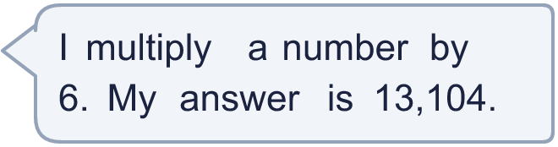
  11 | What number did I start with?
  12 | a) How many points does Amir score altogether?  b) How many points does Whitney score altogether?  c) How many more points does the higher scorer have?
     | 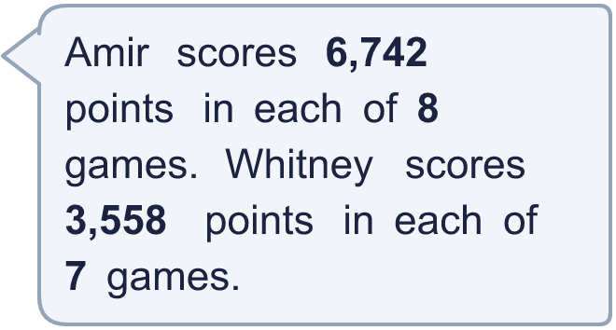
  12 | a) How many points does Amir score altogether?  b) How many points does Whitney score altogether?  c) How many more points does the higher scorer have?
  13 | Use this fact to work out the other multiplications. You do not need the column method.  a) 9,405 × 5 =  b) 9,405 × 7 =  c) 9,406 × 6 =
    
  13 | Use this fact to work out the other multiplications. You do not need the column method.  a) 9,405 × 5 =  b) 9,405 × 7 =  c) 9,406 × 6 =
  14 | Write a 4-digit number and a 1-digit number that multiply to give an answer between 10,000 and 20,000.
  14 | Write a 4-digit number and a 1-digit number that multiply to give an answer between 10,000 and 20,000.

Year 5 · Multiply and divide B · Step 1
Multiplying up to 4 digits by 1 digit
Answers (teacher copy)

  1 | Multiply. There is no exchange to make.  a) 22 × 3 = 66  b) 121 × 4 = 484  c) 1,422 × 2 = 2,844
  2 | Write the missing digits in the multiplication 5,381 × 2.  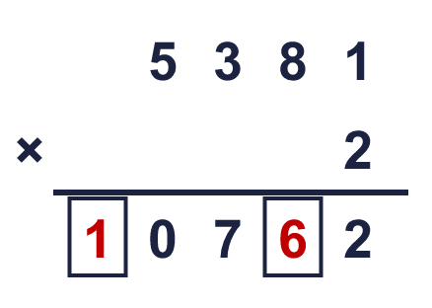  Missing digits, from top to bottom and left to right: 1 6
  3 | Work out the multiplications. Use the column method.  a) 282 × 8 = 2,256  b) 1,950 × 4 = 7,800  c) 1,289 × 4 = 5,156
  4 | Work out the multiplications. Watch the zeros.  a) 2,033 × 2 = 4,066  b) 4,702 × 9 = 42,318
  5 | Estimate 7,443 × 7 by rounding each number to its first digit (1 significant figure).  Estimate: 49,000
  6 | A stadium holds 8,494 people. It is full for 5 matches in a row.  What is the attendance for all the matches? 42,470
  7 | One ticket costs £51.99. A family buys 2 tickets.  How much do the tickets cost altogether? £103.98
  8 | Look at this calculation: 9,325 × 7. Without working it out, which of these could be the answer? Use the ones digit and an estimate.  65,284 652,750 65,275  65,275
  9 | Is Boba correct? Circle yes or no.  Yes / No  Explain how you know.  2 × 3 = 6, so the answer must end in 6. The correct answer is 8,562 × 3 = 25,686, not 25,586.
  10 | a) What is the greatest product you can make? 38,017  b) What is the smallest product you can make? 3,457
  11 | What number did I start with? 2,184
  12 | a) How many points does Amir score altogether? 53,936  b) How many points does Whitney score altogether? 24,906  c) How many more points does the higher scorer have? 29,030
  13 | Use this fact to work out the other multiplications. You do not need the column method.  a) 9,405 × 5 = 47,025  b) 9,405 × 7 = 65,835  c) 9,406 × 6 = 56,436
  14 | Write a 4-digit number and a 1-digit number that multiply to give an answer between 10,000 and 20,000.  Any 4-digit × 1-digit multiplication with a product between 10,000 and 20,000, for example 8,206 × 2 or 1,724 × 9

