  Year 5 · Multiply and divide B · Step 7  Short division | 
  Year 5 · Multiply and divide B · Step 7
  Short division
  1 | Work out the divisions.  a) 56 ÷ 8 =  b) 945 ÷ 9 =  c) 856 ÷ 8 =
  1 | Work out the divisions.  a) 56 ÷ 8 =  b) 945 ÷ 9 =  c) 856 ÷ 8 =
  2 | Work out the divisions. Watch for the zeros.  a) 836 ÷ 4 =  b) 308 ÷ 4 =  c) 864 ÷ 8 =
  2 | Work out the divisions. Watch for the zeros.  a) 836 ÷ 4 =  b) 308 ÷ 4 =  c) 864 ÷ 8 =
  3 | Write the missing number.
    a) |  | ÷ 4 | = | 201
    b) |  | ÷ 6 | = | 156
  3 | Write the missing number.
    a) |  | ÷ 4 | = | 201
    b) |  | ÷ 6 | = | 156
  4 | Write <, > or = in each box.
    a) | 846 ÷ 9 |  | 408 ÷ 3
    b) | 470 ÷ 5 |  | 561 ÷ 3
  4 | Write <, > or = in each box.
    a) | 846 ÷ 9 |  | 408 ÷ 3
    b) | 470 ÷ 5 |  | 561 ÷ 3
  5 | 912 sweets are shared equally between 8 schools.  How many sweets does each school get?
  5 | 912 sweets are shared equally between 8 schools.  How many sweets does each school get?
  6 | Work out the divisions.  a) 301 ÷ 7 =  b) 624 ÷ 6 =
  6 | Work out the divisions.  a) 301 ÷ 7 =  b) 624 ÷ 6 =
  7 | £44.00 is shared equally between 8 children.  How much does each child get?
  7 | £44.00 is shared equally between 8 children.  How much does each child get?
  8 | 8 ÷ 4 = 2. Use this fact to work out the divisions.  a) 80 ÷ 4 =  b) 800 ÷ 4 =  c) 800 ÷ 40 =
  8 | 8 ÷ 4 = 2. Use this fact to work out the divisions.  a) 80 ÷ 4 =  b) 800 ÷ 4 =  c) 800 ÷ 40 =

  9 | Is Boba correct? Circle yes or no.  Yes / No  Explain how you know.
     | 
  9 | Is Boba correct? Circle yes or no.  Yes / No  Explain how you know.
  10 | What number did I start with?
     | 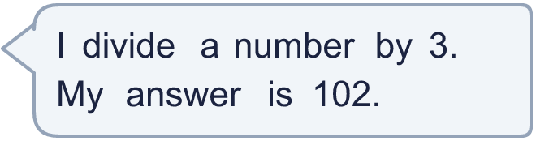
  10 | What number did I start with?
  11 | a) How many trays are filled?  b) How much money does the farm get for all the trays?
     | 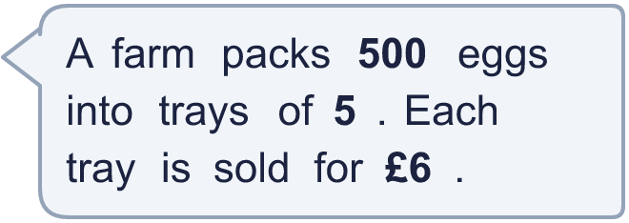
  11 | a) How many trays are filled?  b) How much money does the farm get for all the trays?
  12 | Which is greater: 539 ÷ 7 or 819 ÷ 9?  Write a or b. (a is the first calculation.)
  12 | Which is greater: 539 ÷ 7 or 819 ÷ 9?  Write a or b. (a is the first calculation.)
  13 | How many books does each library have now?
    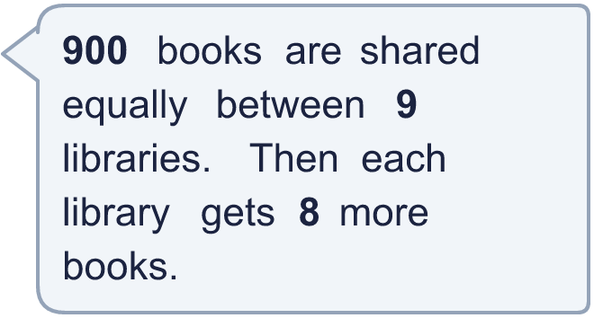
  13 | How many books does each library have now?
  14 | Write three different 3-digit numbers that can be divided by 8 with no remainder.
  14 | Write three different 3-digit numbers that can be divided by 8 with no remainder.

Year 5 · Multiply and divide B · Step 7
Short division
Answers (teacher copy)

  1 | Work out the divisions.  a) 56 ÷ 8 = 7  b) 945 ÷ 9 = 105  c) 856 ÷ 8 = 107
  2 | Work out the divisions. Watch for the zeros.  a) 836 ÷ 4 = 209  b) 308 ÷ 4 = 77  c) 864 ÷ 8 = 108
  3 | Write the missing number.  a) 804 ÷ 4 = 201  b) 936 ÷ 6 = 156
  4 | Write <, > or = in each box.  a) 846 ÷ 9 < 408 ÷ 3  b) 470 ÷ 5 < 561 ÷ 3
  5 | 912 sweets are shared equally between 8 schools.  How many sweets does each school get? 114
  6 | Work out the divisions.  a) 301 ÷ 7 = 43  b) 624 ÷ 6 = 104
  7 | £44.00 is shared equally between 8 children.  How much does each child get? £5.50
  8 | 8 ÷ 4 = 2. Use this fact to work out the divisions.  a) 80 ÷ 4 = 20  b) 800 ÷ 4 = 200  c) 800 ÷ 40 = 20
  9 | Is Boba correct? Circle yes or no.  Yes / No  Explain how you know.  61 × 3 = 183, not 153. The correct answer is 153 ÷ 3 = 51.
  10 | What number did I start with? 306
  11 | a) How many trays are filled? 100  b) How much money does the farm get for all the trays? £600
  12 | Which is greater: 539 ÷ 7 or 819 ÷ 9?  Write a or b. (a is the first calculation.) b
  13 | How many books does each library have now? 108
  14 | Write three different 3-digit numbers that can be divided by 8 with no remainder.  Any three 3-digit numbers with remainder 0 when divided by 8, for example 320, 544, 768

