  Year 5 · Perimeter and area · Step 6  Estimate area | 
  Year 5 · Perimeter and area · Step 6
  Estimate area
  1 | The area of each square is 1 cm². Each part square is exactly half a square. Count the squares and estimate the area of the shape.  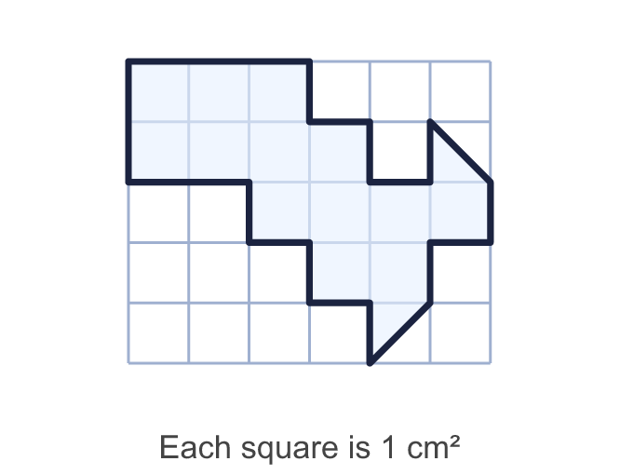
    Whole squares =
    Part squares =
    Estimated area = |  | cm²
  1 | The area of each square is 1 cm². Each part square is exactly half a square. Count the squares and estimate the area of the shape.
    Whole squares =
    Part squares =
    Estimated area = |  | cm²
  2 | The area of each square is 1 cm². Estimate the area of each shape.  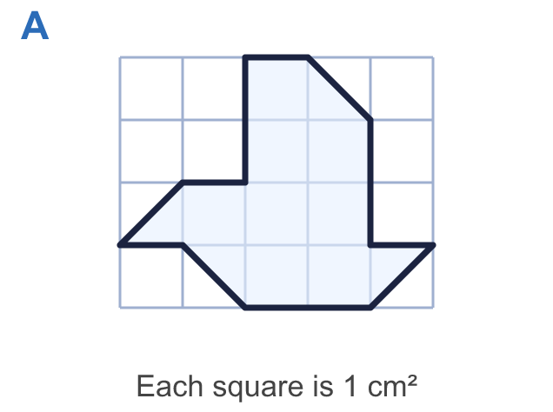  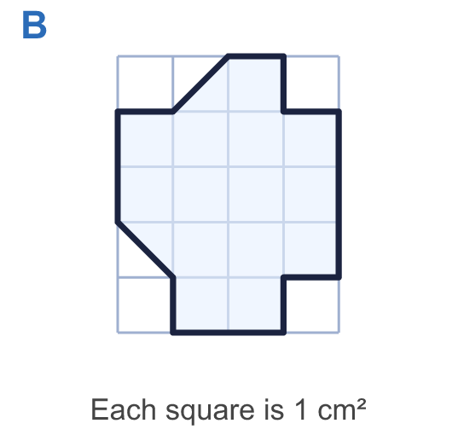
    a) Shape A: |  | cm²
    b) Shape B: |  | cm²
  2 | The area of each square is 1 cm². Estimate the area of each shape.
    a) Shape A: |  | cm²
    b) Shape B: |  | cm²
  3 | Count the squares that are completely inside the shape, and then all the squares that the shape touches (whole squares and part squares).  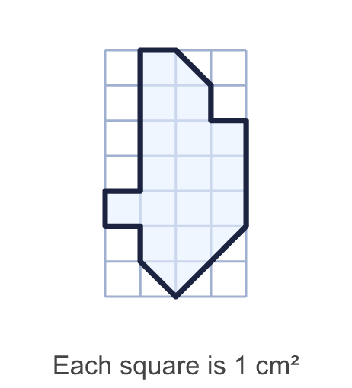
    Squares completely inside =
    All squares touched =
  3 | Count the squares that are completely inside the shape, and then all the squares that the shape touches (whole squares and part squares).
    Squares completely inside =
    All squares touched =
  4 | This plan shows a pond. Each square is 1 m². Each part square is exactly half a square. Estimate the area of the pond.  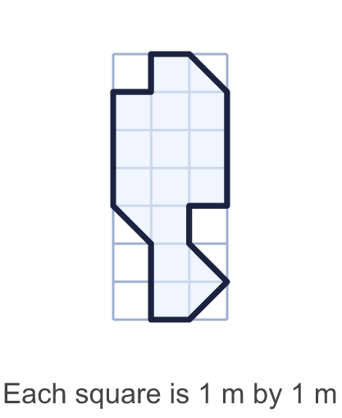
    Estimated area = |  | m²
  4 | This plan shows a pond. Each square is 1 m². Each part square is exactly half a square. Estimate the area of the pond.
    Estimated area = |  | m²
  5 | A shape covers 16 whole squares and 4 part squares. Each part square is exactly half a square. Each square is 1 cm².
    Estimated area = |  | cm²
  5 | A shape covers 16 whole squares and 4 part squares. Each part square is exactly half a square. Each square is 1 cm².
    Estimated area = |  | cm²
  6 | Each square on the grid is 1 km² of land. Which island has the greater area, and how much greater is it?  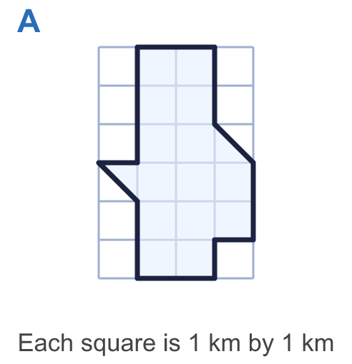  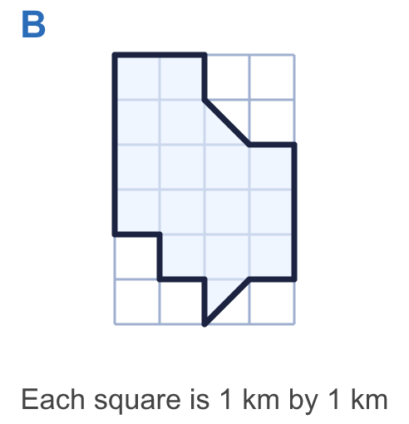
    Greater area: island
    It is greater by |  | km²
  6 | Each square on the grid is 1 km² of land. Which island has the greater area, and how much greater is it?
    Greater area: island
    It is greater by |  | km²
  7 | Each square on the grid is 2 cm by 2 cm, so the area of each square is 4 cm². Each part square is exactly half a square. Estimate the area of the shape.  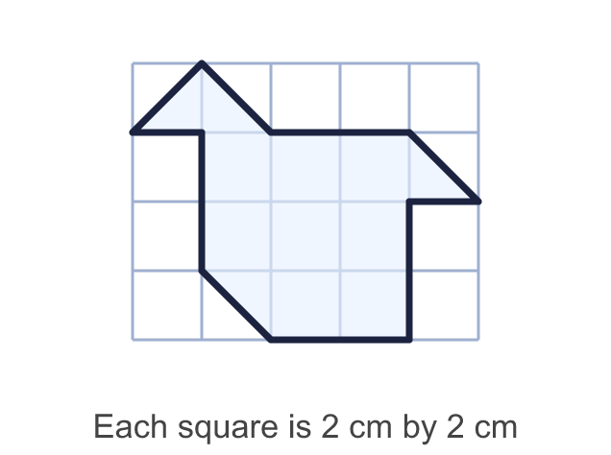
    Estimated area = |  | cm²
  7 | Each square on the grid is 2 cm by 2 cm, so the area of each square is 4 cm². Each part square is exactly half a square. Estimate the area of the shape.
    Estimated area = |  | cm²
  8 | This is the outline of a field. Each square is 10 m by 10 m, so the area of each square is 100 m². Each part square is exactly half a square. Estimate the area of the field.  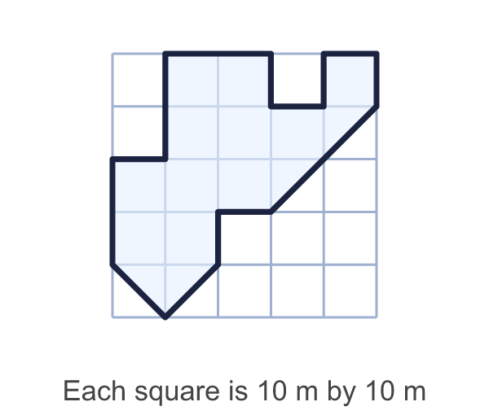
    Estimated area = |  | m²
  8 | This is the outline of a field. Each square is 10 m by 10 m, so the area of each square is 100 m². Each part square is exactly half a square. Estimate the area of the field.
    Estimated area = |  | m²

  9 | Each square is 1 cm². Each part square is exactly half a square.  Is Alex correct? Circle yes or no.  Yes / No  Explain how you know.
     | 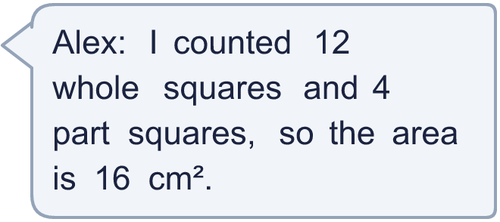
  9 | Each square is 1 cm². Each part square is exactly half a square.  Is Alex correct? Circle yes or no.  Yes / No  Explain how you know.
  10 | The shape covers 11 squares completely and touches 17 squares in all. Each square is 1 cm². Which of these could be the area of the shape? Write the letter.  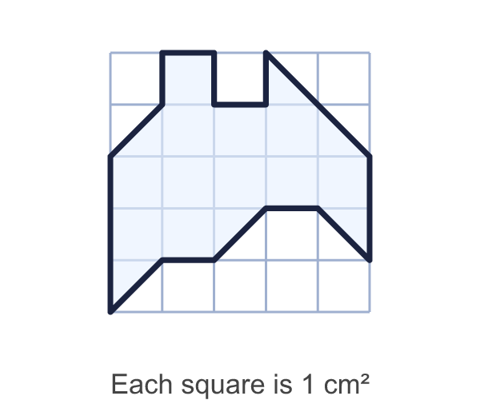  A: 19 cm²  B: 14 cm²  C: 23 cm²  D: 9 cm²
  10 | The shape covers 11 squares completely and touches 17 squares in all. Each square is 1 cm². Which of these could be the area of the shape? Write the letter.  A: 19 cm²  B: 14 cm²  C: 23 cm²  D: 9 cm²
  11 | Each square on the map is 100 m² of land. Each part square is exactly half a square. Estimate the area of the lake and the area of the wood.  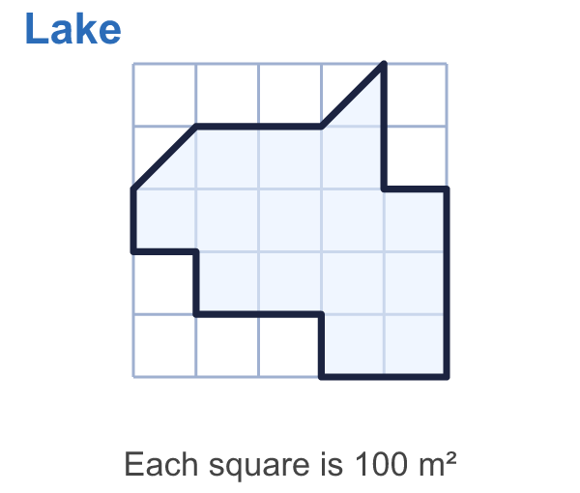  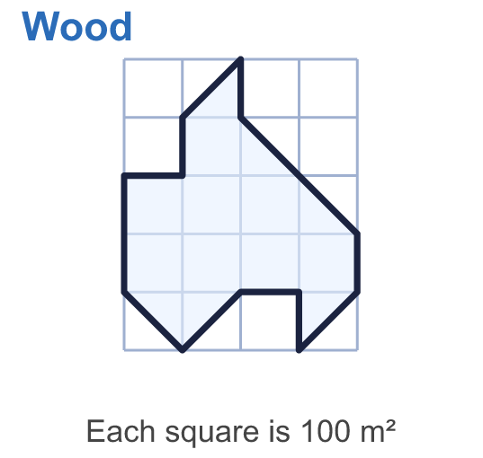
    Lake: |  | m²
    Wood: |  | m²
    The difference is |  | m².
  11 | Each square on the map is 100 m² of land. Each part square is exactly half a square. Estimate the area of the lake and the area of the wood.
    Lake: |  | m²
    Wood: |  | m²
    The difference is |  | m².
  12 | This is the outline of a forest. Each square is 2 m by 2 m, so its area is 4 m². Each part square is exactly half a square. Estimate the area of the forest.  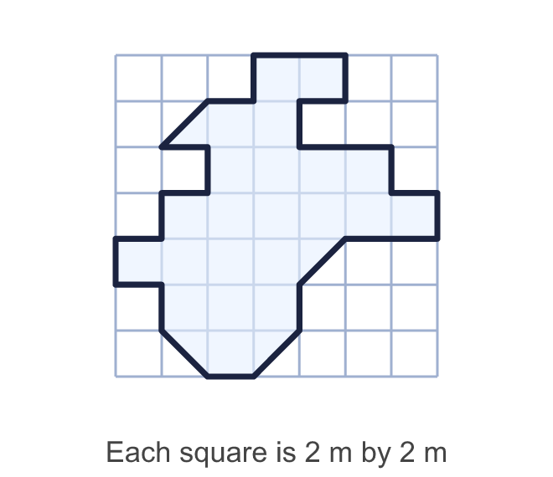
    Estimated area = |  | m²
  12 | This is the outline of a forest. Each square is 2 m by 2 m, so its area is 4 m². Each part square is exactly half a square. Estimate the area of the forest.
    Estimated area = |  | m²
  13 | The area of a shape is 18 cm². It covers 14 whole squares and some part squares. Each part square is exactly half a square. Each square is 1 cm².
    How many part squares?
  13 | The area of a shape is 18 cm². It covers 14 whole squares and some part squares. Each part square is exactly half a square. Each square is 1 cm².
    How many part squares?
  14 | Challenge  A lake covers 38 whole squares and 10 part squares on a map. Each part square is exactly half a square. Each square on the map is 9 km².
    Estimated area of the lake =
    km².
  14 | Challenge  A lake covers 38 whole squares and 10 part squares on a map. Each part square is exactly half a square. Each square on the map is 9 km².
    Estimated area of the lake =
    km².

Year 5 · Perimeter and area · Step 6
Estimate area
Answers (teacher copy)

  1 | The area of each square is 1 cm². Each part square is exactly half a square. Count the squares and estimate the area of the shape.  Whole squares = 13  Part squares = 2  Estimated area = 14 cm²
  2 | The area of each square is 1 cm². Estimate the area of each shape.  a) Shape A: 10 cm²  b) Shape B: 15 cm²
  3 | Count the squares that are completely inside the shape, and then all the squares that the shape touches (whole squares and part squares).  Squares completely inside = 15  All squares touched = 19
  4 | This plan shows a pond. Each square is 1 m². Each part square is exactly half a square. Estimate the area of the pond.  Estimated area = 15 m²
  5 | A shape covers 16 whole squares and 4 part squares. Each part square is exactly half a square. Each square is 1 cm².  Estimated area = 18 cm²
  6 | Each square on the grid is 1 km² of land. Which island has the greater area, and how much greater is it?  Greater area: island B  It is greater by 1 km²
  7 | Each square on the grid is 2 cm by 2 cm, so the area of each square is 4 cm². Each part square is exactly half a square. Estimate the area of the shape.  Estimated area = 40 cm²
  8 | This is the outline of a field. Each square is 10 m by 10 m, so the area of each square is 100 m². Each part square is exactly half a square. Estimate the area of the field.  Estimated area = 1300 m²
  9 | Each square is 1 cm². Each part square is exactly half a square.  Is Alex correct? Circle yes or no.  Yes / No  Explain how you know.  No. Two part squares make one whole square, so the area is 12 + 2 = 14 cm².
  10 | The shape covers 11 squares completely and touches 17 squares in all. Each square is 1 cm². Which of these could be the area of the shape? Write the letter.  A: 19 cm²  B: 14 cm²  C: 23 cm²  D: 9 cm²  B
  11 | Each square on the map is 100 m² of land. Each part square is exactly half a square. Estimate the area of the lake and the area of the wood.  Lake: 1500 m²  Wood: 1100 m²  The difference is 400 m².
  12 | This is the outline of a forest. Each square is 2 m by 2 m, so its area is 4 m². Each part square is exactly half a square. Estimate the area of the forest.  Estimated area = 96 m²
  13 | The area of a shape is 18 cm². It covers 14 whole squares and some part squares. Each part square is exactly half a square. Each square is 1 cm².  How many part squares? 8
  14 | Challenge  A lake covers 38 whole squares and 10 part squares on a map. Each part square is exactly half a square. Each square on the map is 9 km².  Estimated area of the lake = 387 km².

