  Year 5 · Perimeter and area · Step 1  Perimeter of rectangles | 
  Year 5 · Perimeter and area · Step 1
  Perimeter of rectangles
  1 | Work out the perimeter of the rectangle.  
    Perimeter = |  | cm.
  1 | Work out the perimeter of the rectangle.
    Perimeter = |  | cm.
  2 | Work out the perimeter of the playground.  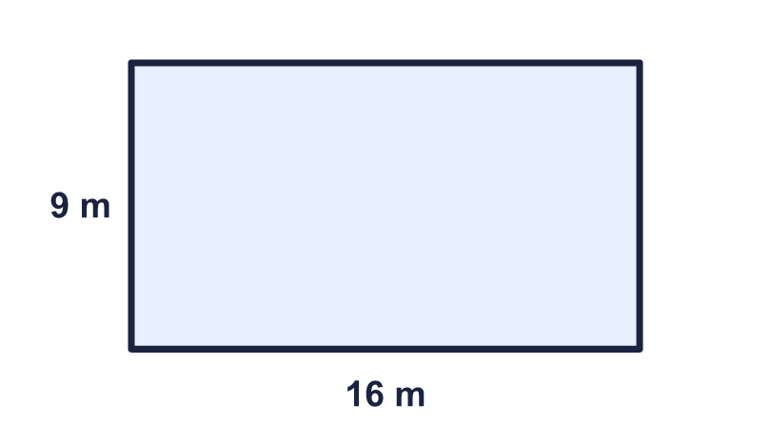
    Perimeter = |  | m.
  2 | Work out the perimeter of the playground.
    Perimeter = |  | m.
  3 | Work out the perimeter of the square.  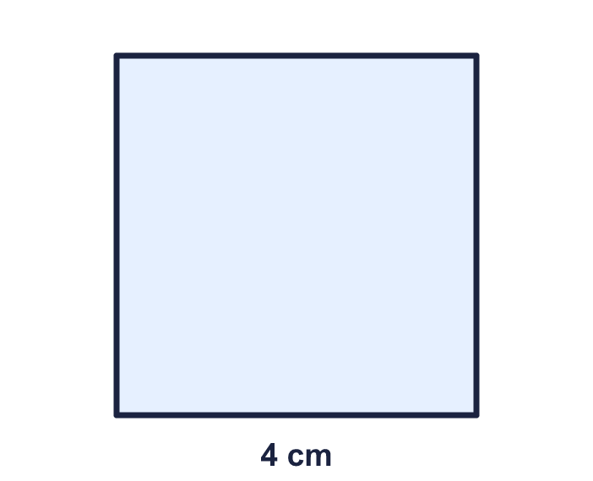
    Perimeter = |  | cm.
  3 | Work out the perimeter of the square.
    Perimeter = |  | cm.
  4 | A rectangle is 11 cm long and 6 cm wide.
    Perimeter = |  | cm.
  4 | A rectangle is 11 cm long and 6 cm wide.
    Perimeter = |  | cm.
  5 | Work out the perimeter of the label.  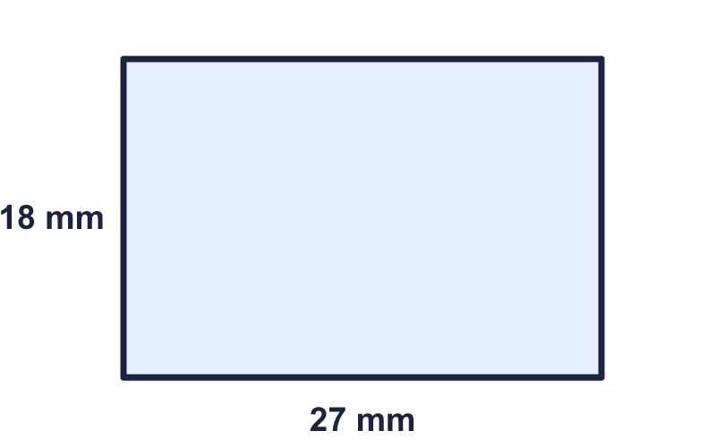
    Perimeter = |  | mm.
  5 | Work out the perimeter of the label.
    Perimeter = |  | mm.
  6 | This rectangle has a perimeter of 34 cm. Find the missing width.  
    Width = |  | cm.
  6 | This rectangle has a perimeter of 34 cm. Find the missing width.
    Width = |  | cm.
  7 | A square has a perimeter of 48 cm.
    Length of one side = |  | cm.
  7 | A square has a perimeter of 48 cm.
    Length of one side = |  | cm.
  8 | A rectangular field is 128 m long and 33 m wide.
    Distance round the edge = |  | m.
  8 | A rectangular field is 128 m long and 33 m wide.
    Distance round the edge = |  | m.

  9 | 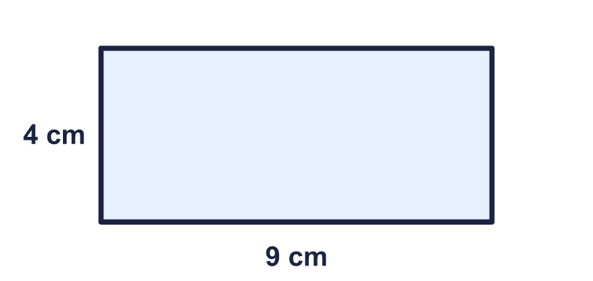  Is Jo correct? Circle yes or no.  Yes / No  Explain how you know.
     | 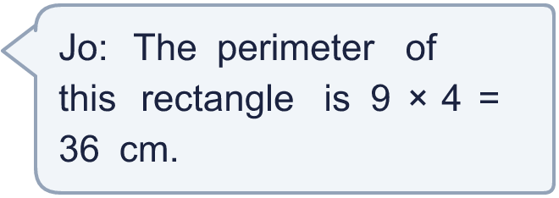
  9 | Is Jo correct? Circle yes or no.  Yes / No  Explain how you know.
  10 | A rectangle is 9 cm long and 4 cm wide. Which calculations give its perimeter? Write the letters.  A: 9 × 4 × 2  B: 4 × 9  C: 2 × 9 + 2 × 4  D: 9 + 4 + 9 + 4  E: 9 + 4
  10 | A rectangle is 9 cm long and 4 cm wide. Which calculations give its perimeter? Write the letters.  A: 9 × 4 × 2  B: 4 × 9  C: 2 × 9 + 2 × 4  D: 9 + 4 + 9 + 4  E: 9 + 4
  11 | A rectangular garden is 17 m long and 8 m wide. Fencing for the whole edge costs £5 for each metre.
    Cost = £
  11 | A rectangular garden is 17 m long and 8 m wide. Fencing for the whole edge costs £5 for each metre.
    Cost = £
  12 | Rectangles have sides that are whole numbers of centimetres. A 2 cm by 7 cm rectangle is the same as a 7 cm by 2 cm rectangle.  How many different rectangles have a perimeter of 24 cm?
    rectangles
  12 | Rectangles have sides that are whole numbers of centimetres. A 2 cm by 7 cm rectangle is the same as a 7 cm by 2 cm rectangle.  How many different rectangles have a perimeter of 24 cm?
    rectangles
  13 | The length of a rectangle is 3 times its width. Its perimeter is 64 cm.
    Width = |  | cm.
    Length = |  | cm.
  13 | The length of a rectangle is 3 times its width. Its perimeter is 64 cm.
    Width = |  | cm.
    Length = |  | cm.
  14 | Challenge  A square has sides of 15 cm. A rectangle has the same perimeter as the square. The rectangle is 9 cm wide.
    Length of the rectangle = |  | cm.
  14 | Challenge  A square has sides of 15 cm. A rectangle has the same perimeter as the square. The rectangle is 9 cm wide.
    Length of the rectangle = |  | cm.

Year 5 · Perimeter and area · Step 1
Perimeter of rectangles
Answers (teacher copy)

  1 | Work out the perimeter of the rectangle.  Perimeter = 28 cm.
  2 | Work out the perimeter of the playground.  Perimeter = 50 m.
  3 | Work out the perimeter of the square.  Perimeter = 16 cm.
  4 | A rectangle is 11 cm long and 6 cm wide.  Perimeter = 34 cm.
  5 | Work out the perimeter of the label.  Perimeter = 90 mm.
  6 | This rectangle has a perimeter of 34 cm. Find the missing width.  Width = 3 cm.
  7 | A square has a perimeter of 48 cm.  Length of one side = 12 cm.
  8 | A rectangular field is 128 m long and 33 m wide.  Distance round the edge = 322 m.
  9 | Is Jo correct? Circle yes or no.  Yes / No  Explain how you know.  No. 9 × 4 = 36 is the area, not the perimeter. The perimeter is 9 + 4 + 9 + 4 = 26 cm.
  10 | A rectangle is 9 cm long and 4 cm wide. Which calculations give its perimeter? Write the letters.  A: 9 × 4 × 2  B: 4 × 9  C: 2 × 9 + 2 × 4  D: 9 + 4 + 9 + 4  E: 9 + 4  C, D
  11 | A rectangular garden is 17 m long and 8 m wide. Fencing for the whole edge costs £5 for each metre.  Cost = £ 250
  12 | Rectangles have sides that are whole numbers of centimetres. A 2 cm by 7 cm rectangle is the same as a 7 cm by 2 cm rectangle.  How many different rectangles have a perimeter of 24 cm?  6 rectangles
  13 | The length of a rectangle is 3 times its width. Its perimeter is 64 cm.  Width = 8 cm.  Length = 24 cm.
  14 | Challenge  A square has sides of 15 cm. A rectangle has the same perimeter as the square. The rectangle is 9 cm wide.  Length of the rectangle = 21 cm.

