  Year 5 · Perimeter and area · Step 2  Perimeter of rectilinear shapes | 
  Year 5 · Perimeter and area · Step 2
  Perimeter of rectilinear shapes
  1 | Work out the perimeter of the shape.  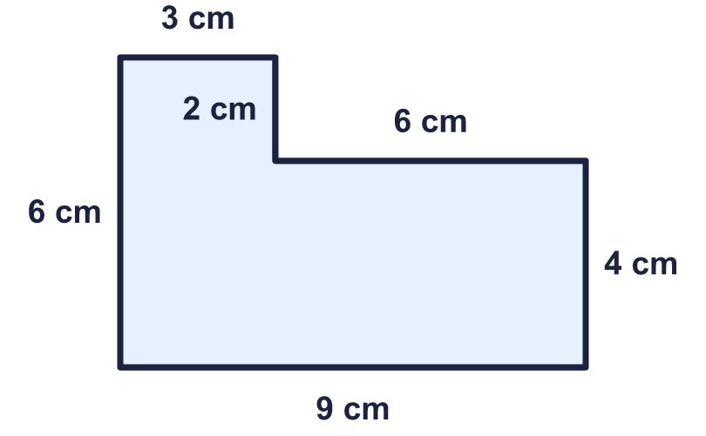
    Perimeter = |  | cm.
  1 | Work out the perimeter of the shape.
    Perimeter = |  | cm.
  2 | Work out the perimeter of the shape.  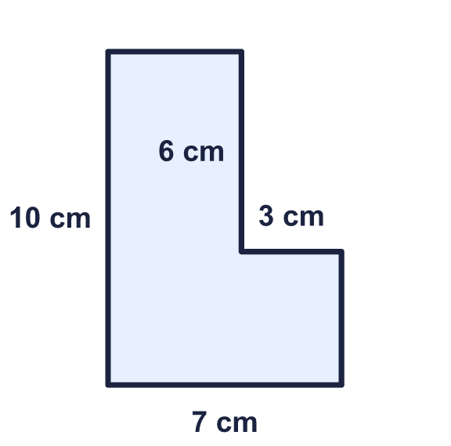
    Perimeter = |  | cm.
  2 | Work out the perimeter of the shape.
    Perimeter = |  | cm.
  3 | Count the lengths of the edges to work out the perimeter of the shape.  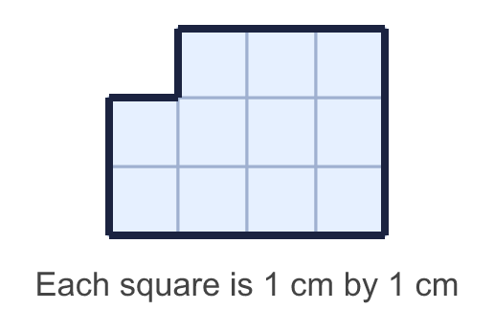
    Perimeter = |  | cm.
  3 | Count the lengths of the edges to work out the perimeter of the shape.
    Perimeter = |  | cm.
  4 | Work out the missing lengths.  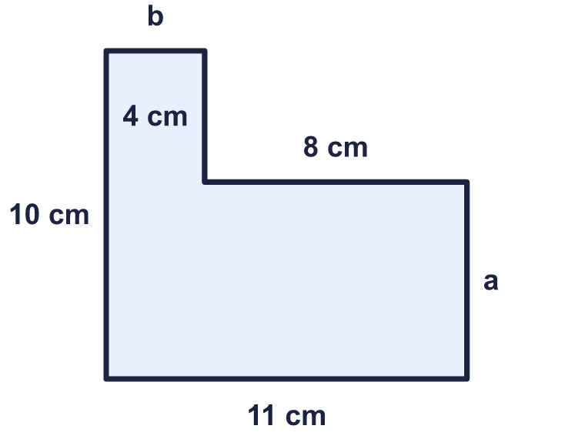
    a = |  | cm.
    b = |  | cm.
  4 | Work out the missing lengths.
    a = |  | cm.
    b = |  | cm.
  5 | Work out the perimeter of the shape.  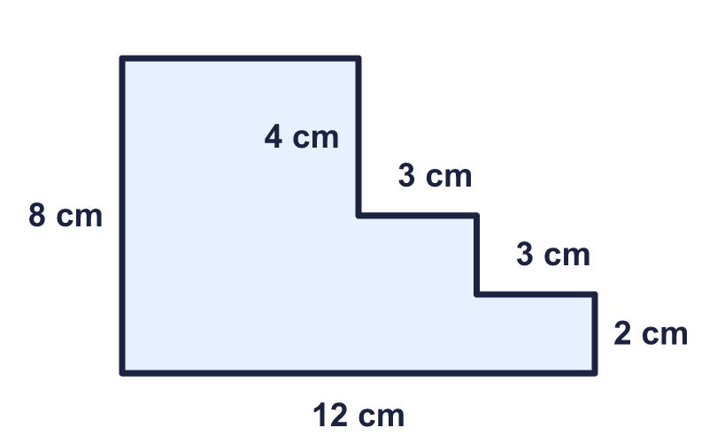
    Perimeter = |  | cm.
  5 | Work out the perimeter of the shape.
    Perimeter = |  | cm.
  6 | Work out the perimeter of the shape.  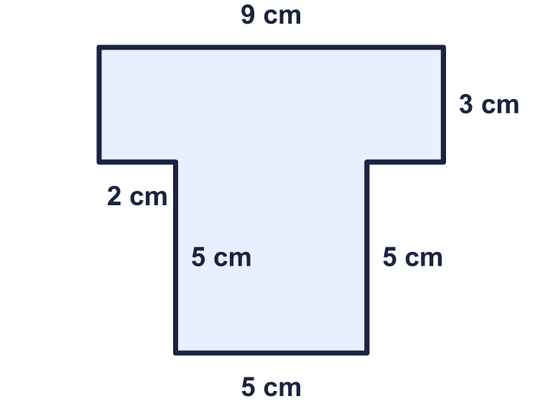
    Perimeter = |  | cm.
  6 | Work out the perimeter of the shape.
    Perimeter = |  | cm.
  7 | Work out the perimeter of the garden.  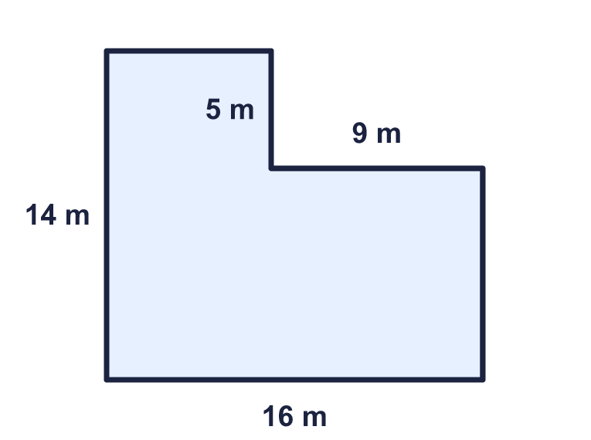
    Perimeter = |  | m.
  7 | Work out the perimeter of the garden.
    Perimeter = |  | m.
  8 | Work out the perimeter of each shape. Which shape has the greater perimeter?  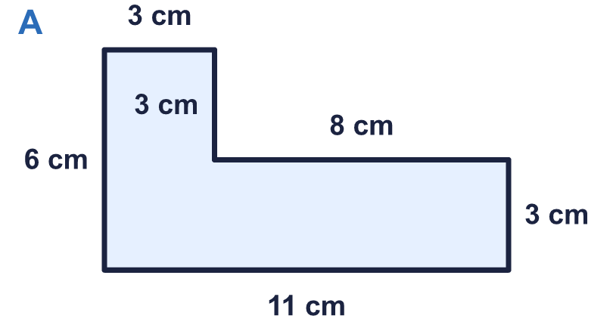  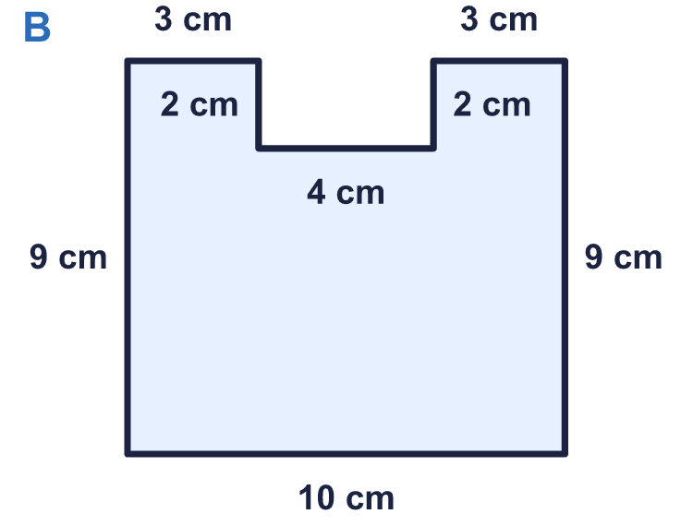
    a) Shape A: |  | cm.
    b) Shape B: |  | cm.
    Greater perimeter: shape
  8 | Work out the perimeter of each shape. Which shape has the greater perimeter?
    a) Shape A: |  | cm.
    b) Shape B: |  | cm.
    Greater perimeter: shape

  9 | 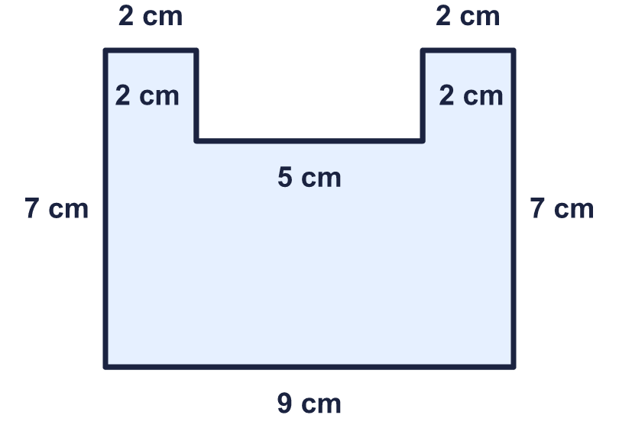  Is Nina correct? Circle yes or no.  Yes / No  Explain how you know.
    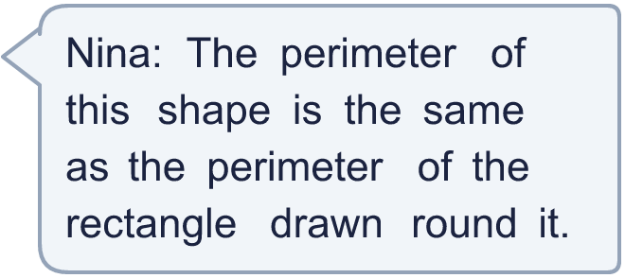
  9 | Is Nina correct? Circle yes or no.  Yes / No  Explain how you know.
  10 | The perimeter of the shape is 28 cm. Work out the missing length.  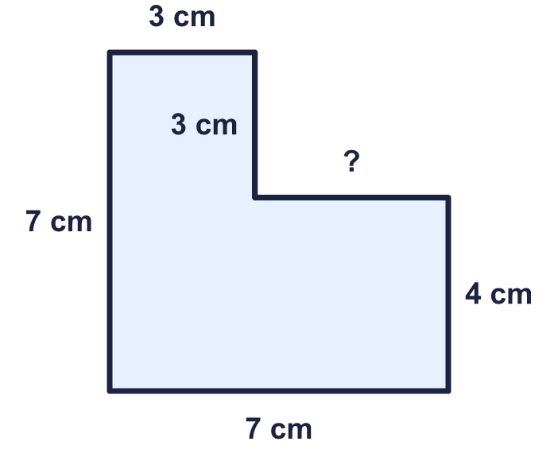
    Missing length = |  | cm.
  10 | The perimeter of the shape is 28 cm. Work out the missing length.
    Missing length = |  | cm.
  11 | Three rectangles are each 12 cm long and 5 cm wide. They are joined edge to edge to make shape A and shape B.    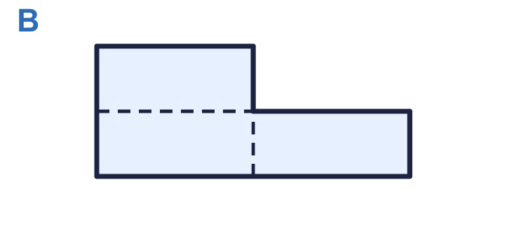
    Perimeter of shape A = |  | cm.
    Perimeter of shape B = |  | cm.
    Greater perimeter: shape
  11 | Three rectangles are each 12 cm long and 5 cm wide. They are joined edge to edge to make shape A and shape B.
    Perimeter of shape A = |  | cm.
    Perimeter of shape B = |  | cm.
    Greater perimeter: shape
  12 | This plan shows a garden. Fencing costs £8 for each metre. The fence goes all the way round the edge.  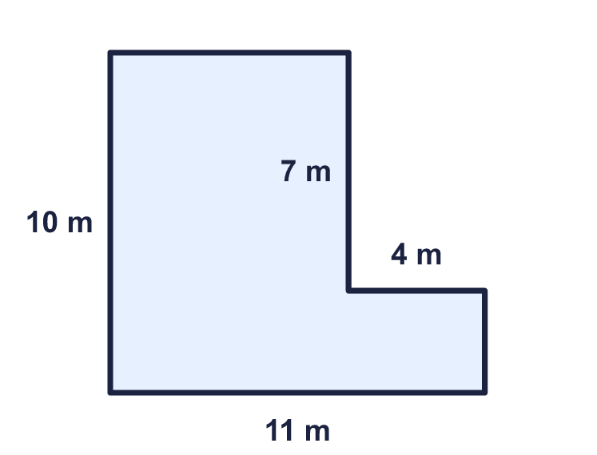
    Cost of the fence = £
  12 | This plan shows a garden. Fencing costs £8 for each metre. The fence goes all the way round the edge.
    Cost of the fence = £
  13 | 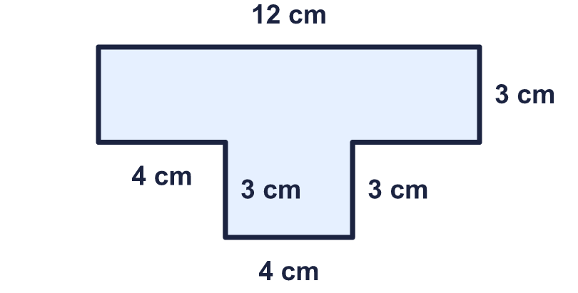  Is Jo correct? Circle yes or no.  Yes / No  Explain how you know.
     | 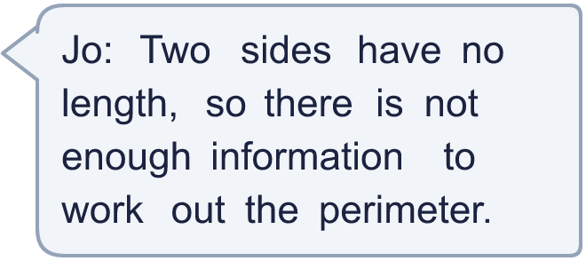
  13 | Is Jo correct? Circle yes or no.  Yes / No  Explain how you know.
  14 | Challenge  6 squares each have sides of 1 cm. They are joined edge to edge, whole side to whole side, to make a shape.
    The greatest possible perimeter is
    cm.
    The least possible perimeter is
    cm.
  14 | Challenge  6 squares each have sides of 1 cm. They are joined edge to edge, whole side to whole side, to make a shape.
    The greatest possible perimeter is
    cm.
    The least possible perimeter is
    cm.

Year 5 · Perimeter and area · Step 2
Perimeter of rectilinear shapes
Answers (teacher copy)

  1 | Work out the perimeter of the shape.  Perimeter = 30 cm.
  2 | Work out the perimeter of the shape.  Perimeter = 34 cm.
  3 | Count the lengths of the edges to work out the perimeter of the shape.  Perimeter = 14 cm.
  4 | Work out the missing lengths.  a = 6 cm.  b = 3 cm.
  5 | Work out the perimeter of the shape.  Perimeter = 40 cm.
  6 | Work out the perimeter of the shape.  Perimeter = 34 cm.
  7 | Work out the perimeter of the garden.  Perimeter = 60 m.
  8 | Work out the perimeter of each shape. Which shape has the greater perimeter?  a) Shape A: 34 cm.  b) Shape B: 42 cm.  Greater perimeter: shape B
  9 | Is Nina correct? Circle yes or no.  Yes / No  Explain how you know.  No. The shape has a perimeter of 36 cm. The rectangle round it has a perimeter of 32 cm. The notch adds extra length, so the shape's perimeter is greater.
  10 | The perimeter of the shape is 28 cm. Work out the missing length.  Missing length = 4 cm.
  11 | Three rectangles are each 12 cm long and 5 cm wide. They are joined edge to edge to make shape A and shape B.  Perimeter of shape A = 82 cm.  Perimeter of shape B = 68 cm.  Greater perimeter: shape A
  12 | This plan shows a garden. Fencing costs £8 for each metre. The fence goes all the way round the edge.  Cost of the fence = £ 336
  13 | Is Jo correct? Circle yes or no.  Yes / No  Explain how you know.  No. The unmarked sides can be worked out from the other sides. Then the perimeter is 36 cm.
  14 | Challenge  6 squares each have sides of 1 cm. They are joined edge to edge, whole side to whole side, to make a shape.  The greatest possible perimeter is 14 cm.  The least possible perimeter is 10 cm.

