  Year 5 · Statistics · Step 2  Read and interpret line graphs | 
  Year 5 · Statistics · Step 2
  Read and interpret line graphs
  1 | The graph shows the height of a sunflower at the start of each week.  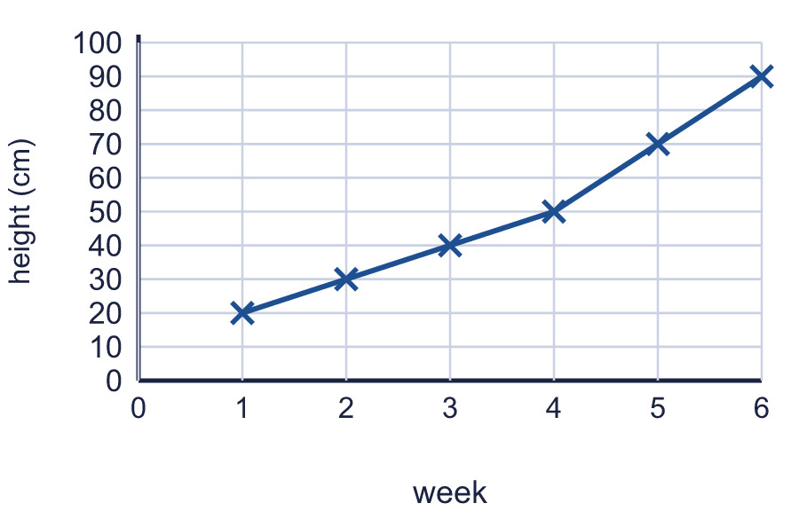
    What was the height at the start of week 2?
    cm
    What was the height at the start of week 4?
    cm
  1 | The graph shows the height of a sunflower at the start of each week.
    What was the height at the start of week 2?
    cm
    What was the height at the start of week 4?
    cm
  2 | The graph shows the height of a sunflower at the start of each week.  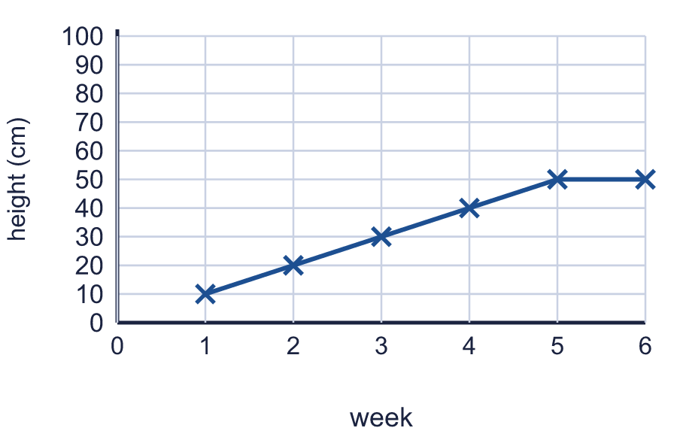
    By how many cm did the sunflower grow from the start of week 1 to the start of week 4?
    cm
  2 | The graph shows the height of a sunflower at the start of each week.
    By how many cm did the sunflower grow from the start of week 1 to the start of week 4?
    cm
  3 | The graph shows the height of a sunflower at the start of each week.  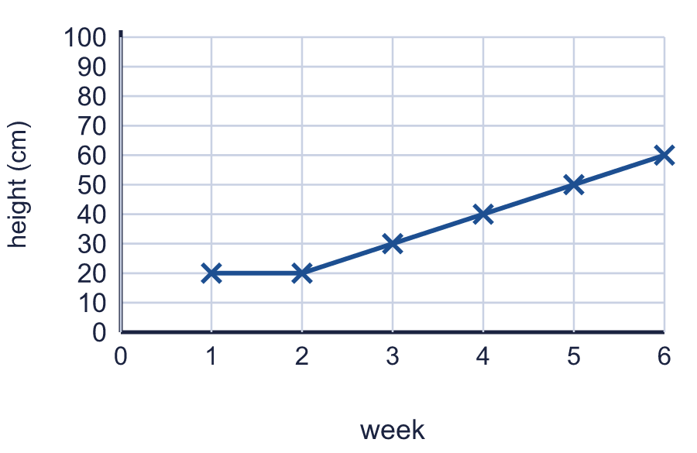
    At the start of which week was the sunflower 40 cm tall? Write the week number.
  3 | The graph shows the height of a sunflower at the start of each week.
    At the start of which week was the sunflower 40 cm tall? Write the week number.
  4 | The graph shows the population of a town at the start of each decade.  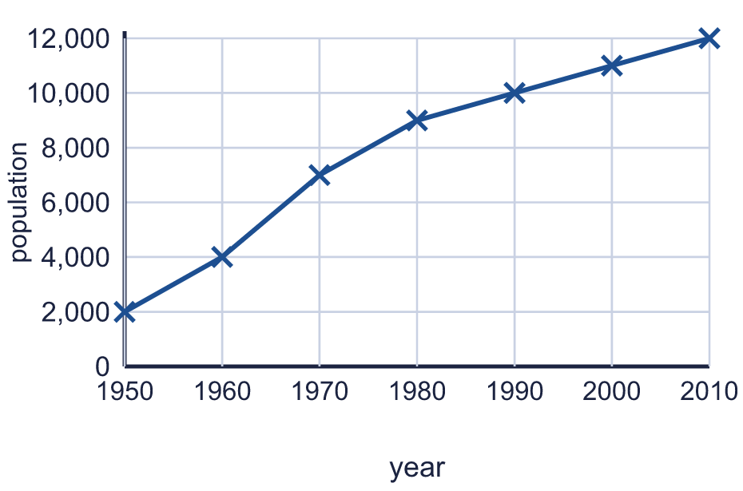
    What was the population in 1960?
    What was the population in 2010?
  4 | The graph shows the population of a town at the start of each decade.
    What was the population in 1960?
    What was the population in 2010?
  5 | The graph shows the population of a town at the start of each decade.  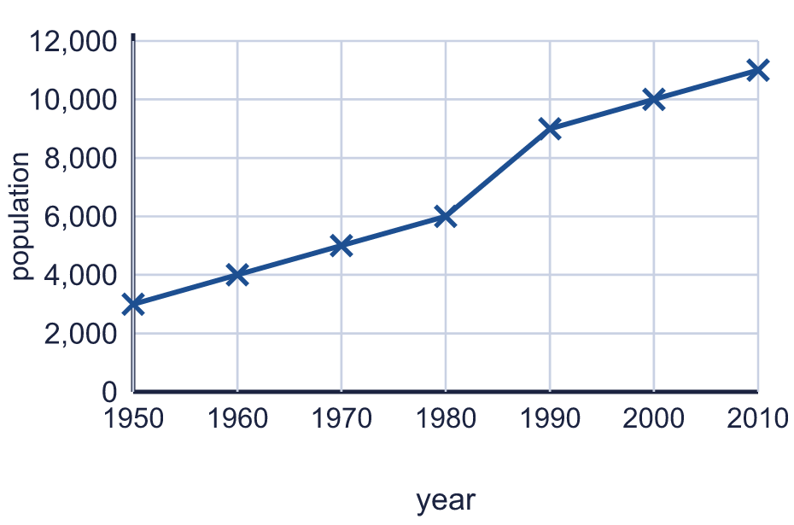
    What was the greatest increase in population in one decade?
    What was the least increase in population in one decade?
  5 | The graph shows the population of a town at the start of each decade.
    What was the greatest increase in population in one decade?
    What was the least increase in population in one decade?
  6 | The graph shows the average rainfall in two cities. The amounts are given to the nearest 5 mm.  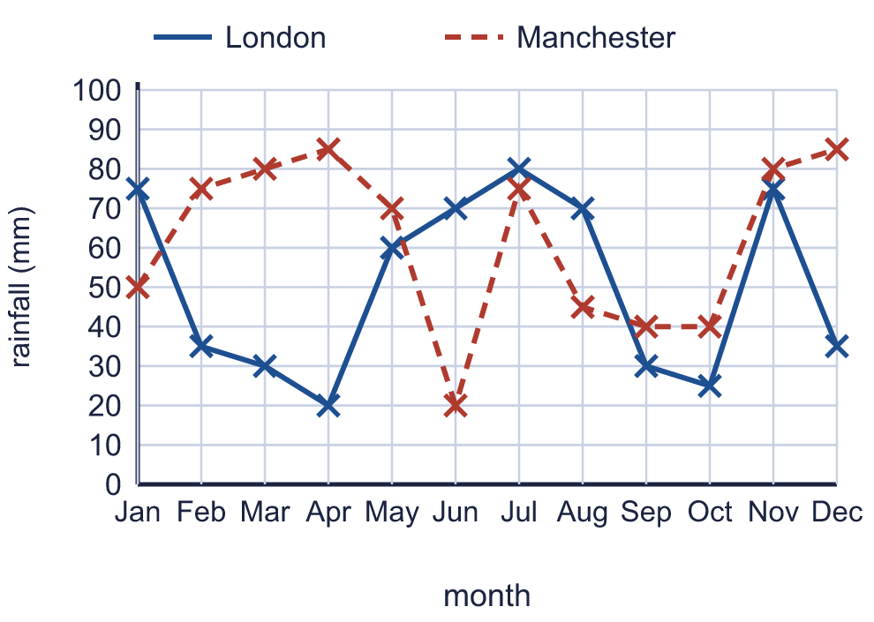
    How many mm of rain fall in London in July?
    mm
    Which is the wettest month in London?
  6 | The graph shows the average rainfall in two cities. The amounts are given to the nearest 5 mm.
    How many mm of rain fall in London in July?
    mm
    Which is the wettest month in London?
  7 | The graph shows the average rainfall in two cities. The amounts are given to the nearest 5 mm.  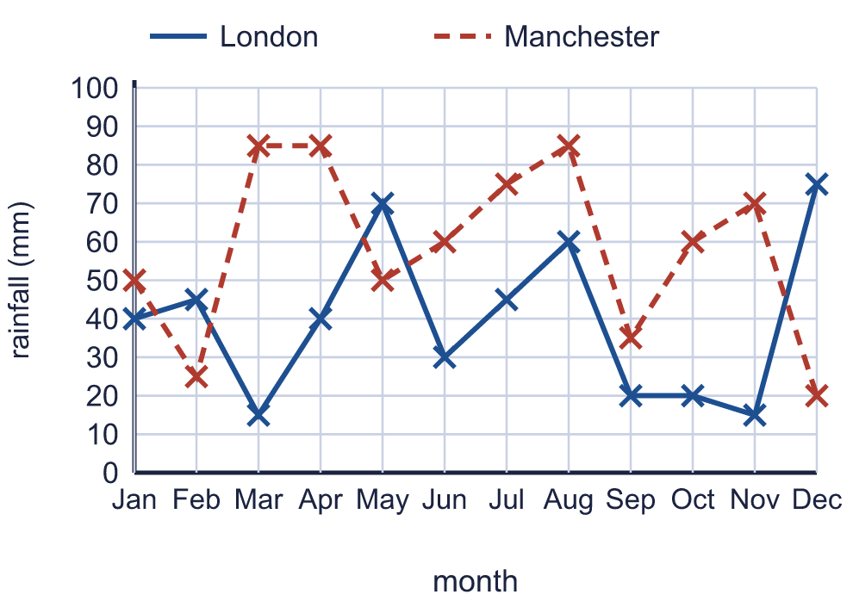
    Which is the driest month in Manchester?
    In June, how much more rain is there in Manchester than in London?
    mm
  7 | The graph shows the average rainfall in two cities. The amounts are given to the nearest 5 mm.
    Which is the driest month in Manchester?
    In June, how much more rain is there in Manchester than in London?
    mm
  8 | The graph shows the average rainfall in two cities.  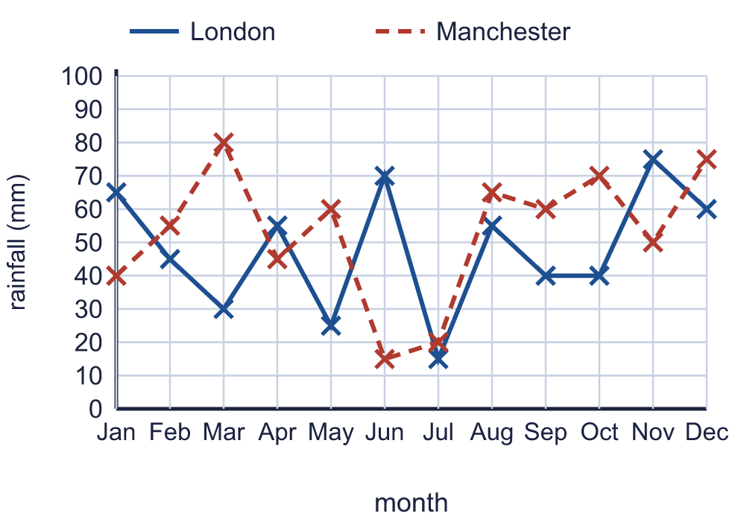
    In how many months does London have more than 50 mm of rain?
    In how many months does Manchester have more than 50 mm of rain?
  8 | The graph shows the average rainfall in two cities.
    In how many months does London have more than 50 mm of rain?
    In how many months does Manchester have more than 50 mm of rain?

  9 | 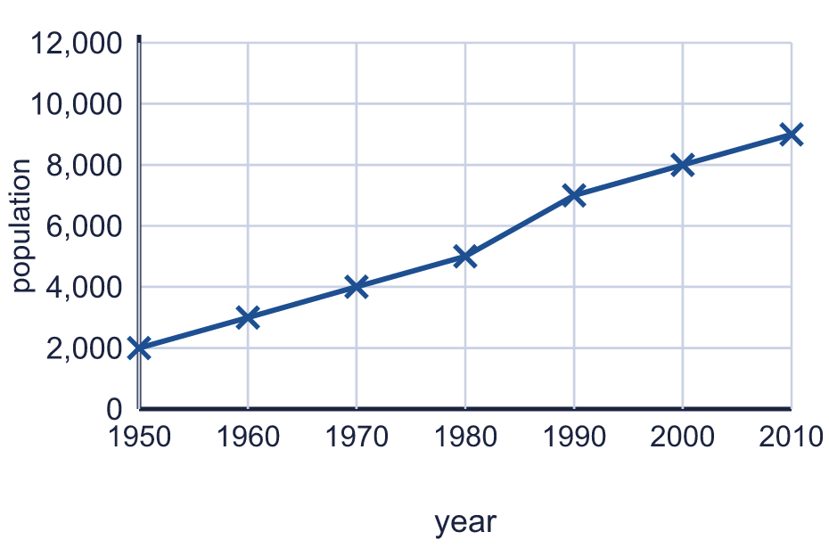  Is Grad correct? Circle yes or no.  Yes / No  Explain how you know.
    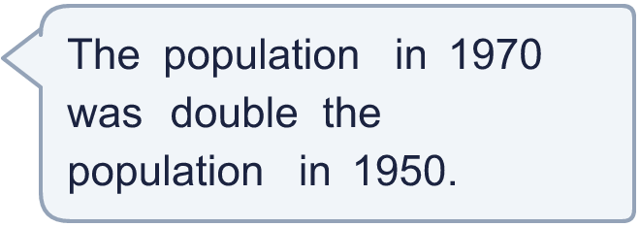
  9 | Is Grad correct? Circle yes or no.  Yes / No  Explain how you know.
  10 | The graph shows the energy used in a house each month. Which of these statements are true? Write the letters.  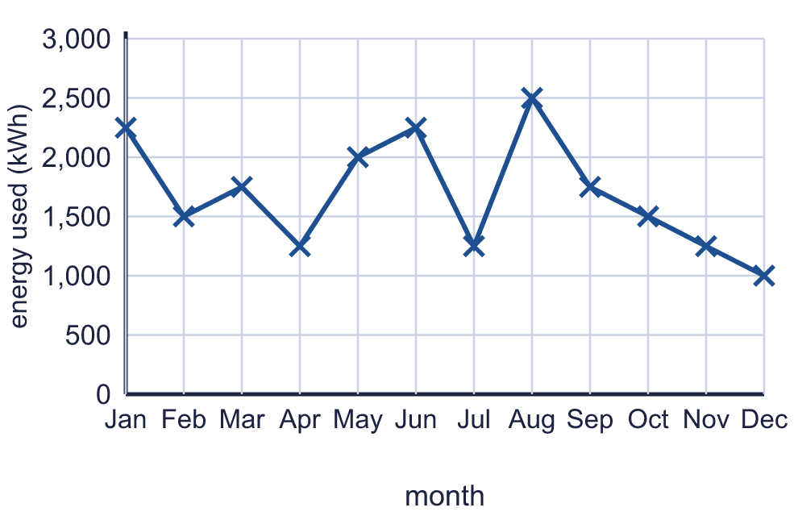  A: More energy was used in March than in April.  B: November used 1,250 kWh.  C: The most energy was used in November.  D: September used 500 kWh more than November.
    True statements:
  10 | The graph shows the energy used in a house each month. Which of these statements are true? Write the letters.  A: More energy was used in March than in April.  B: November used 1,250 kWh.  C: The most energy was used in November.  D: September used 500 kWh more than November.
    True statements:
  11 | The graph shows the average rainfall in two cities.  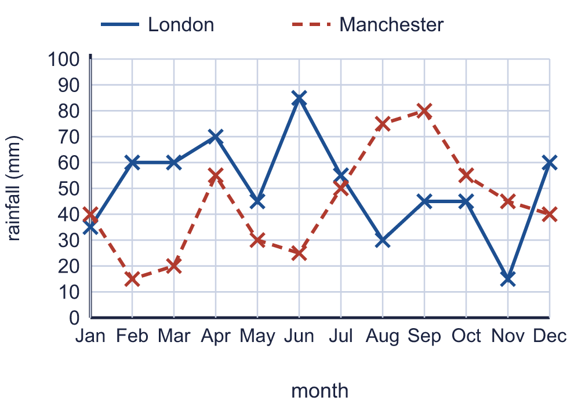  In which months does Manchester get more rain than London? Write the months.
    How many mm of rain fall in London and Manchester together in December?
    mm
  11 | The graph shows the average rainfall in two cities.  In which months does Manchester get more rain than London? Write the months.
    How many mm of rain fall in London and Manchester together in December?
    mm
  12 | The graph shows the average rainfall in two cities.  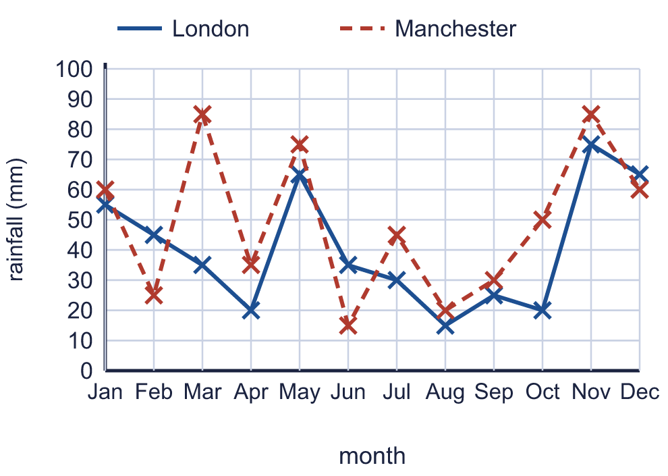
    How many mm of rain fall in London in January, February and March added together?
    mm
    In how many months does it rain more than 50 mm in both cities?
  12 | The graph shows the average rainfall in two cities.
    How many mm of rain fall in London in January, February and March added together?
    mm
    In how many months does it rain more than 50 mm in both cities?
  13 | The graph shows the temperature in Marlow. A reading was taken every hour.  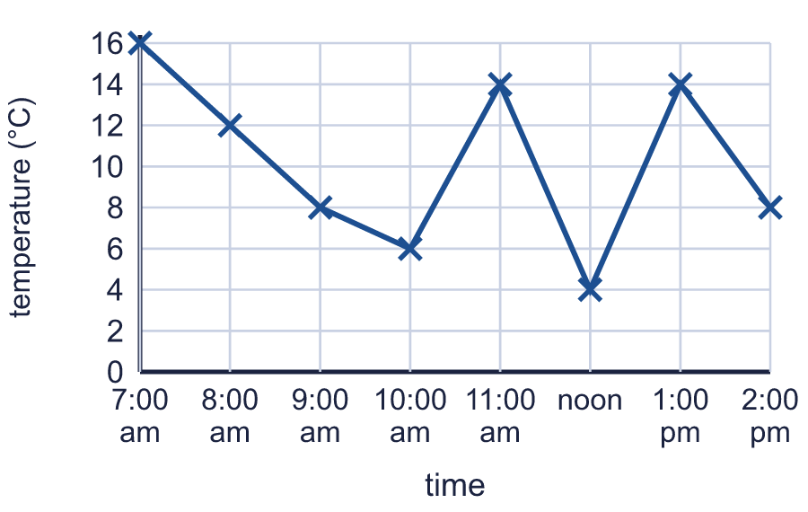
    At what time was the warmest reading? Write the time.
    What was the biggest rise in temperature between two readings?
    °C
  13 | The graph shows the temperature in Marlow. A reading was taken every hour.
    At what time was the warmest reading? Write the time.
    What was the biggest rise in temperature between two readings?
    °C
  14 | A taxi charges the same amount for every mile. The graph is a straight line from 0 miles to 10 miles.  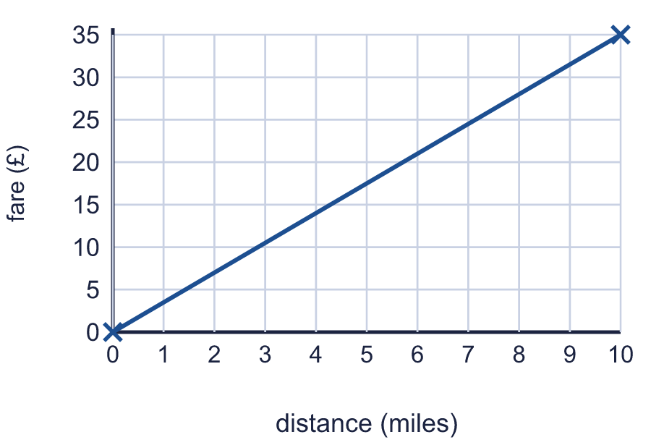
    What is the fare for 4 miles? Write the number of pounds.
    How many miles can you travel for £28?
    miles
  14 | A taxi charges the same amount for every mile. The graph is a straight line from 0 miles to 10 miles.
    What is the fare for 4 miles? Write the number of pounds.
    How many miles can you travel for £28?
    miles

Year 5 · Statistics · Step 2
Read and interpret line graphs
Answers (teacher copy)

  1 | The graph shows the height of a sunflower at the start of each week.  What was the height at the start of week 2? 30 cm  What was the height at the start of week 4? 50 cm
  2 | The graph shows the height of a sunflower at the start of each week.  By how many cm did the sunflower grow from the start of week 1 to the start of week 4? 30 cm
  3 | The graph shows the height of a sunflower at the start of each week.  At the start of which week was the sunflower 40 cm tall? Write the week number. 4
  4 | The graph shows the population of a town at the start of each decade.  What was the population in 1960? 4,000  What was the population in 2010? 12,000
  5 | The graph shows the population of a town at the start of each decade.  What was the greatest increase in population in one decade? 3,000  What was the least increase in population in one decade? 1,000
  6 | The graph shows the average rainfall in two cities. The amounts are given to the nearest 5 mm.  How many mm of rain fall in London in July? 80 mm  Which is the wettest month in London? Jul
  7 | The graph shows the average rainfall in two cities. The amounts are given to the nearest 5 mm.  Which is the driest month in Manchester? Dec  In June, how much more rain is there in Manchester than in London? 30 mm
  8 | The graph shows the average rainfall in two cities.  In how many months does London have more than 50 mm of rain? 6  In how many months does Manchester have more than 50 mm of rain? 7
  9 | Is Grad correct? Circle yes or no.  Yes / No  Explain how you know.  Yes. Double 2,000 is 4,000, and the population in 1970 was 4,000.
  10 | The graph shows the energy used in a house each month. Which of these statements are true? Write the letters.  A: More energy was used in March than in April.  B: November used 1,250 kWh.  C: The most energy was used in November.  D: September used 500 kWh more than November.  True statements: A, B, D
  11 | The graph shows the average rainfall in two cities.  In which months does Manchester get more rain than London? Write the months. Jan, Aug, Sep, Oct, Nov  How many mm of rain fall in London and Manchester together in December? 100 mm
  12 | The graph shows the average rainfall in two cities.  How many mm of rain fall in London in January, February and March added together? 135 mm  In how many months does it rain more than 50 mm in both cities? 4
  13 | The graph shows the temperature in Marlow. A reading was taken every hour.  At what time was the warmest reading? Write the time. 7:00 am  What was the biggest rise in temperature between two readings? 10 °C
  14 | A taxi charges the same amount for every mile. The graph is a straight line from 0 miles to 10 miles.  What is the fare for 4 miles? Write the number of pounds. 14  How many miles can you travel for £28? 8 miles

