  Year 5 · Statistics · Step 5  Read and interpret timetables | 
  Year 5 · Statistics · Step 5
  Read and interpret timetables
  1 | Here is part of a bus timetable.  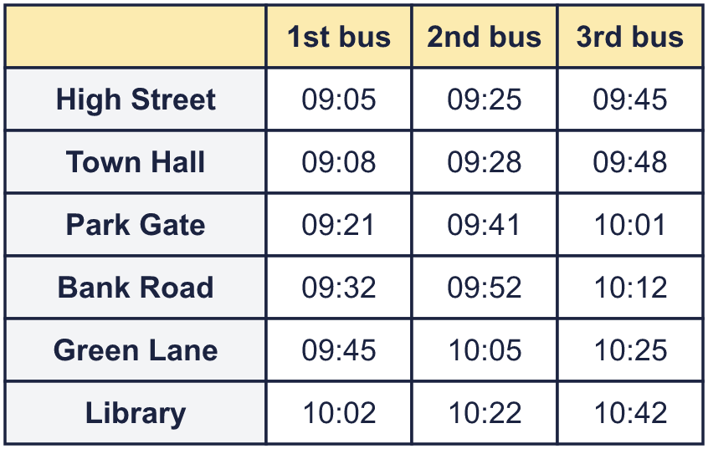
    What time does the 2nd bus leave or arrive at Green Lane?
  1 | Here is part of a bus timetable.
    What time does the 2nd bus leave or arrive at Green Lane?
  2 | Here is part of a bus timetable.  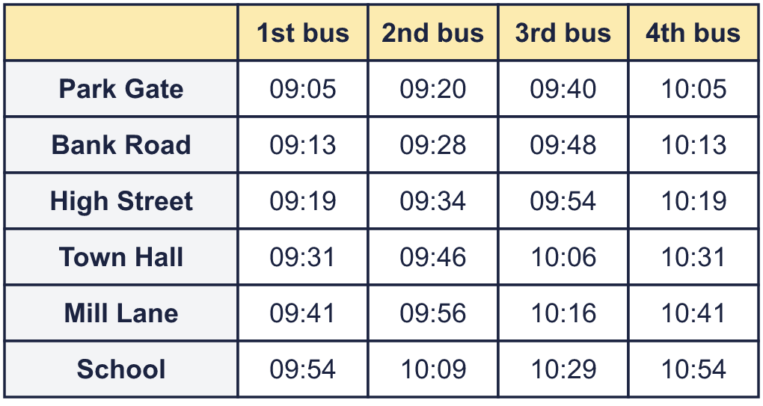
    How many minutes does the 2nd bus take to go from Mill Lane to School?
    minutes
  2 | Here is part of a bus timetable.
    How many minutes does the 2nd bus take to go from Mill Lane to School?
    minutes
  3 | Here is part of a bus timetable.  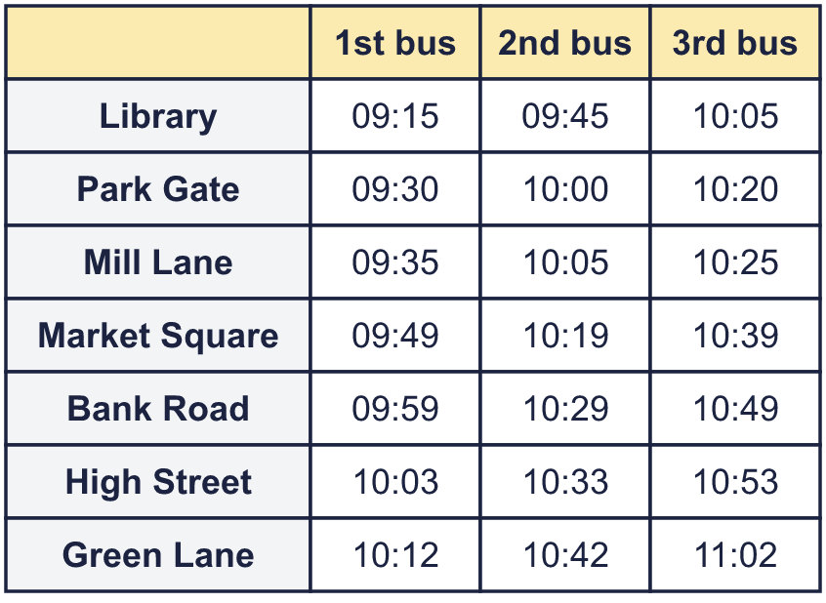
    How many minutes does the whole journey take on the 3rd bus, from Library to Green Lane?
    minutes
  3 | Here is part of a bus timetable.
    How many minutes does the whole journey take on the 3rd bus, from Library to Green Lane?
    minutes
  4 | Here is part of a bus timetable.  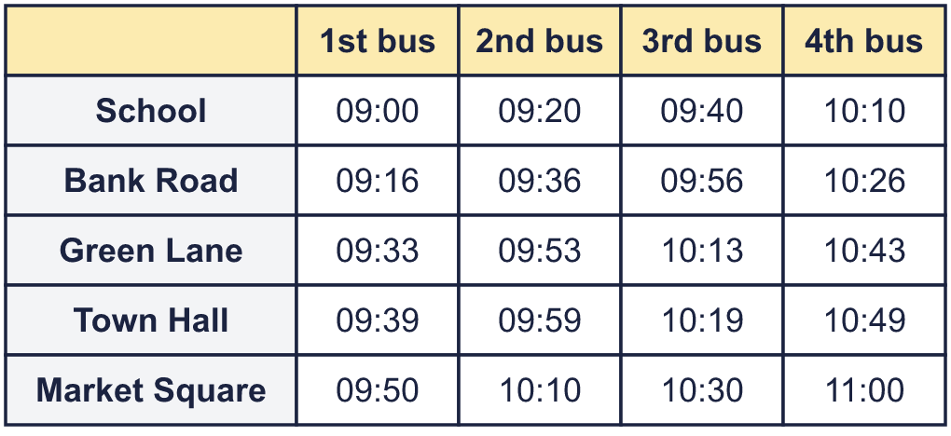  Rosa gets to the Town Hall stop at 10:15.
    What time is the next bus she can catch?
  4 | Here is part of a bus timetable.  Rosa gets to the Town Hall stop at 10:15.
    What time is the next bus she can catch?
  5 | Here is a train timetable. A dash (–) means the train does not stop there.  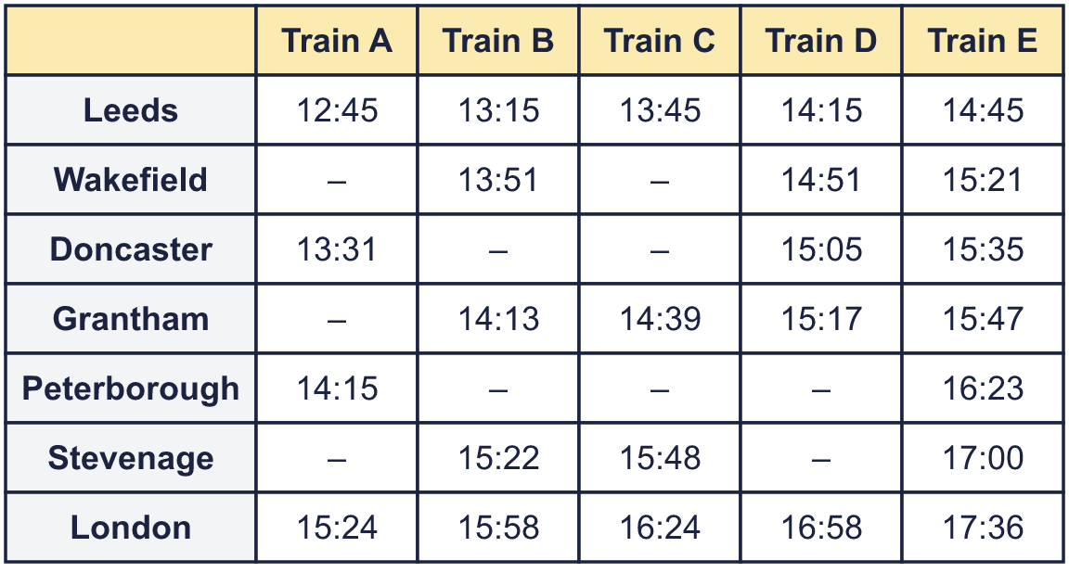  Write the stations where Train E stops, from first to last.
  5 | Here is a train timetable. A dash (–) means the train does not stop there.  Write the stations where Train E stops, from first to last.
  6 | Here is a train timetable. A dash (–) means the train does not stop there.  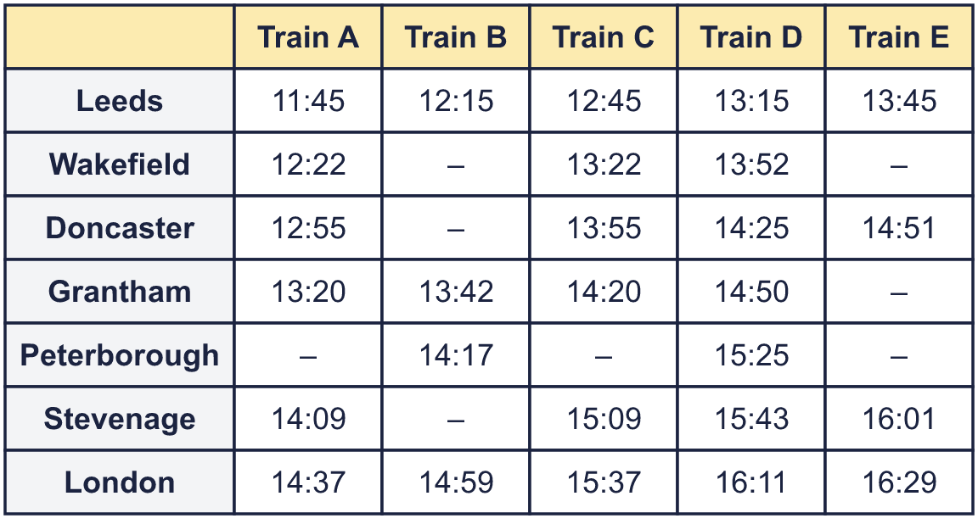  Which trains do not stop at Wakefield? Write the letters.
  6 | Here is a train timetable. A dash (–) means the train does not stop there.  Which trains do not stop at Wakefield? Write the letters.
  7 | Here is a train timetable. A dash (–) means the train does not stop there.  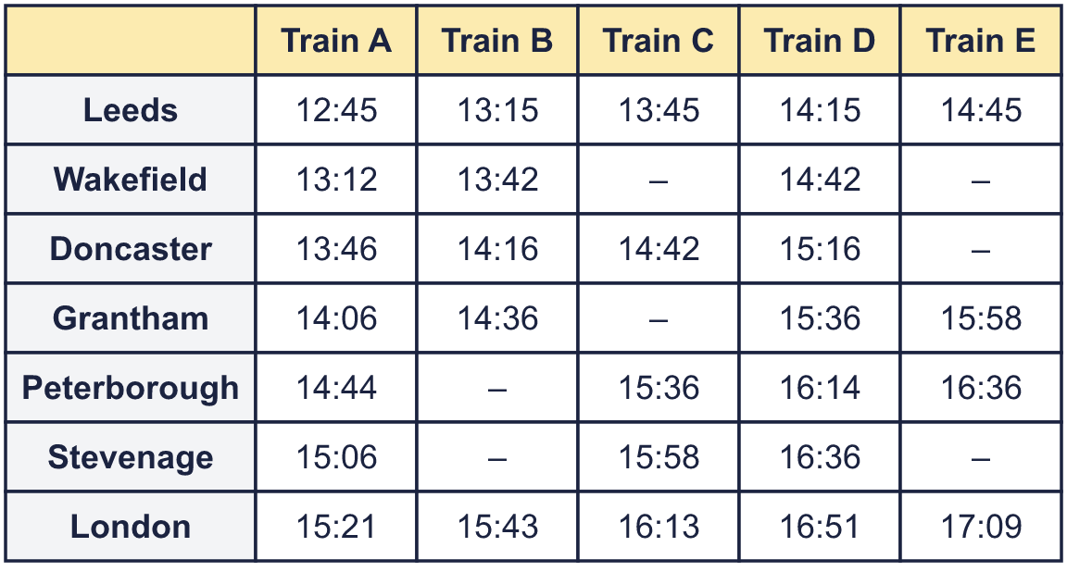
    What time does Train C arrive in London?
    How many minutes does it take to go from Leeds to London?
    minutes
  7 | Here is a train timetable. A dash (–) means the train does not stop there.
    What time does Train C arrive in London?
    How many minutes does it take to go from Leeds to London?
    minutes
  8 | Here is part of a bus timetable.  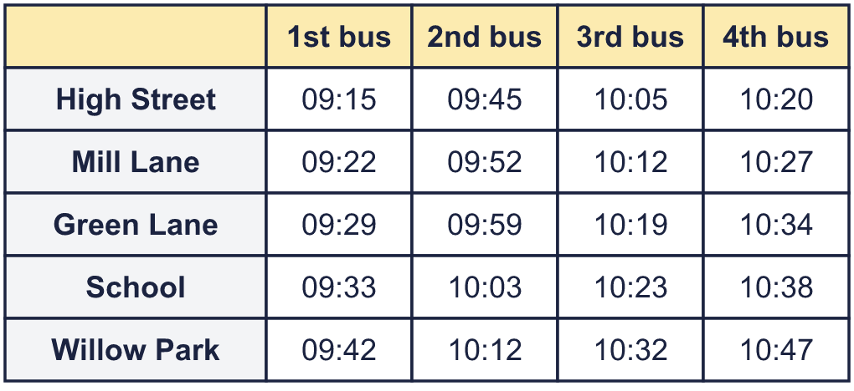  Sam catches the 09:22 bus at Mill Lane.
    What time does Sam arrive at Willow Park?
  8 | Here is part of a bus timetable.  Sam catches the 09:22 bus at Mill Lane.
    What time does Sam arrive at Willow Park?

  9 | Here is a bus timetable.  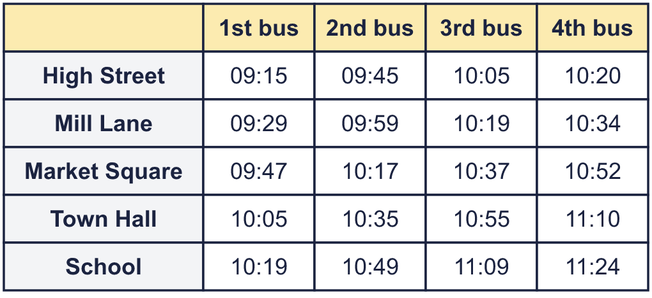  Can Dora still get there in time? Circle yes or no.  Yes / No  Explain how you know.
     | 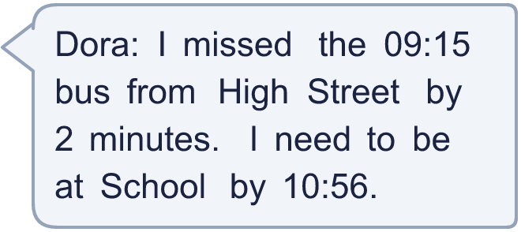
  9 | Here is a bus timetable.  Can Dora still get there in time? Circle yes or no.  Yes / No  Explain how you know.
  10 | Here is a train timetable. A dash (–) means the train does not stop there.  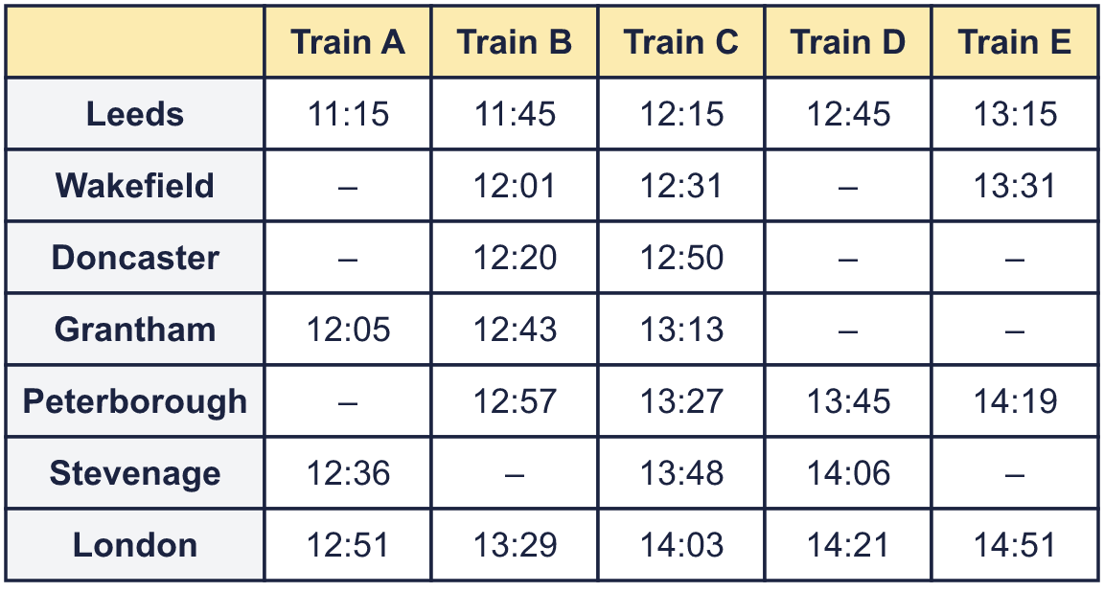  Jo arrives at Grantham station at 12:07 and wants to go to Stevenage. The train must stop at Stevenage.
    What time will Jo arrive in Stevenage?
  10 | Here is a train timetable. A dash (–) means the train does not stop there.  Jo arrives at Grantham station at 12:07 and wants to go to Stevenage. The train must stop at Stevenage.
    What time will Jo arrive in Stevenage?
  11 | Here is a bus timetable. The buses run only at the times shown.  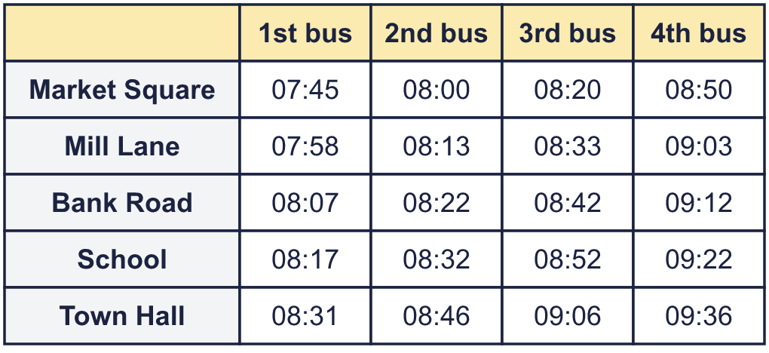  Is Sam correct? Circle yes or no.  Yes / No  Explain how you know.
     | 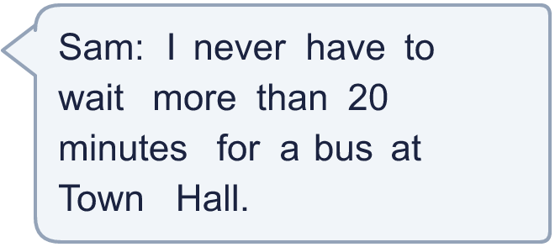
  11 | Here is a bus timetable. The buses run only at the times shown.  Is Sam correct? Circle yes or no.  Yes / No  Explain how you know.
  12 | Here is a train timetable. A dash (–) means the train does not stop there.  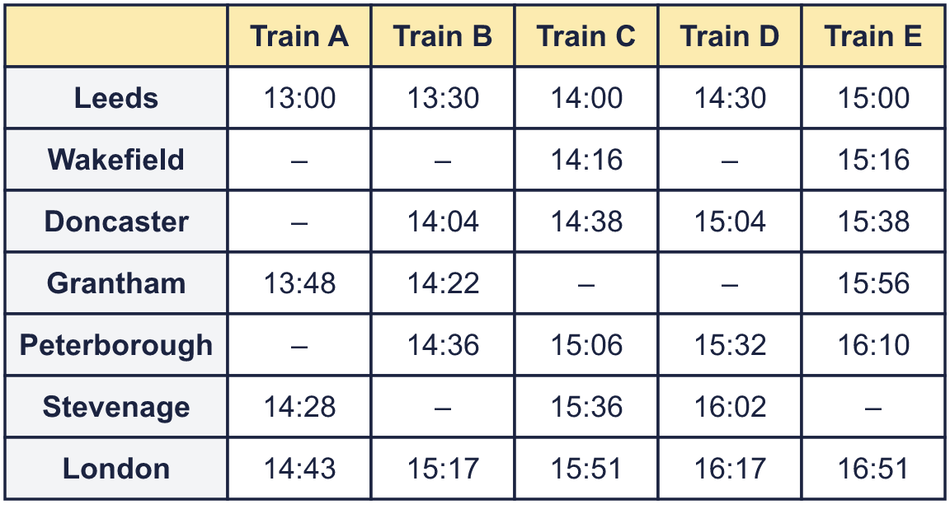  Some trains stop at both Leeds and Stevenage. Look at those trains only.
    Which of these trains takes the shortest time to go from Leeds to Stevenage? Write the letter.
    How many minutes is the journey?
    minutes
  12 | Here is a train timetable. A dash (–) means the train does not stop there.  Some trains stop at both Leeds and Stevenage. Look at those trains only.
    Which of these trains takes the shortest time to go from Leeds to Stevenage? Write the letter.
    How many minutes is the journey?
    minutes
  13 | Here is part of a bus timetable.  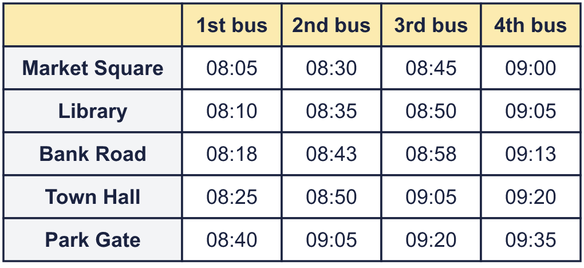  Kim must be at Town Hall by 09:23. She will catch a bus from Market Square.
    What is the latest time that her bus can leave?
  13 | Here is part of a bus timetable.  Kim must be at Town Hall by 09:23. She will catch a bus from Market Square.
    What is the latest time that her bus can leave?
  14 | Challenge  Here is a bus timetable.  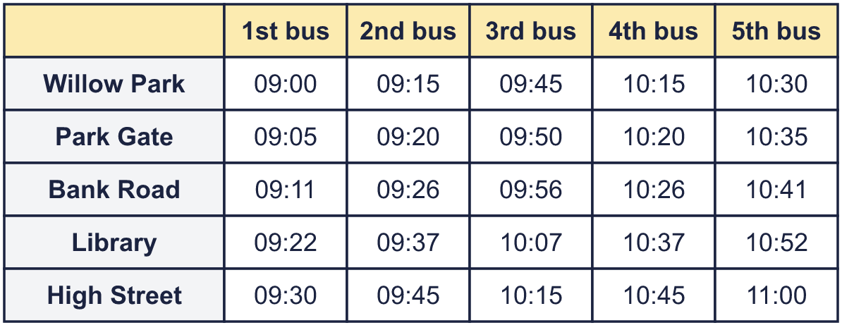  How many buses leave High Street from 09:29 to 10:46, including both of those times?
    Number of buses =
    How many minutes is it from the first bus to the last bus at High Street?
    minutes
  14 | Challenge  Here is a bus timetable.  How many buses leave High Street from 09:29 to 10:46, including both of those times?
    Number of buses =
    How many minutes is it from the first bus to the last bus at High Street?
    minutes

Year 5 · Statistics · Step 5
Read and interpret timetables
Answers (teacher copy)

  1 | Here is part of a bus timetable.  What time does the 2nd bus leave or arrive at Green Lane? 10:05
  2 | Here is part of a bus timetable.  How many minutes does the 2nd bus take to go from Mill Lane to School? 13 minutes
  3 | Here is part of a bus timetable.  How many minutes does the whole journey take on the 3rd bus, from Library to Green Lane? 57 minutes
  4 | Here is part of a bus timetable.  Rosa gets to the Town Hall stop at 10:15.  What time is the next bus she can catch? 10:19
  5 | Here is a train timetable. A dash (–) means the train does not stop there.  Write the stations where Train E stops, from first to last. Leeds, Wakefield, Doncaster, Grantham, Peterborough, Stevenage, London
  6 | Here is a train timetable. A dash (–) means the train does not stop there.  Which trains do not stop at Wakefield? Write the letters. B, E
  7 | Here is a train timetable. A dash (–) means the train does not stop there.  What time does Train C arrive in London? 16:13  How many minutes does it take to go from Leeds to London? 148 minutes
  8 | Here is part of a bus timetable.  Sam catches the 09:22 bus at Mill Lane.  What time does Sam arrive at Willow Park? 09:42
  9 | Here is a bus timetable.  Can Dora still get there in time? Circle yes or no.  Yes / No  Explain how you know.  Yes. The next bus from High Street is at 09:45. It gets to School at 10:49, which is not after 10:56.
  10 | Here is a train timetable. A dash (–) means the train does not stop there.  Jo arrives at Grantham station at 12:07 and wants to go to Stevenage. The train must stop at Stevenage.  What time will Jo arrive in Stevenage? 13:48
  11 | Here is a bus timetable. The buses run only at the times shown.  Is Sam correct? Circle yes or no.  Yes / No  Explain how you know.  No. The longest gap between two buses at Town Hall is 30 minutes, which is more than 20.
  12 | Here is a train timetable. A dash (–) means the train does not stop there.  Some trains stop at both Leeds and Stevenage. Look at those trains only.  Which of these trains takes the shortest time to go from Leeds to Stevenage? Write the letter. A  How many minutes is the journey? 88 minutes
  13 | Here is part of a bus timetable.  Kim must be at Town Hall by 09:23. She will catch a bus from Market Square.  What is the latest time that her bus can leave? 09:00
  14 | Challenge  Here is a bus timetable.  How many buses leave High Street from 09:29 to 10:46, including both of those times?  Number of buses = 4  How many minutes is it from the first bus to the last bus at High Street? 90 minutes

