  Year 5 · Statistics · Step 4  Two-way tables | 
  Year 5 · Statistics · Step 4
  Two-way tables
  1 | A film is shown twice in one day. The table shows how many adults and how many children watched each showing.  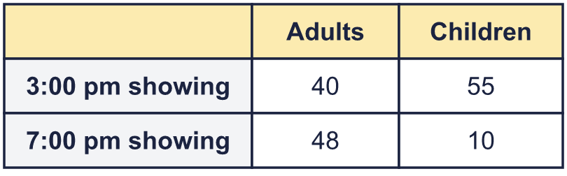
    How many children watched the 7:00 pm showing?
  1 | A film is shown twice in one day. The table shows how many adults and how many children watched each showing.
    How many children watched the 7:00 pm showing?
  2 | A film is shown twice in one day. The table shows how many adults and how many children watched each showing.  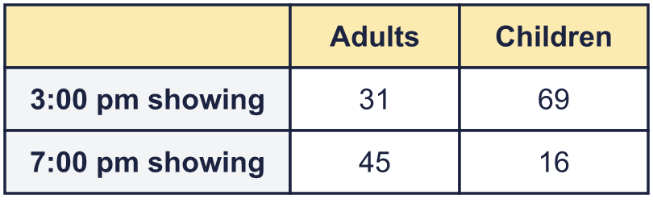
    How many adults watched the film that day?
    How many children watched the film that day?
  2 | A film is shown twice in one day. The table shows how many adults and how many children watched each showing.
    How many adults watched the film that day?
    How many children watched the film that day?
  3 | The cinema has 120 seats. The table shows how many adults and children watched each showing.  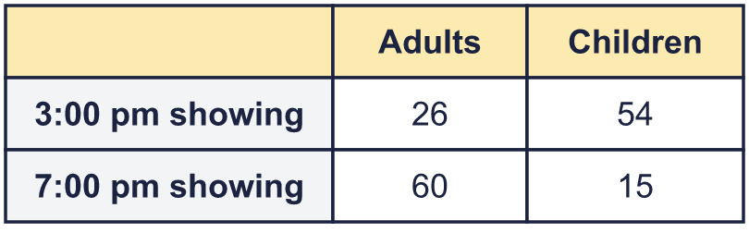
    How many seats were empty at the 7:00 pm showing?
  3 | The cinema has 120 seats. The table shows how many adults and children watched each showing.
    How many seats were empty at the 7:00 pm showing?
  4 | The table shows how many adults and children visited a museum on two days.  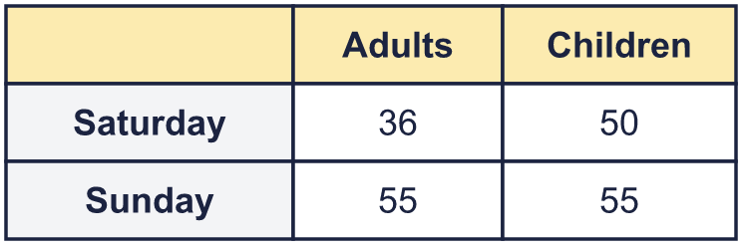
    Did more adults or more children visit over the two days?
    How many more?
  4 | The table shows how many adults and children visited a museum on two days.
    Did more adults or more children visit over the two days?
    How many more?
  5 | The table shows the eye colours of some children. Some numbers are missing. Work out the missing numbers and write them in the table.  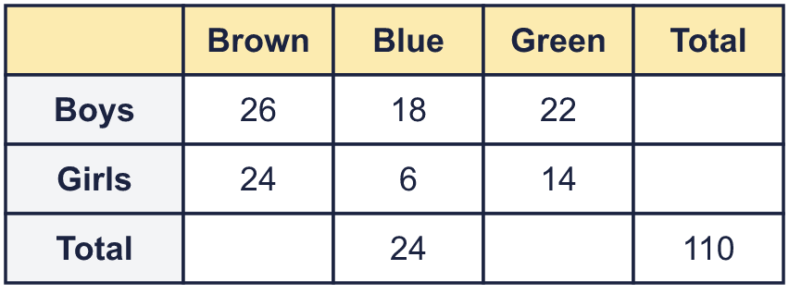
    How many girls have brown eyes?
  5 | The table shows the eye colours of some children. Some numbers are missing. Work out the missing numbers and write them in the table.
    How many girls have brown eyes?
  6 | The table shows the pets that children in two year groups have. Some numbers are missing. Work out the missing numbers and write them in the table.  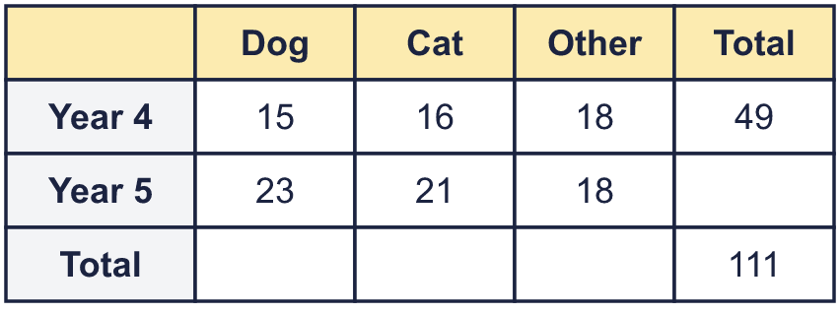
    How many children in Year 5 have a dog or a cat?
  6 | The table shows the pets that children in two year groups have. Some numbers are missing. Work out the missing numbers and write them in the table.
    How many children in Year 5 have a dog or a cat?
  7 | The table shows the distances in miles between some towns.  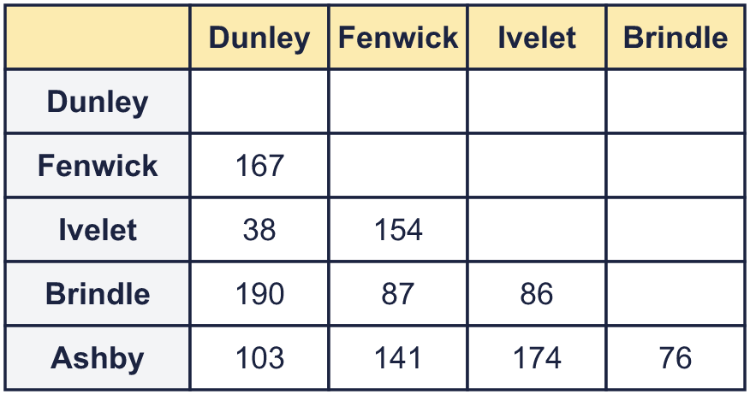
    What is the distance between Ashby and Fenwick?
    miles
  7 | The table shows the distances in miles between some towns.
    What is the distance between Ashby and Fenwick?
    miles
  8 | The table shows the distances in miles between some towns.  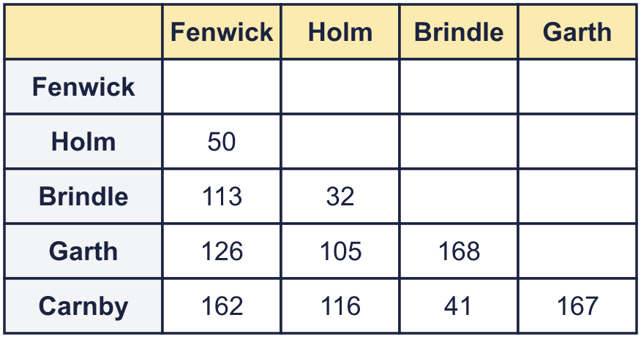
    Which two towns are the furthest apart?
    How far apart are they? |  | miles
  8 | The table shows the distances in miles between some towns.
    Which two towns are the furthest apart?
    How far apart are they? |  | miles

  9 | Teams get points for each event at a swimming gala. Some of the points have been washed off the table. Work out the missing points and write them in the table.  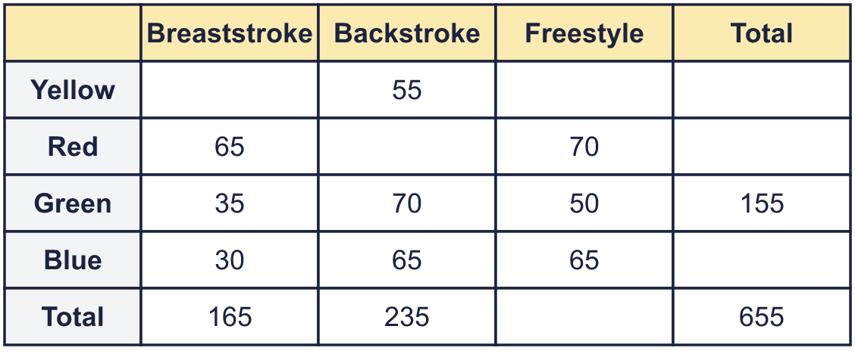
    How many points did the Blue team get for backstroke?
    How many points did all the teams get altogether?
  9 | Teams get points for each event at a swimming gala. Some of the points have been washed off the table. Work out the missing points and write them in the table.
    How many points did the Blue team get for backstroke?
    How many points did all the teams get altogether?
  10 | The table shows some tall buildings.  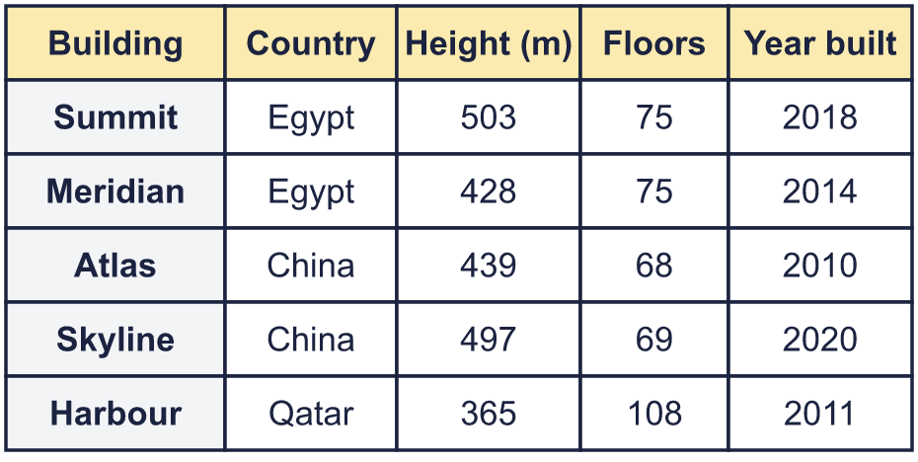
    Which building is 365 m tall?
    Which two buildings have the same number of floors?
  10 | The table shows some tall buildings.
    Which building is 365 m tall?
    Which two buildings have the same number of floors?
  11 | The table shows some tall buildings.
    Which building was built most recently?
    How many metres taller is the tallest building than the shortest?
    m
  11 | The table shows some tall buildings.
    Which building was built most recently?
    How many metres taller is the tallest building than the shortest?
    m
  12 | Is Nina correct? Circle yes or no.  Yes / No  Explain how you know.
     | 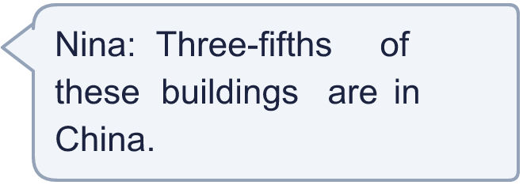
  12 | Is Nina correct? Circle yes or no.  Yes / No  Explain how you know.
  13 | Challenge  The table shows the favourite foods of some children. Most of the numbers are missing. Work out all the missing numbers and write them in the table.  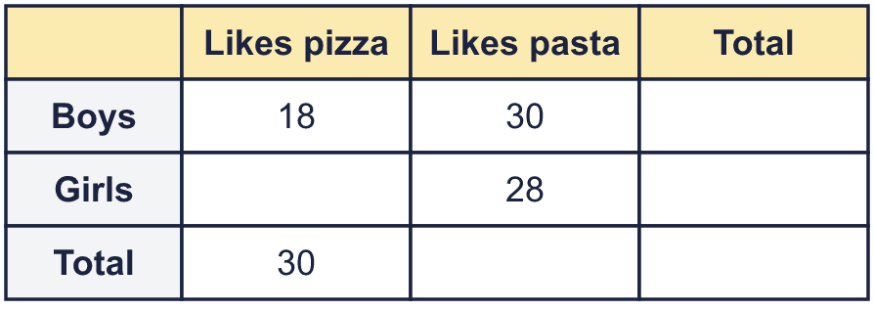
    How many girls like pasta?
    How many children were asked altogether?
  13 | Challenge  The table shows the favourite foods of some children. Most of the numbers are missing. Work out all the missing numbers and write them in the table.
    How many girls like pasta?
    How many children were asked altogether?
  14 | The table shows the distances in miles between some towns.  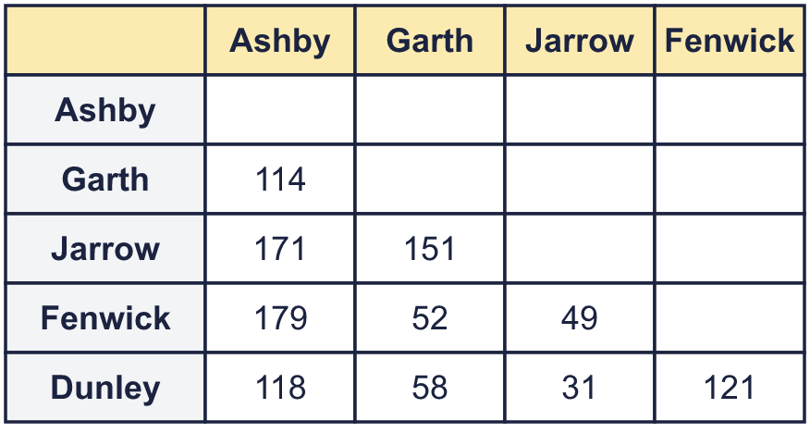  Sam drives from Fenwick to Garth and then from Garth to Jarrow.
    How far does Sam drive altogether?
    miles
    How many miles shorter is it to drive straight from Fenwick to Jarrow?
    miles
  14 | The table shows the distances in miles between some towns.  Sam drives from Fenwick to Garth and then from Garth to Jarrow.
    How far does Sam drive altogether?
    miles
    How many miles shorter is it to drive straight from Fenwick to Jarrow?
    miles

Year 5 · Statistics · Step 4
Two-way tables
Answers (teacher copy)

  1 | A film is shown twice in one day. The table shows how many adults and how many children watched each showing.  How many children watched the 7:00 pm showing? 10
  2 | A film is shown twice in one day. The table shows how many adults and how many children watched each showing.  How many adults watched the film that day? 76  How many children watched the film that day? 85
  3 | The cinema has 120 seats. The table shows how many adults and children watched each showing.  How many seats were empty at the 7:00 pm showing? 45
  4 | The table shows how many adults and children visited a museum on two days.  Did more adults or more children visit over the two days? Children  How many more? 14
  5 | The table shows the eye colours of some children. Some numbers are missing. Work out the missing numbers and write them in the table.  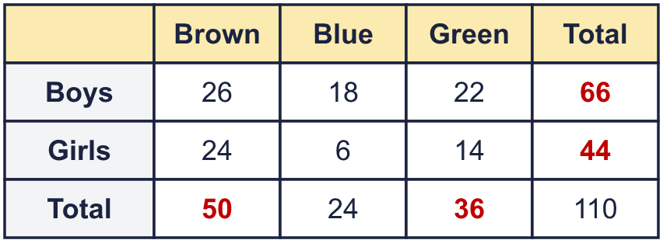  How many girls have brown eyes? 24
  6 | The table shows the pets that children in two year groups have. Some numbers are missing. Work out the missing numbers and write them in the table.  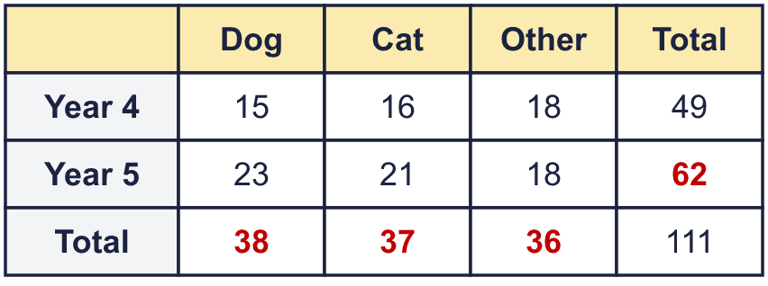  How many children in Year 5 have a dog or a cat? 44
  7 | The table shows the distances in miles between some towns.  What is the distance between Ashby and Fenwick? 141 miles
  8 | The table shows the distances in miles between some towns.  Which two towns are the furthest apart? Brindle and Garth  How far apart are they? 168 miles
  9 | Teams get points for each event at a swimming gala. Some of the points have been washed off the table. Work out the missing points and write them in the table.  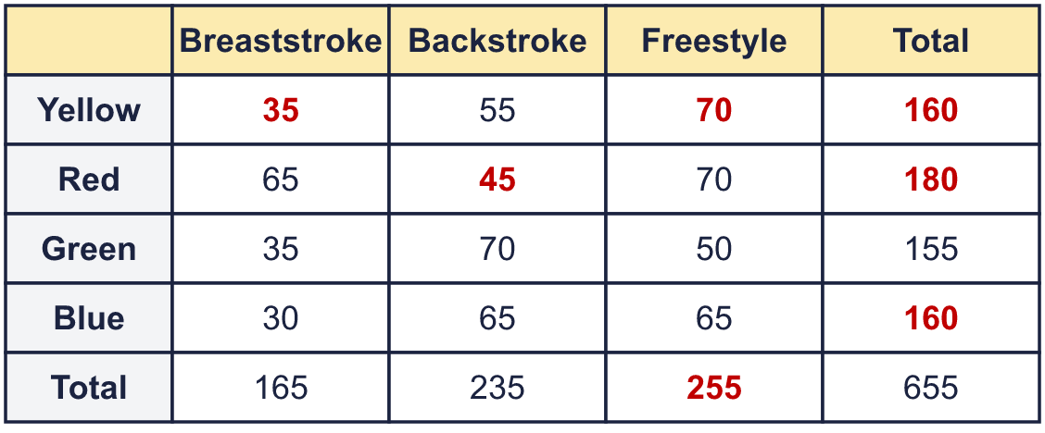  How many points did the Blue team get for backstroke? 65  How many points did all the teams get altogether? 655
  10 | The table shows some tall buildings.  Which building is 365 m tall? Harbour  Which two buildings have the same number of floors? Summit and Meridian
  11 | The table shows some tall buildings.  Which building was built most recently? Skyline  How many metres taller is the tallest building than the shortest? 138 m
  12 | Is Nina correct? Circle yes or no.  Yes / No  Explain how you know.  No. 2 of the 5 buildings are in China, and ²⁄₅ is not ³⁄₅.
  13 | Challenge  The table shows the favourite foods of some children. Most of the numbers are missing. Work out all the missing numbers and write them in the table.  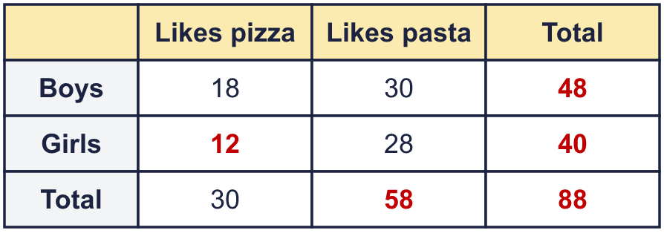  How many girls like pasta? 28  How many children were asked altogether? 88
  14 | The table shows the distances in miles between some towns.  Sam drives from Fenwick to Garth and then from Garth to Jarrow.  How far does Sam drive altogether? 203 miles  How many miles shorter is it to drive straight from Fenwick to Jarrow? 154 miles

