  Year 6 · Add, subtract, multiply and divide · Step 1  Adding and subtracting integers | 
  Year 6 · Add, subtract, multiply and divide · Step 1
  Adding and subtracting integers
  1 | Work out the additions.  a) 6,155 + 471,820 =  b) 89,765 + 15,321 =  c) 944,194 + 321,094 =
  1 | Work out the additions.  a) 6,155 + 471,820 =  b) 89,765 + 15,321 =  c) 944,194 + 321,094 =
  2 | Work out the subtractions.  a) 84,075 − 56,018 =  b) 504,564 − 33,234 =  c) 3,191,227 − 159,966 =
  2 | Work out the subtractions.  a) 84,075 − 56,018 =  b) 504,564 − 33,234 =  c) 3,191,227 − 159,966 =
  3 | Write the missing digits in the calculation.  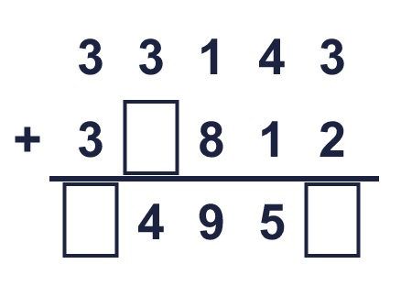  Missing digits, from top to bottom and left to right:
  3 | Write the missing digits in the calculation.  Missing digits, from top to bottom and left to right:
  4 | Write the missing digits in the calculation.  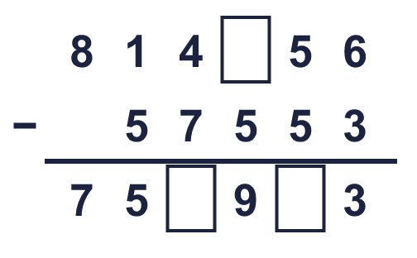  Missing digits, from top to bottom and left to right:
  4 | Write the missing digits in the calculation.  Missing digits, from top to bottom and left to right:
  5 | Write the missing number in each calculation.
    a) | 77,100 + |  | = 299,405
    b) |  | − 79,988 = 886,990
  5 | Write the missing number in each calculation.
    a) | 77,100 + |  | = 299,405
    b) |  | − 79,988 = 886,990
  6 | Estimate 588,974 + 77,781 by rounding each number to the nearest 10,000 first.  Estimate:
  6 | Estimate 588,974 + 77,781 by rounding each number to the nearest 10,000 first.  Estimate:
  7 | Four players score points in a game. Dee’s score is 88,300 less than Beth’s.  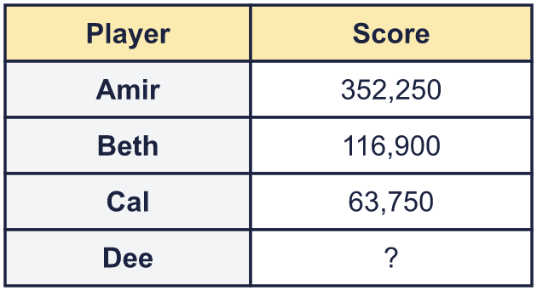  a) What is Dee’s score?  b) What is the difference between the highest and the lowest score?
  7 | Four players score points in a game. Dee’s score is 88,300 less than Beth’s.  a) What is Dee’s score?  b) What is the difference between the highest and the lowest score?
  8 | A theatre sold 25,350 tickets in May and 12,680 in June. It wants to sell 47,100 tickets by the end of June.  How many more tickets does it need to sell?
  8 | A theatre sold 25,350 tickets in May and 12,680 in June. It wants to sell 47,100 tickets by the end of June.  How many more tickets does it need to sell?

  9 | 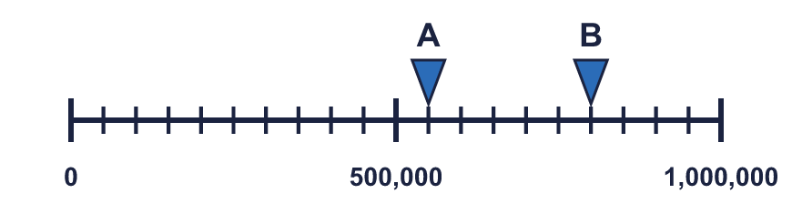  What is the difference between A and B?
     | 
  9 | What is the difference between A and B?
  10 | 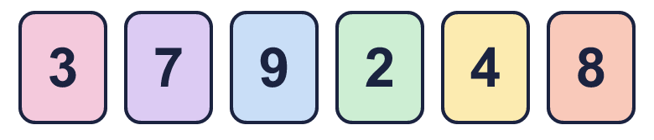  The answer must be bigger than 500. What is the smallest answer above 500 that you can make?
     | 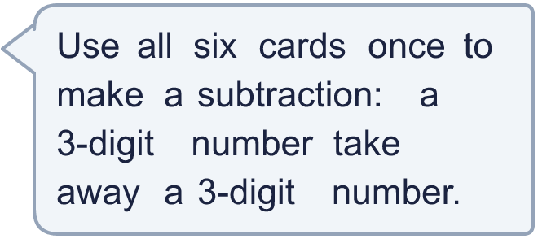
  10 | The answer must be bigger than 500. What is the smallest answer above 500 that you can make?
  11 | What number did I start with?
    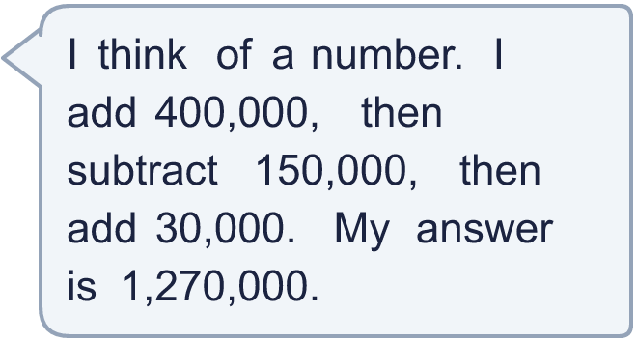
  11 | What number did I start with?
  12 | Is Boba correct? Circle yes or no.  Yes / No  Explain how you know.
     | 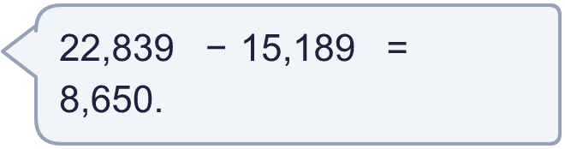
  12 | Is Boba correct? Circle yes or no.  Yes / No  Explain how you know.
  13 | 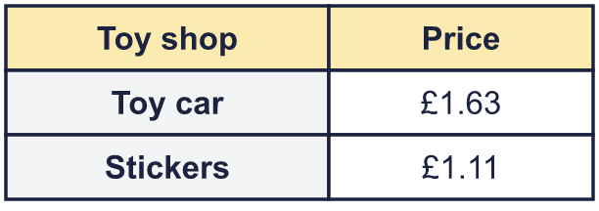  a) How much do they cost altogether?  b) John pays with a £10 note. How much change does he get?
    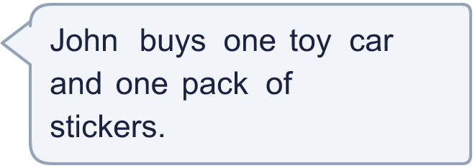
  13 | a) How much do they cost altogether?  b) John pays with a £10 note. How much change does he get?
  14 | Write two different pairs of 6-digit numbers that add up to 1,000,000.
  14 | Write two different pairs of 6-digit numbers that add up to 1,000,000.

Year 6 · Add, subtract, multiply and divide · Step 1
Adding and subtracting integers
Answers (teacher copy)

  1 | Work out the additions.  a) 6,155 + 471,820 = 477,975  b) 89,765 + 15,321 = 105,086  c) 944,194 + 321,094 = 1,265,288
  2 | Work out the subtractions.  a) 84,075 − 56,018 = 28,057  b) 504,564 − 33,234 = 471,330  c) 3,191,227 − 159,966 = 3,031,261
  3 | Write the missing digits in the calculation.  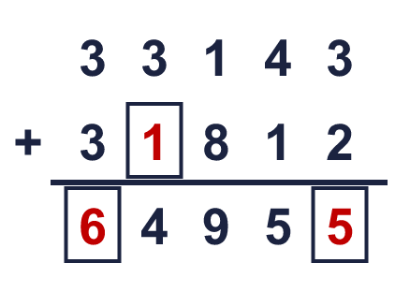  Missing digits, from top to bottom and left to right: 1 6 5
  4 | Write the missing digits in the calculation.  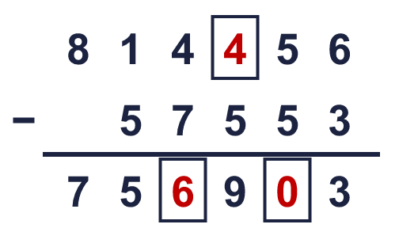  Missing digits, from top to bottom and left to right: 4 6 0
  5 | Write the missing number in each calculation.  a) 77,100 + 222,305 = 299,405  b) 966,978 − 79,988 = 886,990
  6 | Estimate 588,974 + 77,781 by rounding each number to the nearest 10,000 first.  Estimate: 670,000
  7 | Four players score points in a game. Dee’s score is 88,300 less than Beth’s.  a) What is Dee’s score? 28,600  b) What is the difference between the highest and the lowest score? 323,650
  8 | A theatre sold 25,350 tickets in May and 12,680 in June. It wants to sell 47,100 tickets by the end of June.  How many more tickets does it need to sell? 9,070
  9 | What is the difference between A and B? 250,000
  10 | The answer must be bigger than 500. What is the smallest answer above 500 that you can make? 509
  11 | What number did I start with? 990,000
  12 | Is Boba correct? Circle yes or no.  Yes / No  Explain how you know.  22,839 − 15,189 = 7,650, not 8,650. To check, add: 7,650 + 15,189 = 22,839.
  13 | a) How much do they cost altogether? £2.74  b) John pays with a £10 note. How much change does he get? £7.26
  14 | Write two different pairs of 6-digit numbers that add up to 1,000,000.  Any two pairs of 6-digit numbers with a total of 1,000,000, for example 150,000 + 850,000 and 350,000 + 650,000

