Place value chart to help you:  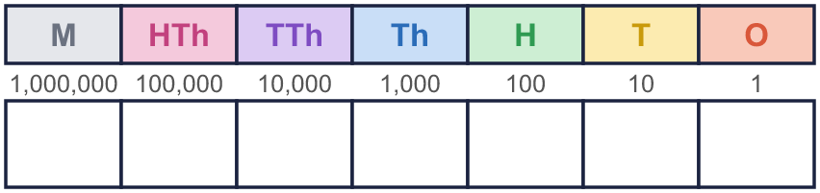 |  | Place value chart to help you:
  Year 6 · Add, subtract, multiply and divide · Step 1  Adding and subtracting integers | 
  Year 6 · Add, subtract, multiply and divide · Step 1
  Adding and subtracting integers
  1 | Work out the additions.  a) 6,155 + 471,820 =  b) 89,765 + 15,321 =  c) 944,194 + 321,094 =  Hint: Line the digits up: ones under ones, tens under tens. Start with the ones and carry when you reach 10.  Worked example. Line up the digits:  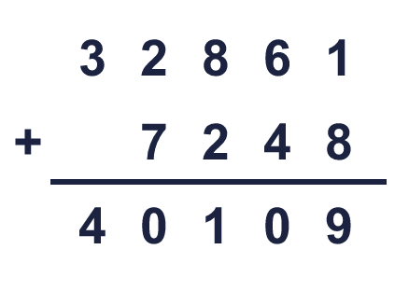
  1 | Work out the additions.  a) 6,155 + 471,820 =  b) 89,765 + 15,321 =  c) 944,194 + 321,094 =  Hint: Line the digits up: ones under ones, tens under tens. Start with the ones and carry when you reach 10.  Worked example. Line up the digits:
  2 | Work out the subtractions.  a) 84,075 − 56,018 =  b) 504,564 − 33,234 =  c) 3,191,227 − 159,966 =  Hint: Line the digits up. Start with the ones. If the top digit is smaller, exchange 1 from the next column.  Worked example. Line up the digits:  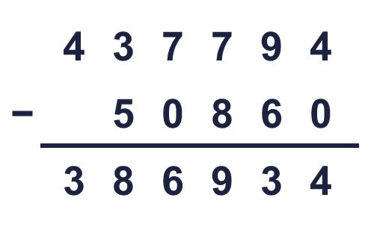
  2 | Work out the subtractions.  a) 84,075 − 56,018 =  b) 504,564 − 33,234 =  c) 3,191,227 − 159,966 =  Hint: Line the digits up. Start with the ones. If the top digit is smaller, exchange 1 from the next column.  Worked example. Line up the digits:
  3 | Write the missing digits in the calculation.  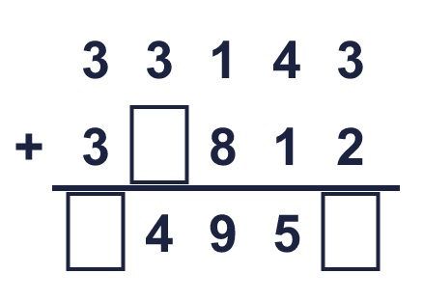  Missing digits, from top to bottom and left to right:  Hint: Start at the ones column. What digit makes the ones add up? Remember to carry.  Worked example. Line up the digits:  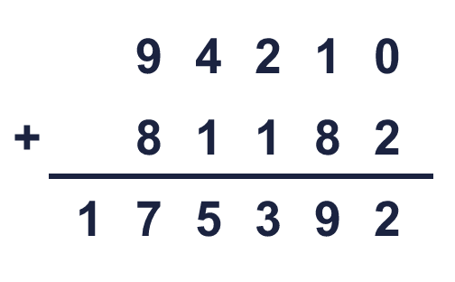
  3 | Write the missing digits in the calculation.  Missing digits, from top to bottom and left to right:  Hint: Start at the ones column. What digit makes the ones add up? Remember to carry.  Worked example. Line up the digits:
  4 | Write the missing digits in the calculation.  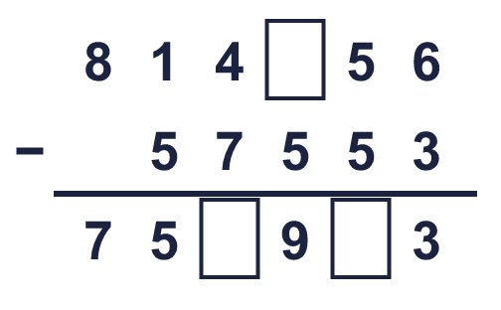  Missing digits, from top to bottom and left to right:  Hint: Check by adding: the answer plus the number taken away must make the top number.  Worked example. Line up the digits:  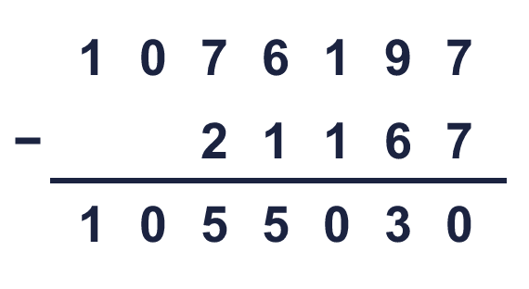
  4 | Write the missing digits in the calculation.  Missing digits, from top to bottom and left to right:  Hint: Check by adding: the answer plus the number taken away must make the top number.  Worked example. Line up the digits:
  5 | Write the missing number in each calculation.  Hint: a) Take the number you know away from the total. b) Add: the missing number is the answer plus the number taken away.
    a) | 77,100 + |  | = 299,405
    b) |  | − 79,988 = 886,990
  5 | Write the missing number in each calculation.  Hint: a) Take the number you know away from the total. b) Add: the missing number is the answer plus the number taken away.
    a) | 77,100 + |  | = 299,405
    b) |  | − 79,988 = 886,990
  6 | Estimate 588,974 + 77,781 by rounding each number to the nearest 10,000 first.  Estimate:  Hint: Round each number to the nearest 10,000. Then add or take away the rounded numbers. A quick estimate lets you check your answer.  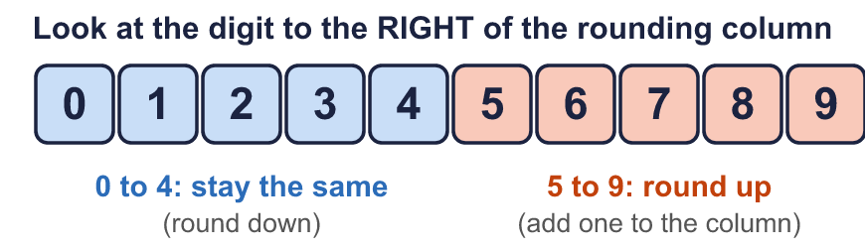
  6 | Estimate 588,974 + 77,781 by rounding each number to the nearest 10,000 first.  Estimate:  Hint: Round each number to the nearest 10,000. Then add or take away the rounded numbers. A quick estimate lets you check your answer.
  7 | Four players score points in a game. Dee’s score is 88,300 less than Beth’s.  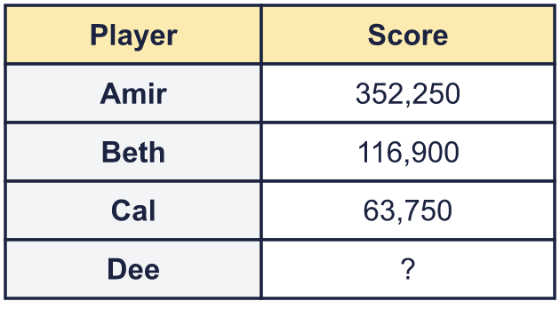  a) What is Dee’s score?  b) What is the difference between the highest and the lowest score?  Hint: a) Take 88,300 away from Beth’s score. b) Find the biggest and the smallest score, then take the smallest away from the biggest.
  7 | Four players score points in a game. Dee’s score is 88,300 less than Beth’s.  a) What is Dee’s score?  b) What is the difference between the highest and the lowest score?  Hint: a) Take 88,300 away from Beth’s score. b) Find the biggest and the smallest score, then take the smallest away from the biggest.
  8 | A theatre sold 25,350 tickets in May and 12,680 in June. It wants to sell 47,100 tickets by the end of June.  How many more tickets does it need to sell?  Hint: First find how many tickets were sold altogether. Then take that away from the target.
  8 | A theatre sold 25,350 tickets in May and 12,680 in June. It wants to sell 47,100 tickets by the end of June.  How many more tickets does it need to sell?  Hint: First find how many tickets were sold altogether. Then take that away from the target.

  9 | 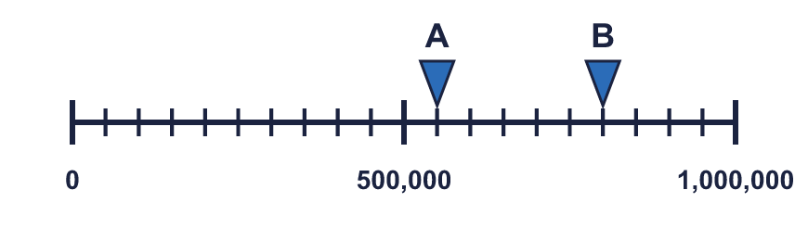  What is the difference between A and B?  Hint: Read A and B. Each step on this line is 50,000. Then take the smaller number away from the bigger one.
     | 
  9 | What is the difference between A and B?  Hint: Read A and B. Each step on this line is 50,000. Then take the smaller number away from the bigger one.
  10 | 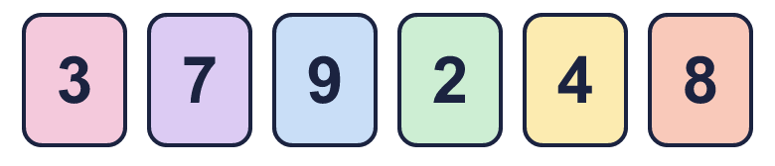  The answer must be bigger than 500. What is the smallest answer above 500 that you can make?  Hint: Make the first number big and the second number small. Try different cards in the hundreds column first, then check the answer is above 500.
     | 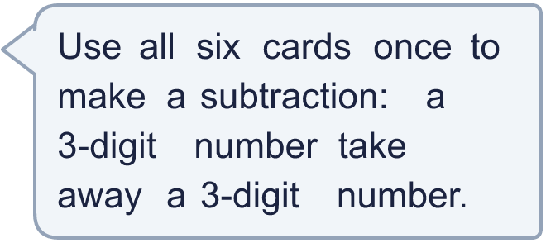
  10 | The answer must be bigger than 500. What is the smallest answer above 500 that you can make?  Hint: Make the first number big and the second number small. Try different cards in the hundreds column first, then check the answer is above 500.
  11 | What number did I start with?  Hint: Work backwards. Do the opposite of each step, starting from my answer: take away 30,000, add 150,000, take away 400,000.
    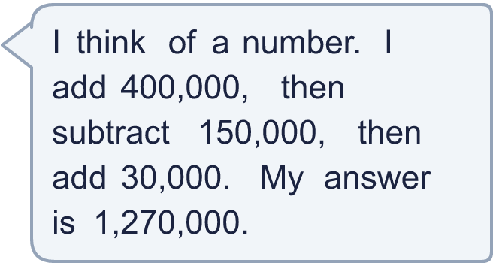
  11 | What number did I start with?  Hint: Work backwards. Do the opposite of each step, starting from my answer: take away 30,000, add 150,000, take away 400,000.
  12 | Is Boba correct? Circle yes or no.  Yes / No  Explain how you know.  Hint: Check a subtraction by adding the answer and the number you took away. Do you get the number you started with?
     | 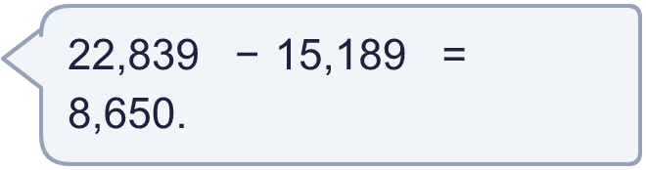
  12 | Is Boba correct? Circle yes or no.  Yes / No  Explain how you know.  Hint: Check a subtraction by adding the answer and the number you took away. Do you get the number you started with?
  13 | 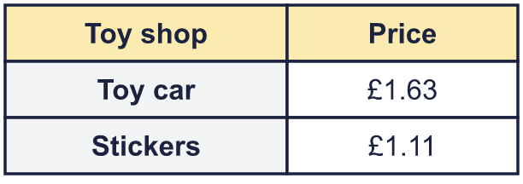  a) How much do they cost altogether?  b) John pays with a £10 note. How much change does he get?  Hint: Work in pence if you find it easier: £1.49 is 149p. Then change back to pounds.
    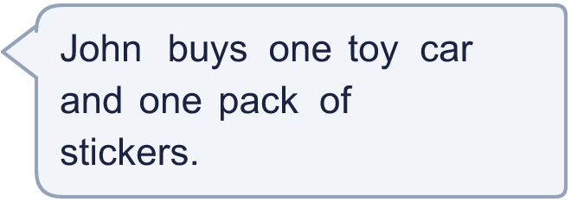
  13 | a) How much do they cost altogether?  b) John pays with a £10 note. How much change does he get?  Hint: Work in pence if you find it easier: £1.49 is 149p. Then change back to pounds.
  14 | Write two different pairs of 6-digit numbers that add up to 1,000,000.  Hint: Pick any 6-digit number below 500,000. What must you add to it to reach 1,000,000? Check that the second number has 6 digits.
  14 | Write two different pairs of 6-digit numbers that add up to 1,000,000.  Hint: Pick any 6-digit number below 500,000. What must you add to it to reach 1,000,000? Check that the second number has 6 digits.

Year 6 · Add, subtract, multiply and divide · Step 1
Adding and subtracting integers
Answers (teacher copy)

Place value chart to help you:
  1 | Work out the additions.  a) 6,155 + 471,820 = 477,975  b) 89,765 + 15,321 = 105,086  c) 944,194 + 321,094 = 1,265,288  Hint: Line the digits up: ones under ones, tens under tens. Start with the ones and carry when you reach 10.  Worked example. Line up the digits:
  2 | Work out the subtractions.  a) 84,075 − 56,018 = 28,057  b) 504,564 − 33,234 = 471,330  c) 3,191,227 − 159,966 = 3,031,261  Hint: Line the digits up. Start with the ones. If the top digit is smaller, exchange 1 from the next column.  Worked example. Line up the digits:
  3 | Write the missing digits in the calculation.  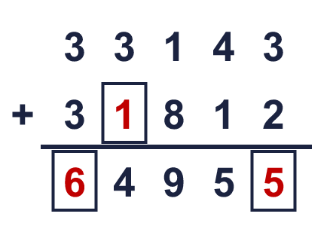  Missing digits, from top to bottom and left to right: 1 6 5  Hint: Start at the ones column. What digit makes the ones add up? Remember to carry.  Worked example. Line up the digits:
  4 | Write the missing digits in the calculation.  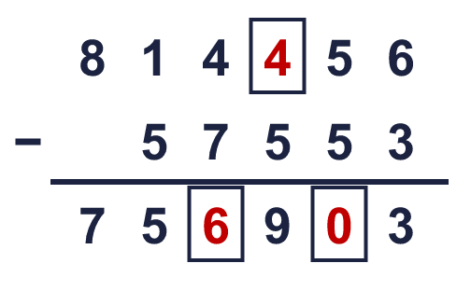  Missing digits, from top to bottom and left to right: 4 6 0  Hint: Check by adding: the answer plus the number taken away must make the top number.  Worked example. Line up the digits:
  5 | Write the missing number in each calculation.  a) 77,100 + 222,305 = 299,405  b) 966,978 − 79,988 = 886,990  Hint: a) Take the number you know away from the total. b) Add: the missing number is the answer plus the number taken away.
  6 | Estimate 588,974 + 77,781 by rounding each number to the nearest 10,000 first.  Estimate: 670,000  Hint: Round each number to the nearest 10,000. Then add or take away the rounded numbers. A quick estimate lets you check your answer.
  7 | Four players score points in a game. Dee’s score is 88,300 less than Beth’s.  a) What is Dee’s score? 28,600  b) What is the difference between the highest and the lowest score? 323,650  Hint: a) Take 88,300 away from Beth’s score. b) Find the biggest and the smallest score, then take the smallest away from the biggest.
  8 | A theatre sold 25,350 tickets in May and 12,680 in June. It wants to sell 47,100 tickets by the end of June.  How many more tickets does it need to sell? 9,070  Hint: First find how many tickets were sold altogether. Then take that away from the target.
  9 | What is the difference between A and B? 250,000  Hint: Read A and B. Each step on this line is 50,000. Then take the smaller number away from the bigger one.
  10 | The answer must be bigger than 500. What is the smallest answer above 500 that you can make? 509  Hint: Make the first number big and the second number small. Try different cards in the hundreds column first, then check the answer is above 500.
  11 | What number did I start with? 990,000  Hint: Work backwards. Do the opposite of each step, starting from my answer: take away 30,000, add 150,000, take away 400,000.
  12 | Is Boba correct? Circle yes or no.  Yes / No  Explain how you know.  22,839 − 15,189 = 7,650, not 8,650. To check, add: 7,650 + 15,189 = 22,839.  Hint: Check a subtraction by adding the answer and the number you took away. Do you get the number you started with?
  13 | a) How much do they cost altogether? £2.74  b) John pays with a £10 note. How much change does he get? £7.26  Hint: Work in pence if you find it easier: £1.49 is 149p. Then change back to pounds.
  14 | Write two different pairs of 6-digit numbers that add up to 1,000,000.  Any two pairs of 6-digit numbers with a total of 1,000,000, for example 150,000 + 850,000 and 350,000 + 650,000  Hint: Pick any 6-digit number below 500,000. What must you add to it to reach 1,000,000? Check that the second number has 6 digits.

