  Year 6 · Add, subtract, multiply and divide · Step 3  Common multiples | 
  Year 6 · Add, subtract, multiply and divide · Step 3
  Common multiples
  1 | Write the first 8 multiples of each number.  a) 3:  b) 5:
  1 | Write the first 8 multiples of each number.  a) 3:  b) 5:
  2 | Sort the numbers into the diagram. Write each group.  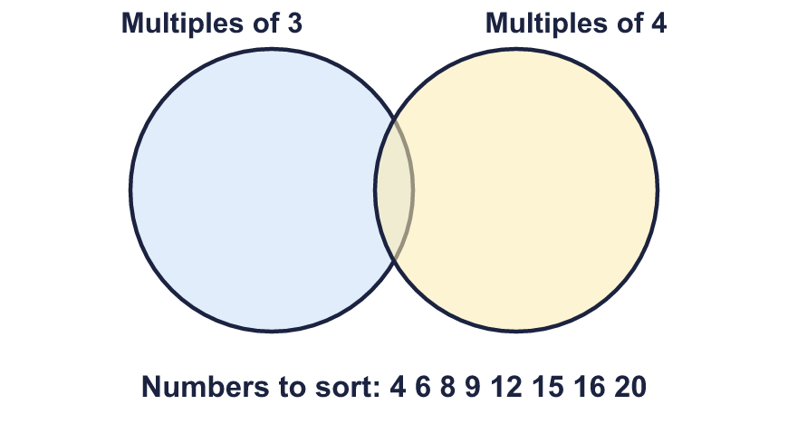  Multiples of 3 only:  Multiples of both:  Multiples of 4 only:  Neither:
  2 | Sort the numbers into the diagram. Write each group.  Multiples of 3 only:  Multiples of both:  Multiples of 4 only:  Neither:
  3 | Write the first three common multiples of each pair.  a) 2 and 4:  b) 4 and 5:  c) 3 and 6:
  3 | Write the first three common multiples of each pair.  a) 2 and 4:  b) 4 and 5:  c) 3 and 6:
  4 | Find the lowest common multiple of each pair.  a) 10 and 15:  b) 4 and 6:  c) 8 and 12:
  4 | Find the lowest common multiple of each pair.  a) 10 and 15:  b) 4 and 6:  c) 8 and 12:
  5 | Circle the common multiples of 5 and 6. Write them below.  15 18 20 24 30 36 45
  5 | Circle the common multiples of 5 and 6. Write them below.  15 18 20 24 30 36 45
  6 | Write the first two common multiples of all three numbers.  a) 3, 5, 6:  b) 2, 3, 4:
  6 | Write the first two common multiples of all three numbers.  a) 3, 5, 6:  b) 2, 3, 4:
  7 | List all the common multiples of 3 and 4 that are more than 20 and less than 40.
  7 | List all the common multiples of 3 and 4 that are more than 20 and less than 40.
  8 | Mason plays tennis every 3 days. Gill plays tennis every 5 days. They both played today.  In how many days will they next both play on the same day?
  8 | Mason plays tennis every 3 days. Gill plays tennis every 5 days. They both played today.  In how many days will they next both play on the same day?

  9 | a) Will both lights flash together at 408 seconds? Write yes or no.  b) After how many seconds will they next flash together?
    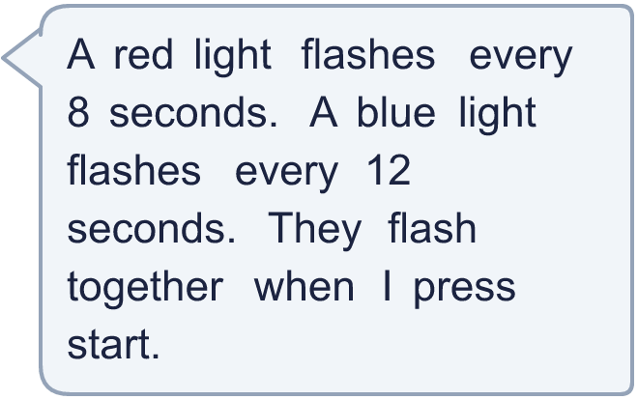
  9 | a) Will both lights flash together at 408 seconds? Write yes or no.  b) After how many seconds will they next flash together?
  10 | On her 72th birthday, Gran says: “My age is a multiple of both your ages today.” Her two grandchildren are in different school years (aged 5 to 16).  How old could the grandchildren be? Find two different answers.
  10 | On her 72th birthday, Gran says: “My age is a multiple of both your ages today.” Her two grandchildren are in different school years (aged 5 to 16).  How old could the grandchildren be? Find two different answers.
  11 | Is Boba correct? Circle yes or no.  Yes / No  Explain how you know.
     | 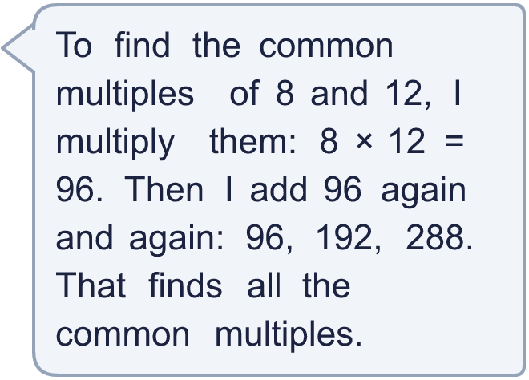
  11 | Is Boba correct? Circle yes or no.  Yes / No  Explain how you know.
  12 | How tall could the towers be?
     | 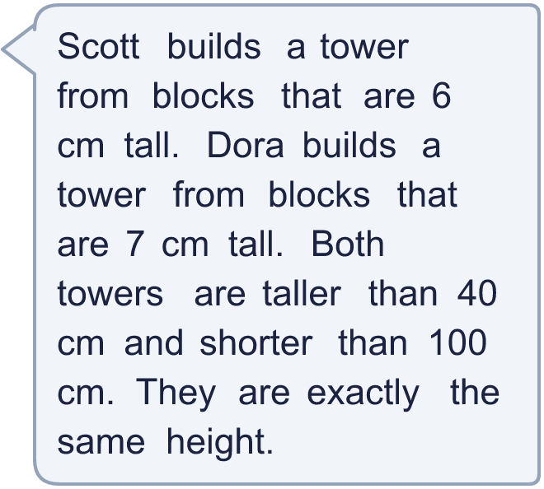
  12 | How tall could the towers be?
  13 | • It is a common multiple of 8 and 12.  • It is more than 45 and less than 105.  • The digits add up to 9.  What is my number?
     | 
  13 | • It is a common multiple of 8 and 12.  • It is more than 45 and less than 105.  • The digits add up to 9.  What is my number?
  14 | Write three different numbers between 100 and 200 that are common multiples of 6 and 9.
  14 | Write three different numbers between 100 and 200 that are common multiples of 6 and 9.

Year 6 · Add, subtract, multiply and divide · Step 3
Common multiples
Answers (teacher copy)

  1 | Write the first 8 multiples of each number.  a) 3: 3, 6, 9, 12, 15, 18, 21, 24  b) 5: 5, 10, 15, 20, 25, 30, 35, 40
  2 | Sort the numbers into the diagram. Write each group.  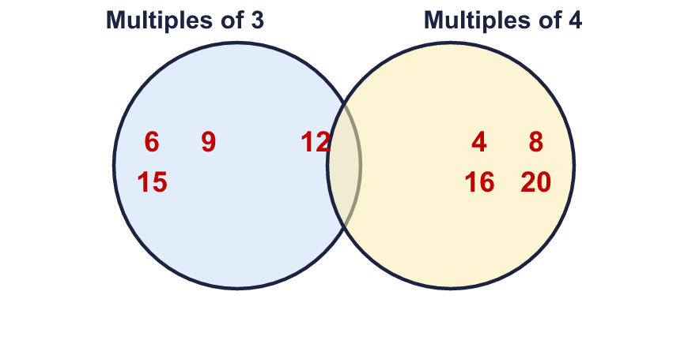  Multiples of 3 only: 6, 9, 15  Multiples of both: 12  Multiples of 4 only: 4, 8, 16, 20  Neither: none
  3 | Write the first three common multiples of each pair.  a) 2 and 4: 4, 8, 12  b) 4 and 5: 20, 40, 60  c) 3 and 6: 6, 12, 18
  4 | Find the lowest common multiple of each pair.  a) 10 and 15: 30  b) 4 and 6: 12  c) 8 and 12: 24
  5 | Circle the common multiples of 5 and 6. Write them below.  15 18 20 24 30 36 45  30
  6 | Write the first two common multiples of all three numbers.  a) 3, 5, 6: 30, 60  b) 2, 3, 4: 12, 24
  7 | List all the common multiples of 3 and 4 that are more than 20 and less than 40.  24, 36
  8 | Mason plays tennis every 3 days. Gill plays tennis every 5 days. They both played today.  In how many days will they next both play on the same day? 15
  9 | a) Will both lights flash together at 408 seconds? Write yes or no. Yes  b) After how many seconds will they next flash together? 24
  10 | On her 72th birthday, Gran says: “My age is a multiple of both your ages today.” Her two grandchildren are in different school years (aged 5 to 16).  How old could the grandchildren be? Find two different answers.  Any two different ages from 5 to 16 that are both factors of 72, for example 8 and 12 or 6 and 8
  11 | Is Boba correct? Circle yes or no.  Yes / No  Explain how you know.  24 is a common multiple of 8 and 12 that Boba misses, because 24 is less than 96. 24 ÷ 8 = 3 and 24 ÷ 12 = 2.
  12 | How tall could the towers be? 42, 84
  13 | • It is a common multiple of 8 and 12.  • It is more than 45 and less than 105.  • The digits add up to 9.  What is my number? 72
  14 | Write three different numbers between 100 and 200 that are common multiples of 6 and 9.  Any three of the common multiples of 6 and 9 between 100 and 200, for example 108, 126, 144

